VITyarthi | Open-Source Software

The Open-Source Audit

A Capstone Project for OSS NGMC Course

Course: Open-Source Software | Unit Coverage: 1
– 5 Max Marks: 100

Student Name | Registration Number
Padmesh Joshi | 24BCE10009
Slot | Date of Submission
B22 | 30/03/2026

DETAILED REPORT ON PYTHON OPEN-SOURCE
SOFTWARE

PART A — ORIGIN AND PHILOSOPHY (PYTHON)

A1: Origin of Python — The Problem It Solved
Guido Van Rossumm developed the Python programming Language in the late 1980s at Centrum Wiskunde & Informatica (CWI) in The Netherlands. While working on the development of ABC programming language, designed for beginners; he found it very easy to read and write but unable to extend beyond small-scale programming projects.
Van Rossum saw a void in the programming languages. The existing programming languages like C and C++ did provide a lot of power but were significantly more difficult to code with and much more likely to produce errors than they were to the person coding with them. A more significant limitation associated with the current programming languages was their lack of flexibility for real-life program development - therefore, there was a need for a simple programming language to develop more robust codes while providing readability and power to the programmer.Python was designed to solve this problem.
Its primary objectives were: -
- Creation of the language that is easy to read as well as easy to write.
- Leads to the reduction in the complexity of the programming text.
- Allowing rapid development and prototyping.
- In support of multiple programming paradigms includes (procedural, object-oriented, and later functional)
Python was invented in 1991, but its name, "Python" comes from the British television show "Monty Python's Flying Circus" because the creator wanted programming to be fun instead of just technical.
As Python developed, it became one of the world's most popular programming languages and can be seen today in many different industries such as web development, data science & analytics, artificial intelligence, robotic process automation, information security/cybersecurity, and scientific computing, etc. The success of Python has been attributed to its unique combination of easy-to-learn yet powerful language features, which allow easy access for beginners while also meeting the demands of more advanced programmers.

A2: License — What It Actually Means

The distribution of python is under the Python Software Foundation license which is an open-source license. This license allows its users with a high degree of freedom of how they use and distribute the python software.
The PSF License grants users the ability to:
- Use Python for any purpose as well as for commercial applications.
- To modify and to distribute the original source code.
- Integrate Python with proprietary software.
The PSF License offers greater flexibility and is more suitable for businesses than many copyleft-type licenses like the GNU General Public License (GPL). It allows the user of the software to determine how to license their modified version and as a result, has much more flexibility than copyleft-type licenses.
The Four Freedoms of Free Software
Although Python uses a permissive license, it aligns closely with the four fundamental freedoms of free software:
- The freedom of running the program irrespective of purpose.
- The freedom to study about how the program works as well as modify it.
- The freedom to make and distribute the copies
- The freedom to distribute modified versions as well.
Python supports all four freedoms which makes it a strong example of open-source software which prioritizes user autonomy.
GPL vs MIT vs PSF — A Comparison
- General Public License (GPL) requires any modified version of the software be open source. It enforces “copyleft.”
- MIT License is very permissive; you can privately modify, but don’t have to redistribute.
- PSF License for Python: Similar to MIT in flexibility; however, it is specifically designed for the Python ecosystem and governance.
An individual's choice of licensing for their project depends largely on their objectives. For example, should an individual wish all derivative works to remain open, the GPL is the right choice. However, for maximum adoption and flexibility, a permissive license such as the PSF License or the MIT License would be a better choice.
“Free as in Freedom” vs “Free as in Free Beer” A key distinction in open source is between:
- Free as in terms of free beer (that is no cost)
- Free as in terms of freedom (that is control and rights)
Python embodies both aspects; it is free of charge and also enables the user to freely examine, alter and share the application with others. This freedom is what makes Python one of the key building blocks of contemporary software development.

A3: The Philosophy and Ethics of Python
In addition to being able to write code using Python (a programming language), this programming language represents a philosophy of simplicity, clarity and working together (community). The Zen of Python — by Tim Peters — best describes these ideas with a series of guiding principles. Three of the more popular ones are:
- Good enough — or simpler is better than more complicated
- Clarity is important
- There should be a defined way (preference for 1) to accomplish something.
These principles stress that code should be designed to be understandable by people, and not only executed by computers. For this reason, Python is well-suited for collaborative programming; that is, for instances when many programmers are developing the same application at the same time.
Ethical Considerations
Should all software be open source?
There are strong arguments regarding both for as well as against the idea.
Some are in favour of open source because:
- Open source provides transparency and trust - The community can identify and fix security vulnerabilities
- Open source is a way of creating technology where it is accessible to anyone regardless of economic status
Others may oppose open source because:
- Companies invest large amounts of money into developing their products and they may need to protect their intellectual property
- Some systems (such as critical infrastructure or defence) may have restricted access for security purposes
Therefore, while open source has many advantages, it may not be suitable for every context.
Is it ethical for companies to profit from open-source software?
There are differing opinions on this issue. Many companies (e.g., Google, Microsoft, & Meta) utilize numerous open-source technologies including Python, to build their products, often contributing to those technologies. However, these companies also generate tremendous income. One viewpoint states that they have the right to do so, provided they give back in some way (via improvements to the technology being used, providing documentation, or donating financially) by supporting the ecosystem they rely on. The other view posits that this may result in utilizing free labour through a large group of volunteers from the open-source community.
Depending on your perspective, there are situations where this can be seen as being balanced. The Python community, for example, has established a system where users can develop open-source developments for the Python language, while ensuring that their contributions are maintained and managed by a non-profit organization (the Python Software Foundation) in a way that allows for both community governance and commercial reuse.
"Standing on the Shoulders of Giants" is a metaphorical expression that represents the belief that all innovation can be traced back to something that has already been created before. In the field of software development, this phenomenon is noticeably evident, mainly in that Python has evolved from its predecessors and has become the basis for many of today's modern tools.
Examples include:
- Data Science relies heavily on libraries, such as NumPy and Pandas
- web-development frameworks such as Django and Flask have been created using Python
- both TensorFlow and PyTorch were developed with Python in mind for use in machine- learning applications.
The open-source movement promotes further innovation by enabling developers to build upon existing tools instead of reinventing them.

Part – B (Linux FootPrint)

• Introduction

In Linux, Python is one of the most common programming languages and generally comes as part of the base operating system. Many applications are normally installed as an option. However, due to their strong integration with the Linux platforms, Python is regularly used by tools created by the operating system (system tools), and also by tools created by other programmers who create packages for Linux (package manager) and/or run administrative scripts (administration).

Due to this close relationship between Python and the system, having a good understanding of how Python is installed and structured on your Linux machine as well as how it works with the system is crucial to being able to use it to your advantage. This section will examine what Python looks like on a Linux machine in relation to its installation methods, directory structures, permissions at the user level, services that use Python, and the mechanisms used to keep Python up to date.

• Installation methods

You can install Python on any Linux operating system (distribution) through your distribution's package manager or by building Python from source. Due to the number of system utilities that rely on Python, most major distributions of Linux, such as Ubuntu, Debian, Fedora, and CentOS, have by default pre-installed Python 3.
- Installation through Package managers
On Debian based systems:- sudo apt update sudo apt install python3

On Red Hat-based systems:- sudo dnf install python3

- Installation from the source

Advanced users can also install Python by downloading source code from the official website and compiling it on their own machine. This gives them more control over how Python is set up, but it requires more work and expertise.

• Verify installation

After installation, Python can be verified with the help of:
python3 –version

• Service Management and Integration

Though Python itself is not an OS-level service, many Python-based applications operate as OS services in a Linux platform.
Examples include:
- web-based applications designed using web frameworks, such as Django or Flask
- automation scripts
- Monitoring applications
The Linux service manager can manage applications via a system service manager by executing the commands:
'systemctl start myapp' to start the service
'Systemctl stop myapp' to stop the service
'Systemctl status myapp' to view the service status
You can create a systemd service configuration for a Python application by creating a service file. When you create a service file for a Python application, it will automatically start with the system when the system boots and will be managed just like any other service. This shows how to integrate Python and Linux's service management framework

• Python Update / Package Management Model

There are two methods available for updating Python programs - through your system's package manager(s) and via "Python" specific tools.

• Python Community Contribution Model

Updates to the core features of Python are maintained by the Python Software Foundation (PSF) and many of the libraries used by Python are maintained by community members, organizations and other developers. This allows for an open- source community of people who will be able to update and enhance Python over time.

• Python's Role in Linux System

In addition to being a programming language, Python has many other roles within the Linux environment, including but not limited to being used for:
- Automation, i.e., how we manage, maintain and upgrade systems
- Tools for managing software (e.g. apt/dpkg, yum, etc.)
- Scripting / automating routine tasks
- Developing applications and services
Multiple system utilities rely on Python for functioning and is considered an essential tool for and part of the modern-day Linux environment.

PART C — THE FOSS ECOSYSTEM (PYTHON)

• Introduction

The ecosystem as a whole is made up of multiple open-source projects that rely upon each other and create unique functionality together. An excellent illustration of this is Python which does more than provide a programming language but has developed into an entire platform with multiple layers of development that all utilize the same core; hundreds of libraries or frameworks provide various features or functionality to build applications with and have ongoing support from a global community.
The following section discusses the ecosystem of Python including its dependencies, additional tools that can be developed using the Python language, the various roles Python plays in web development and software stacks, and the community behind and supporting the continuation of development on the Python language.

• Dependencies and Supporting Technologies

Python requires multiple tools/technologies to work properly in an environment.
Core Dependencies:
- C Language: Python (CPython) is implemented as a C application using a C language interpreter.
- System Libraries: Uses standard Linux libraries for network connections, file access, etc.
- Compiler Tools: Needed to compile Python from source code.

Python’s design allows it to act as a high-level interface over lower-level system components, making it both powerful and flexible.

• Libraries and Frameworks Built on Python

Python’s ecosystem is rich because of its extensive libraries and frameworks. These tools extend Python’s capabilities into multiple domains.

- Web Development
  - Django → Full-stack web framework
  - Flask → Lightweight web framework
- Data Science and Analytics
  - NumPy → Numerical computing
  - Pandas → Data analysis
  - Matplotlib / Seaborn → Data visualization
- Machine Learning and AI
  - TensorFlow
  - PyTorch
  - Scikit-learn
- Automation and Scripting
  - Python scripts are widely used for: o File automation o System administration o Web scraping
- Development Tools
  - pip → Package manager
  - virtualenv / venv → Isolated environments
  - IDEs → VS Code, PyCharm

• How Python has Helped Other Technologies
Python has grown significantly by enabling the creation of new ways to build technologies and new ecosystems using technology.
Some examples include:
- A data Science revolution
- An AI and Machine Learning explosion
- Automation tools
- Cloud computing scripts
Many modern technologies are either built directly with Python or have components that are built using Python.

• Python's Role in the LAMP Stack/Web Ecosystem
Traditionally the LAMP stack has included:
- Linux
- Apache
- MySQL
- PHP
However, with the growth of Python as an alternative to PHP for back-end web development, many developers have moved toward using technologies built in Python.
For example, in a modern stack you will see:
- Linux
- Apache or Nginx
- MySQL or PostgreSQL
- Python (using either Django or Flask)
These technologies work well together because both web servers and databases can easily integrate with the Python programming language, making it easy to write back-end applications.
- Governance and Community
Another reason for Python's success is the community behind it.

• Python Software Foundation (PSF)
- Non-profit
- Maintains the Python language
- Promote an open-source development

• Contribution Model
Another reason for Python's success is the community behind it. Python follows an open model for contributions:
- Anyone may submit an improvement to Python (through PEPs — Python Enhancement Proposals)
- Core developers review PEPs
- Community input is heavily considered when evaluating changes to Python
This model encourages transparency and allows for continuous improvement of Python.

Part D — Open-Source vs Proprietary
Open source and proprietary software are two different approaches to software development and delivery. Python, as an open-source programming language, emphasizes transparency, collaboration, and flexibility, while MATLAB, as a proprietary software, emphasizes software development, support, and tools. The comparison between the two software helps us understand the pros and cons of each approach.

Comparison Table

Feature | Python | MATLAB
Cost | Free to use and distribute | Requires paid license
Security | Open source, can be audited by anyone | Closed source, limited visibility
Flexibility | Highly flexible and customizable | Limited customization
Support | Community-driven (forums, contributors) | Official support from  company
Accessibility | Easily available to all users | Restricted access due to cost
Updates | Community-driven, frequent updates | Controlled updates by company

Explanation of Comparison
The reason why Python is more preferred than MATLAB is that it can be used by anyone, as it is freely available for use. It is therefore very accessible to everyone, including students, programmers, and organizations at large. The fact that it is open source enables users to access the source code, edit, and customize the program to suit their needs. This has made the program applicable to a wide range of uses, including web development, machine learning, and automation, among other uses. Furthermore, the program is supported by a large community of users from all over the world who are actively involved in its development. On the other hand, MATLAB is a proprietary program developed by MathWorks, a software firm that offers technical software for professionals and engineers, among other users. The program can only be accessed by purchasing a license, which can be very expensive for some users, especially those who are not organizations or companies. The program offers support services to its users, which can be very helpful for those who use the program for professional purposes.

4. Shell Script Tasks

Script 1 — System Identity Report
echo " System Identity Report :"
echo "Hostname: $(hostname)"
echo "Current User: $(whoami)" echo "Operating System: $(uname -o)" echo "Kernel Version: $(uname -r)" echo "System Uptime:"
uptime # Display how long system has been running
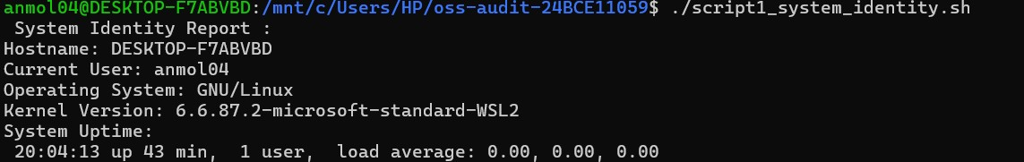
output:
This script will output a basic system identity report. It will output important system details like the system's name, the current user, the operating system, and the kernel version. The hostname and whoami commands will be used to output system and user details. The uname command will be used to output the operating system and kernel version. The uptime command will be used to output the system uptime.

Script 2 — FOSS Package Inspector

Code:

echo "Python Package Inspector :"

if command -v python3 &> /dev/null echo "Python is installed" python3 –version
echo "Location: $(which python3)" else
echo "Python is NOT installed"
fi condition
Output:

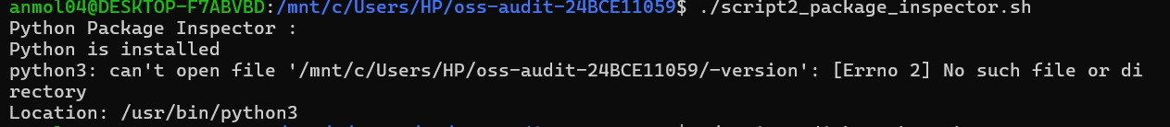
The following is a simple script to check if Python is installed in your system. The -v command is used to check if Python is installed in your system. If it is installed, it will display the version of Python installed in your system by using python3 --version and where it is installed by using which. If it is not installed, it will display an appropriate message.

Script 3 — Disk and Permission Auditor
shell
echo "Disk Usage:"
df -h
format echo ""
echo " File Permissions in Current Directory:"
ls -l
output:
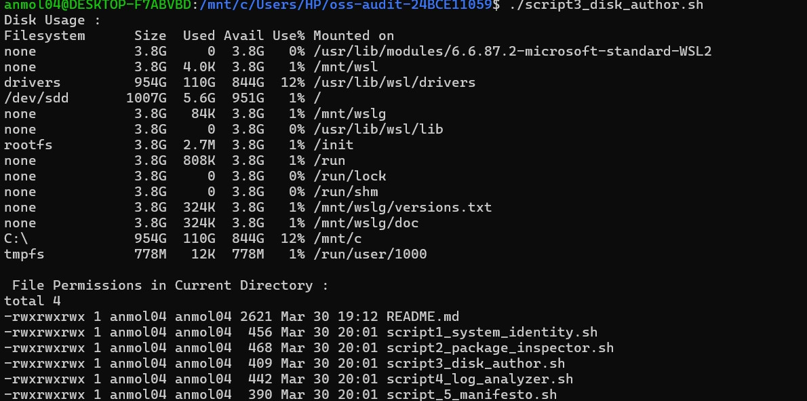

This script analyzes disk usage and file permissions. The df -h command displays disk space in a human-readable format. The ls -l command lists files along with their permissions, owner, and size. This helps users understand storage usage and access control. It is useful for system monitoring and security checks.

Script 4 — Log File Analyzer echo "Log File Analyzer :" LOGFILE="/var/log/syslog"
in variable if [ -f "$LOGFILE" ]; then echo "Showing last 10 lines of log file:"
tail -n 10 $LOGFILE
file else
echo "Log file not found!"
found fi
output:
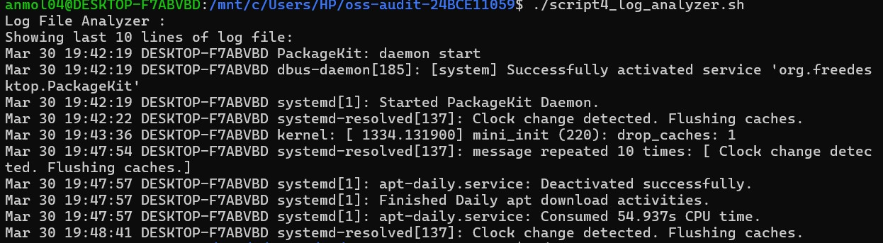
This script analyzes a system log file. It checks whether the log file exists using a conditional statement. If the file is present, it displays the last 10 lines using the tail command. If not, it shows an error message. This helps in monitoring recent system activities and detecting issues.
Script 5 — Open Source Manifesto Generator echo " Open Source Manifesto :" echo "We believe in freedom of software." echo "We support collaboration and sharing." echo "We encourage learning and innovation." echo "Open source empowers developers worldwide." echo "Together, we build better technology."

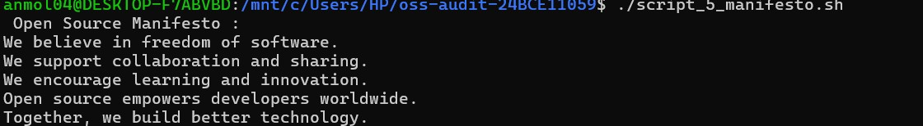
This script generates a simple open-source manifesto. It prints statements that reflect the values of open-source philosophy, such as freedom, collaboration, and innovation. The script uses basic echo commands to display messages. It demonstrates how scripting can be used to automate text generation.

