OpenLDAP-Client

<http://www.server-world.info/en/note?os=Ubuntu_14.04&p=ldap&f=2>

sudo apt-get install libnss-ldap libpam-ldap nscd

vi /etc/ldap/ldap.conf

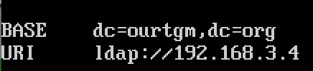

vi /etc/nsswitch.conf

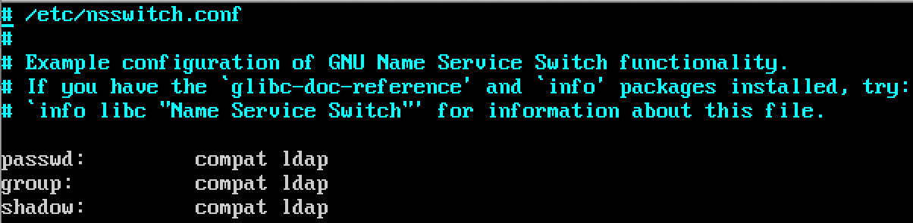

vi /etc/ldap.conf

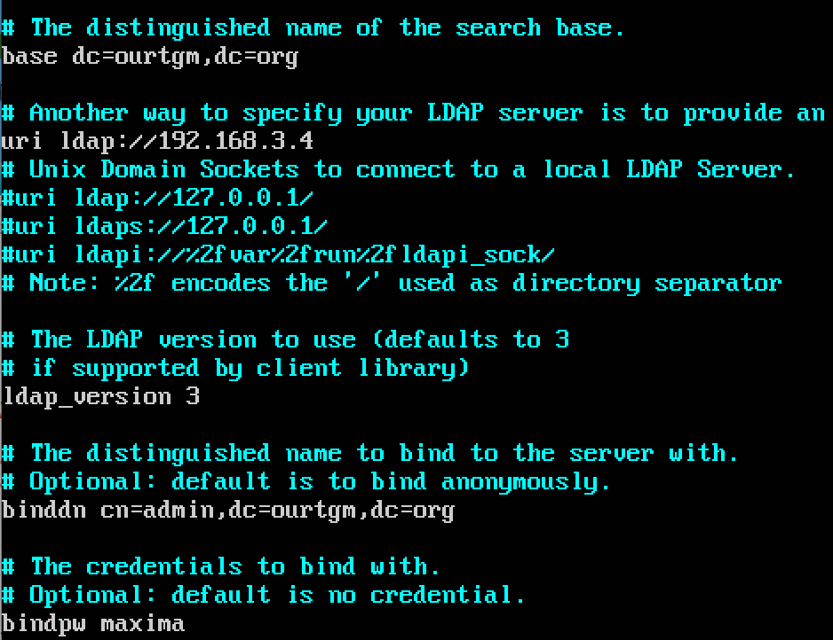

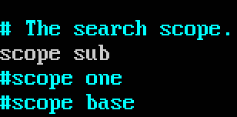

vi /etc/pam.d/common-password



vi /etc/pam.d/common-session

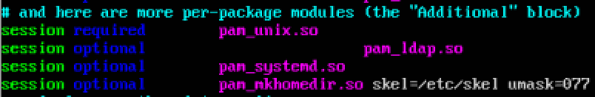

sudo service nscd restart

su benutzername