Windows-Client

FUNKTIONIERT LEIDER NICHT

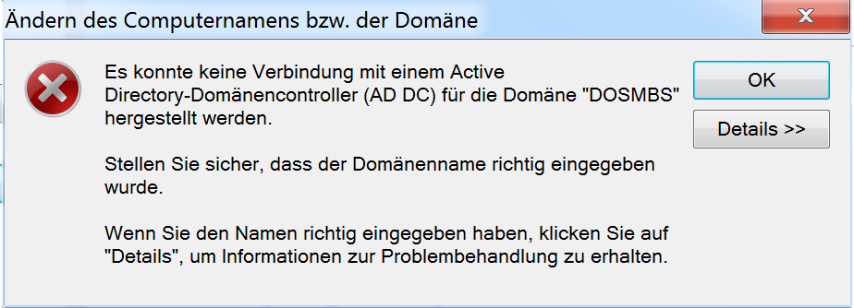

<http://haknode.blogspot.co.at/2014/03/ldap-und-samba-ubuntu-server-1204.html>

<https://www.youtube.com/watch?v=RV4fRETf3Tc>

<http://www.unixmen.com/setup-samba-domain-controller-with-openldap-backend-in-ubuntu-13-04/>

<http://islandlinux.org/howto/installing-samba-openldap-ubuntu>