FTP

Protokoll

* root@debian:~# apt-get install vsftpd
* root@debian:~# vim /etc/nsswitch.conf

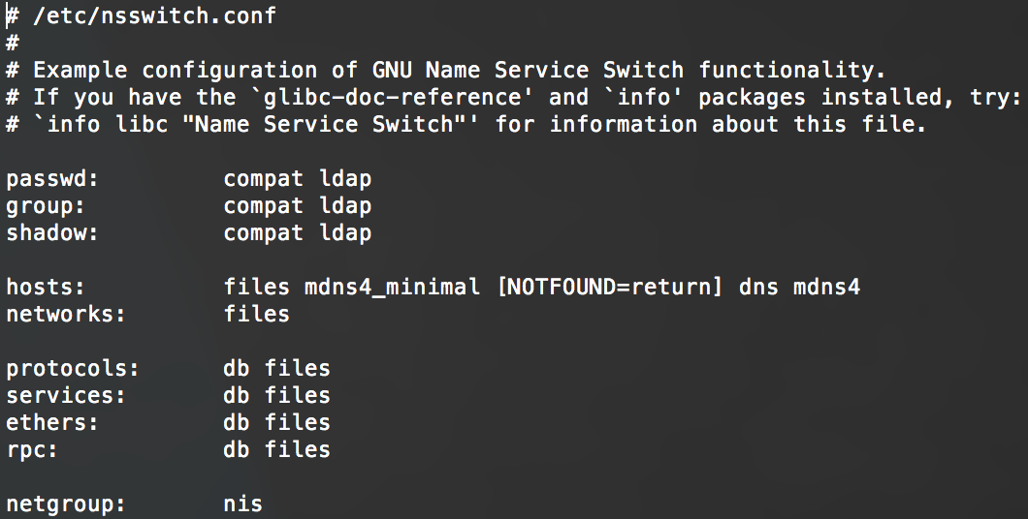

* root@debian:~# vim /etc/ldap/ldap.conf

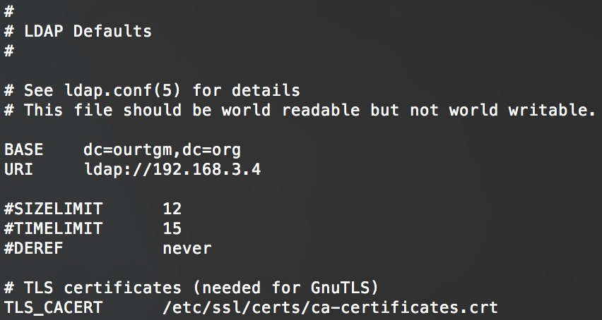

* root@debian:~# apt-get install libpam-ldap
* root@debian:~# vim /etc/pam.d/vsftpd

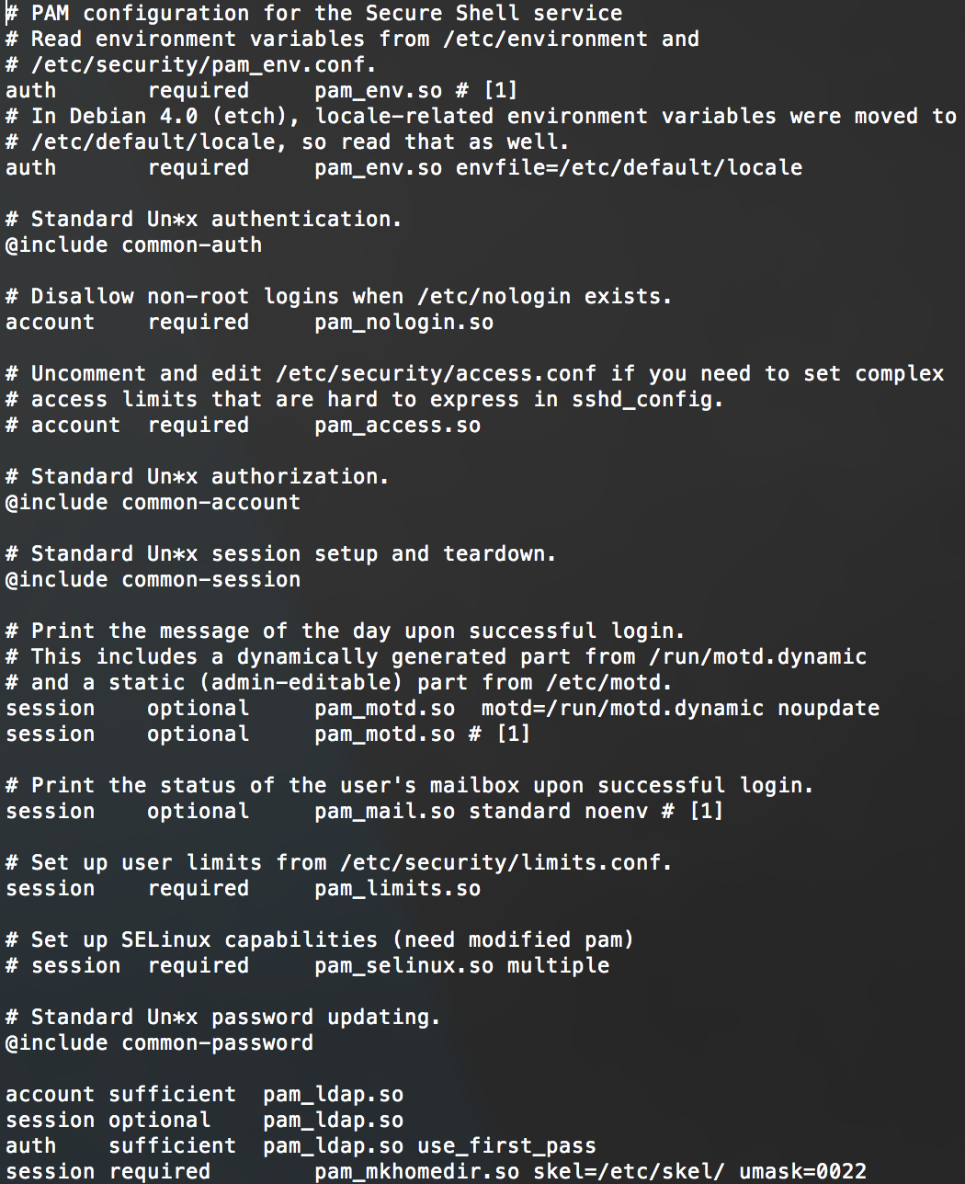

* root@debian:~# vim /etc/pam.d/common-auth

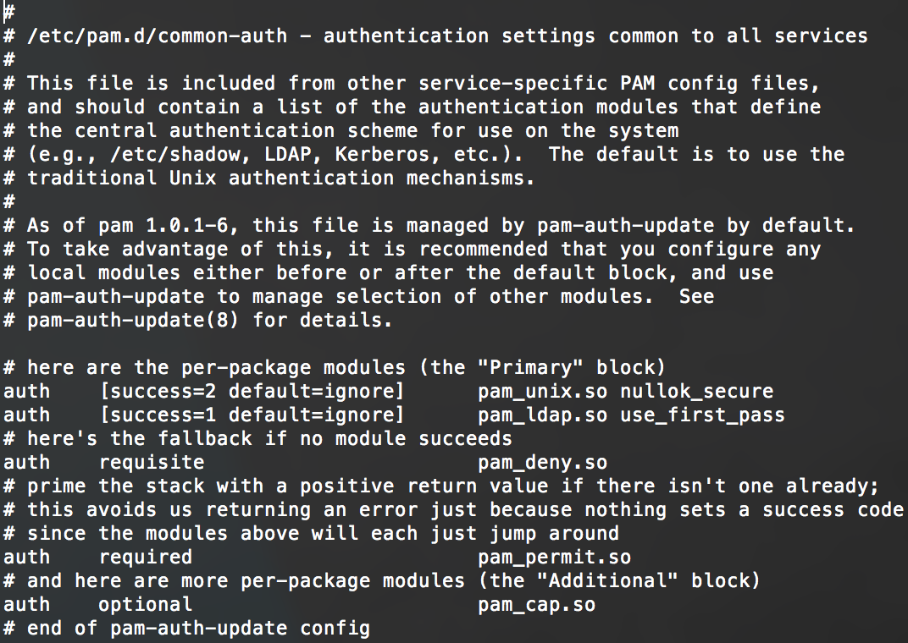

* root@debian:~# vim /etc/pam.d/common-session

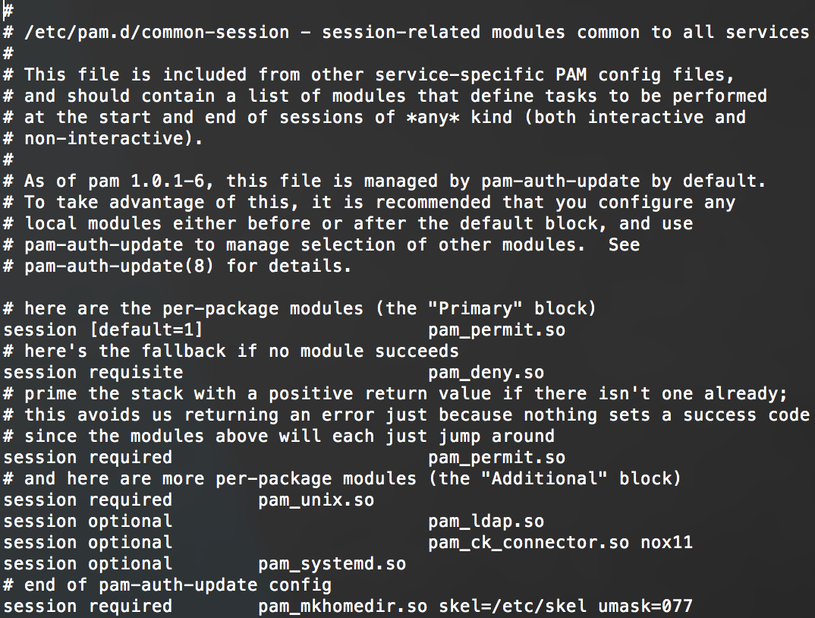

* root@debian:~# vim /etc/pam.d/common-password

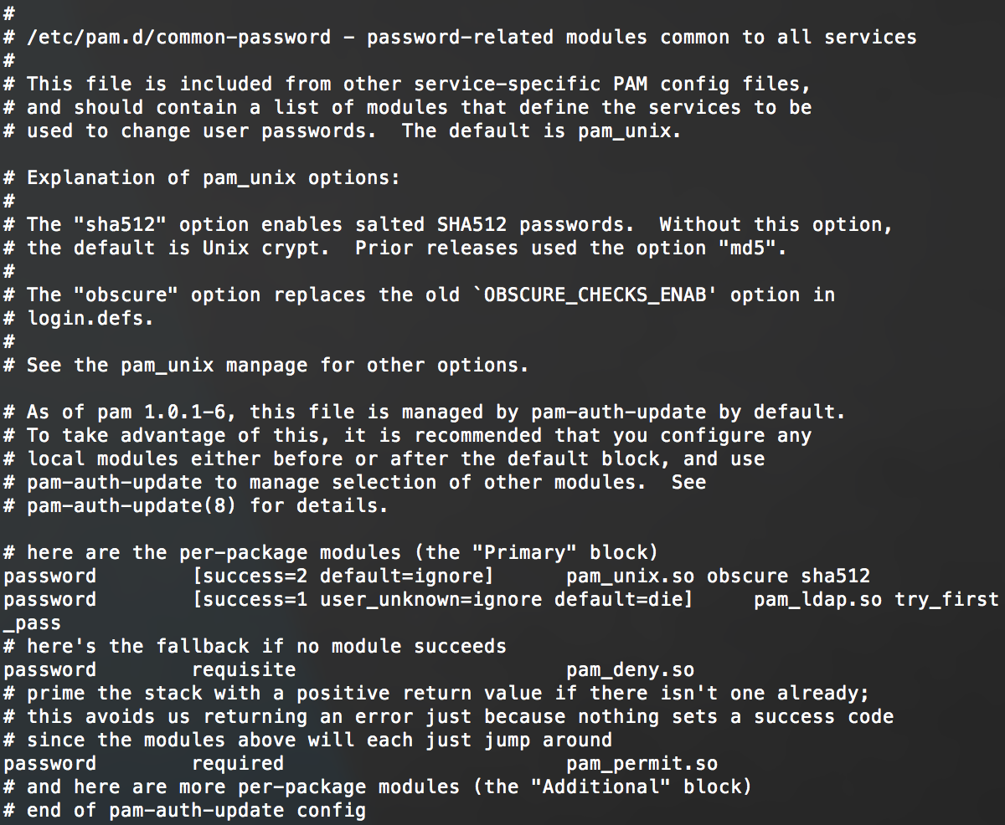

* root@debian:~# vim /etc/pam.d/common-account

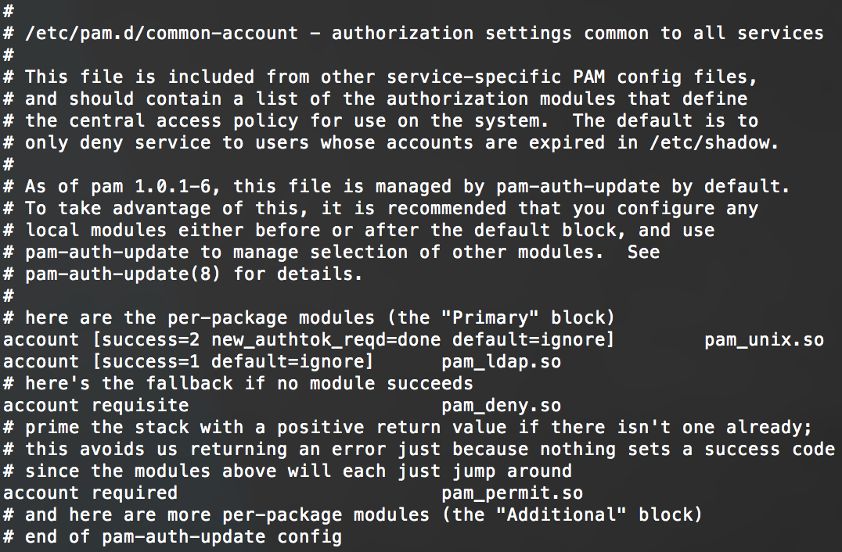

* root@debian:~# dpkg-reconfigure ldap-auth-config
* root@debian:~# vim /etc/libnss-ldap.conf

