OpenLDAP

<https://www.digitalocean.com/community/tutorials/how-to-install-and-configure-a-basic-ldap-server-on-an-ubuntu-12-04-vps>

sudo apt-get install slapd ldap-utils

sudo dpkg-reconfigure slapd

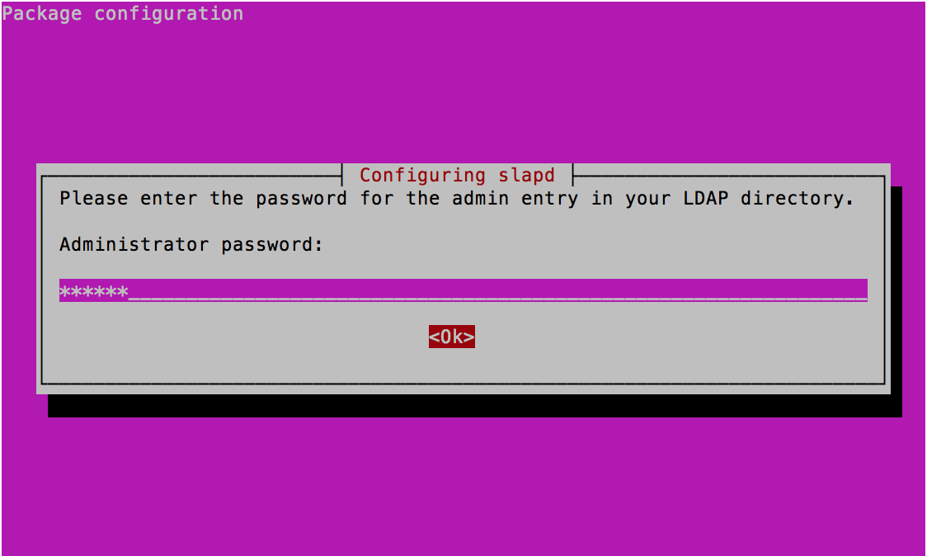

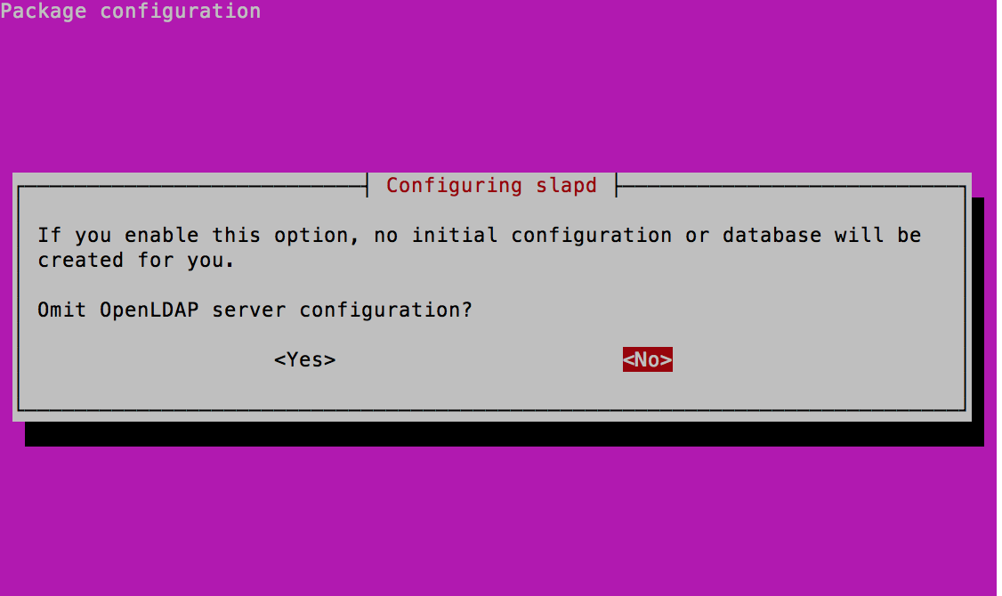

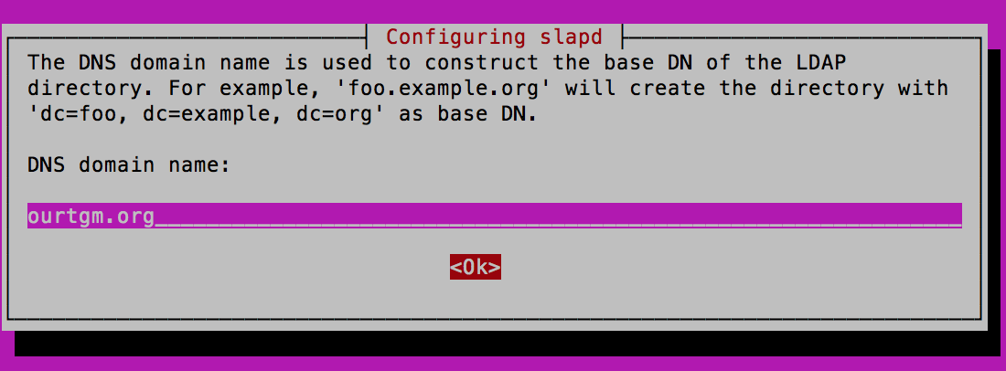

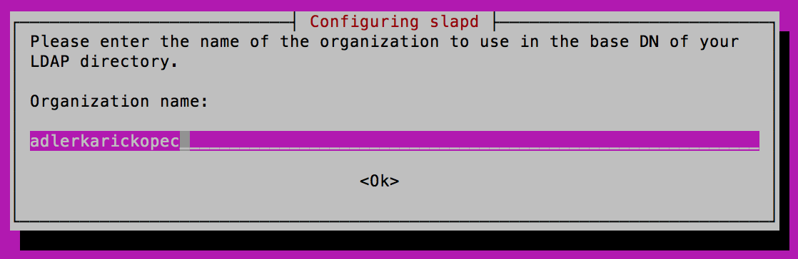

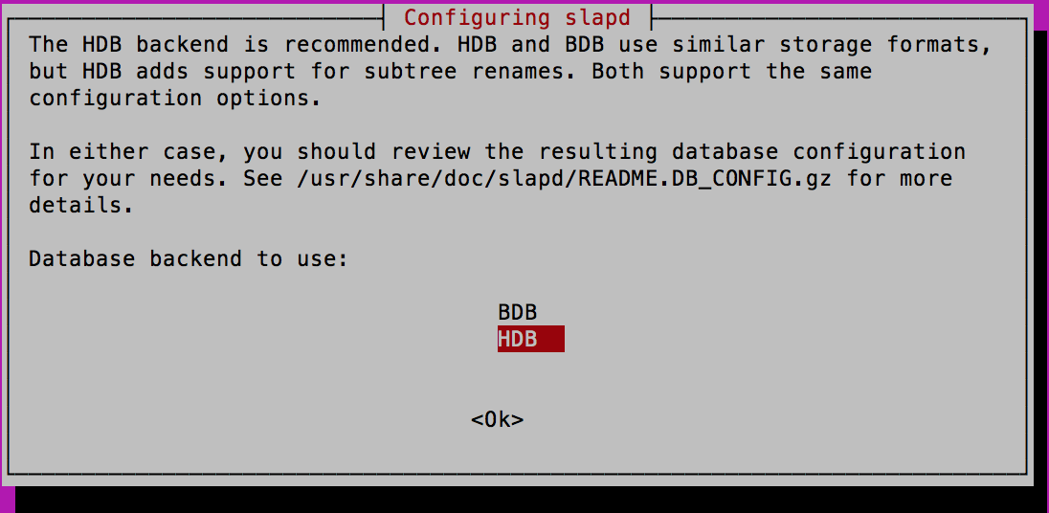

sudo apt-get install phpldapadmin

sudo nano /etc/phpldapadmin/config.php

$servers->setValue('server','host','domain_nam_or_IP_address');

$servers->setValue('server','base',array('dc=ourtgm,dc=org'));

$servers->setValue('login','bind_id','cn=admin,dc=ourtgm,dc=org');

$config->custom->appearance['hide_template_warning'] = true;

Login LDAP mittels PHP

Create Organizational Units

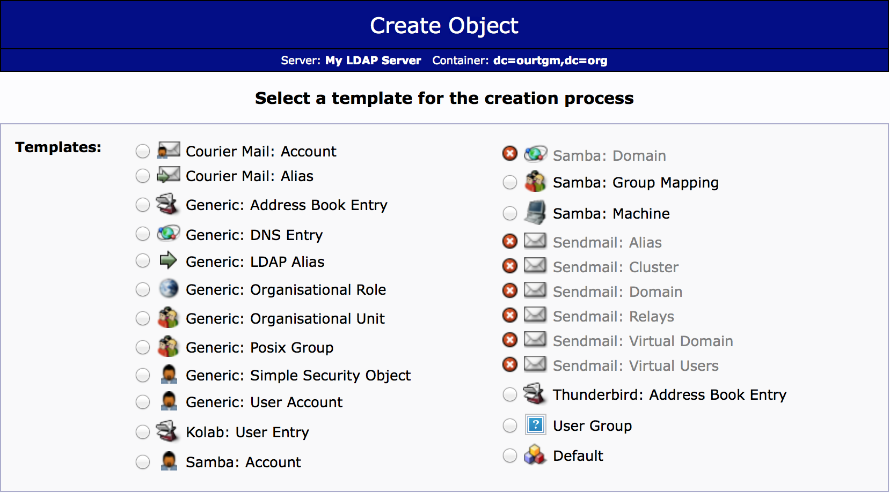

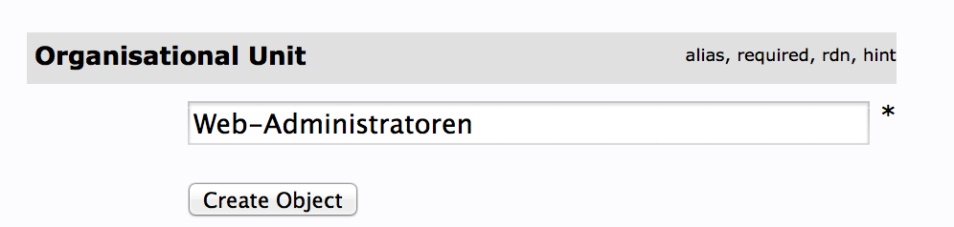

Create Groups

Confirm Password nicht erschienen

Lösung <http://stackoverflow.com/questions/20673186/getting-error-for-setting-password-feild-when-creating-generic-user-account-phpl>

Port auf den OpenLDAP Listen

vi /etc/default/slapd

SLAPD_SERVICES="ldap://0.0.0.0:389/ ldaps:/// ldapi:///"