Samba-Server

<http://haknode.blogspot.co.at/2014/03/ldap-und-samba-ubuntu-server-1204.html>

sudo apt-get install samba samba-doc smbldap-tools

sudo apt-get install dpkg-dev

sudo apt-get source smbldap-tools

vi /etc/samba/smb.conf

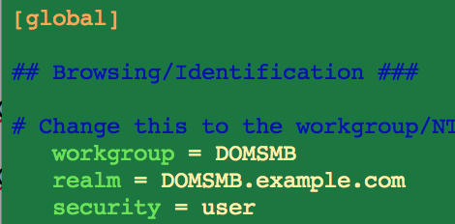

Am Ende der Datei

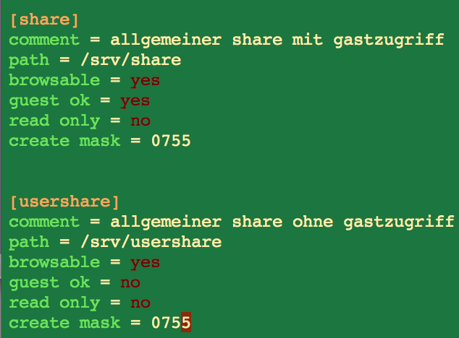

mkdir -p /srv/share && mkdir -p /srv/usershare

chown nobody.nogroup /srv/share && chown nobody.nogroup /srv/usershare

**Samba Schema zu LDIF konvertieren**

sudo gzip -d /usr/share/doc/samba-doc/examples/LDAP/samba.schema.gz

cp /usr/share/doc/samba-doc/examples/LDAP/samba.schema.gz /etc/ldap/schema/samba.schema

cd

vi schema_convert.conf erzeugen mit folgenden Inhalt:

include /etc/ldap/schema/core.schema

include /etc/ldap/schema/collective.schema

include /etc/ldap/schema/corba.schema

include /etc/ldap/schema/cosine.schema

include /etc/ldap/schema/duaconf.schema

include /etc/ldap/schema/dyngroup.schema

include /etc/ldap/schema/inetorgperson.schema

include /etc/ldap/schema/java.schema

include /etc/ldap/schema/misc.schema

include /etc/ldap/schema/nis.schema

include /etc/ldap/schema/openldap.schema

include /etc/ldap/schema/ppolicy.schema

include /etc/ldap/schema/ldapns.schema

include /etc/ldap/schema/pmi.schema

include /etc/ldap/schema/samba.schema

mkdir ldif_out

slapcat -f schema_convert.conf -F ldif_out -n 0 | grep samba,cn=schema

slapcat -f schema_convert.conf -F ldif_out -n0 -H ldap:///cn={14}samba,cn=schema,cn=config -l cn=samba.ldif

vi cn=samba.ldif

Ersten Zeilen Index {14} löschen und letzten 7 Zeilen

ldapadd -Q -Y EXTERNAL -H ldapi:/// -f cn\=samba.ldif

ldapsearch -Q -LLL -Y EXTERNAL -H ldapi:/// -b cn=schema,cn=config 'cn=*samba*'

**Indexeinträge erstellen**

vi samba_indices.ldif erzeugen mit folgenden Inhalt:

dn: olcDatabase={1}hdb,cn=config

changetype: modify

add: olcDbIndex

olcDbIndex: uidNumber eq

olcDbIndex: gidNumber eq

olcDbIndex: loginShell eq

olcDbIndex: uid eq,pres,sub

olcDbIndex: memberUid eq,pres,sub

olcDbIndex: uniqueMember eq,pres

olcDbIndex: sambaSID eq

olcDbIndex: sambaPrimaryGroupSID eq

olcDbIndex: sambaGroupType eq

olcDbIndex: sambaSIDList eq

olcDbIndex: sambaDomainName eq

olcDbIndex: default sub

sudo ldapmodify -Q -Y EXTERNAL -H ldapi:/// -f samba_indices.ldif

sudo ldapsearch -Q -LLL -Y EXTERNAL -H ldapi:/// -b cn=config olcDatabase={1}hdb olcDbIndex

**smbldap-tools**

apt-get source smbldap-tools

cd smbldap-tools_0.9.7

./configure

make && make install

mkdir /usr/local/smbldap-tools

./smbldap-config.cmd

Alles mit ENTER außer:

ldap suffix:            dc=nwsy,dc=ldap

ldap group suffix            ou=groups

ldap user suffix            ou=users

ldap machine suffix        ou=computers

ldap master bind dn:        cn=admin,dc=nwsy,dc=ldap

ldap master bind password:    cisco

ldap slave bind dn:        cn=admin,dc=nwsy,dc=ldap

ldap slave bind password:    cisco

slapcat -l backup1.ldif

smbldap-populate -e samba.ldif

smbldap-populate

vim schema_convert.conf

slapcat -f schema_convert.conf -F ldif_out -n0 -H ldap:///cn={14}samba,cn=schema,cn=config -l cn=samba.ldif

vim cn\=samba.ldif

/etc/init.d/slapd restart

cd /etc/ldap/slapd.d/cn\=config/cn\=schema

ls -l

chown openldap:openldap *

/etc/init.d/slapd start

cd

smbldap-populate

**Samba konfigurieren**

vi /etc/samba/smb.conf

restart smbd

restart nmbd

smbpasswd -w maxima

LDAP Authentifizierung am Server

apt-get install libnss-ldap

vi /etc/ldap.conf

auth-client-config -t nss -p lac_ldap

pam-auth-update

reboot

**Neuen Samba Benutzer erzeugen**

smbldap-useradd -a hannes

smbldap-passwd cisco

**Domain**

cd /etc/samba/

ls

vim smb.conf

service samba restart

tail /var/log/samba/log.smbd

samba-tool domain provision

ls

mv smb.conf smb.conf.old

samba-tool domain provision

vim smb.conf

mv smb.conf.old smb.conf

vim smb.conf

service samba restart

/etc/init.d/samba restart

samba-tool domain provision

vim smb.conf

samba-tool domain provision

hostname -fqdn

hostname -A

hostname

domainname

samba-tool domain provision

vim smb.conf

samba-tool domain provision

mv smb.conf smb.conf.old

samba-tool domain provision

vim smb.conf

cat smb.conf >> smb.conf.old

mv smb.conf.old smb.conf

vim smb.conf

samba-tool domain provision

vim smb.conf

/etc/init.d/samba restart

/etc/init.d/samba-ad-dc restart

/etc/init.d/smbd restart

tail /var/log/syslog

tail /var/log/samba/log.adler-pc

ls -l /var/log/samba/

tail /var/log/samba/log.smbd

smbclient -L localhost

smbclient -L localhost -U%

smbclient //localhost/netlogon -UAdministrator -c 'ls'

tail /var/log/samba/log.smbd

ls -l /var/log/samba/

tail /var/log/samba/log.%m

vim smb.conf

service samba restart

pstree

ip addr