OpenLDAP-Webserver

<http://www.server-world.info/en/note?os=Ubuntu_14.04&p=httpd&f=12>

vi /etc/apache2/sites-available/auth-ldap.conf

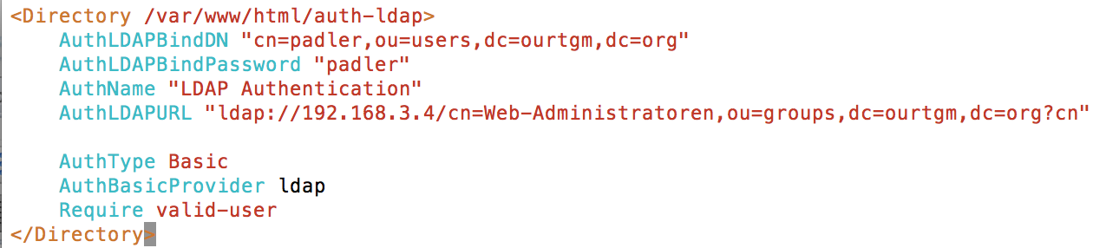

mkdir /var/www/html/auth-ldap

a2ensite auth-ldap

/etc/init.d/apache2 restart

vi /var/www/html/auth-ldap/index.html



