Emma Fordyce MacRae

[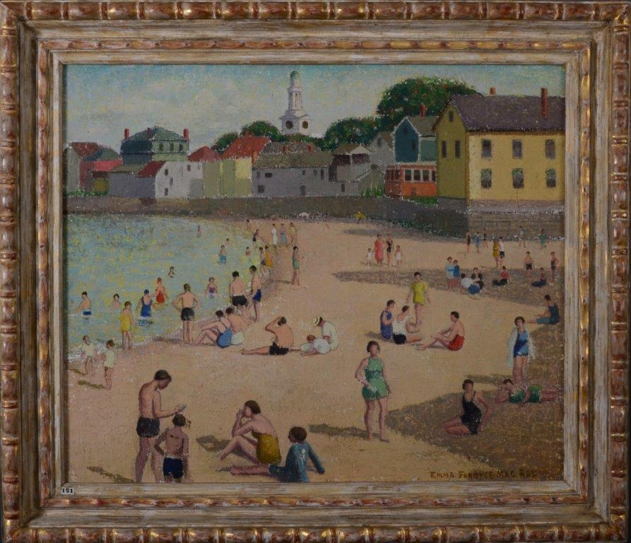](http://www.emmafordycemacrae.com/efm5/images/beach_front.jpg) [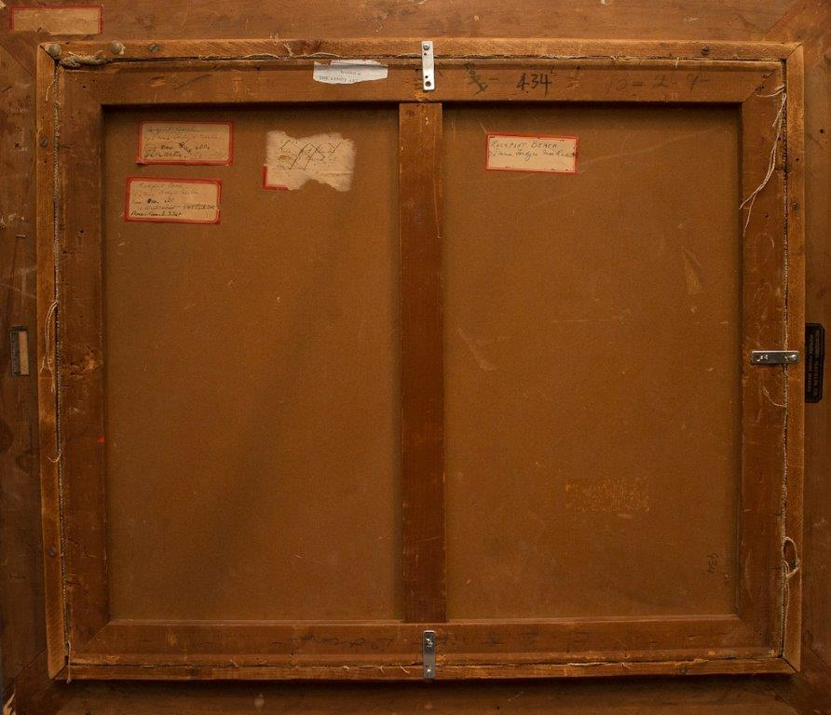](http://www.emmafordycemacrae.com/efm5/images/beach_back.jpg)

Inquiries: Brian Clark 203-869 8304 bclark@morganmanhattan.com

Another stunning landscape of Rockport Beach by Emma Fordyce MacRae, *(Christies sale 2029)*. This artist of landscapes, figurative compositions and floral still life’s with studios at 12 West 69th Street in New York City and in the summer months in Gloucester, Massachusetts travelled widely and had many solo exhibitions as well as exhibiting at the National Academy of Design, Pennsylvania Academy of Fine Arts, Art Institute of Chicago, Corcoran Gallery, Doll and Richards, Ainslie and Grand Central Galleries. Following her death there have been solo exhibitions at the Richard York Gallery and the [Cape Ann Museum in Gloucester](http://www.emmafordycemacrae.com/pdf/Emma_Fordyce_MacRae_Cat.pdf) as well as an exhibition with fellow members of the Philadelphia Ten.

MacRae enrolled at the Art Students League in 1911 after refusing to leave New York with her husband and go West. Early in her career MacRae developed her own individual style and use of colour. She often scraped the paint back to the gesso which flattened the brush strokes and she then added additional layers of thin paint for additional emphasis so that her brush strokes sometimes just catch parts of the canvas leaving the canvas flecked with the white gesso ground or an additional color as in this exceptional beach scene .

Gloucester opened up MacRae’s choice of subjects and she painted the [Cape Ann landscapes](http://www.emmafordycemacrae.com/cape_ann_landscapes_tour.html) of beaches and coves along Ipswich Bay and views from her garden and the flowers themselves.

New England, Rockport Beach

Oil on canvas on board

No known exhibition history

Signed lower right

Frame Newcomb-Macklin  
25" x 30"  
Emma Fordyce MacRae N.A. 1887 – 1974

**Provenance**

The artist

Estate of the above

By descent to the present owner

**Literature**

*Emma Fordyce MacRae*: 1887 - 1974, Richard York Gallery, New York, exhibition catalogue November 19-December 17, 1983

*The Philadelphia Ten: A Women’s Artist Group 1917 – 1945*, Page Talbot and Patricia Tanis Sydney 1998, Philadelphia, Pennsylvania, 1998 page 153

*The Philadelphia Ten: A Women's Artist Group,* American Art Review, volume X, no 1, January-February 1998, p 110, illustrated

*Emma Fordyce MacRae, N.A., 1887 - 1974*, exhibition catalogue 2008 Cape Ann Museum, Gloucester, Massachusetts

*"Paintings of Emma Fordyce MacRae, N.A. (1887-1974*)," by Karen Quinn. American Art Review, volume XX, no. 2, March 2008, p. 75, illustrated.