MacRae.Morgan.Handout.June2011Heading Calibri 36 small cal at 11

PADDY ALL THE PAINTINGS ARE FROM THE BELLANIS CD NO FRAMES

Paddy when I put (c) for copyright it only means I can’t find the symbol on this machine. Can you use the copyright symbol.

Red is for you ---

Page 1

BIOGRAPHY

Emma Fordyce MacRae was born in 1887 in Vienna, Austria of American parents who returned to New York in 1888. MacRae started to draw early illustrating her letters to her mother with flowers and later studied art at the New York School of Art before enrolling at the Art Students League of New York in 1911 following her husband leaving her and their daughter.

On 29 March, 1920 her marriage to Thomas MacRae was dissolved and annulled leaving both parties restored to the status of single person with liberty to marry after the expiration of twelve months. Two years later she married Dr Homer Fordyce Swift a member of the Rockefeller Institute for Medical Research in Greenwich, Connecticut on 24 April.

In her youth she travelled annually to Europe. While her father Dr Fordyce spoke before medical societies the family visited museums and galleries and no doubt these European travels influenced her as well as her studies and Arthur Dow’s book on composition which was in her library.

MacRae opened her studio at 12 West 69th Street in New York and exhibited in December 1914 at the Anderson Gallery. Although her style would evolve, the catalogue for the show indicates that MacRae had already established the subjects she would work with: landscape, floral still life and figurative compositions.

Later MacRae opened a summer studio in Gloucester, Massachusetts and her choice of subjects distanced her from what was then being produced by painters on Cape Ann preferring as she did for her landscapes the stretch of beaches and coves along Ipswich Bay such as *August in New England* as well asthe views from her garden and the flowers themselves.

**Literature**

Cape Ann Museum, *Emma Fordyce MacRae, N.A., 1887 - 1974*, exhibition catalogue, Gloucester, Massachusetts, 2008,   
K.E. Quinn, "Paintings of Emma Fordyce MacRae, N.A. (1887-1974)," *American Art Review*, vol. XX, no. 2, March 2008, p. 75, illustrated.

**Provenance**

The artist.  
Estate of the above.  
By descent to the present owner.

**Catalogue Raisonne**

The paintings will be included in the Catalogue being prepared.

Page 2 But in fact the first page Brian sends out if the biography can be referenced at the bottom. Paddy TAKE AWAY THE FRAME AND MAKE THE COPYRIGHT AS SMALL AS POSSIBLE

LEONORE IN RED

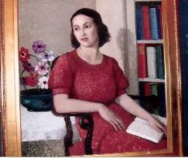

More information: Telephone: Brian Clark 203 869 8700 Ext 225

Email: [www.bclark@morganmanhattan.com](http://www.bclark@morganmanhattan.com)

By the early 1920’s MacRae had developed her own individual style with the judicious placement of objects and use of color in her figure paintings.

Painted in 1936 *Leonore in Red* is a classic MacRae with no adherence to formula so disliked by Edward Alden Jewell the art critic of the New York Sunday Times but rich in color and texture with a large color surface and shallow depth. MacRae includes in the composition objects to hand such as the chair also painted in Distant News, the bookshelf and a display of anemones with the red of Leonore’s dress repeated in the books and anemones. By taking the paint back to an underpaint or even the gesso MacRae achieved a chalky mottled appearance enhancing the decorative qualities.

Leonore, the daughter of MacRae’s friend Ivan O’Linsky was also the sitter in MacRae’s painting *Leonore in White*. *Leonore in Red* sometimes identified as the *Italian Girl* is not varnished. MacRae often hung glass in front of her paintings.

*Exhibited: 1936 – Allied Artists of America, North Shore Arts Association, Grand Central Art Gallery; 1937 – Boston Art Club, Corcoran BiAnnual; 1938 – National Association of Women Painters and Sculptors, New Jersey State Museum, MacDowell Club; 1939 - Grand Central Art Gallery; 2008 – Cape Ann Museum*

Leonore in Red

Oil on canvas on board Signed Framed

34” x 30”

Emma Fordyce MacRae 1887 – 1974

**Catalogue Raisonne**

The painting will be included in the Catalogue being prepared.

More information Return Home Biography

(c) 2011 A.J.Kissel

Paaage 3

AUGUST IN NEW ENGLAND

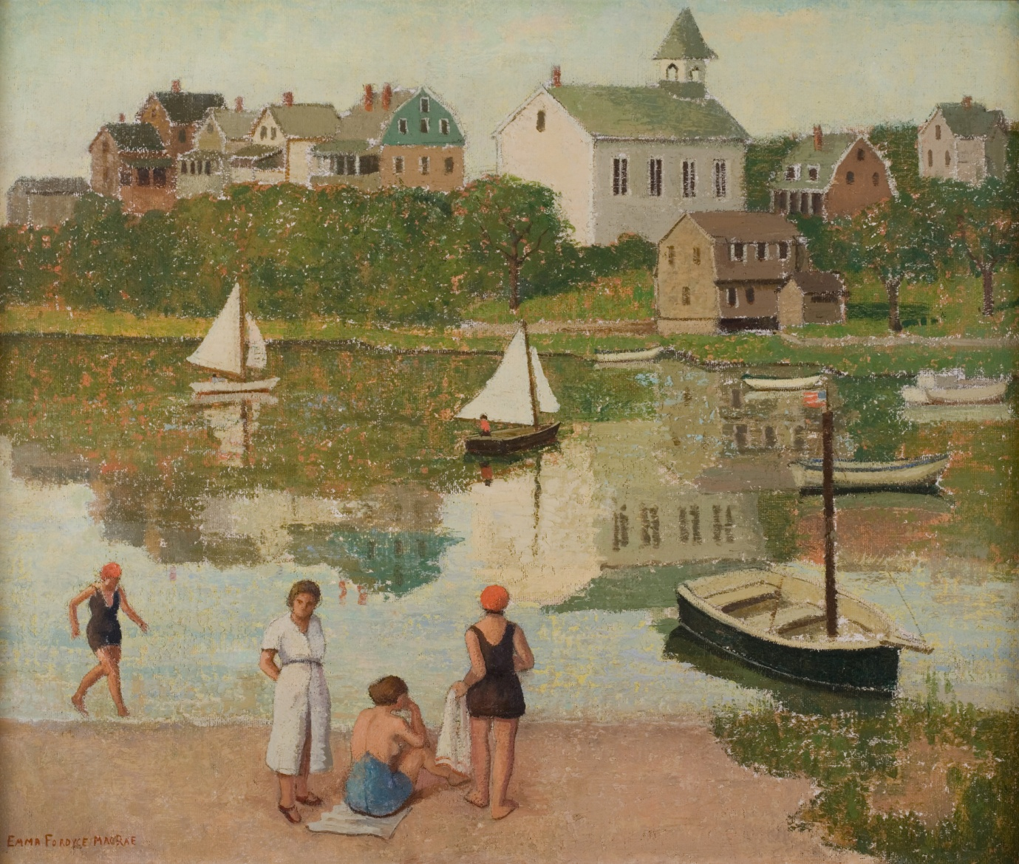

More information: Telephone: Brian Clark 203 869 8700 Ext 225

Email: [www.bclark@morganmanhattan.com](http://www.bclark@morganmanhattan.com)

Like many artists MacRae abandoned the New York heat for the cool of Gloucester in New England in the summer and until 1951 successfully painted the Cape Ann landscape with its coves, beaches and harbors. In 1925 she inherited Atlantic Highlands in Gloucester, MA from her father and Homer Swift, her husband, arranged for a studio to be built onto the house and planted flowers in the garden for her to paint.

One day in 1941 MacRae stretched open weave canvas over a board, applied gesso to the canvas, and incorporated the texture of the fabric into her work *August in New England.*  For this composition MacRae ignored the vista of the open sea preferring to include Riverdale on the land opposite the beach with the water in between reflecting the church, houses, boats and trees. *August in New England* is a wonderful example of Emma’s later distinctive painting style and her method of manipulating color to create impressionistic reflections in the water.  In this landscape August in New England MacRae used a brick red blocked in under the different greens of the trees below and around the houses on the opposite shore and again in the reflection in the sea giving depth to the composition. She left the surface of her work unvarnished, further playing up its decorative qualities.

*Exhibited: 1945 – 1946 Pepsi Cola second exhibit; 1947 – North Shore Arts Association: 1948 – Pen and Brush: 1949 – National Academy: 2008 - Cape Ann Museum*

August in New England

oil and pencil on canvas on board Signed Framed

25” x 30”

Emma Fordyce MacRae 1887 – 1974

**Catalogue Raisonne**

The painting will be included in the Catalogue being prepared.

More information Return Home Biography

© 2011 A J Kissel

THE LILY

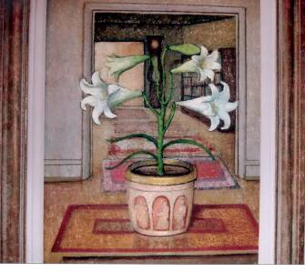

More information: Telephone: Brian Clark 203 869 8700 Ext 225

Email: [www.bclark@morganmanhattan.com](http://www.bclark@morganmanhattan.com)

Following the death of her husband MacRae closed the Gloucester studio and her canvases were taken to her home in New York where she painted the carefully arranged composition The Lily with the lilies painted with almost photographic realism framed by two doorways leading into and out of the hallway with the vase and its decorative panels on her Max Kuehne table and the oriental rugs, bookcase and French repeating clock forming the background in place of a backdrop of a textile or print often used. The bowl was first painted in the 1940 painting of “Ruth”. Once again in The Lily MacRae achieved a flat look.

*Exhibited: 2008 - Cape Ann Museum*

The Lily

Oil on Masonite board Signed Framed

28” x 22”

Emma Fordyce MacRae 1887 – 1974

**Catalogue Raisonne**

**The painting will be included in the Catalogue being prepared**

More Information Return Home Biography

© A J Kissel

Last page

ANEMONES IN BARKING DOG BOWL

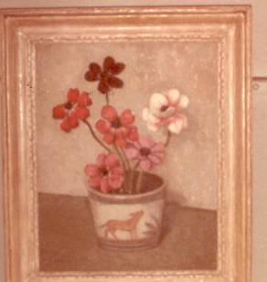

Painted in 1942 Anemones in Barking Dog Bowl is stylistically unlike other flower paintings with the plain background and mottled appearance.

*Exhibited: 2008 - Cape Ann Museum*

Anemones in Barking Dog Bowl

Oil on board Signed Framed

19” x 15”

Emma Fordyce MacRae 1887 – 1974

**Catalogue Raisonne**

**The painting will be included in the Catalogue being prepared**

More Information Return Home Biography

© A J Kissel