**Children on the Beach Red Cummerbund Biography Contact**

**CHILDREN ON THE BEACH**

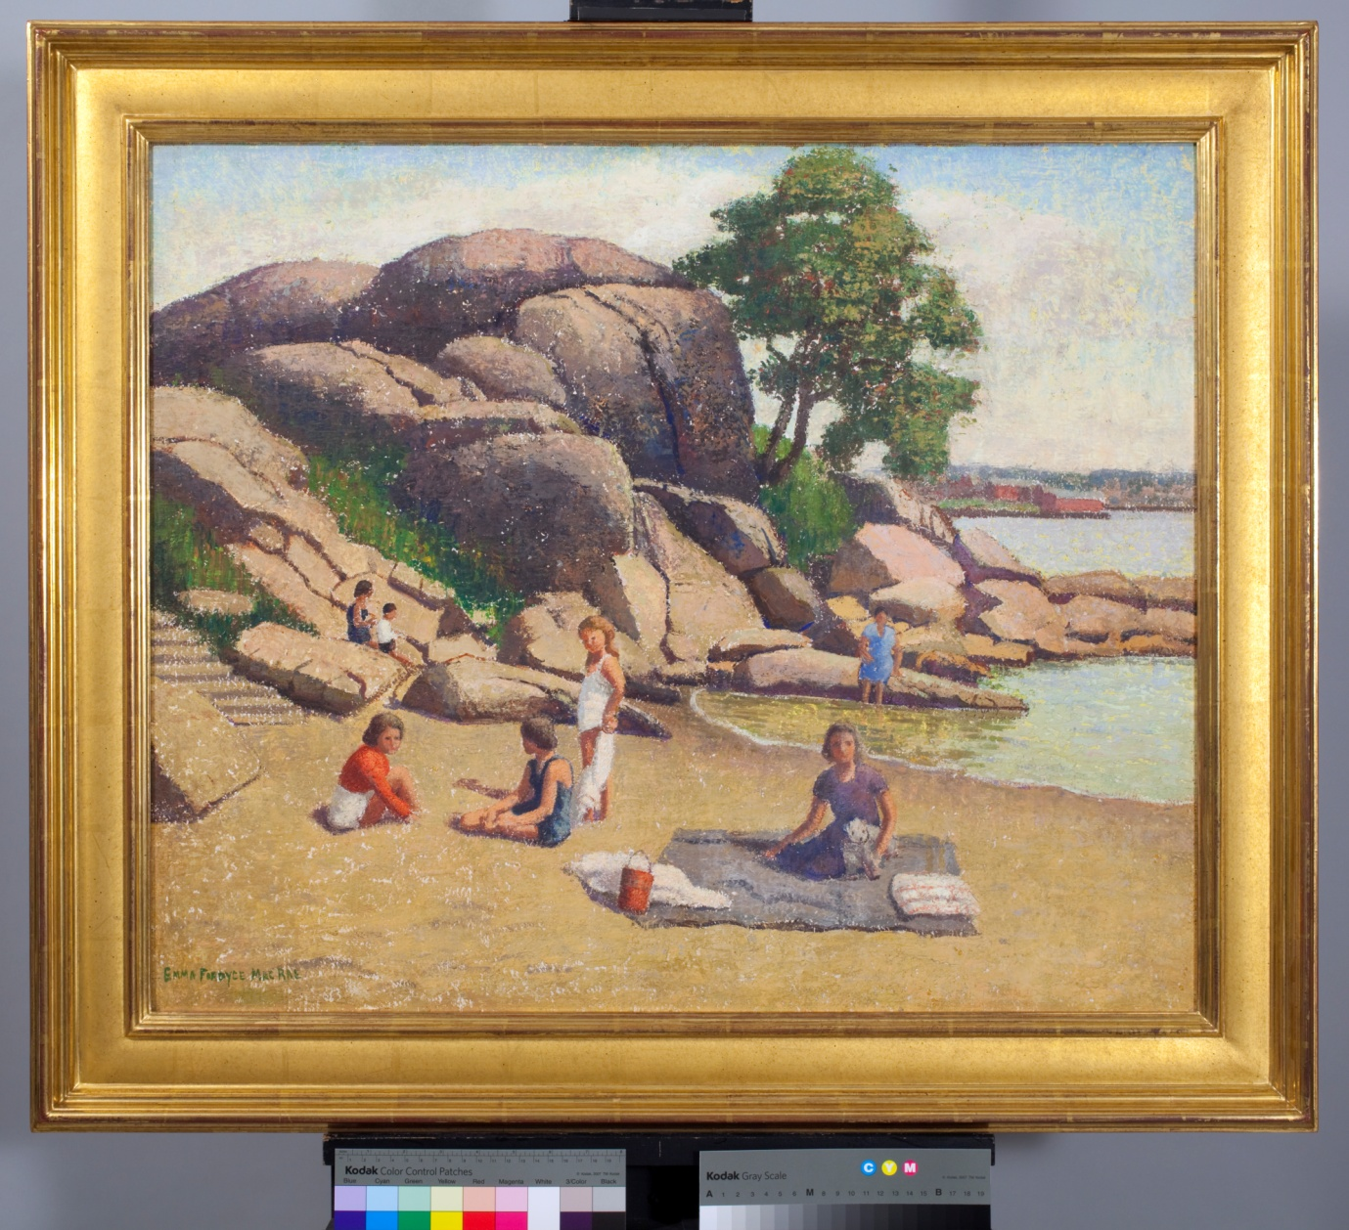

**To discuss with Brian Clark**

**Email:** [**bclark@morganmanhattan.com**](mailto:bclark@morganmanhattan.com)

**Telephone: 202-869-8304**

Karen Quinn writing about Emma Fordyce MacRae notes she populated her landscapes with figures but that there was little movement and in this painting a timeless quality pervades the view. MacRae avoided the open vista of the ocean preferring inlets, harbors and beaches and in Children on the Beach she has reinforced the organisation of her composition of the picnic by focusing on the granite rocks.

MacRae’s summer studio was above Stage Fort Park in Gloucester, MA and this Cape Ann scene may be a nearby beach particularly with the view of Gloucester in the background.

Emma Fordyce MacRae has allowed the ground to be visible through the thinner layers of paint laid on top and it has become part of the composition. In his Treatment Report Jim Wright, Painting Conservation, Somerville, Ma on September 24, 2012 states: “The painting is in excellent condition. There are several very minor scattered retouches. Per the artist’s request it is not varnished nor should it be.”

Children on the Beach

Oil on canvas on board Signed Framed

25” x 30”

Emma Fordyce MacRae N.A. 1887 – 1974

Provenance: To present owner from estate of artist

Photography by Bill Kipp.com

No known exhibition history

Next **Red Cummerbund**

(c) 2012 A.J. Kissel

**Children on the Beach Red Cummerbund Biography Contact**

**RED CUMMERBUND**

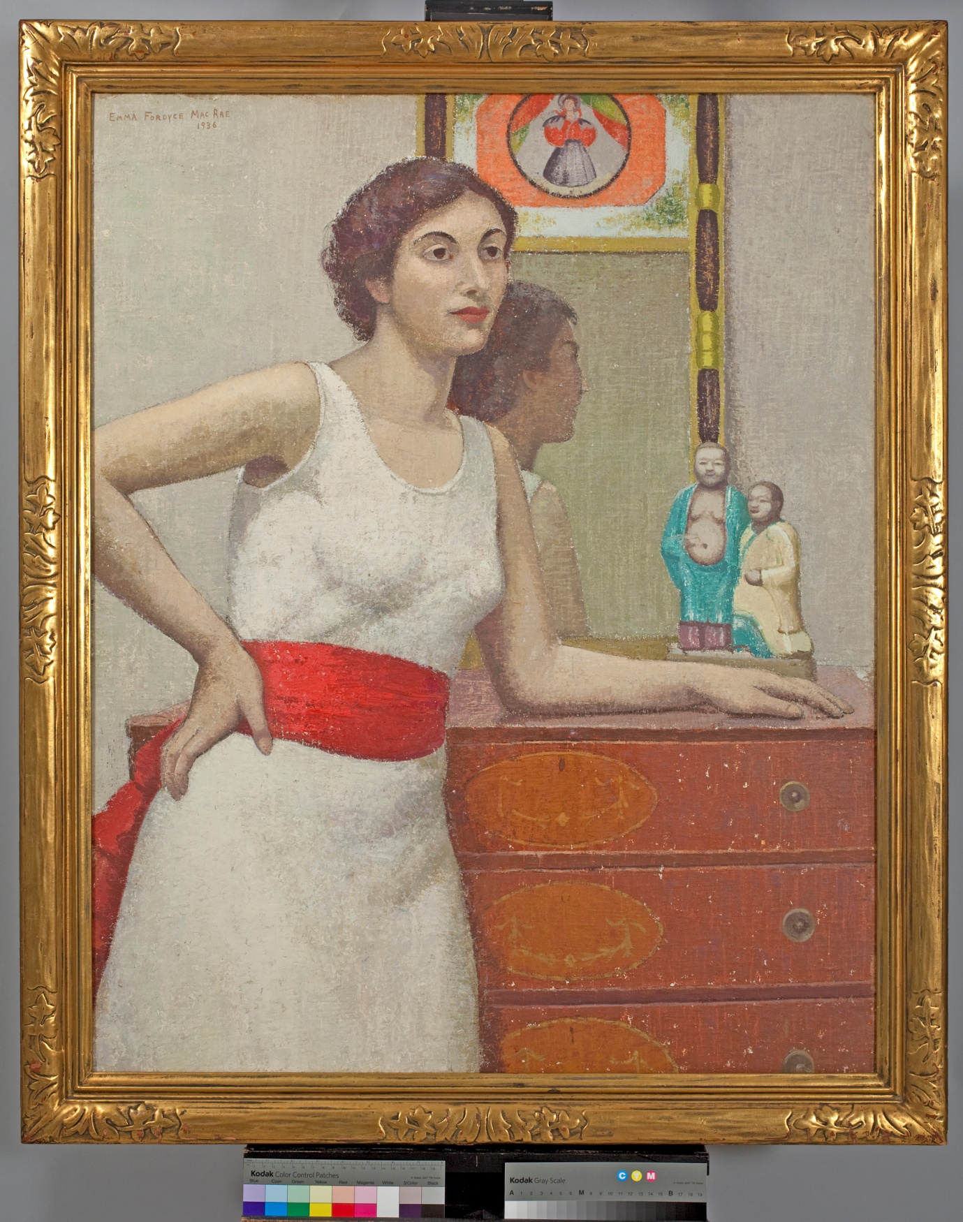

**To discuss with Brian Clark**

**Email:** [**bclark@morganmanhattan.com**](mailto:bclark@morganmanhattan.com)

**Telephone: 202-869-8304**

Painted in 1936 Red Cummerbund is another decorative canvas of Emma Fordyce MacRae’s distinctive style of painting. The red cummerbund on the young woman’s white dress is the dominant note which is held in place by the background gray wall and the reflection in the mirror and as usual her brush strokes sometimes just catch parts of the canvas leaving the canvas flecked with the white background.

The frame once framed another painting G*reen Jade* and the figures MacRae included to complete the decorative balance were from her extensive collection.

**Exhibited:-**

**1936 Solo at Grand Central Galleries**

**1937 Solo Boston Art Club and National Academy**

**1938 MacDowell Club**

**1939 Montclair Museum and National Association of Women Painters and Sculptors**

**2008 Cape Ann Museum**

Red Cummerbund Also Victoria in White or Persian Girl

Oil on canvas on board Signed 1936 Framed

40” x 32”

Emma Fordyce MacRae N.A. 1887 – 1974

Provenance: To present owner from estate of artist

Photography by Bill Kipp.com

Previous **Children on the Beach**

(c) 2011 A.J. Kissel

**Children on the Beach Red Cummerbund Biography Contact**

**BIOGRAPHY**

Emma Fordyce MacRae established her subjects – landscapes, still lifes and landscapes – early in her career and by the late 1910’s or early 1920’s had evolved her own style.

Born in Vienna in 1887 of American parents who returned to New York City MacRae enrolled at the Art Students League in 1911 after apparently refusing to join her husband who left New York to go West. MacRae studied with Frank Vincent DuMond, Kenneth Hayes Miller, Luis Mora, Ernest Blumenschein and John Sloan and attended a summer course with Robert Reid.

In her youth MacRae travelled annually to Europe. While her father Dr Fordyce spoke before medical societies the family visited museums and galleries and no doubt these European travels influenced her as well as her studies. Arthur Dow’s book on composition which was in her library may have also encouraged her judicious placements of objects and use of color in her paintings.

MacRae opened her studio at 12 West 69th Street in New York and exhibited in December 1914 at the Anderson Gallery. Later MacRae opened a summer studio in Gloucester, Massachusetts and her choice of subjects distanced her from what was then being produced by painters on Cape Ann preferring as she did for her landscapes the stretch of beaches and coves along Ipswich Bay such as *Rockport Beach* and *August in New England* as well asthe views from her garden and the flowers themselves.

**Literature**

*The Philadelphia Ten A Women’s Artist Group 1917 – 1945*, Page Talbot and Patricia Tanis Sydney 1998

*Emma Fordyce MacRae, N.A., 1887 - 1974*, exhibition catalogue. Cape Ann Museum, Gloucester, Massachusetts, 2008,

*"Paintings of Emma Fordyce MacRae, N.A. (1887-1974*)," by Karen Quinn. AmericanArt Review, vol. XX, no. 2, March 2008, p. 75, illustrated.

**Catalogue Raisonne**

The paintings will be included in the Catalogue being prepared.

**Children on the Beach Red Cummerbund Biography Contact**

**CONTACT PAGE**

Xxxxxxxxxxxxx

xxxxxxxxxxxxxxxx