|  |  |  |  |  |
| --- | --- | --- | --- | --- |
| **Orange White and Green** | **Sonya** | **Self Portrait** | [**Catalogue**](http://www.emmafordycemacrae.com/_pdf/Emma_Fordyce_MacRae_Cat.pdf) | **Contact** |

# Emma Fordyce MacRae N.A.

## (1887 - 1974)

# Oil Paintings for Sale

Orange White and Green 2

Sonya 3

Self Portrait – Painting at Pigeon Cove, Rockport 4

**For more information please email:**

[codefey@gmail.com](mailto:codefey@gmail.com?subject=MacRae)

|  |
| --- |
| **Return to Top** |

|  |  |  |  |  |
| --- | --- | --- | --- | --- |
| **Orange White and Green** | **Sonya** | **Self Portrait** | [**Catalogue**](http://www.emmafordycemacrae.com/_pdf/Emma_Fordyce_MacRae_Cat.pdf) | **Contact** |

# Orange White and Green

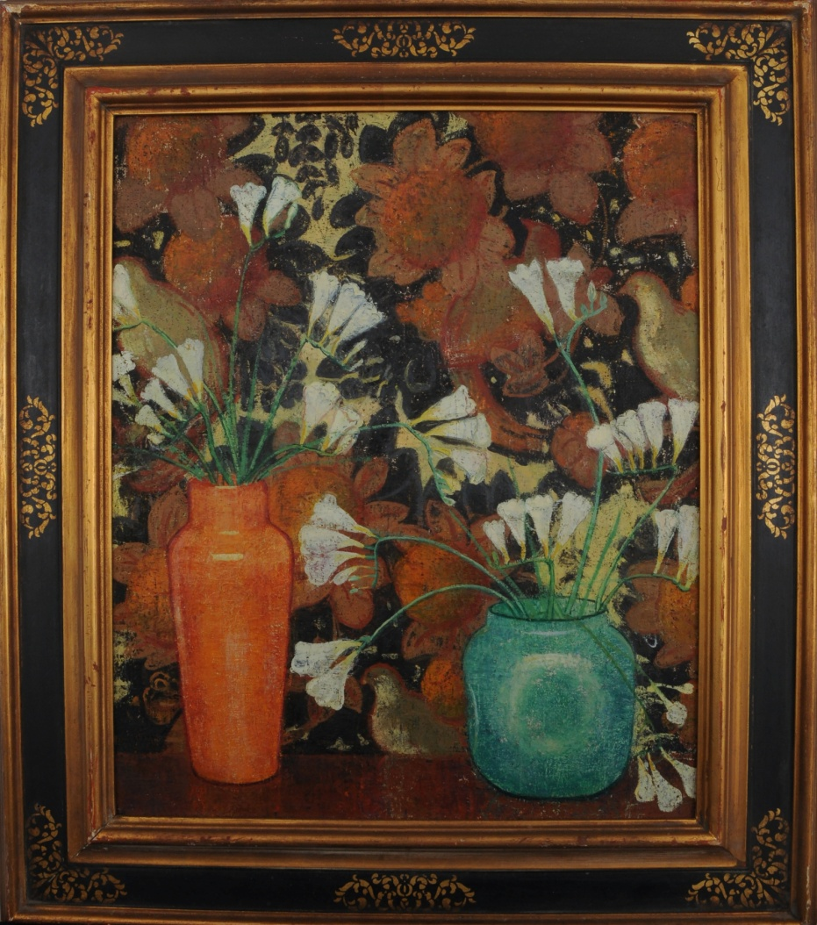

Emma Fordyce MacRae was not a prolific painter and she records she spent two months in 1923 painting *Orange White and Green*. a floral arrangement of freesias set against a tapestry background with the flowers merging and contrasting with the textile behind. *Orange White and Green* is an example of MacRae's early balanced and symmetrical compositions, emphasized by the flower vases of orange and green and painted before MacRae perfected her distinct style of scraping back and adding layers of paint sparingly.

## Exhibited:

*1923 National Academy; 1923 Milch Gallery;*

*1923 Chicago Art Institute; 1923 John Herron Institute;*

*1924 City Art Museum, St Louis; 1924 Syracuse Museum;*

*1925 Rotary Show; 1925 National Association of Women Artists;*

*1925 State Fair Texas; 1925 Peabody Institute Baltimore Museum of Art;*

*1928 Grand Central Galleries; 1930 Roerich Museum, New York*

Orange White and Green

Oil on Canvas

Unsigned Framed

30 x 25 inches

|  |
| --- |
| **Return to Top** |

Emma Fordyce MacRae N.A, 1887 – 197

|  |  |  |  |  |
| --- | --- | --- | --- | --- |
| **Orange White and Green** | **Sonya** | **Self Portrait** | [**Catalogue**](http://www.emmafordycemacrae.com/_pdf/Emma_Fordyce_MacRae_Cat.pdf) | **Contact** |

# Sonya

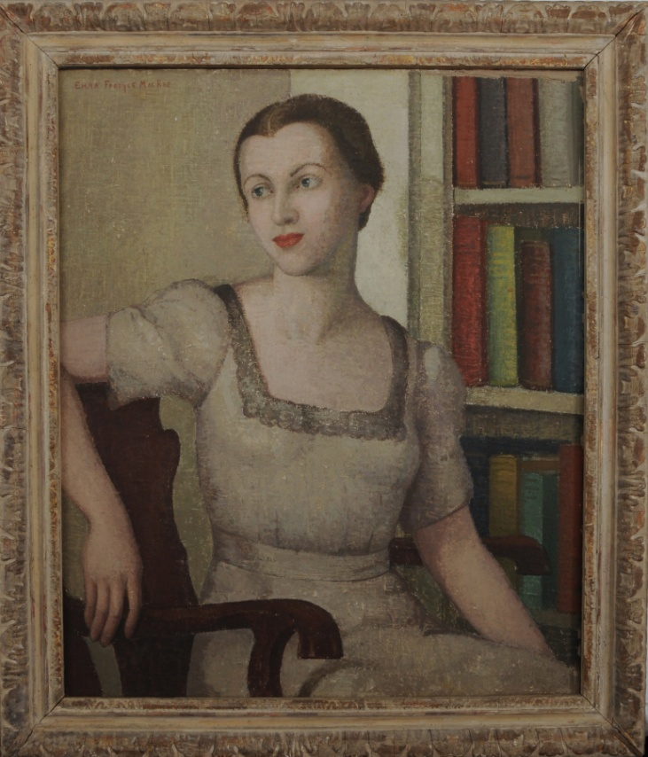

Emma Fordyce MacRae painted *Sonya* in 1935. In 1934 MacRae was awarded the Edith Penman Memorial Prize for “*Cosmos*” at the 43rd Annual Exhibition of the National Association of Women Painters and Sculptors and in 1935 had a solo exhibition in March at The Currier Gallery of Art in Manchester, New Hampshire and another at Doll and Richards in Boston April through May. MacRae painted many figure paintings at this time in her distinctive recognised style *Melina in Green, the Red Sweater, The Dancer* and *Before the Song* and in *Sonya* the small areas within the composition where MacRae has taken back the paint to the underpaint or the gesso are sometimes mistaken by some viewers as areas of paint loss rather than a deliberate act by the artist.

### Exhibited:

*1936 National Academy; 1936 Association of Women Artists;*

*1936 Grand Central Art Gallery; 1937 Boston Art Club;*

*1938 MacDowell Club; 1940 National Association of Women Painters and Sculptors;*

*1944 Gloucester Society*

Sonya

Painted 1935

Oil on Canvas

Signed Framed

30 x 25 inches

|  |
| --- |
| **Return to Top** |

Emma Fordyce MacRae N.A. 1887 – 1974

|  |  |  |  |  |
| --- | --- | --- | --- | --- |
| **Orange White and Green** | **Sonya** | **Self Portrait** | [**Catalogue**](http://www.emmafordycemacrae.com/_pdf/Emma_Fordyce_MacRae_Cat.pdf) | **Contact** |

# Self Portrait – Painting at Pigeon Cove, Rockport

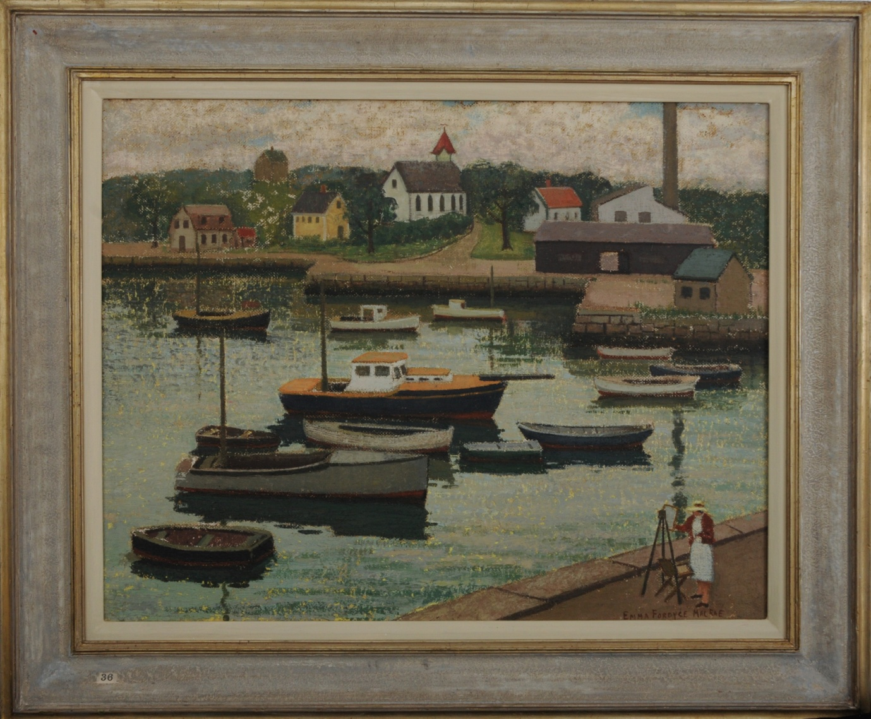

Emma Fordyce MacRae's summer studio was in Gloucester, MA . She painted herself several times and Pigeon Cove Rockport was one of her favorite venues. In "[**The Love of Lingering over a Composition**](http://www.emmafordycemacrae.com/_pdf/Emma_Fordyce_MacRae_Cat.pdf)" Karen E Quinn refers to MacRae's choice of subject distancing her from her fellow painters in Cape Ann preferring as she did for her landscapes the stretch of beaches and coves along Ipswich Bay in place of Banner Hill and Gloucester city. The Cape Ann Museum in Gloucester has a self portrait and a painting of Pigeon Cove.

### Exhibited:

*No history*

Self Portrait - Painting at Pigeon Cove, Rockport

Oil on Board

Signed Framed

22 x 28 inches

Emma Fordyce MacRae N.A. 1887 – 1974

|  |
| --- |
| **Return to Top** |