Pax RENTAL 2018

Pax Place, Portloe, TR2 5QX - Holiday Let - 2018

Please read the Terms & Conditions below before signing the booking form..

1 If booking form below is not signed and returned to Mrs J Kissel within 48 hours of booking the booking shall be considered cancelled
2 Accommodation for 1 or 2 adults No pets, children or smoking allowed.
3 Week commences 4.00 pm on the first day of your holiday and ends at 10am on the last day of your holiday

4 Deposit: £100.00
5 Pet not allowed in the bedroom or on the furniture and any dog fouling to be removed immediately. You will be responsible for all damage caused by the pet.
6 If Pax Place unavailable due to circumstances outside my control the rental money received will be returned.
7 Key arrangement will be emailed following receipt of full payment by Owners Direct together with an inventory. Please check inventory when you arrive and email jenpax1@yahoo.co.uk advising of any missing items or breakages. Complaints cannot be accepted after your departure.
8 All personal waste must be removed from inside Pax Place and placed in the dustbin provided.
9 Black bag to be tied up and left in dustbin pushed to the edge of the road for collection on Monday
10 All furniture and equipment shall be returned to its original position before departure.
11 You are responsible for any loss or damage to the property (reasonable wear and tear excluded), for taking good care of Pax Place and leaving it in a clean and tidy condition. Should it be found that an excessive amount of cleaning is required a charge will be made.
12 You will allow access to Pax Place upon reasonable notice except in an emergency.

13 You are responsible for any loss or damage to the property (reasonable wear and tear excluded), for taking good care of Pax Place and leaving it in a clean and tidy condition. Should it be found that an excessive amount of cleaning is required a charge will be made.
14 Broadband may be accessed through BT Fon.
15 16 All information is given in good faith and no responsibility taken for any errors or omissions.

Contact Details…
View from cottage
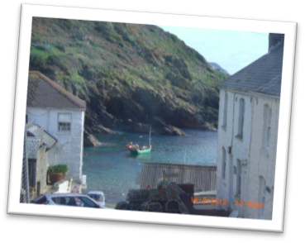
Mrs. J Kissel, Garden Cottage, Chipping Campden, GL 55 6AL
Email: jenpax1@yahoo.co.uk
Telephone: 01386 840272
Mobile: 0792 219 0481
Pax Place, Portloe, TR2 5QX Booking Form for 2018…

Please complete the following details and send to
Mrs J. Kissel, Garden Cottage, Chipping Campden, GL55 6AL



Name(1): ....................................................................................................................................................................
Name(2) .....................................................................................................................................................................
Address:......................................................................................................................................................................
………………………….........................................................................................................................................................
............................................................................................. Postcode: ........................................................
Telephone Number: …………………………….............….............. Mobile Number: ................................................
Email: ......................................................................................... Nationality..............................................................
Date from: ............................................... to ........................................................... 2018
Breed of DOG: .............................................................. Name:......................................................
Weight:................ Age:..................... Sex:...........................
Rent £ ...................
Pet (25 per week) £ .....................
Total £ ...................... to be paid to OwnersDirect Co Uk

Signed ......................................................................................... Date: …………………………………………........ 2018
I declare I am over 18 years of age and I accept the booking terms and conditions above on behalf of myself and other traveller

