

Pax Place - Holiday Let

Pax Place, Portloe, Cornwall, TR2 5QX

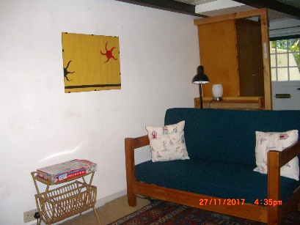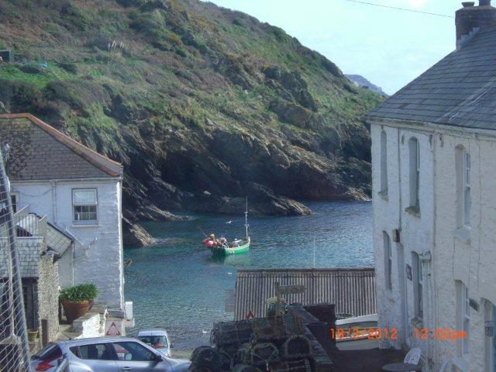

2018 - Particulars, Terms and Conditions

1 Bedroom (2 adults) - 1 sitting room - l bathroom

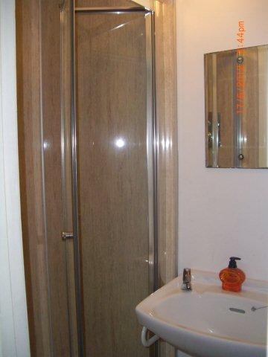Set in the centre of the pretty coastal fishing village of Portloe Pax Place enjoys views over the harbour and cliffs. The accommodation of sitting room and well equipped bespoke kitchen with all mod cons on the ground floor, bedroom and shower room upstairs is ideal for a holiday.

Pax is beside a stream running into the harbour so there should be no reason not to sleep peacefully in the bedroom overlooking the Jacka and cliffs without being disturbed and being so close to the sea to take an early morning swim before setting off for the day.

**Arrival:** 15th March 2018

**Departure:** 10am Friday 18th May 2018.

**Equipment:** Refrigerator/freezer, microwave/oven, electric hob, clothes washer, kettle, toaster, TV with DVD, radio, books, cards and board games. Electric thermostatically controlled wall panel heaters.

Directions…

**By Car:** From Tregony follow signs to Veryan/St Mawes until petrol

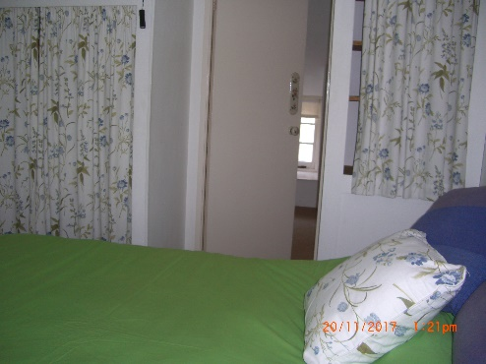station and shop where you fork left. Continue until sign to Portloe to

left. Keep on the road down the hill and continue past car park to Church and phone box on your right. Pax Place is the dark blue front door opposite the

Church.

Parking between Pax Place and the harbour or by the Church.

Car park about 5 minute walk away.

**By Train and Bus:** To Truro and occasional bus to Portloe.

**By Plane:** to Newquay.

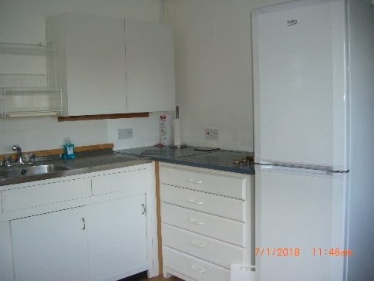 Local Area…

* **Swim** in Portloe harbour or nearby Carne/Pendower beach.
* **Walk** the costal path passing the door and other footpaths
* **Eat out** in Portloe at the Ship, Lugger Hotel or nearby at the Nare Hotel.
* **Explore** National Trust and other properties and gardens
* **Food and Petrol** Buy newspapers and shop at Texaco garage (passed on

your way to Portloe) or close by in Veryan and Tregony.

* **Bus** stop to Truro outside the Church opposite front door.

Terms & Conditions...

Accommodation for 1 or 2 adults. Sorry, no children or smoking or pets.

Arrival: 15th March 2018

Departure: 10am Friday 18th May 2018.

**Payment:** On booking.  If Pax Place unavailable due to circumstances outside my control the rental money received will be returned.

**Key:** To be agreed, inventory provided.

Payment: Deposit £300 to be returned if no problems on departure.

Please check inventory when you arrive and let me know of any missing items or breakages. Complaints cannot be accepted after the tenancy has ended.

The hirer is responsible for any loss or damage to the property (reasonable wear and tear excluded), for taking good care of Pax Place and leaving it in a clean and tidy condition. Should it be found that an excessive amount of cleaning is required a charge will be made.

Electricity: Meter read on arrival and departure, charged at EDF(Supplier) rate monthly.

Water : included.

Broadband may be accessed through BT Fon. All information is given in good faith and no responsibility taken for any errors or omissions.



Contact details and 2018 prices …

|  |  |
| --- | --- |
| **Dates** | **Price (£)** |
| Thursday 15th March – Friday 18th May | £1926.00 |

Email:[jenpax1@yahoo.co.uk](mailto:jenpax1@yahoo.co.uk)

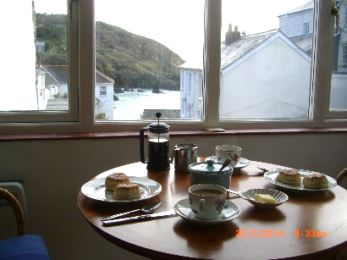Telephone:01386 840272

## Post: Mrs A. J. Kissel,

## Garden Cottage,

## Chipping Campden,

## GL55 6AL



## Please complete the form and email to jenpax1@yahoo.co.uk, bank details to follow.

Name(1): ....................................................................................................................................................................

Name(2) .....................................................................................................................................................................

Address:......................................................................................................................................................................

………………………….........................................................................................................................................................

............................................................................................. Postcode: ............................................................

Telephone Number: …………………………….............….............. Mobile Number: .................................................

Email: .................................................................................. Nationality...........................................................

Dates: **Thursday 15th March 2018** – **Friday 18th May 2018** at **£1926.00**

Signed (1): ......................................................................................... Date: …………………………………………........ 2018

Signed (2): ……………………………………………........................................... Date: … ……………..……..…...................... 2018