|  |
| --- |
| GamingFUN |
| GAMEPROGRAMMING-1 |
| **Assignment-3**  **Part-1** |
| Version #01  All work Copyright © 2016 by GamingFun.  All rights reserved. |
| **Padma Chakraborty** |
|  |

C:\Users\chakraborty\Downloads\logo_1956770_web.jpg

|  |
| --- |
| March 11,2016 |

**Table of Contents**

**Page**

Detailed Game Description \_\_\_\_\_\_\_\_\_\_\_\_\_\_\_\_\_\_\_\_\_\_\_\_\_\_\_\_\_\_\_\_\_\_\_\_\_\_\_ 3

Controls \_\_\_\_\_\_\_\_\_\_\_\_\_\_\_\_\_\_\_\_\_\_\_\_\_\_\_\_\_\_\_\_\_\_\_\_\_\_\_\_\_\_\_\_\_\_\_\_\_\_\_\_\_\_\_ 3

Interface Sketch \_\_\_\_\_\_\_\_\_\_\_\_\_\_\_\_\_\_\_\_\_\_\_\_\_\_\_\_\_\_\_\_\_\_\_\_\_\_\_\_\_\_\_\_\_\_\_\_\_ 3

Characters / Vehicles \_\_\_\_\_\_\_\_\_\_\_\_\_\_\_\_\_\_\_\_\_\_\_\_\_\_\_\_\_\_\_\_\_\_\_\_\_\_\_\_\_\_\_\_\_ 7

Enemies \_\_\_\_\_\_\_\_\_\_\_\_\_\_\_\_\_\_\_\_\_\_\_\_\_\_\_\_\_\_\_\_\_\_\_\_\_\_\_\_\_\_\_\_\_\_\_\_\_\_\_\_\_\_\_\_ 7

Scoring \_\_\_\_\_\_\_\_\_\_\_\_\_\_\_\_\_\_\_\_\_\_\_\_\_\_\_\_\_\_\_\_\_\_\_\_\_\_\_\_\_\_\_\_\_\_\_\_\_\_\_\_\_\_\_\_\_ 7

Sound Index \_\_\_\_\_\_\_\_\_\_\_\_\_\_\_\_\_\_\_\_\_\_\_\_\_\_\_\_\_\_\_\_\_\_\_\_\_\_\_\_\_\_\_\_\_\_\_\_\_\_\_\_\_ 8

Art / Multimedia Index \_\_\_\_\_\_\_\_\_\_\_\_\_\_\_\_\_\_\_\_\_\_\_\_\_\_\_\_\_\_\_\_\_\_\_\_\_\_\_\_\_\_\_ 8

**Version History**

Game Overview

Initial GDD - March 2, 2016

Final GDD - March 11, 2016

1. **Detailed Game Description**

The game is about a child searching for toys, balloons etc. while playing in a kiddies park. The game contains three levels.

*Level-1*

The child will have to collect teddy bears that are placed on different locations in the park. The child has to encounter multiple obstacles such as monkey bars, see-saws, slide etc. While collecting the teddy bears, the child must avoid jumping into kiddie pools that are placed on the playground. The child will score points for collecting the teddy bears.

*Level-2*

After crossing the first level, the child will enter a maze. The child has to find her/his way to exit the maze. There will be clowns holding balloons inside the maze. The child must collect balloons to collect points. There will be children holding water guns trying to wet the child. The child will lose points if he/she comes in contact with children spraying water.

*Level-3*

After crossing the maze, the child will enter an empty room where there is a box full of toys. The room is very big .So the child must quickly run towards the box to collect all the toys. This level is timed. The child must be able to reach the box in the time given. If the child is unable to reach the box before the time elapses, he loses the game.

1. **Controls**

The child can be navigated in all directions by using the arrow keys or WASD keys on the keyboard. The child jump/climbs when the up-arrow button is clicked and moves left or right in the garden based on the left and right arrow keys.

1. **Interface Sketch**

***LEVEL-1***

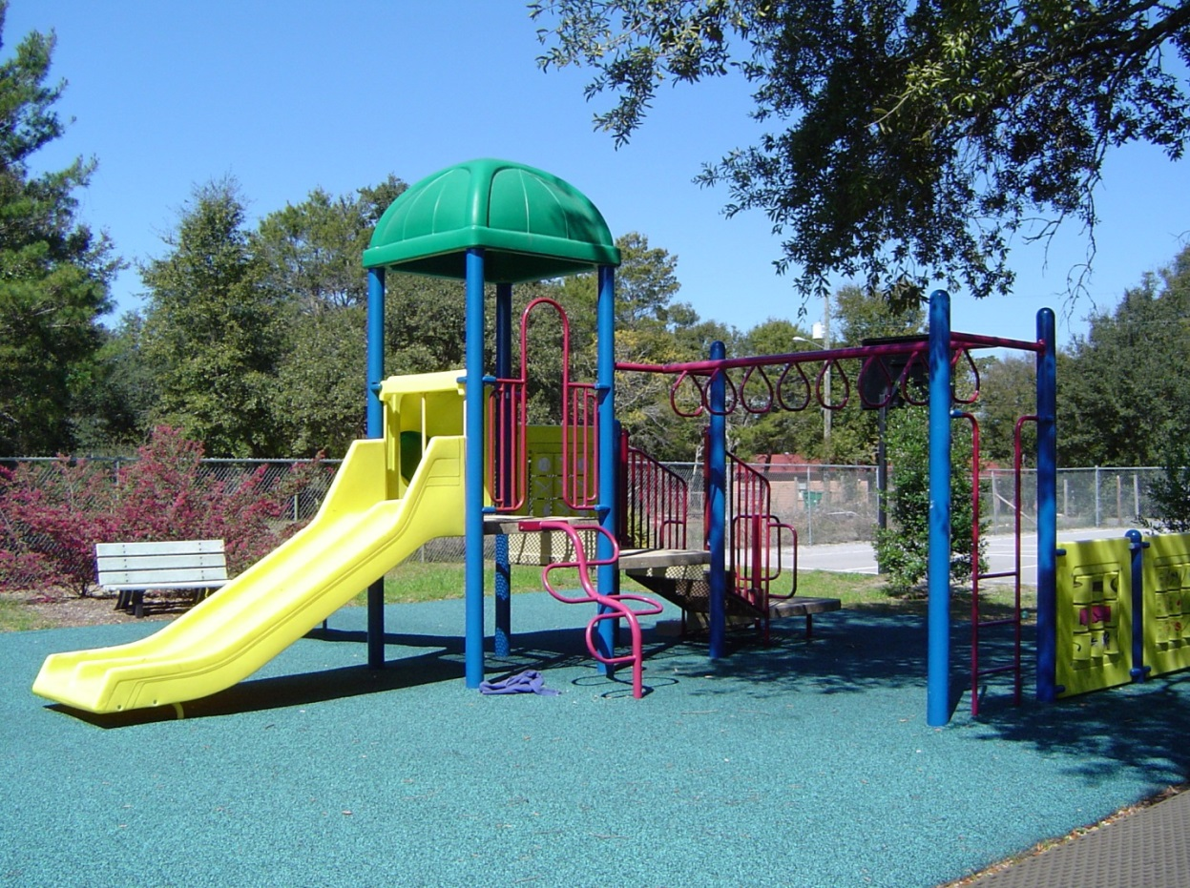

**Lives:**



http://www.rw-designer.com/cursor-view/2095.pnghttp://www.rw-designer.com/cursor-view/2095.png

**Score:**

*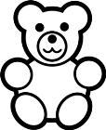*

*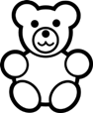*

**

****

****

***LEVEL-2***

******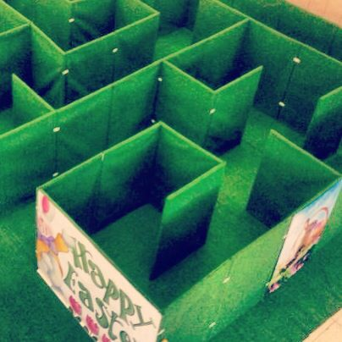**

***LEVEL-3***

**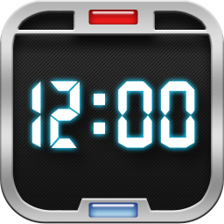****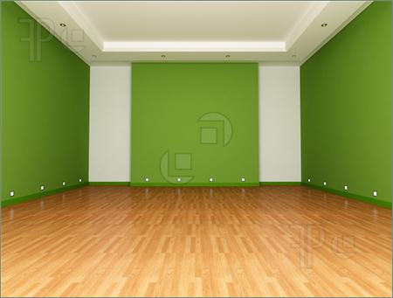**

**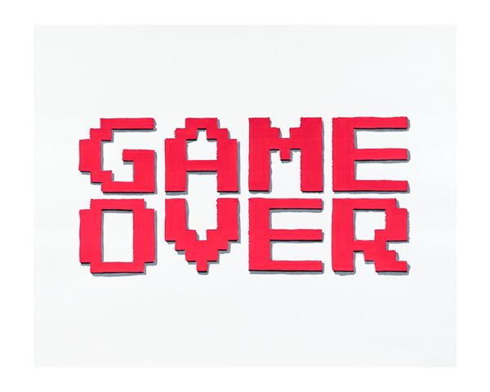**

**RESTART**

**Total Score : 5 teddy bears, 3 balloons**

**Congratulations!. You won the game**

1. **Characters / Vehicles**

The character is a child who is trying to gather toys and balloons while playing in the playground. The child will be able to navigate in all directions and will also be able to jump.

1. **Enemies**

The enemy for the first level are kiddie pools that are placed randomly on the playground which the child must avoid.

The enemy for the second level are children standing with water guns trying to sprinkle water on the child (avatar).The child must avoid getting wet.

The enemy for the third level is time that the child must race with. The child must be able to reach the box of toys before the time elapses.

1. **Scoring**

In the first level, one teddy bear is added to the score when the child is able to collect a teddy bear from the playground. In the second level, two balloons will be added to the score when the child is able to collect balloons from the clown. For each balloon collected, the balloon score will be doubled. In the third level, when the child reaches the toy box in the time available, he/she wins the game.

The child will lose one smile (http://blogs.voanews.com/russia-watch/wp-includes/images/smilies/icon_smile.gif) each time, he/she interacts with a kiddie’s pool or children with water guns. The child will lose the game when the time is finished in the third level and he/she was unable to reach the toy box.

1. **Sound Index**

*jumpAudio –This audio is used when the child takes a jump.*

*toyAudio=This audio is used when the child is able to collect a teddy bear or a balloon.*

*hazardAudio – This audio is used when the child falls into kiddies pool or gets wet by children in the maze.*

*timeAudio – This audio is used in the last level when the child has to race against time to reach the toy box.*

1. **Art / Multimedia Index**

***Vehicle/Avatar***

**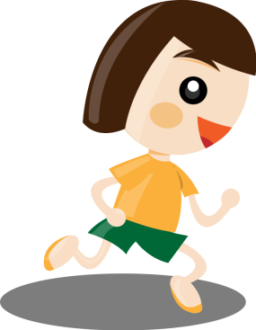**

***Enemy***



**** Kiddie pool Water gun

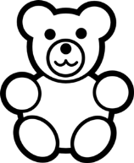***Points gainer***

***Additional Resources***

*