BIG DATA ANALYTICS
A Project Report Submitted in Partial Fulfillment of the Requirements for the Award of the Degree of
BACHELOR OF TECHNOLOGY
IN
COMPUTER SCIENCE AND ENGINEERING
By
Keerthi Laxmi Vinay – 2320030188
Lakshmi Prasanna – 2320030387
Gopisetti Venkata Sree Padmaja – 2320030038
Under the Esteemed Guidance of
Mr. Venkateswara E Katevarapu

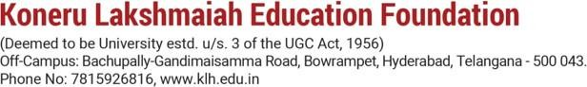

K L (Deemed to be) University
Department of Computer Science and Engineering

DECLARATION

The Project Report entitled “The Smart Customer Purchase Analytics & Recommendation System” is a record of Bonafide work of team members KEERTHI LAXMI VINAY – 2320030188 , LAKSHMI PRASANNA – 2320030387, Venkata Sree Padmaja - 2320030038, submitted in partial fulfilment for the award of B. Tech in Computer Engineering to K L University. The results embodied in this report have not been copied from any other departments/University/Institute.
KEERTHI LAXMI VINAY- 2320030188
LAKSHMI PRASANNA – 2320030387
GOPISETTI VENKATA SREE PADMAJA - 2320030038



K L (Deemed to be) University DEPARTMENT OF COMPUTER SCIENCE ENGINEERING
CERTIFICATE
This is to certify that the project-based report entitled “The Smart Customer Purchase Analytics & Recommendation System” is a Bonafide work carried out and submitted by KEERTHI LAXMI VINAY – 2320030188,LAKSHMI PRASANNA – 2320030387,Gopisetti Venkata Sree Padmaja - 2320030038, in partial fulfilment of the requirements for the award of the degree of Bachelor of Technology in Computer Science Engineering, at K L (Deemed to be University), during the academic year 2025– 2026.

Signature of the Supervisor

Signature of the HOD Signature of the External Exami

ACKNOWLEDGEMENT
The success in this project would not have been possible but for the timely help and guidance rendered by many people. Our wish to express my sincere thanks to all those who has assisted us in one way or the other for the completion of my project.

Our greatest appreciation to my guide, VENKATESWARA E KATEVARAPU, Department of Computer Science which cannot be expressed in words for her tremendous support, encouragement and guidance for this project.

We express our gratitude to Dr. P Venkateswara Rao, Head of the Department for Computer Science Engineering for providing us with adequate facilities, ways and means by which we can complete this project-based Lab.

We thank all the members of teaching and non-teaching staff members, and who have assisted us directly or indirectly for successful completion of this project. Finally, I sincerely thank my parents, friends and classmates for their kind help and cooperation during my work.

KEERTHI LAXMI VINAY-2320030188
LAKSHMI PRASANNA-2320030387
VENKATA SREE PADMAJA-2320030038

TABLE OF CONTENTS
S.No | Contents | Page no
1 | Declaration | 2
2 | Certificate | 3
3 | Acknowledgement | 4
4 | Abstract | 6
5 | Introduction | 7
6 | Literature survey | 9
7 | Hardware and Software requirements | 10
8 | Implementation | 11
9 | Experimentation and Code | 14
10 | Results | 33
11 | Conclusion | 34
12 | References | 35

ABSTRACT
The Smart Customer Purchase Analytics & Recommendation System is a data analytics project that focuses on analyzing customer purchase behavior using big data analytics techniques. In today’s digital retail environment, organizations generate large volumes of transactional data that contain valuable information about customer preferences, buying patterns, and product performance. However, without proper analysis, this data cannot be effectively utilized for decision-making. This project uses historical customer purchase data to perform data cleaning, integration, and exploratory data analysis. Various analytical techniques are applied to study sales trends, customer segmentation, product-wise performance, and purchasing frequency. Data visualization tools are used to present insights through graphs and charts such as sales trends, category-wise revenue, and customer spending patterns. In addition, a basic rule-based recommendation approach is implemented to suggest products based on customer purchase history and frequently bought items. The system helps identify high-value customers, popular products, and potential cross-selling opportunities. This project demonstrates how big data analytics and visualization can support data-driven business decisions and serve as a foundation for intelligent recommendation systems in real-world retail applications.

INTRODUCTION
In the modern digital era, organizations generate a large amount of customer transaction data. This data includes purchase history, buying patterns, preferences, and spending behavior. However, raw data alone does not provide meaningful insights.
The Smart Customer Purchase Analytics & Recommendation System is designed to analyze this data using data analytics techniques. The system helps in understanding customer behavior, identifying trends, and improving decision-making.
It focuses on converting raw transaction data into useful insights through data cleaning, analysis, and visualization. The system also helps businesses improve marketing strategies, customer retention, and revenue.

PROBLEM STATEMENT
- Large amount of customer transaction data is generated
- Raw data does not provide useful insights directly
- Difficult to analyze customer behavior and buying patterns
- Manual analysis is time-consuming and inefficient
MOTIVATION
Understanding customer behavior helps to improve:
- Marketing strategies
- Customer retention
- Business revenue
Data analytics provides clear insights from data, and recommendation systems help in better product suggestions.

OBJECTIVES
Project Objectives
- Analyze customer purchase behavior using data analytics
- Perform customer segmentation based on buying patterns
- Identify sales trends and product performance
- Visualize insights using charts and dashboards
- Develop a basic recommendation system
Expected Outcomes
- Identification of high-value customers
- Understanding customer buying patterns and frequency
- Improved product recommendations
- Better decision-making using data insights
METHODOLOGY
- Data Collection
- Customer transaction data is collected from structured datasets representing real-world purchasing behavior.
- Data Analytics using Python
- Data is analyzed using Python for cleaning, processing, and exploratory data analysis.
- Customer Segmentation
- Customers are divided into groups based on purchase behavior and frequency.
- Visualization & Insights
- Charts and dashboards are created to understand customer patterns and support decision-making.
LITERATURE SURVEY
Existing Works
- Traditional CRM systems provide only static reports
- Many systems use expensive analytics platforms
- Limited use of advanced data analytics techniques
Gaps Identified
- High infrastructure cost
- Complex system setup
- Limited accessibility for small businesses

IMPLEMENTATION
The system follows a step-by-step process:
- Raw Transaction Data
- Data Cleaning & Processing
- Exploratory Data Analysis (EDA)
- Customer Segmentation
EXPECTED RESULTS & DELIVERABLES
- Provides meaningful insights into customer purchase behavior
- Supports data-driven decision-making
Key Deliverables
- Cleaned and processed dataset
- Customer segmentation results
- Visualization dashboards (charts & graphs)
- Python notebook with complete workflow
- Final project report

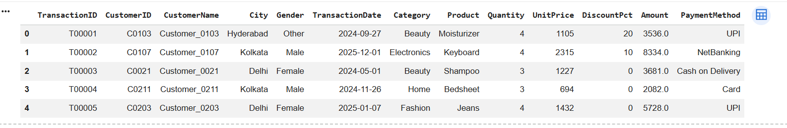

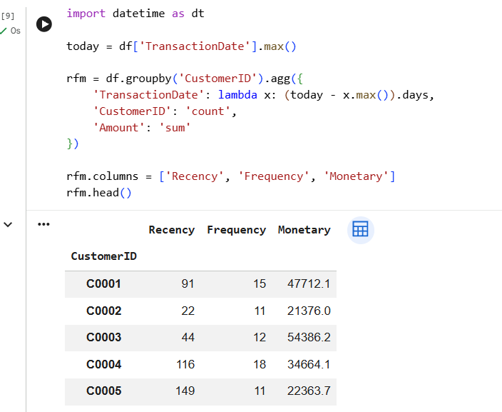

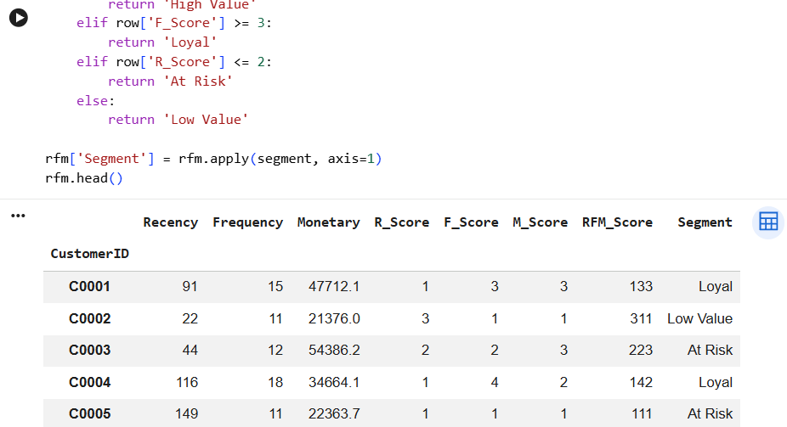

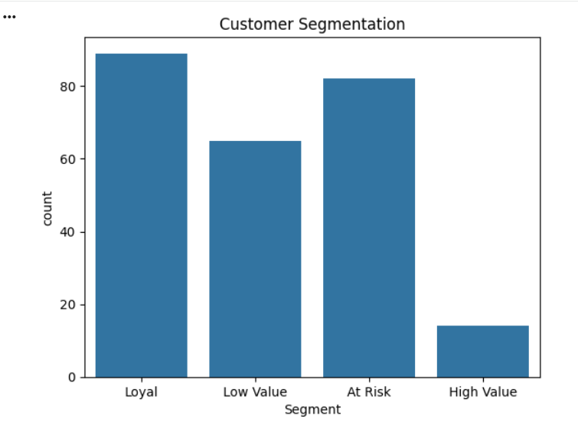

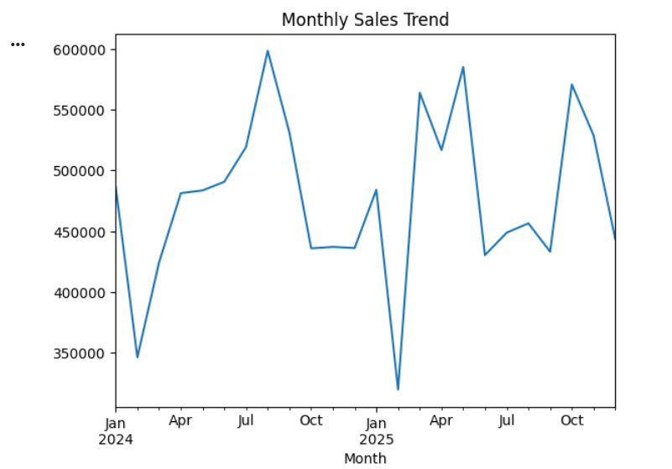

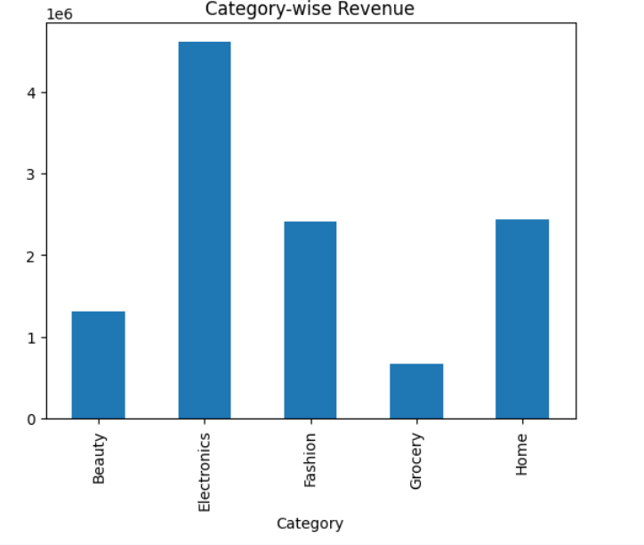
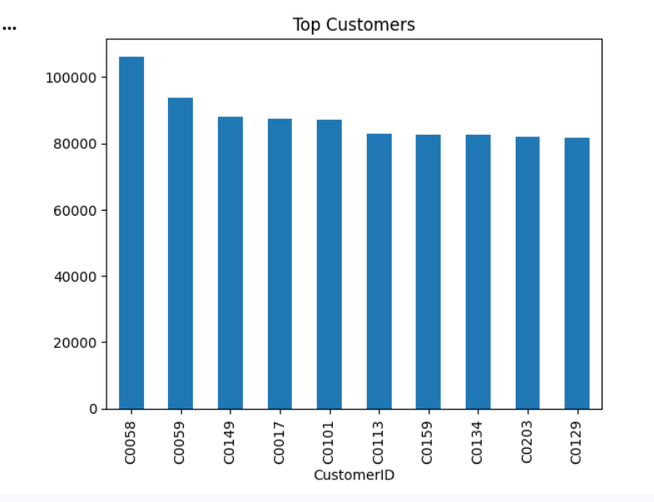

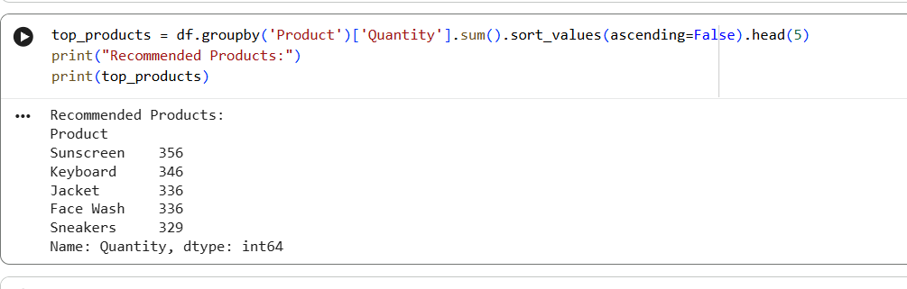

Dataset Download and RFM Analysis

Dataset Collection
The customer transaction dataset was downloaded from a reliable source and imported into Google Colab for further processing. The dataset contained essential attributes such as Customer ID, transaction date, purchase amount, and product details.
DATA HANDLING
- Processed data is stored in structured format
- Used for analysis and visualization
- Enables easy access for dashboards

RFM Analysis
RFM (Recency, Frequency, Monetary) analysis is a widely used technique to analyze customer behavior based on their transaction history.

Recency (R)
  - Measures how recently a customer made a purchase
  - Customers who purchased recently are more likely to buy again

Frequency (F)
  - Measures how often a customer makes purchases
  - Higher frequency indicates loyal customers

Monetary (M)
  - Measures how much money a customer spends
  - Higher spending customers are more valuable

RFM Processing Steps
The following steps were performed in Google Colab:
  - Converted transaction date into proper date format

  - Calculated recency based on last purchase date
  - Counted number of transactions for frequency
  - Calculated total spending for monetary value
  - Assigned scores to each customer based on RFM values
  - Grouped customers into segments

Customer Segmentation
Based on RFM scores, customers were categorized into different segments such as:

  - High-Value Customers – Recent, frequent, and high spenders
  - Loyal Customers – Frequent buyers with consistent purchases
  - At-Risk Customers – Customers who have not purchased recently
  - Low-Value Customers – Low frequency and low spending

Outcome
  - Improved understanding of customer behavior
  - Identification of valuable and potential customers
  - Better targeting for marketing strategies
  - Enhanced decision-making based on data insights

RESULT

Customer data was successfully analyzed

Insights were visualized using charts and graphs

Customer segments and trends were clearly identified

No manual analysis required

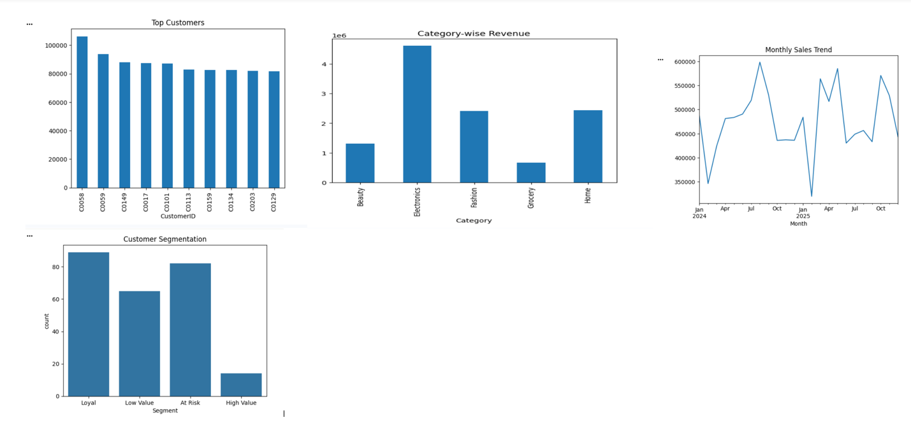

CONCLUSION

The Smart Customer Purchase Analytics & Recommendation System was successfully developed to analyze customer transaction data and generate meaningful insights.
The system performs data cleaning, analysis, and visualization effectively. RFM analysis helps in identifying high-value, loyal, at-risk, and low-value customers. Customer segmentation improves understanding of buying patterns and supports better decision-making.
Visualization techniques help present data clearly through charts and dashboards, making it easy to understand trends and performance.
Overall, this project provides a simple and effective approach to convert raw data into useful insights and supports data-driven business decisions.

REFRENCES

1.Power BI Documentation
https://learn.microsoft.com/en-us/power-bi/

2.Python Documentation
https://docs.python.org/3/

3.Google Colab Documentation
https://colab.research.google.com/

4.Hughes, A. M. – Strategic Database Marketing
(RFM Analysis concept)

