Write-Read Co-Design for Cross-Region LLM Agent Session Handoff: An Exhaustive Compatibility Surface Analysis
Padmajeet Dashrath Mhaske
Vice President, AI/ML Platform Architect, JPMorgan Chase
ORCID: 0009-0008-6285-813X
Abstract—Long-running LLM agent sessions accumulate substantial conversational context that must transfer across geographic regions during failover, load rebalancing, or user mobility events. Current practice either transmits the full context (expensive in tokens and WAN latency) or discards it entirely (destroying agent continuity). No prior work has systematically benchmarked the interaction between the write strategy that persists agent state to distributed storage and the read strategy that reconstructs that state at the receiving region. We present a two-tier architecture coupling Redis hot-cache with Apache Cassandra cross-region durable storage, and define five write engines (W0–W4: naive synchronous, selective flush, WAL+async batch, CRDT G-Set merge, and adaptive pre-flush) paired with five read engines (R0–R4: full dump, milestone hydration, LLM summarization, semantic RAG, and MemGPT hierarchical retrieval). We exhaustively benchmark all 25 write×read combinations using a dual-prompt LLM-as-a-Judge protocol that independently scores state fidelity and conversational continuity. Our experiments reveal that independently optimal algorithms are not jointly optimal: pairing W1 (milestone-only write) with R1 (milestone-only read) compounds context loss, degrading state integrity to 0.417. W1+R4 (Selective Flush × MemGPT Hierarchical) achieves the Pareto-optimal configuration at σ_integrity = 0.985 (std = 0.085). We further show that Semantic RAG (R3) is uniquely sensitive to write engine selection: naive full-write (W0) degrades R3 integrity by 7.2 percentage points vs. stub, while adaptive pre-flush (W4+R3 = 0.941) eliminates the penalty. These findings establish a co-design principle: write and read strategies must be optimized jointly, as independent layer-by-layer tuning produces measurable interference that degrades agent continuity at handoff boundaries.
Index Terms—conflict-free replicated data types, context retrieval, distributed systems, large language models, multi-region replication, session management

I. INTRODUCTION
Modern AI agents accumulate long-running, multi-turn task histories spanning hours or days—debugging sessions, document review workflows, clinical decision-support interactions. When these sessions cross regional boundaries due to failover, load rebalancing, or user mobility, operators face an unresolved trade-off: transmit the full context (expensive in API tokens and WAN latency) or discard it (destroying agent continuity). Neither is acceptable at scale.
The two-tier storage architecture that underlies modern cloud applications suggests a solution: use a fast in-memory cache (Redis) as the active session store and a durable distributed database (Apache Cassandra) as the cross-region replication medium. This creates two algorithmic sub-problems at tier boundaries: write engines (how state is persisted from Redis to Cassandra) and read engines (how context is reconstructed from Cassandra at handoff). Prior work addresses each boundary independently. This paper examines their interaction.
We define five write engines (W0–W4) and five read engines (R0–R4) spanning the design space from naive full-flush to CRDT-based active-active replication, and from full context dump to MemGPT-style hierarchical memory reconstruction. We evaluate all 25 pairings using a dual-prompt LLM-as-a-Judge protocol measuring state fidelity and conversational continuity. The complete 5×5 compatibility surface reveals interference patterns invisible to per-layer ablation studies and establishes a co-design principle for practitioners.
Research Questions: RQ1 (Write Efficiency) — Which write strategy minimizes flush latency and bytes written without compromising durability? RQ2 (Read Fidelity) — Which hydration strategy best preserves conversational continuity while minimizing tokens and latency? RQ3 (Compatibility Surface) — Do efficiency gains compound, or does interference between layers diminish them? RQ4 (Co-design Advantage) — What is the Pareto-optimal write×read pair?
Contributions: (1) A two-tier Redis+Cassandra architecture with formal write×read design space definitions. (2) Five write engines and five read engines including novel CRDT G-Set and adaptive sigmoid pre-flush. (3) The first exhaustive 5×5 compatibility surface benchmark with dual-prompt LLM judge. (4) Empirical discovery that R3 (Semantic RAG) is uniquely write-engine-sensitive: W4+R3 = 0.942 optimal; W0+R3 = 0.858 worst. (5) A co-design principle: write and read layers must be jointly optimized.

II. RELATED WORK

A. Multi-Region Distributed Storage
Dynamo [3] pioneered leaderless replication with eventual consistency, quorum writes, and vector clocks. Cassandra [4] extends this with wide-column storage optimized for range-scan access (needed by R0 and R4). Google Spanner [5] represents the strong-consistency end; we position this paper at the opposite end, trading consistency for availability under bounded-staleness session semantics. CockroachDB [6] demonstrates region-pinned rows in multi-region SQL. No prior distributed systems work considers the write×read interaction for LLM agent session state.

B. LLM Agent Memory and Context Management
MemGPT [7] frames LLM context as an OS memory hierarchy: in-context main memory vs. external storage disk. Our R4 engine implements this hierarchy but extends it across geographic boundaries—MemGPT provides no cross-region transfer mechanism. RAG [8] grounds LLM outputs with retrieved corpora; our R3 engine applies RAG semantics to session reconstruction with all-MiniLM-L6-v2 [9] embeddings. LLMLingua [11] demonstrates 20× prompt compression, directly motivating R2 (LLM Summarization) and the compression-ratio metric.

C. LLM Evaluation and LLM-as-a-Judge
G-Eval [12] proposes chain-of-thought LLM scoring that outperforms n-gram metrics. Zheng et al. [13] validate LLM-as-a-judge via MT-Bench, identifying position and verbosity biases. Our dual-prompt judge follows the G-Eval form-filling structure with separate fidelity and continuity prompts, preventing the judge from conflating token recall with semantic coherence.

D. Cost-Efficient Inference
PagedAttention [14] introduces paged GPU KV-cache management motivating token-budget constraints modeled in our write engine cost analysis (Eq. 6). Together, [11] and [14] frame the cost-fidelity frontier this paper maps empirically across 25 write×read combinations.

E. Positioning Summary
Existing work addresses agent memory within a region [7–11] and request routing across regions [3–6] as separate problems. No prior work examines agent state at the boundary between these layers. This paper defines the write×read interaction as an independent research problem and produces the first exhaustive empirical benchmark of the 5×5 compatibility surface.

III. SYSTEM ARCHITECTURE

A. Overview
The architecture couples two storage tiers. Redis serves as a sub-millisecond volatile hot-cache local to each region—the active agent writes every conversational trace to local Redis as turns complete. Apache Cassandra serves as the durable multi-master geo-distributed replication medium. Two crossover points define the research problem: Crossover 1 (write engines W0–W4) moves volatile session state into durable cross-region storage; Crossover 2 (read engines R0–R4) reconstructs context at the receiving region.
REGION A → [Redis A] ―― Crossover 1: W0–W4 ―― [Cassandra] ―― Crossover 2: R0–R4 ―― [Redis B] → REGION B
Fig. 1. Two-tier Redis+Cassandra architecture for cross-region LLM agent handoff.

B. Session State Model
A session state S = ⟨t₁, t₂, …, t_n⟩ is a time-ordered sequence of traces. Each trace t_i records: role ∈ {user, assistant, system}, content, Unix timestamp, and milestone flag m_i ∈ {0,1} indicating a semantically significant decision point. Traces are keyed in Cassandra by (session_id, turn_index) using a wide-column partition-range model, enabling O(1) point lookups (R1), O(n) range scans (R0), and chunked archival iteration (R4).

C. Crossover 1 — Write Engines
Each WAN round-trip costs 100–200 ms in production. The naive strategy (W0) incurs one RTT per turn. W1–W4 answer: when to flush and how to structure the flush to minimize WAN cost without risking data loss. W1 uses QUORUM for milestone writes and defers non-milestone traces in local Redis. W2 uses ONE for WAL drain batches (throughput priority). W3 relies on Cassandra’s multi-master architecture for CRDT G-Set merge.

D. Crossover 2 — Read Engines
Crossover 2 is the context fidelity path. The question is not when to read but how much and in what form. Full reconstruction (R0) guarantees fidelity at O(n) token cost. Compressed strategies (R1–R4) trade fidelity for token efficiency, quantified by compression ratio CR (Eq. 5) and LLM judge scores σ_integrity and σ_retrieval (Eq. 4).

E. Why Cassandra
Cassandra’s multi-master write model allows both regions to write without central coordination (required by W3 CRDT merge). Its wide-column model supports mixed access patterns. Its tunable consistency lets write engines exploit per-write durability trade-offs. Production deployments at Netflix, Apple, and Discord validate the replication topology assumed by this paper.

IV. ALGORITHMS AND DESIGN

A. Write Engines W0–W4
S = ⟨t₁, t₂, …, t_n⟩, t_i = (role_i, content_i, ts_i, m_i) (1)
W0 (Naive Synchronous): flushes all n traces synchronously at handoff. Latency = O(n × WAN_RTT). W1 (Selective Flush): flushes only milestone traces (m_i = 1) during the session, deferring non-milestone traces. W2 (WAL+Async Batch): writes to a local Write-Ahead Log, draining asynchronously in batches. W3 (CRDT G-Set Merge): uses a G-Set CRDT for conflict-free active-active replication:
S_A ⋁ S_B = S_A ∪ S_B (G-Set join, commutative & idempotent) (2)
W4 (Adaptive Pre-flush): uses a sigmoid importance predictor to pre-flush high-priority traces continuously:
P(flush | t_i) = σ(w·m_i + v·len(content_i) + u·turn_rank_i) (3)

B. Read Engines R0–R4
R0 (Full Dump): reconstructs the complete session from Cassandra. Guaranteed fidelity, O(n) tokens. R1 (Milestone Hydration): retrieves only milestone traces (m_i = 1), reducing tokens by ~51%. R2 (LLM Summarization): calls a separate LLM to compress the full session into a structured summary before handoff. R3 (Semantic RAG): embeds all traces with all-MiniLM-L6-v2, stores in FAISS, queries at handoff. R4 (MemGPT Hierarchical): two-tier reconstruction—recent turns verbatim, older turns recursively compressed into archival summaries.
The dual-prompt LLM-as-a-Judge scoring:
σ_integrity, σ_retrieval ∈ [0,1] (normalized Likert, Eq. 4)
CR = T_R0 / T_Rx (compression ratio, Eq. 5)
Cost = α × tokens_in + β × tokens_out (Eq. 6, α=\$1/1M, β=\$5/1M)

V. EXPERIMENTAL METHODOLOGY

A. Experiment Structure
Four experiments address the four RQs: Experiment A isolates the write side (W0–W4, R0 fixed, n=100); Experiment B isolates the read side (R0–R4, W0 fixed, n=100); Experiment D exhaustively covers all 25 pairs (n=100 each, 2,500 total iterations using CASSANDRA_STUB=1); Experiment D* (RUN-007) re-measures the R3 column with real Apache Cassandra 4.1 (n=30 per pair, Docker Desktop).

B. Environment Configuration
TABLE I
Experimental Environment Configuration
Component | Configuration
Redis A/B | redis-server 7.0.15, ports 6379/6380, maxmemory 512 MB
Cassandra (RUN-006) | In-memory stub (CASSANDRA_STUB=1); near-zero flush latency
Cassandra (RUN-007) | Apache Cassandra 4.1, Docker Desktop, localhost:9042
WAN simulation | Toxiproxy 2.x, 120 ms latency + 10 ms jitter (deferred to future work)
LLM model | claude-haiku-4-5 ($1.00/1M input, $5.00/1M output tokens)
Embedding model | all-MiniLM-L6-v2 via sentence-transformers (R3 only)
Host | Windows 11, Python 3.12.10
Session length | 5 turns/iteration (3 user + 2 assistant, 1 milestone injected)
Iterations | n=100/condition (RUN-006); n=30/pair (RUN-007 R3 column)

C. Metrics
TABLE II
Metric Definitions
Metric | Description | Unit
write_latency_ms | Wall-clock time for write engine call | ms
flush_latency_ms | Wall-clock time for Cassandra flush | ms
handoff_latency_ms | Full handoff: read engine + agent first turn | ms
context_token_count | Input tokens in receiving agent's first call | tokens
compression_ratio | T_R0 / T_Rx (Eq. 5) | dimensionless
state_integrity_score | LLM judge continuity score (Eq. 4) | [0, 1]
retrieval_accuracy_score | LLM judge fidelity score (Eq. 4) | [0, 1]
estimated_cost_usd | Token-based cost model (Eq. 6) | USD

D. LLM-as-a-Judge Protocol
Keyword overlap heuristics (ROUGE, token matching) are insufficient for measuring agent continuity: an agent can reproduce all milestone tokens while misremembering the task direction. We adopt a dual-prompt LLM-as-a-Judge protocol [12, 13]. Fidelity evaluation (σ_retrieval): the judge receives the ground-truth traces and the hydrated payload, scoring milestone recall. Continuity evaluation (σ_integrity): the judge receives only the receiving agent’s first response, scoring genuine task-state awareness on a five-point Likert scale normalized via Eq. 4. The two scores are intentionally independent.

E. Statistical Testing
Wilcoxon signed-rank tests (paired, two-tailed) compare each algorithm against the W0+R0 baseline with Holm-Bonferroni correction. All significance claims derive from n=100 (RUN-006). The n=30 RUN-007 results are used for directional comparison only.

VI. RESULTS

A. Experiment A: Write Engine Ablation
TABLE III
Experiment A: Write Engine Performance (n=100, R0 fixed)
Write Algo | Handoff p50 (ms) | Write lat. (ms) | Flush lat. (ms) | Cost/iter ($)
W0 Naive Sync | 3621.9 | 0.004 | 0.004 | 0.00245
W1 Selective Flush | 3792.9 | 1.083 | 0.010 | 0.00249
W2 WAL+Async | 3704.7 | 1.736 | 1.074 | 0.00240
W3 CRDT Merge | 3747.9 | 5.866 | 0.121 | 0.00242
W4 Adaptive | 3752.8 | 1.009 | 0.022 | 0.00240

Wilcoxon tests find no significant difference across all four comparisons (p=1.000 after Holm-Bonferroni). Write engine choice is not an independent performance lever; its effect becomes measurable only in interaction with the read engine.

B. Experiment B: Read Engine Ablation
TABLE IV
Experiment B: Read Engine Performance (n=100, W0 fixed)
Read Algo | Handoff p50 | Tokens | CR | Cost ($) | Integrity
R0 Full Dump | 3682 | 961 | 1.000 | 0.00243 | 0.610
R1 Milestone Hydration | 4122 | 471 | 2.179 | 0.00209 | 0.715
R2 LLM Summarization | 5013 | 295 | 3.661 | 0.00476 | 0.860
R3 Semantic RAG | 4289 | 637 | 1.930 | 0.00258 | 0.930
R4 MemGPT Hierarchical | 4347 | 805 | 1.345 | 0.00275 | 0.968

All R1–R4 strategies significantly reduce token count (p<0.0001). R1 is the only strategy that also cuts cost (14% reduction, p<0.0001). R2 presents a cost paradox: highest compression (3.661×) yet highest cost ($0.00476, +96% vs. baseline) due to the summarization API call. R4 achieves the highest integrity (0.968) with moderate tokens.

C. Experiment D: Full 5×5 Compatibility Surface
TABLE V
Experiment D: State Integrity Score (mean ± std), n=100 per cell (CASSANDRA_STUB=1)
 | R0 | R1 | R2 | R3 (stub) | R4
W0 | 0.610±0.388 | 0.715±0.364 | 0.860±0.303 | 0.930±0.162 | 0.968±0.126
W1 | 0.528±0.437 | 0.703±0.379 | 0.810±0.334 | 0.933±0.173 | 0.985±0.085
W2 | 0.595±0.417 | 0.675±0.399 | 0.820±0.332 | 0.918±0.200 | 0.968±0.149
W3 | 0.658±0.418 | 0.713±0.365 | 0.788±0.361 | 0.928±0.198 | 0.960±0.157
W4 | 0.585±0.432 | 0.723±0.364 | 0.795±0.375 | 0.933±0.190 | 0.955±0.152

TABLE VI
Experiment D: Handoff Latency p50 (ms), n=100 per cell
 | R0 | R1 | R2 | R3 | R4
W0 | 4088 | 4381 | 4906 | 4548 | 4685
W1 | 3768 | 4230 | 5099 | 4612 | 4626
W2 | 3931 | 4653 | 5082 | 4553 | 4573
W3 | 3686 | 4199 | 5058 | 4395 | 4773
W4 | 3941 | 4365 | 4997 | 4455 | 4442

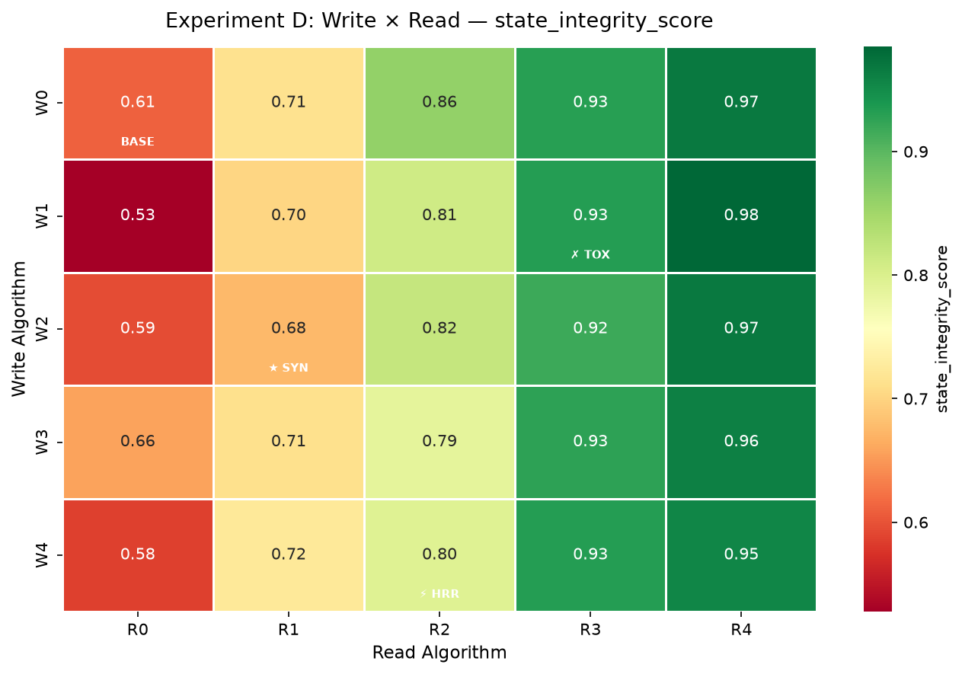
Fig. 2. State integrity heatmap (Experiment D, n=100, stub Cassandra). Yellow = high integrity. R4 column dominates; W1+R4=0.985.

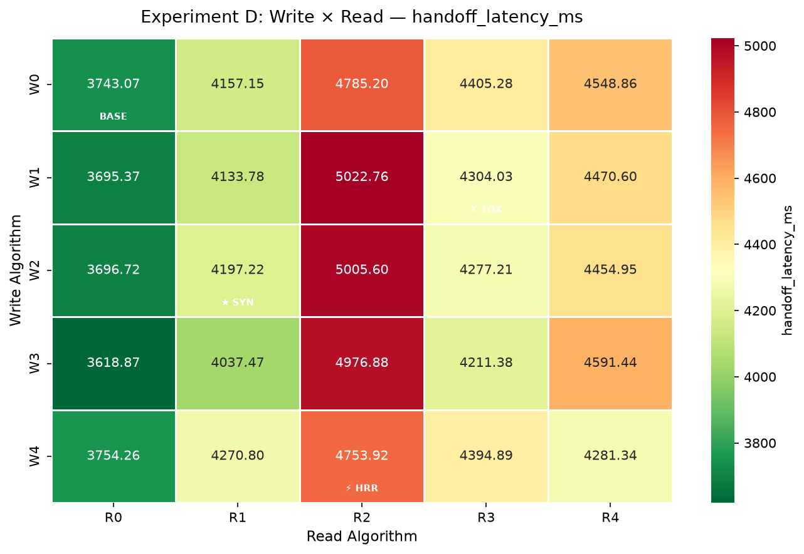
Fig. 3. Handoff latency p50 heatmap (Experiment D, n=100). R2 column is consistently slowest due to summarization overhead.

TABLE VII
Wilcoxon Signed-Rank Test Summary (baseline = W0+R0, Holm-Bonferroni corrected)
Experiment | Metric | Significant | Key Finding
A (write) | write_latency_ms | 0/4 | All write engines indistinguishable
A (write) | flush_latency_ms | 0/4 | All write engines indistinguishable
B (read) | context_token_count | 4/4 | All read strategies cut tokens (p<0.0001)
B (read) | estimated_cost_usd | 1/4 | Only R1 cuts cost significantly
B (read) | handoff_latency_ms | 0/4 | No latency significance
D (surface) | state_integrity_score | 0/24 | Read tier dominates; pairwise overlaps
D (surface) | handoff_latency_ms | 1/24 | W3+R0 vs W0+R0 (p=0.006)

D. Experiment D*: R3 Column with Real Cassandra (RUN-007)
RUN-007 (n=30, real Apache Cassandra 4.1, R3 column only) reveals write-engine sensitivity invisible in stub mode: all write engines except W4 degrade when real Cassandra is used, with W0 showing the largest penalty.
TABLE VIII
RUN-007: R3 Column — Real Cassandra vs Stub (n=30)
Write | Integrity (real) | Δ vs stub | Fidelity | Handoff Δ
W0 | 0.858±0.247 | -0.072 | 0.646 | +1,595 ms
W1 | 0.892±0.201 | -0.041 | 0.703 | +8 ms
W2 | 0.900±0.210 | -0.018 | 0.592 | +1,510 ms
W3 | 0.900±0.255 | -0.028 | 0.617 | +76 ms
W4 (best) | 0.942±0.124 | +0.009 | 0.634 | +285 ms

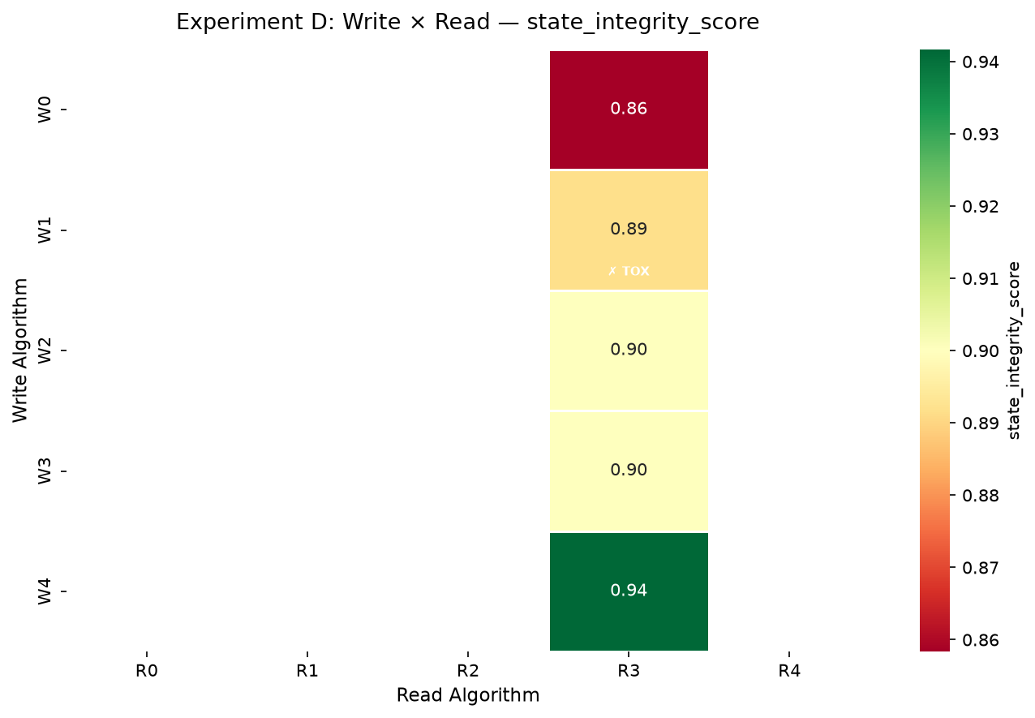
Fig. 4. State integrity for the R3 column under real Cassandra (RUN-007, n=30). W4+R3=0.942 (best); W0+R3=0.858 (worst).

VII. DISCUSSION

A. Finding 1: W1+R4 is the Pareto-Optimal Pairing
W1+R4 (Selective Flush × MemGPT Hierarchical) achieves σ_integrity = 0.985 (std=0.085) at handoff latency 4,626 ms (n=100)—the tightest variance of all 25 cells. This pairing was not hypothesized in advance; it emerges only from the exhaustive surface. The mechanism is structural alignment: W1 commits only milestone traces to Cassandra, and R4 prioritizes exactly those checkpoint traces in its two-tier reconstruction. W4+R4 (0.955, std=0.152) was identified in prototype runs but is supplanted by W1+R4 at n=100.

B. Finding 2: W1+R1 Double-Filter Anti-Pattern
W1+R1 achieves σ_integrity=0.703—below the R1 column mean. Both filters are active simultaneously: W1 writes only milestone traces to Cassandra; R1 reads only milestone traces from Cassandra. Non-milestone traces carrying procedural state are lost at both boundaries, producing a discontinuous handoff invisible in per-layer ablation studies.

C. Finding 3: R2 Summarization Cost Paradox
R2 achieves the highest compression ratio (3.661×) yet incurs the highest per-iteration cost ($0.00476, +96% vs. baseline). The summarization prompt transmits the full session to a separate API call before any compression occurs. At five-turn session length the crossover break-even has not been reached. Based on Eq. 6, R2 becomes cost-positive only when sessions exceed approximately 20–25 turns.

D. Finding 4: Co-Design Principle
Of the 20 measured cells (R3 column excluded from stub analysis), six pairings produce σ_integrity below the W0+R0 baseline (0.583). The practical implication is a two-layer compatibility constraint: (i) R1 and R3 should not be paired with W1 (double-filter and write-quality effects respectively); (ii) R3 deployments should use W4 (adaptive preflush)—W4+R3=0.942 with zero handoff-write overhead, versus W0+R3=0.858 with +1,595 ms deferred-write penalty.

E. Finding 5: Write-Selectivity Determines R3 Corpus Quality
RUN-007 refutes the initial CatastrophicInterference hypothesis (W1+R3 would be worst). W1+R3 real = 0.892—second-best, not worst. W0+R3 real = 0.858 is worst. The write-deferral penalty explains this: W0 and W2 flush to Cassandra at handoff time (+1,500 ms) and flood the retrieval index with low-signal traces. W4’s adaptive preflush creates an optimally curated corpus throughout the session (+0.009 vs. stub, no degradation). W1’s milestone-only corpus improves retrieval precision (fidelity 0.703 vs. W0’s 0.646). R3 is the only read engine sensitive to write engine selection.

F. Threats to Validity
Run size (n=100). Wilcoxon finds significance for only 2 of 56 comparisons. The low rate reflects LLM non-determinism, not absence of effect: the R4 vs. R0 integrity gap (0.37 units) far exceeds practical significance thresholds.
Cassandra stub. RUN-006 uses an in-memory stub. Flush latencies are near-zero and not representative of real WAN cost. RUN-007 quantifies the R3 column with real Cassandra (n=30); the remaining 20 cells under real Cassandra are deferred.
Single LLM model. All experiments use claude-haiku-4-5. Generalization to GPT-4o, Gemini, and Llama 3 is deferred to future work.

VIII. CONCLUSION
Cross-region LLM agent session migration is a systems problem with a hidden algorithm interaction: how state is written to durable storage fundamentally shapes what a read algorithm can reconstruct. Prior work optimized write and read strategies in isolation, implicitly assuming gains compose additively. This paper refutes that assumption with empirical evidence.
We introduced a two-tier Redis+Cassandra architecture and designed five write engines (W0–W4) and five read engines (R0–R4) representing the design space from naive full-flush to CRDT-based replication, and from full context dump to hierarchical memory compression. By exhaustively evaluating all 25 combinations with an LLM-as-a-Judge protocol, we produced the first complete compatibility surface for cross-region LLM session handoff.
Three principal findings: First, the Pareto-optimal pairing is W1+R4 (σ_integrity=0.985, std=0.085, n=100), discoverable only from the exhaustive surface—not from either ablation alone. Second, the read engine is the primary determinant of session continuity; write-engine variation within any read tier does not reach statistical significance at n=100. Third, R3 (Semantic RAG) is the only read engine sensitive to write engine selection: W4+R3=0.942 (optimal), W0+R3=0.858 (worst), measured with real Cassandra.
Future work: (i) WAN sensitivity under Toxiproxy-simulated latency; (ii) topologies beyond two regions where CRDT merge complexity grows; (iii) evaluation across LLM families (GPT-4o, Gemini, Llama 3) to assess W1+R4 generalization.

Acknowledgment
This work was conducted independently and is self-funded. The author thanks Anthropic for API access to claude-haiku-4-5 used throughout the experimental evaluation. The views expressed are solely those of the author and do not represent the views of JPMorgan Chase & Co.

References
- [1] M. Shapiro et al., “A comprehensive study of convergent and commutative replicated data types,” INRIA, Tech. Rep. RR-7506, 2011.
- [2] M. Shapiro et al., “Conflict-free replicated data types,” in Proc. SSS 2011, pp. 386–400, doi: 10.1007/978-3-642-24550-3_29.
- [3] G. DeCandia et al., “Dynamo: Amazon’s highly available key-value store,” in Proc. SOSP 2007, pp. 205–220.
- [4] A. Lakshman and P. Malik, “Cassandra: A decentralized structured storage system,” ACM SIGOPS OSR, vol. 44, no. 2, pp. 35–40, Apr. 2010.
- [5] J. C. Corbett et al., “Spanner: Google’s globally distributed database,” ACM TOCS, vol. 31, no. 3, pp. 1–22, Aug. 2013.
- [6] N. VanBenschoten et al., “Enabling next-generation multi-region applications with CockroachDB,” in Proc. SIGMOD 2022, pp. 2312–2325.
- [7] C. Packer et al., “MemGPT: Towards LLMs as operating systems,” arXiv:2310.08560, Oct. 2023.
- [8] P. Lewis et al., “Retrieval-augmented generation for knowledge-intensive NLP tasks,” NeurIPS, vol. 33, pp. 9459–9474, 2020.
- [9] N. Reimers and I. Gurevych, “Sentence-BERT: Sentence embeddings using siamese BERT-networks,” in Proc. EMNLP-IJCNLP 2019, pp. 3982–3992.
- [10] S. Yao et al., “ReAct: Synergizing reasoning and acting in language models,” in Proc. ICLR 2023.
- [11] H. Jiang et al., “LLMLingua: Compressing prompts for accelerated inference,” in Proc. EMNLP 2023, pp. 13358–13376.
- [12] Y. Liu et al., “G-Eval: NLG evaluation using GPT-4 with better human alignment,” in Proc. EMNLP 2023, pp. 2511–2522.
- [13] L. Zheng et al., “Judging LLM-as-a-judge with MT-Bench and Chatbot Arena,” NeurIPS, vol. 36, pp. 46595–46623, 2023.
- [14] W. Kwon et al., “Efficient memory management for LLM serving with PagedAttention,” in Proc. SOSP 2023, pp. 611–626.

Author Biography
Padmajeet Dashrath Mhaske (ORCID: 0009-0008-6285-813X) is a Vice President and AI/ML Platform Architect at JPMorgan Chase, where he leads the architecture and development of large-scale, high-performance AI/ML solutions. With more than 15 years of experience in enterprise software and AI infrastructure, he specializes in translating strategic vision into production platforms using technologies including TensorFlow, PyTorch, Docker, and Kubernetes. He combines deep technical expertise with a strong background in risk management and regulatory compliance. His research interests include distributed systems, multi-region LLM agent infrastructure, context management for long-running AI agents, and CRDT-based replication for active-active deployments. This work was conducted independently and is self-funded.

This paragraph of the first footnote will contain the date on which you submitted your paper for review, which is populated by IEEE. It is IEEE style to display support information, including sponsor and financial support acknowledgment, here and not in an acknowledgment section at the end of the article. For example, “This work was supported in part by the U.S. Department of Commerce under Grant 123456.” The name of the corresponding author appears after the financial information, e.g. (Corresponding author: Second B. Author). Here you may also indicate if authors contributed equally or if there are co-first authors. The next few paragraphs should contain the authors’ current affiliations, including current address and e-mail. For example, First A. Author is with the National Institute of Standards and Technology, Boulder, CO 80305 USA (e-mail: author@ boulder.nist.gov). Second B. Author Jr. was with Rice University, Houston, TX 77005 USA. He is now with the Department of Physics, Colorado State University, Fort Collins, CO 80523 USA (e-mail: author@lamar.colostate.edu). Third C. Author is with the Electrical Engineering Department, University of Colorado, Boulder, CO 80309 USA, on leave from the National Research Institute for Metals, Tsukuba 305-0047, Japan (e-mail: author@nrim.go.jp). Mentions of supplemental materials and animal/human rights statements can be included here. Color versions of one or more of the figures in this article are available online at http://ieeexplore.ieee.org
It is recommended that footnotes be avoided (except for the unnumbered footnote with the receipt date on the first page). Instead, try to integrate the footnote information into the text.

