## **Install Docker and docker-compose**

1- SSH to your new Ubuntu 16.04 server.

$ ssh sguyennet@10.10.40.4

2- Add the Docker GPG key.

$ curl -fsSL https://[download.docker.com/linux](http://download.docker.com/linux)/ubuntu/gpg | \

sudo apt-key add -

3- Add the Docker repository.

$ sudo add-apt-repository \

"deb [arch=amd64]<https://download.docker.com/linux/ubuntu> \

$(lsb_release -cs) \

stable"

4- Install Docker.

$ sudo apt-get update

$ sudo apt-get install docker-ce

5- Allow your user to use Docker without administrator privileges.

$ sudo usermod -aG docker $USER

6- Exit the SSH session.

$ exit

7- Log back in.

$ ssh sguyennet@10.10.40.4

8- Check that your user can use Docker.

$ docker info

9- Install docker-compose.

$ sudo apt-get install docker-compose

## **Generate self-signed certificates**

1- Create a certificate authority.

$ openssl req \

-newkey rsa:4096 -nodes -sha256 -keyout ca.key \

-x509 -days 3650 -out ca.crt

2- Generate a certificate signing request.

$ openssl req \

-newkey rsa:4096 -nodes -sha256 -keyout harbor.inkubate.io.key \

-out harbor.inkubate.io.csr

3- Create a configuration file for the Subject Alternative Name.

$ vim extfile.cnf

subjectAltName = IP:10.10.40.4

4- Generate a certificate.

$ openssl x509 -req -days 3650 \

-in harbor.inkubate.io.csr -CA ca.crt -CAkey ca.key -CAcreateserial \

-extfile extfile.cnf \

-out harbor.inkubate.io.crt

5- Copy the certificate to /etc/ssl/certs.

$ sudo cp *.crt *.key /etc/ssl/certs

## **Install harbor**

1- Download the Harbor online installer.

$ wget https://[storage.googleapis.com/harbor](http://storage.googleapis.com/harbor)-releases/harbor-online-installer-v1.5.2.tgz

2- Untar the installer.

$ tar xvzf harbor-online-installer-v1.5.2.tgz

3- Go to the Harbor directory.

$ cd harbor

4- Edit the Harbor configuration and change the following options in the file.

$ vim harbor.cfg

hostname = 10.10.40.4

ui_url_protocol = https

ssl_cert = /etc/ssl/certs/harbor.inkubate.io.crt

ssl_cert_key = /etc/ssl/certs/harbor.inkubate.io.key

harbor_admin_password = [your_harbor_admin_password]

db_password = [your_db_password]

clair_db_password = [your_clair_db_password]

5- Install Harbor.

$ sudo ./install.sh --with-notary --with-clair

## **Create a private image**

1- Access the Harbor web interface, browse to<https://10.10.40.4> and login with the admin user.

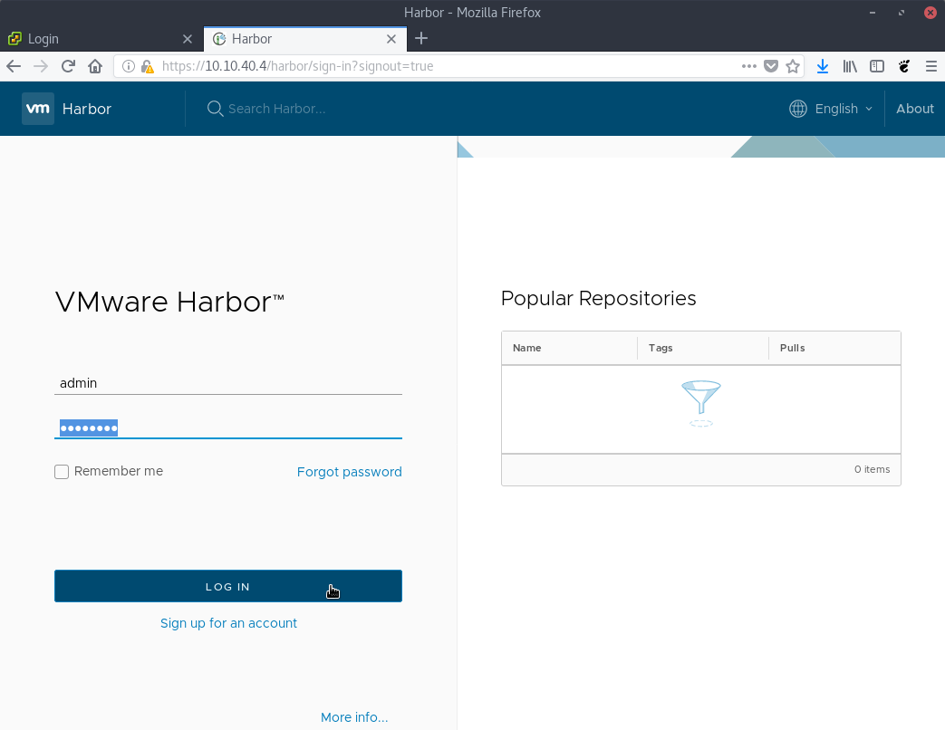

2- Create a new project.

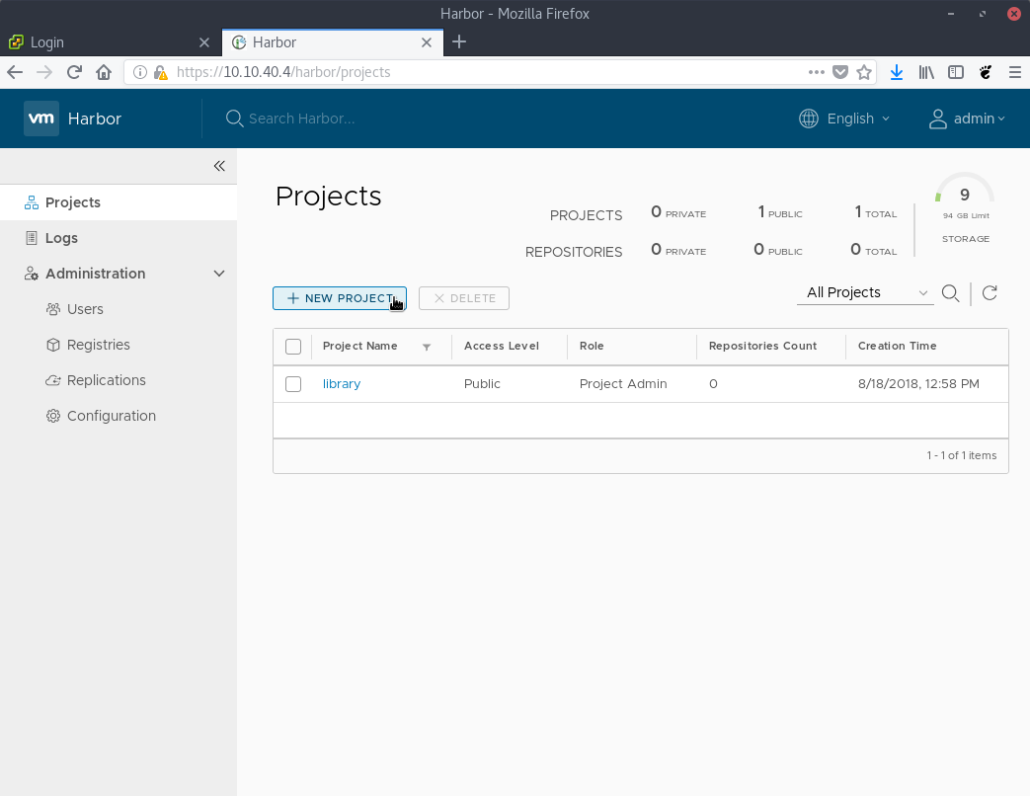

3- Call it private and leave the public checkbox unchecked.

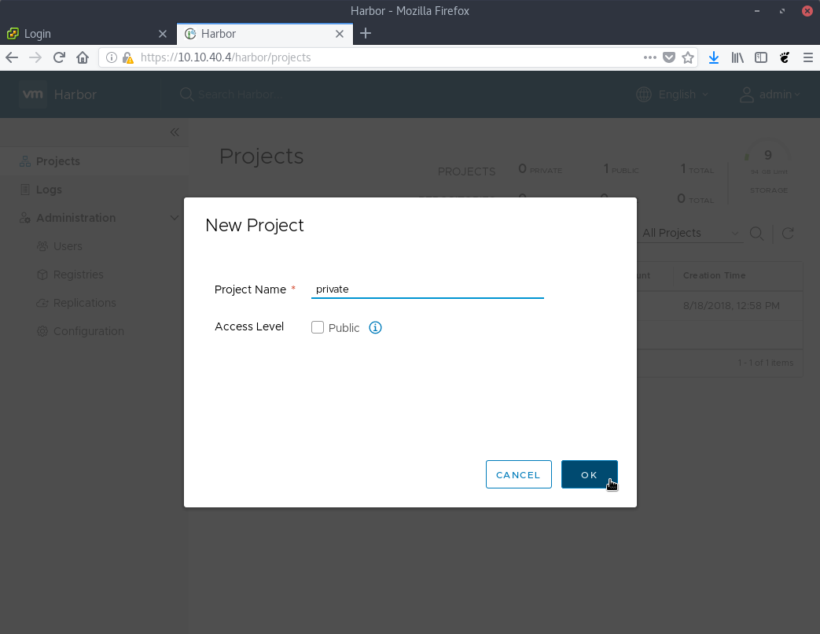

4- Download the public image from Kubernetes Up & Running book.

$ docker pull [gcr.io/kuar-demo/kuard-](http://gcr.io/kuar-demo/kuard-)amd64:1

5- Tag the image to use your Harbor private registry.

$ docker tag [gcr.io/kuar-demo/kuard-amd64](http://gcr.io/kuar-demo/kuard-amd64):1 10.10.40.4/private/kuard:v1

6- Login to the Harbor private registry.

$ docker login 10.10.40.4

7- Upload the image to the private Harbor registry.

$ docker push 10.10.40.4/private/kuard:v1

8- Check that the image has been properly uploaded to the Harbor private registry.

