- Act as a Dietician and Nutritionist
Age: 45+ years with less activity trying to lose weight
Food pattern: non-veg during weekends and veg in weekdays
Prepare a 7-day healthy meal plan for the above person including snack, breakfast, lunch and dinner
Provide in a tabular column with Day | Meal | Dish | Portion

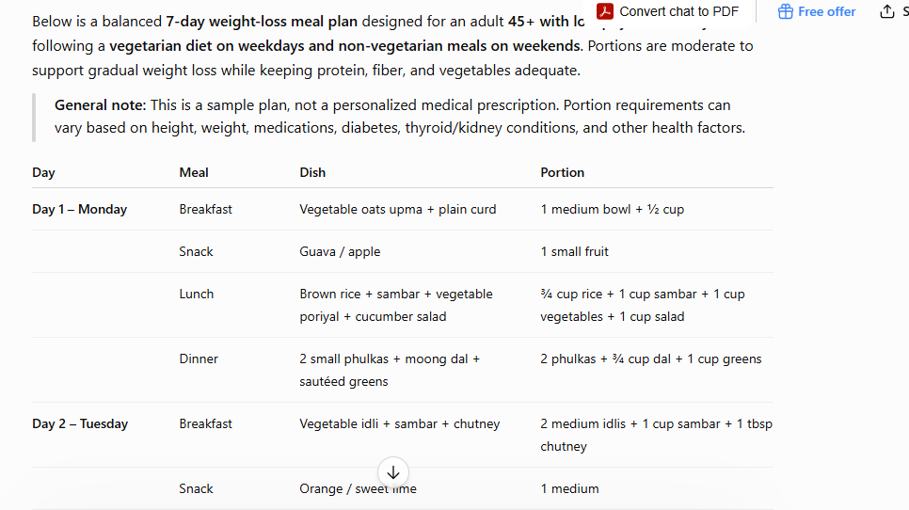
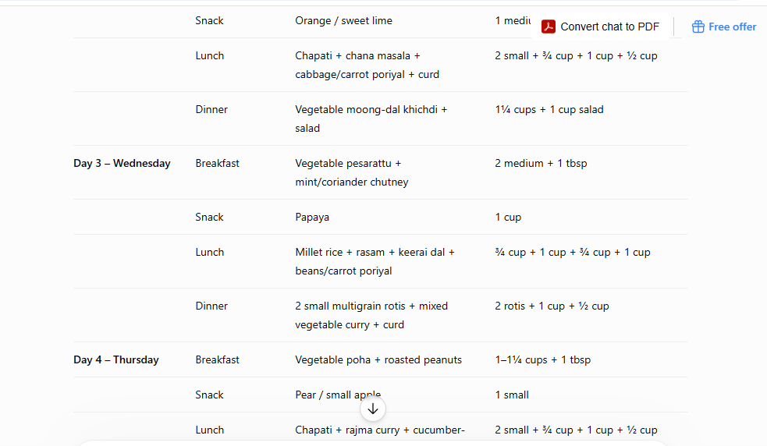
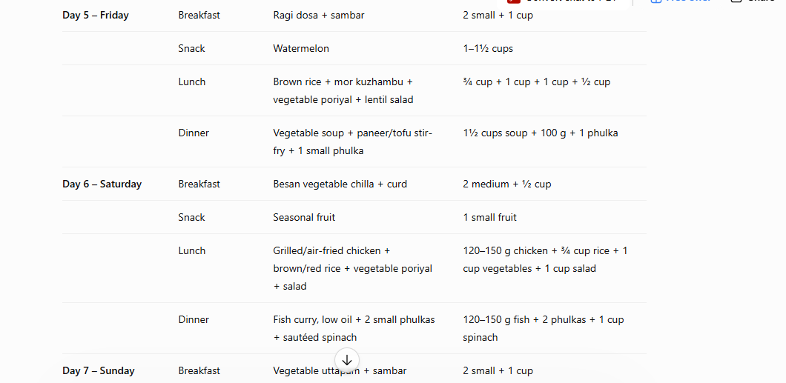
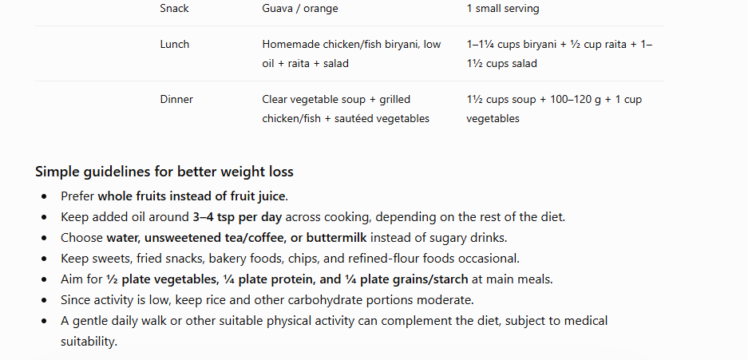
2. Act as a Nutritionist
Age: for 10 year kid boy who practice badminton regularly
Food pattern: non-veg during weekends and veg in weekdays
Prepare a 7-day healthy meal plan for the above person including snack, breakfast, lunch and dinner
Provide in a tabular column with Day | Meal | Dish | Portion
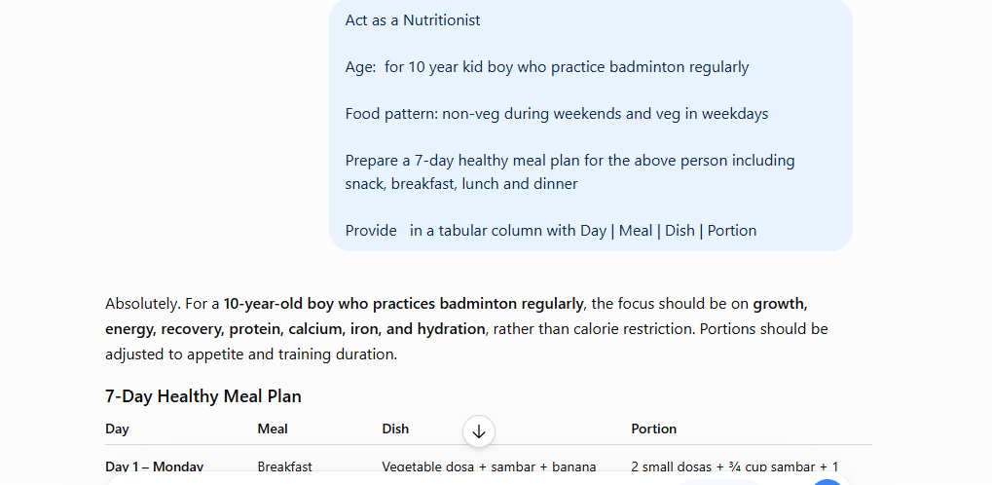
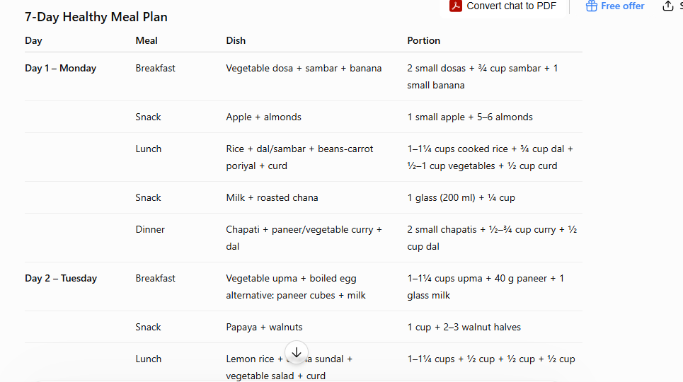
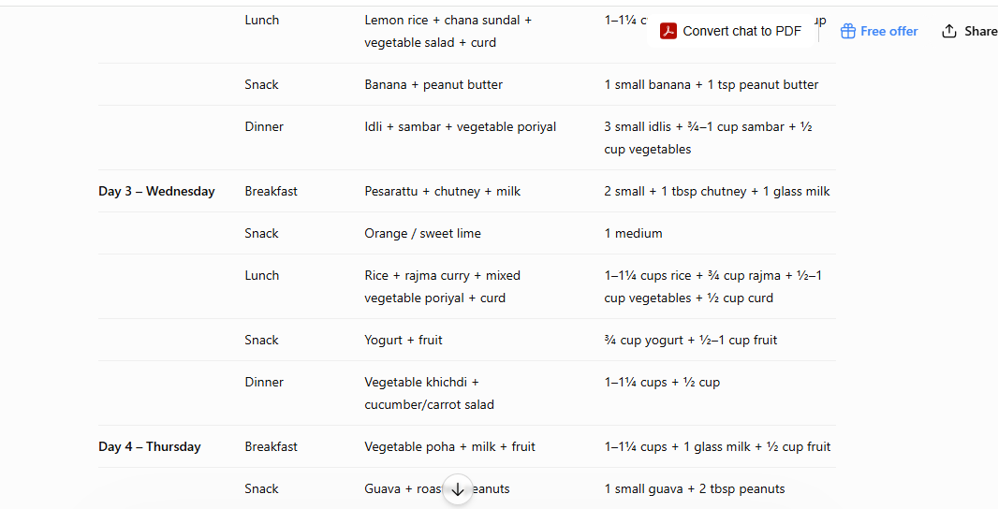
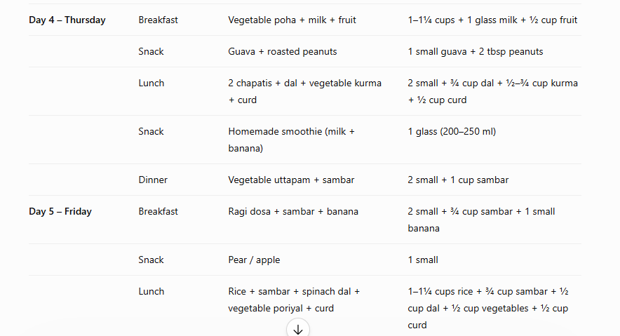
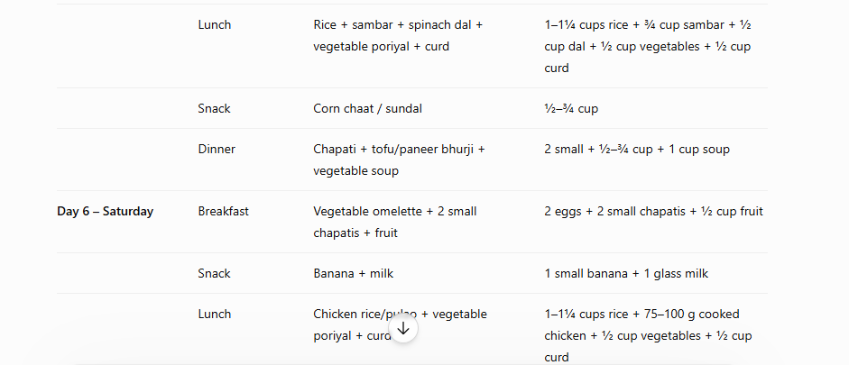
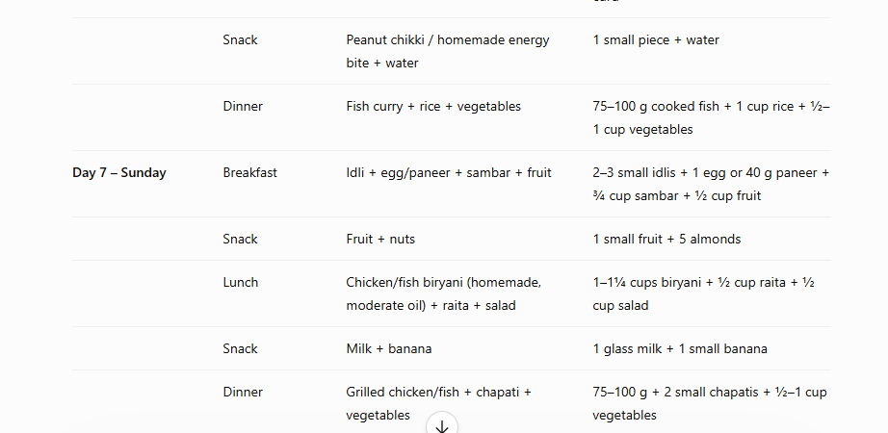
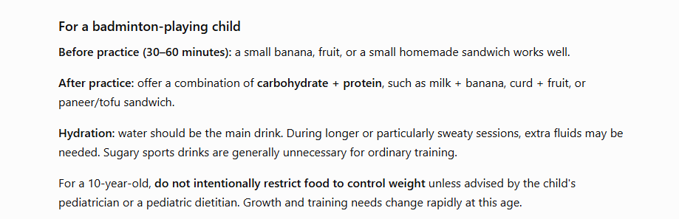

Changed the “Age: 45+ years with less activity trying to lose weight” in promt1 for prompt 2 as “Age: for 10 year kid boy who practice badminton regularly”

