----------------------------------------------------------
FastAPI Screenshots run through postman:
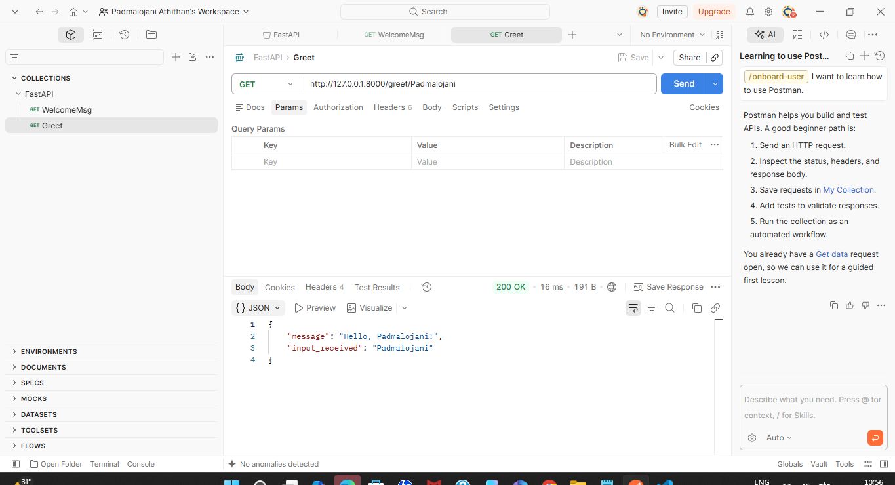
StreamLit Student-GradingSystem Screenshots:
--------------------------------------------------------------

