**Best Choice – Cars**

The “**Best Choice**” is one of the company in market which sells all used cars.

This application enables the customers to buy **used cars** online.C

**Details\***

Home screen enables the customer to search for the cars based on brand or price range. Customer clicks on search cars by brand or search cars by price hyperlinks to find and book the cars.

The home page can look like this:

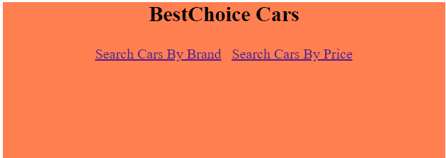

If the customer clicks on Search Cars by Brand link, he will be asked to select the brand from the drop down to find the available models of the respective brand.

The Customer will be shown the screen as below to select the brand and go back to home page:

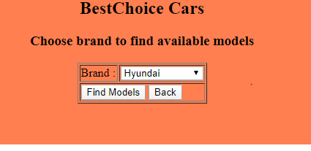

Based on the brand selected in above screen, below screen is showed to the customer with all the available models along with the other details of the car. Customer selects a car and clicks on one of the radio button against to the chosen/selected car details.

If Customer clicks on back button, previous page will be shown to change the brand name

If Customer clicks on home button, home page will be shown

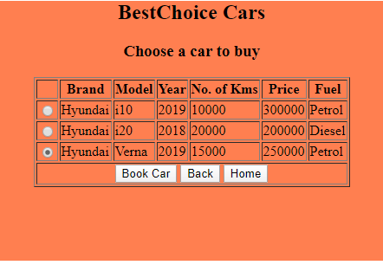

In the above screen, if user click on Book Car button, below success page will be shown.



If the customer clicks on Search Cars by Price link, he will be asked to select the price range to find the available cars.

The Customer will be shown the screen as below to select the price range and go back to home page:

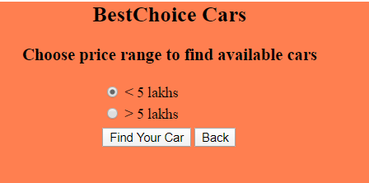

Based on the price range selected in above screen, below screen is showed to the customer with all the available details of the car within the selected price range. Customer selects a car and clicks on one of =the radio button against to the chosen/selected car details.

If Customer clicks on back button, previous page will be shown to change the price range.

If Customer clicks on home button, home page will be shown

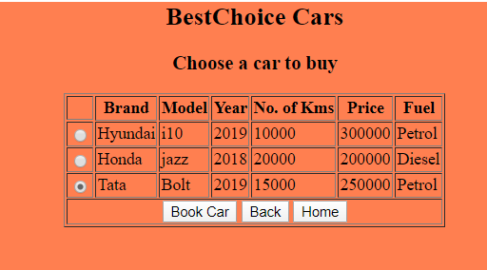

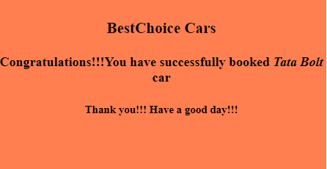

**Suggested Datab structures ase/Table :**

**Cars Table**

|  |  |  |  |  |  |
| --- | --- | --- | --- | --- | --- |
| Brand | Model | Year | No.of Kms | Price | Fuel |
| Hyundai | I10 | 2019 | 10000 | 300000 | Petrol |
| Hyundai | I20 | 2018 | 20000 | 200000 | Diesel |
| Hyundai | Verna | 2019 | 15000 | 250000 | Petrol |
| Tata | Bolt | 2019 | 15000 | 250000 | Petrol |
| Maruthi Suzuki | Ciaz | 2019 | 5000 | 600000 | Petrol |
| Honda | jazz | 2018 | 20000 | 200000 | Diesel |
| Honda | City | 2019 | 15000 | 400000 |  |
| Maruthi Suzuki | Ertiga | 2018 | 10000 | 550000 | Petrol |
| Tata | Nexon | 2019 | 5000 | 600000 | Petrol |

**General Requirements:**

1. Apply suitable headings/titles as deemed appropriate.
2. Apply suitable validations to the forms wherever applicable (All the fields mandatory etc.,)
3. The screen designs given above are for easy understanding of the flow and functionality. You can design the screens as per your choice.
4. Please use appropriate HTML5 input types and attributes as found suitable.
5. Styling and colors can be used as per your choice

**Technologies mandatorily that needs to be used:**

* **Languages and Frameworks:** Spring Boot, JAX-RS & Spring Data
* **Databases :** Any In-Memory DB or RDBMS of your choice
* **Build Tool:** Use and implement it as a Maven based project