## AI BASED DIABETES PREDICTION SYSTEM

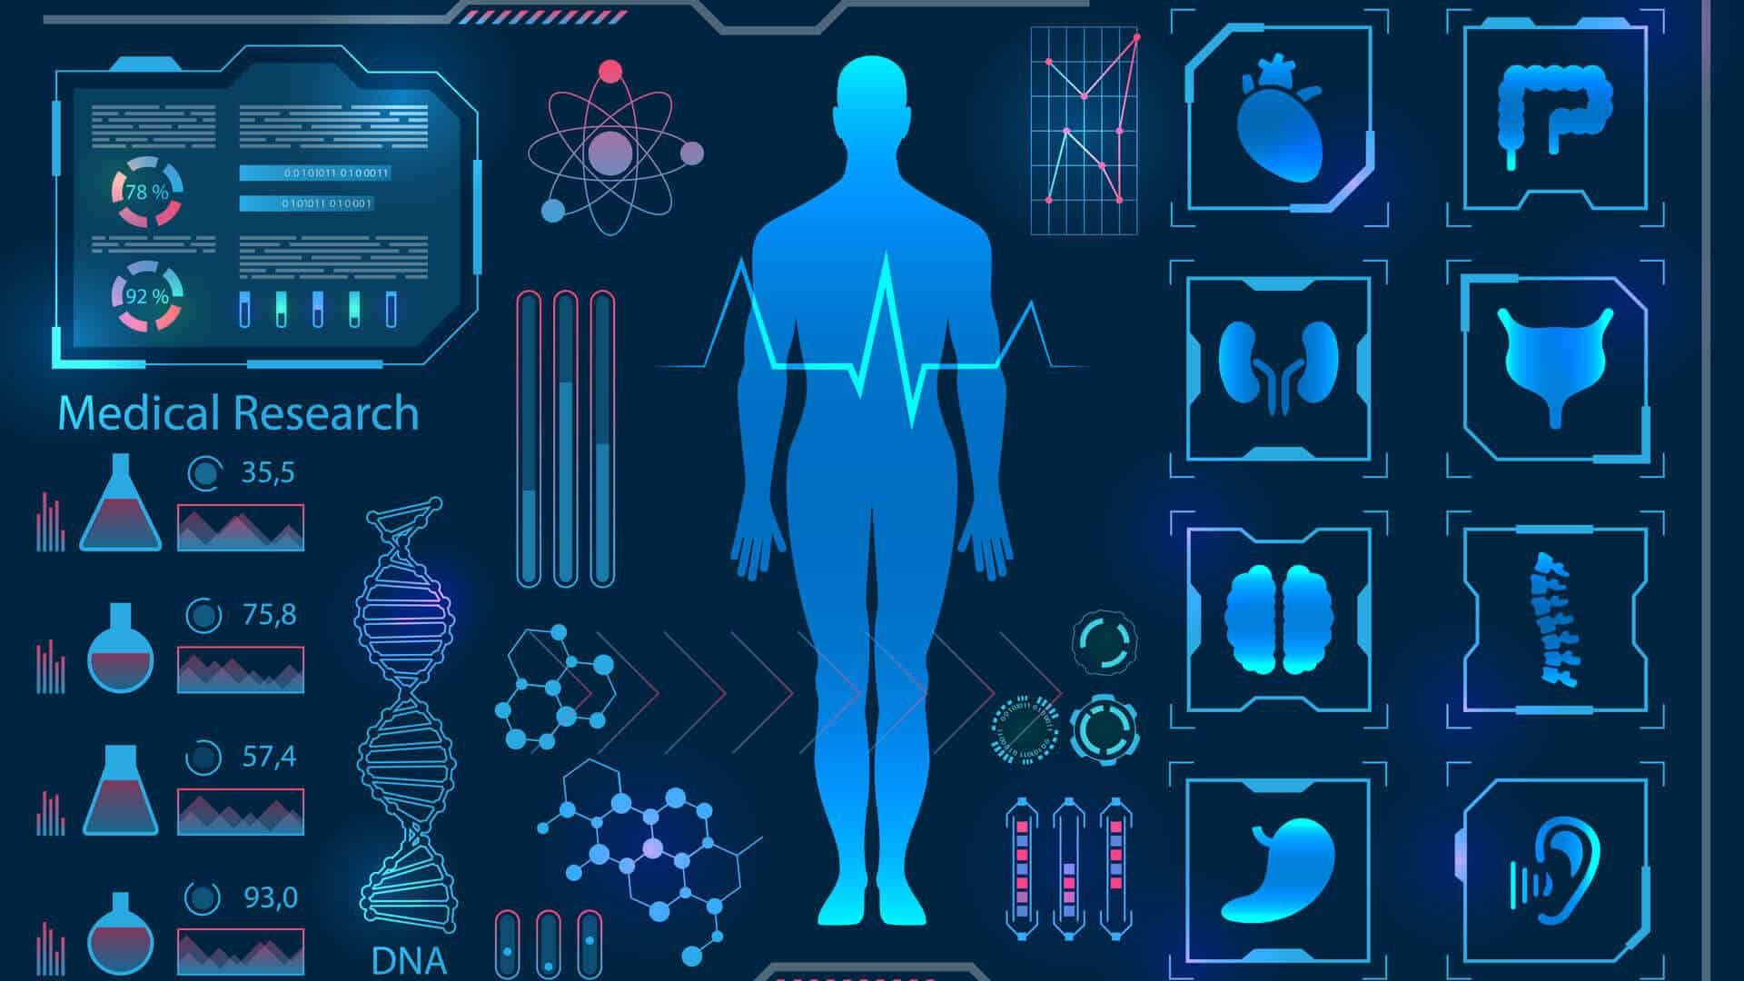

**OUTLINE:**

* Abstract
* Introduction
* Data collection
* Data preprocessing
* ARDUINO UNO

1. Height measurement in **AURDINO UNO**

* SD SHIELD CATALEX

1. Weight measurement in AURDINO UNO

* Load cell
* Digital blood presure monitor
* Data analysis
* Model selecting
* System thinking
* Data splitting
* Model training
* Merits& demerits
* Output prediction

**ABSTRACT:**

The AI-Based Diabetes Prediction System is a cutting-edge healthcare solution that leverages artificial intelligence and machine learning techniques to assist in the early detection and prediction of diabetes. Diabetes is a widespread chronic health condition with significant global health implications. Early diagnosis and intervention are crucial for managing the disease and reducing its associated complications. This system is designed to empower healthcare professionals and patients by providing accurate predictions and insights related to diabetes risk.

**Introduction:**

AI is used to spot patterns in behavior that lead to either high or low blood sugar levels in diabetes patients. Continuous glucose monitors used by those with diabetes collect a huge amount of data that has previously not been used efficiently.Providing instructions for an AI-Based Diabetes Prediction System involves guiding users on how to interact with the system, input data, and interpret the results. Here's a set of instructions to help users effectively utilize the system.

A software application or platform that utilizes artificial intelligence (AI) and machine learning techniques to analyze medical and demographic data of individuals and predict the likelihood of them developing diabetes in the future. This system provides early risk assessment and personalized preventive measures to help individuals manage and reduce their risk of diabetes.

**DATA COLLECTION:**

The system utilizes a comprehensive dataset containing various health parameters, such as blood glucose levels, body mass index (BMI), age, family history, and lifestyle factors, to develop predictive models. Machine learning algorithms, such as logistic regression, decision trees, or neural networks, are employed to analyze this data. These models are trained on historical data from diabetic and non-diabetic individuals, allowing the system to recognize patterns and relationships between these variables.

Collect split up the data for age wise and BMI (Body Mass Index)level in asper dataset.

DATA LIST:

Gender : Female

No.of.Pregnancies : 0-17

Glucose :0-200mg/dL

BloodPressure :0-122 mm/Hg

SkinThickness :0-70 mm

Insulin :0-900pmol/L

BMI :0-70.0Kg/M^2

Age :21-70

**DATA PREPROCESSING:**

A software application or platform that utilizes artificial intelligence (AI) and machine learning techniques to analyze medical and demographic data of individuals and predict the likelihood of them developing diabetes in the future. This system provides early risk assessment and personalized preventive measures to help individuals manage and reduce their risk of diabetes. Using for basic embedded systems in Arduino uno board simple implementation of input information getting device.

**ARDUINO UNO:**

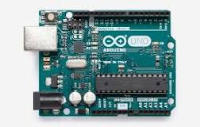

"Uno" means one in Italian and was chosen to mark the release of Arduino Software (IDE) 1.0. The UNO board and version 1.0 of Arduino Software (IDE) were the reference versions of Arduino, now evolved to newer releases.

The Arduino UNO is the best board to get started with electronics and coding. If this is your first experience tinkering with the platform, the UNO is the most robust board you can start playing with. The UNO is the most used and documented board of the whole Arduino family.

Main Features of ARDUINO UNO:

Arduino UNO is a microcontroller board based on the **ATmega328P**. It has 14 digital input/output pins (of which 6 can be used as PWM outputs), 6 analog inputs, a 16 MHz ceramic resonator, a USB connection, a power jack, an ICSP header and a reset button. It contains everything needed to support the microcontroller; simply connect it to a computer with a USB cable or power it with a AC-to-DC adapter or battery to get started. You can tinker with your UNO without worrying too much about doing something wrong, worst case scenario you can replace the chip for a few dollars and start over again.

**DATA INPUT:**

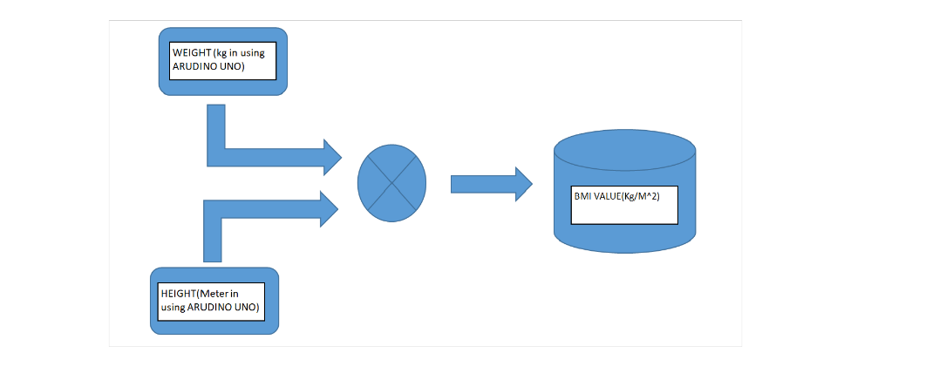

**HEIGHT MEASUREMENT PART:**

The system of this tool has an input in the form of an ultrasonic sensor HC-SR04. The input received is in the form of sensor measurement data, which will be processed by the Arduino Uno microcontroller. At the output, there is a Liquid Crystal Display (LCD) to display the measurement results obtained.

**HEIGHT MEASUREMENT IN AURDINO UNO FOR EMBEDDED C-LANGUAGE PROGRAM ALGORITHM:**

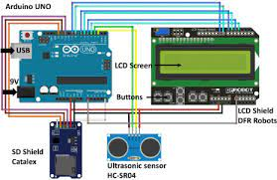

* We include the "Ultrasonic" library (make sure it's installed in the Arduino IDE).
* Define the TrigPin and EchoPin, which are the pins used to trigger the ultrasonic sensor and read the echo signal.
* In the setup function, we initialize serial communication for debugging purposes.
* In the loop function, we measure the distance using the ultrasonic sensor and calculate the height based on the time it takes for the sound wave to bounce back.
* We assume a constant speed of sound (approximately 343 m/s) and divide the duration by 2 to account for the round trip of the sound wave.
* The height is printed to the serial monitor.
* We introduce a delay (e.g., 1 second) between measurements. Adjust this delay as needed based on your application.

Make sure to connect the Trig and Echo pins of the ultrasonic sensor to the correct pins on your Arduino Uno. You may need to adapt the code and connections to your specific hardware and requirements.

**SD SHIELD CATALEX:**

The Catalex SD Card Shield is an expansion board for Arduino that allows you to add an SD (Secure Digital) card slot to your Arduino projects. This shield is particularly useful for data logging, storing configuration settings, or reading and writing files on an SD card. Below are the basic steps for using the Catalex SD Card Shield with an Arduino:

**Mount the Shield:**

Stack the Catalex SD Card Shield on top of your Arduino board. Make sure the pins align correctly with the Arduino headers.

**Wiring:**

If your shield doesn't come with pre-soldered header pins, you may need to solder them to the shield. Ensure the header pins match your Arduino model.

There's no need for additional wiring as the shield connects directly to the Arduino.

**Libraries:**

You'll need to include some libraries to work with the Catalex SD Card Shield. The primary library is the "SD" library, which is included with the Arduino IDE. You can use it to interface with the SD card.

**Serial Monitor:**

To view output and debug information, open the Arduino IDE's Serial Monitor.

**Power Supply:**

Make sure to power your Arduino and SD card shield appropriately, especially if you're using multiple devices or peripherals. Some shields may require external power sources or provide voltage regulators.

Remember that the actual code and pin usage may vary based on your specific Arduino model and SD card shield variant. Always refer to the documentation or datasheets provided by Catalex or your specific shield manufacturer for precise instructions and pin details.

**WEIGHT MEASUREMENT PART:**

This Electronic Arduino Weight Sensor is able to detect 1kg weight. It based on HX711, a precision 24-bit analog-to-digital converter designed for weight scale and industrial control applications to interface directly with a bridge sensor.

**WEIGHT MEASUREMENT IN AURDINO UNO FOR EMBEDDED C-LANGUAGE PROGRAM ALGORITHM:**

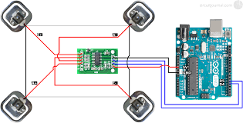

* We include the "HX711" library (make sure it's installed in the Arduino IDE).
* Define the pins for the HX711 load cell amplifier, DOUT_PIN and SCK_PIN.
* In the setup function, we initialize serial communication for debugging and then initialize the HX711 scale.
* In the loop function, we read the weight from the load cell using the scale.get_units() function. The argument specifies the number of readings to average (10 in this case). You can adjust this value based on your requirements.
* The measured weight is printed to the serial monitor. You can adjust the units and format as needed.
* We introduce a delay (e.g., 1 second) between measurements. Adjust this delay as needed based on your application.

Make sure to connect the load cell and the HX711 amplifier to the specified pins on your Arduino Uno. Also, ensure that you have correctly wired the load cell to the HX711 module and powered it appropriately. The HX711 library simplifies interfacing with load cells, but it's essential to follow the manufacturer's documentation for your specific load cell and amplifier.

**LOAD CELL:**

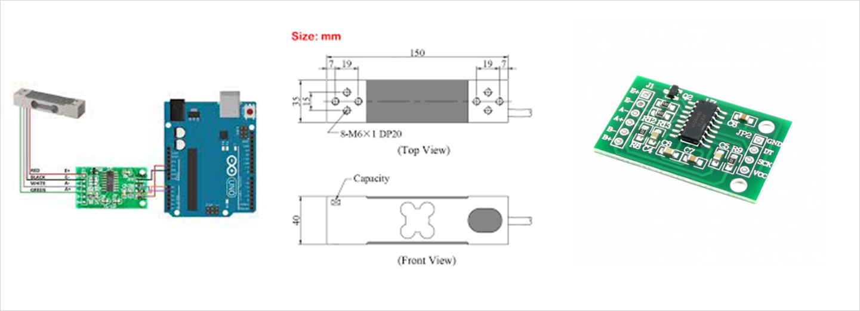

A load cell is a transducer that converts an applied force (usually weight) into an electrical signal. When using a load cell with an Arduino Uno, you need to interface with it through a specialized load cell amplifier, such as the HX711, which converts the small analog signals from the load cell into digital data that the Arduino can read. Here's how the load cell in an Arduino Uno setup works:

**Load Cell Connection:**

Connect the wires from the load cell to the HX711 load cell amplifier. A typical load cell has four wires: red (power), black (ground), white (signal+), and green (signal-). Connect the red wire to E+ on the HX711, black to E-, white to A-, and green to A+.

**HX711 Amplifier Connection:**

* Connect the HX711 to the Arduino Uno:
* VCC on the HX711 to 5V on the Arduino Uno for power.
* GND on the HX711 to GND on the Arduino Uno for ground.
* DT (Data) on the HX711 to a digital pin on the Arduino Uno (e.g., D2).
* SCK (Clock) on the HX711 to another digital pin on the Arduino Uno (e.g., D3).

**HX711 Library:**

You will need to use a library like the "HX711" library for Arduino, which simplifies communication with the HX711 load cell amplifier. Make sure you have the library installed in your Arduino IDE.

**Arduino Code:**

Write an Arduino program (in C/C++) to interface with the HX711. You can use the code I provided in the previous response as a starting point.

**Reading Weight:**

The HX711 library provides functions to read the weight value from the load cell. The primary function is get_units(). You can call this function to get the weight measurement in the units you desire (grams, kilograms, pounds, etc.). The library also allows for taring, calibration, and filtering options.

**Calibration (Optional):**

To ensure accurate measurements, you may need to calibrate your setup. This involves determining a calibration factor by measuring known weights. The calibration factor is then used to convert the raw data from the load cell into accurate weight measurements.

**Data Processing:**

You can process and use the weight measurements in your Arduino code as needed, such as displaying the weight on an LCD, sending it to a computer, or triggering actions based on weight thresholds.

**Serial Communication:**

For debugging and monitoring, you can use the Arduino's serial communication to print the measured weight to the Serial Monitor in the Arduino IDE.

Remember that the exact wiring and code may vary depending on the specific load cell and amplifier you are using, so always refer to the datasheets and documentation provided by the manufacturer of your load cell and amplifier for precise instructions.

**DIGITAL BLOOD PRESURE MONITOR:**

A digital blood pressure monitor will not be as accurate if your body is moving when you are using it. Also, an irregular heart rate will make the reading less accurate. However, digital monitors are the best choice for most people.

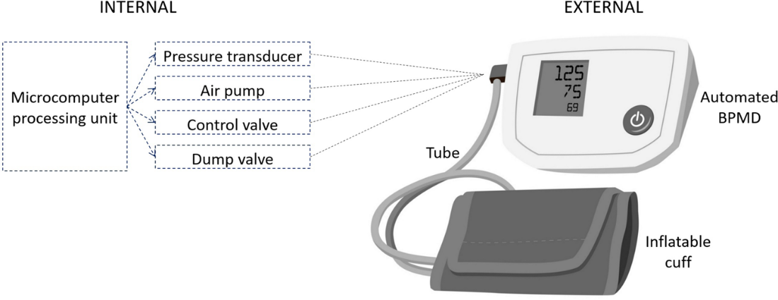

A software application or platform that utilizes artificial intelligence (AI) and machine learning techniques to analyze medical and demographic data of individuals and predict the likelihood of them developing diabetes in the future. This system provides early risk assessment and personalized preventive measures to help individuals manage and reduce their risk of diabetes. Using for basic embedded systems in Arduino uno board simple implementation of input information getting device.

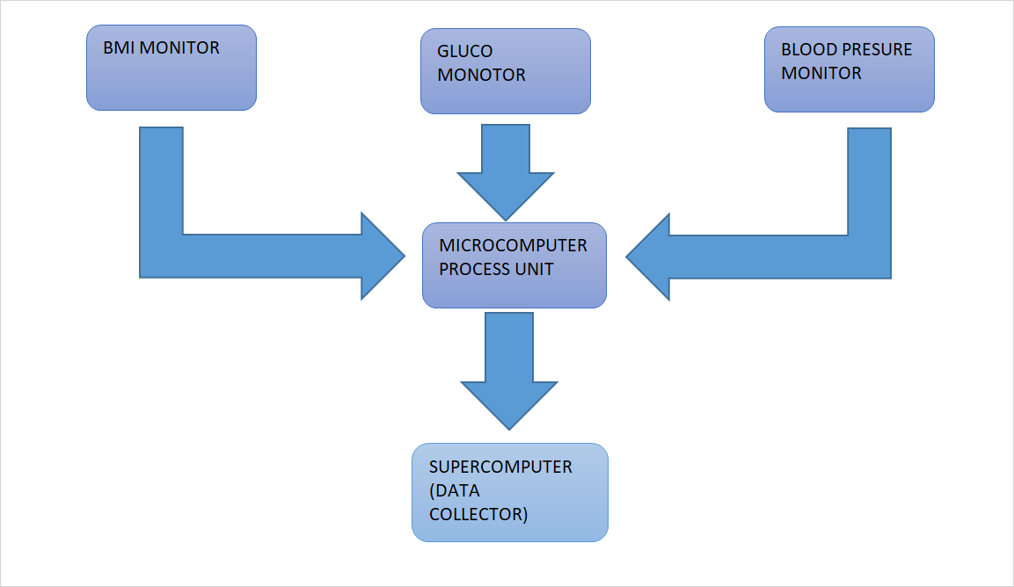

**DATA ANALYSIS:**

Handle missing data: Impute missing values using techniques like mean, median, or more advanced imputation methods.

Outlier detection and treatment: Identify and address outliers that might distort the model's performance.

Encoding categorical variables: Convert categorical data (e.g., gender) into numerical format , one-hot encoding).

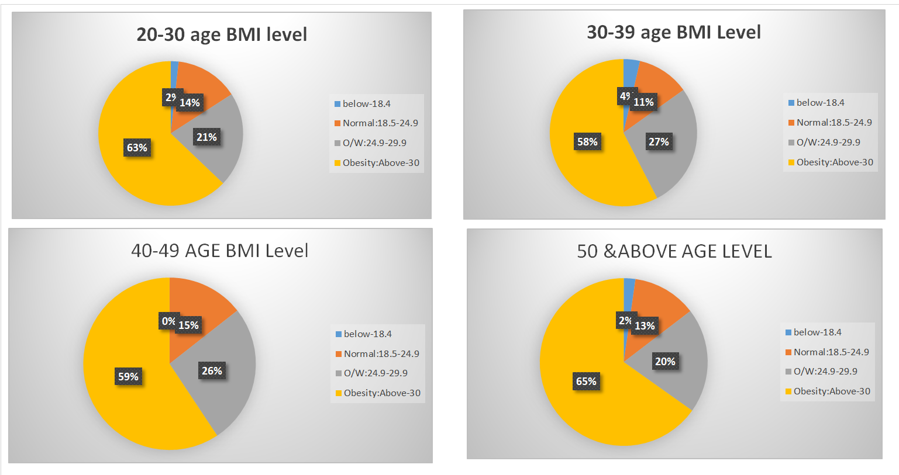

**Model Selection:**

    Choose machine learning algorithms suitable for classification tasks. Common choices for binary classification (diabetes vs. non-diabetes) include:

   Using:

1. machine learning algorithms.
2. EMBEDDED C-LANGUAGE PROGRAM

**Model :**

model is implement on low level languages, medium level languages and High level machine learning languages. There use for data structure , syntaxes and iteration loops.

**SYSTEM THINKING:**

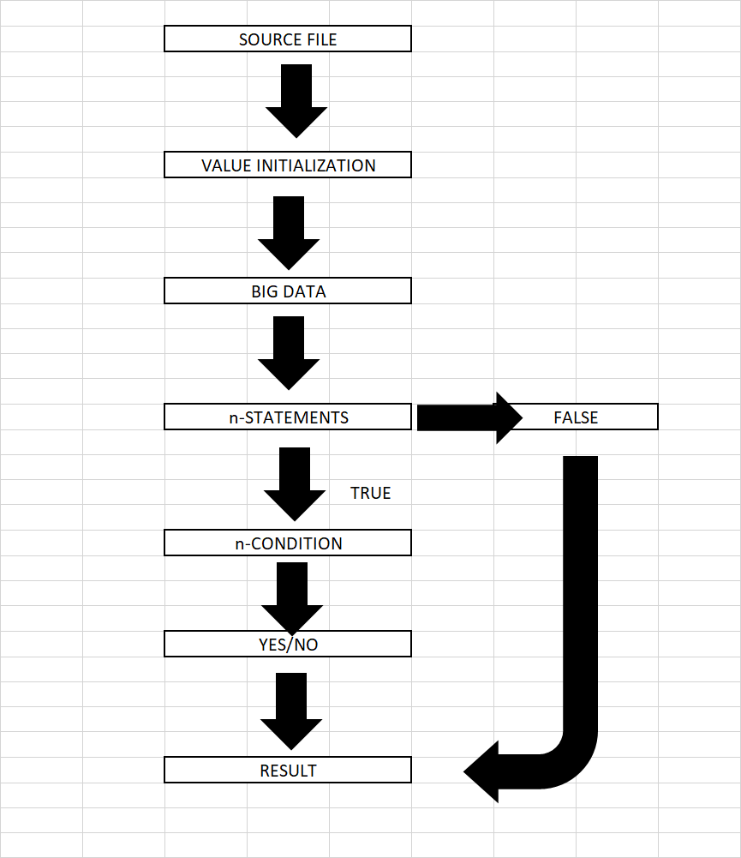

**Data Splitting:**

 Split your dataset into training, validation, and test sets. A common split is 70% for training, 15% for validation, and 15% for testing.

**Data splitting criteria:**

1. Age :21-above50
2. BMI level :0-70.0Kg/M^2
3. Glucose level :0-200mg/dL
4. Blood pressure level :0-122 mm/Hg

**MODEL TRAINING:**

Upon inputting a patient's relevant health information, the system employs its predictive model to estimate the likelihood of diabetes development. It can provide risk scores, probability assessments, and even classify patients into different risk categories. Additionally, the system offers valuable recommendations for lifestyle modifications, regular monitoring, and further diagnostic tests based on the individual's risk assessment.

The AI-Based Diabetes Prediction System is a valuable tool for healthcare providers, enabling them to identify high-risk individuals and allocate resources more efficiently for preventive care and education. For patients, it serves as an early warning system that encourages proactive health management and lifestyle changes to prevent or manage diabetes.

**OUTPUT PREDICTION:**

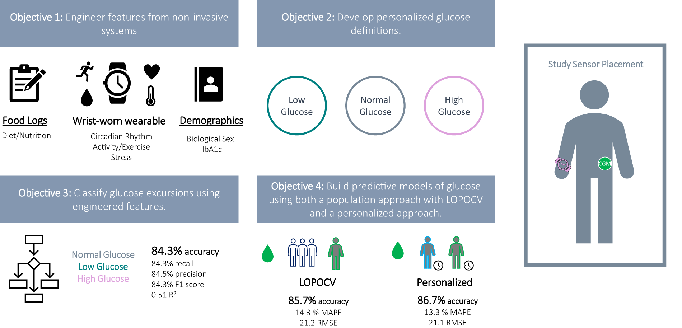

The output is depending of the analyzing information and getting data . More data is for heath conditions and health issues Gather a comprehensive dataset that includes medical and demographic information of individuals, such as age, gender, BMI (Body Mass Index), blood pressure, glucose levels, pregnancy, Skin thinkness,Insuline level and other relevant features.Collect split up the data for age wise and BMI (Body Mass Index)level in asper dataset.

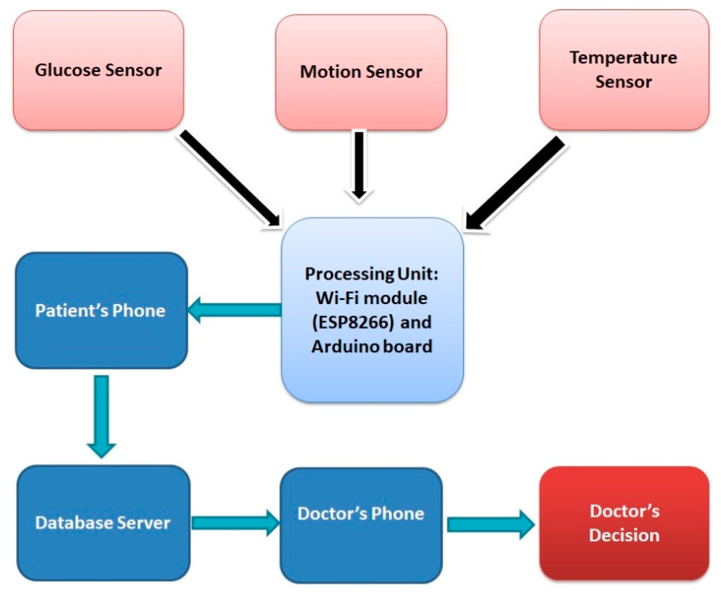

**Advantages:**

* Early Detection
* Data-Driven Accuracy
* Continuous Monitoring
* Personalized Medicine
* Reduced Healthcare Costs
* Health Education

**Disadvantages:**

* Data Privacy Concerns
* Accuracy Dependence
* False Positives and Negatives
* Cost of Implementation
* Interpretability

**Limitations:**

* Dependency on Data:
* Static Models:
* Socioeconomic Factors
* Legal and Ethical Challenges
* Lack of Medical Expertise
* Generalization

**CONCLUSION:**

In conclusion, this AI-based system is a significant advancement in diabetes care, promoting early detection and prevention, ultimately improving patient outcomes and reducing the burden of this chronic disease on healthcare systems and society as a whole.