## AI Based Diabetes Prediction System

*a software application or platform that utilizes artificial intelligence (AI) and machine learning techniques to analyze medical and demographic data of individuals and predict the likelihood of them developing diabetes in the future. This system provides early risk assessment and personalized preventive measures to help individuals manage and reduce their risk of diabetes* 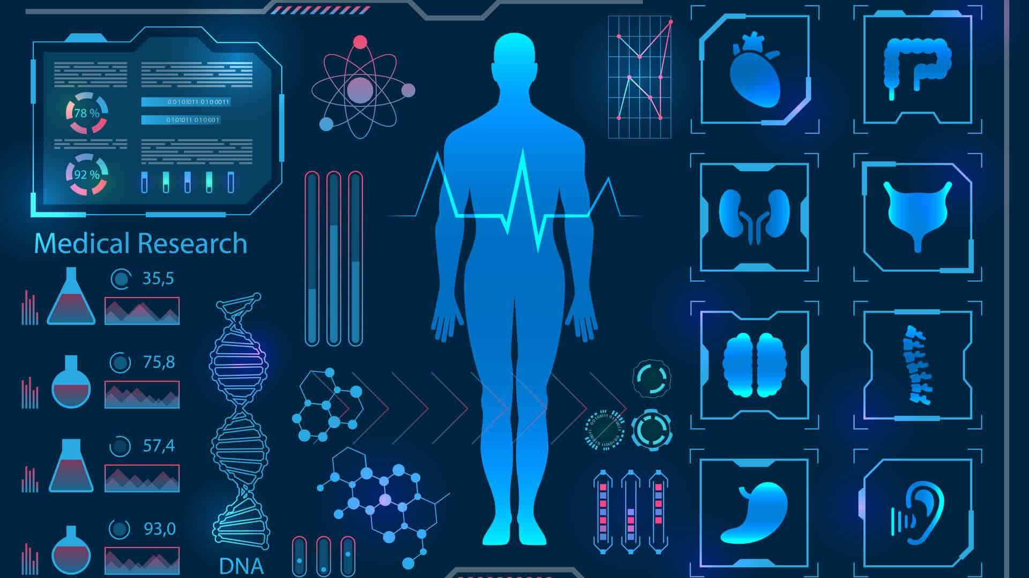

**Design Thinking:**

The short form of the design thinking process can be articulated in five steps or phases: empathize, define, ideate, prototype and test. Let's briefly explore each of these phases in relation to a practical design process.

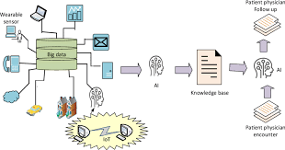

**Data Collection:**

* Gather a comprehensive dataset that includes medical and demographic information of individuals, such as age, gender, family history, BMI (Body Mass Index), blood pressure, glucose levels, and other relevant features.
* Ensure that the dataset is large enough and representative of the target population.

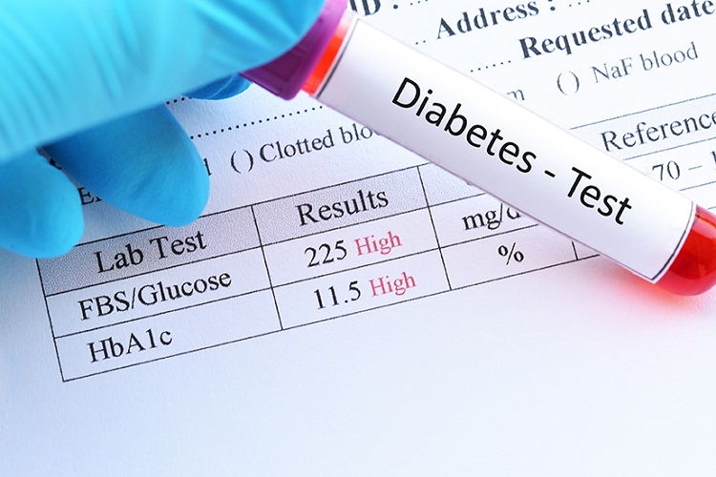

****Data Preprocessing**:**

* + Handle missing data: Impute missing values using techniques like mean, median, or more advanced imputation methods.
  + Outlier detection and treatment: Identify and address outliers that might distort the model's performance.
  + Encoding categorical variables: Convert categorical data (e.g., gender) into numerical format , one-hot encoding)

****Feature Engineering****:

* + Select relevant features: Analyze the importance of each feature and remove irrelevant ones.
  + Create new features if necessary: For example, you could create a feature that calculates insulin resistance based on glucose and BMI.

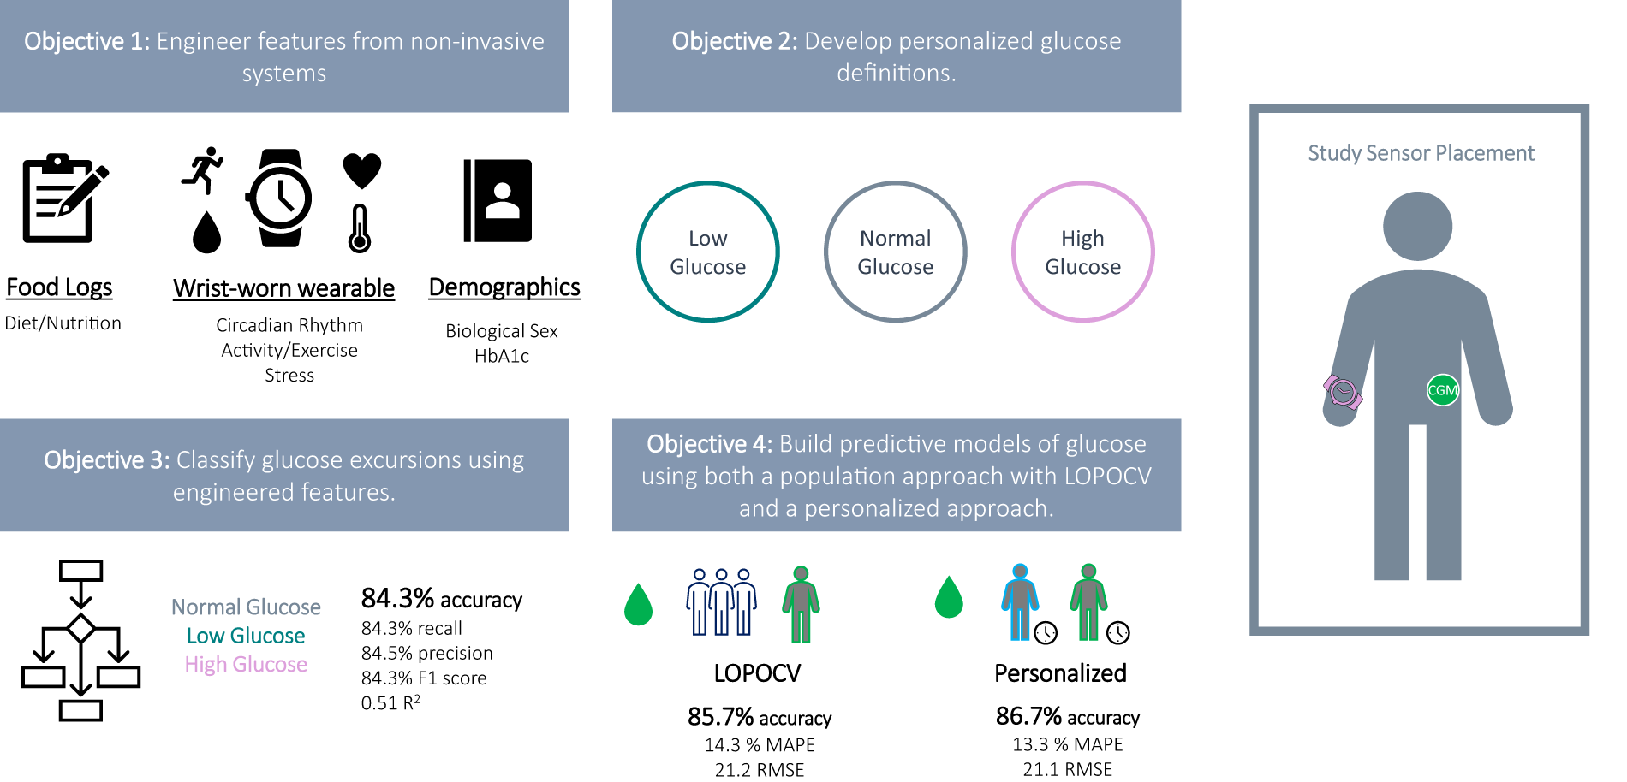

****Model Selection****:

* + Choose machine learning algorithms suitable for classification tasks. Common choices for binary classification (diabetes vs. non-diabetes) include:
  + Using:machine learning algorithms

****Data Splitting****:

* + Split your dataset into training, validation, and test sets. A common split is 70% for training, 15% for validation, and 15% for testing.

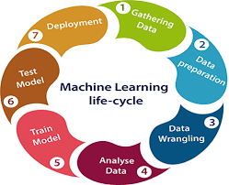

****Model Training****:

* + Train the selected machine learning model(s) using the training dataset.
  + Tune hyperparameters using cross-validation on the validation set to optimize the model's performance.

****Model Evaluation****:

* + Evaluate the trained model(s) using the test dataset to assess their predictive performance.
  + Common evaluation metrics for binary classification include accuracy.

****Monitoring and Maintenance:****

Continuously monitor the model's performance in the real-world setting and update it as necessary.

****Personalized Recommendations****:

1. Use the model's predictions to provide personalized preventive measures and recommendations to individuals at risk.
2. These recommendations may include lifestyle changes, dietary advice, exercise plans, and regular medical check-ups.

