**Optimisation of Bed Turnaround Process in a Hospital using Resource Visualisation**

**(Lakshmi Sivaram, Padmanabhan Rajendran)**

• Step 1: **Motivation**

Why are you doing this project?

For many hospitals, availability of beds in a unit is a key measure to maximise patient care and effective cost management. One of the reasons for the lack of availability of beds is the ineffective use of resources like Cleaners and Porters during the bed turnaround process.

Our aim of this project is to optimise the process involved in the Bed turnaround time through visualization of resources in an efficient way. Also, to lookout for any trends in the dataset with regards to patient discharges and admissions that might influence the bed turnaround time.

• Step 2: **Data**

What data will you need? What data do you think you have?

* Patient Discharge log of a unit – (Discharge date-time) [some data metrics obtained]
* Patient Transfers dataset – (transfer datetime, unit) [Simulate data]
* Bed Status in each unit [Simulate data]
* Cleaner info, Porter info [Simulate data]
* Hospital layout [awaiting input]

What are the important pieces of information you’ll be using?

* Patient Admission details to see the pattern over a period and compare with Discharges.
* Wait-times (if available) to correlate with the Bed-turnaround time

• Step 3: **Patterns/Interactions**

What patterns will be relevant for analysts? What interactions are you considering?

* Availability of bed status (Clean, Occupied, Dirty)
* Availability of Cleaner/Porter info
* Potential discharges/ transfers in a day
* Total admissions statistics (to see the trend in the weekday - - any peaks during weekend? Friday?)

• Step 4: **Time-frame**

Scoping the project

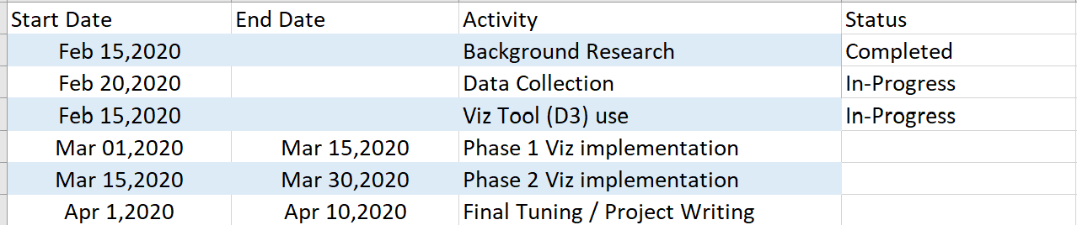

We are trying to visualize the bed status in each unit so that as soon as a discharge occurs it gets indicated in the visuals where both the unit clerk and Access coordinator can see at the same time , minimizing the time to call Access co-coordinator.