This is the scree sort

This is the screen sort for the backend

Screen 1: For Invalid User Details

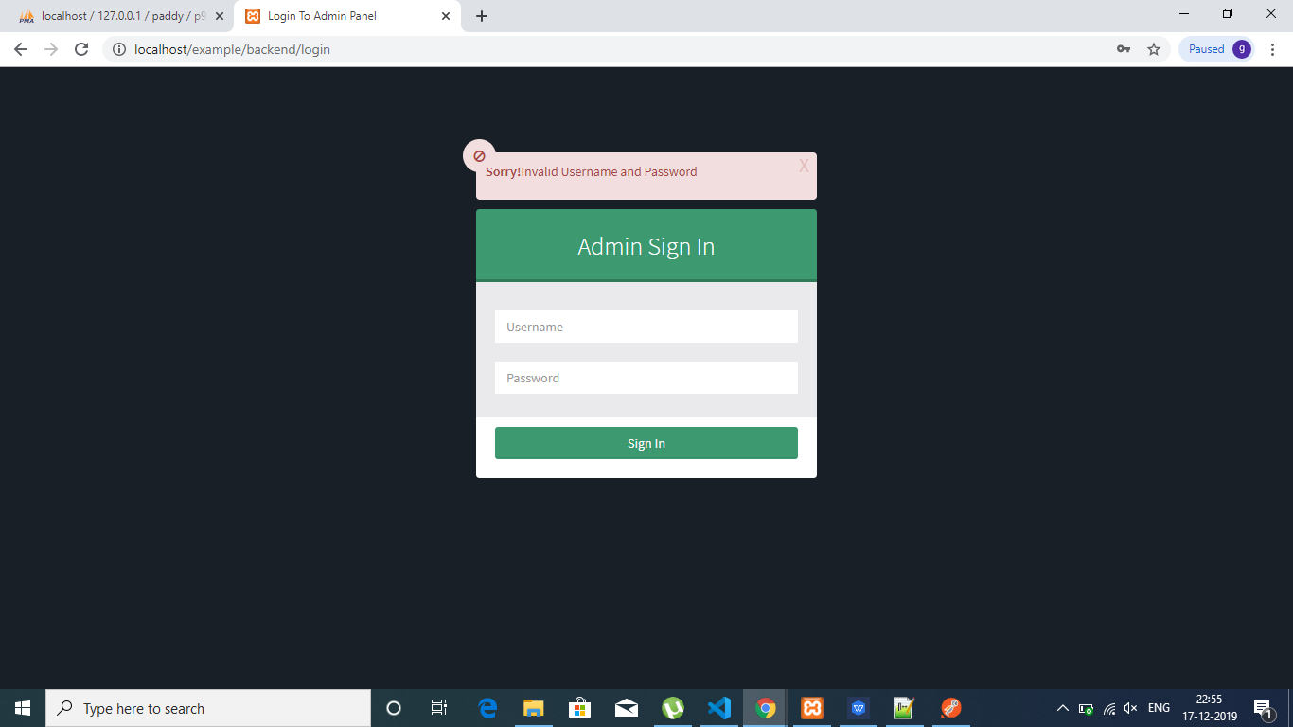

Screen2:Validation for Login Page

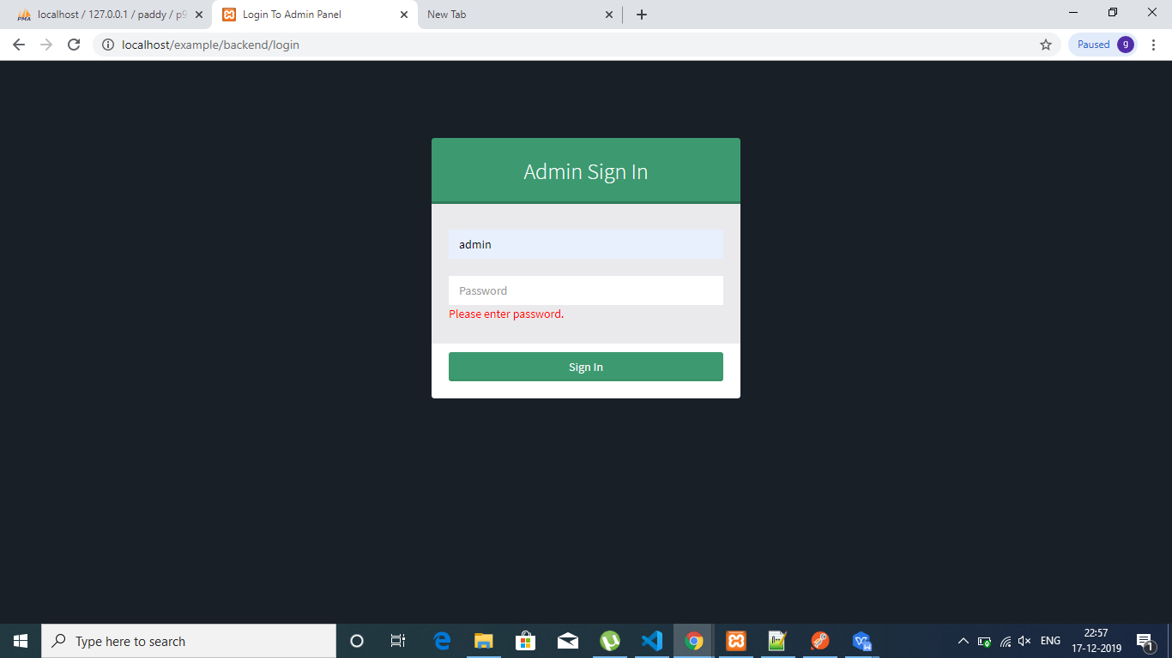

Screen 3: Listing of All User

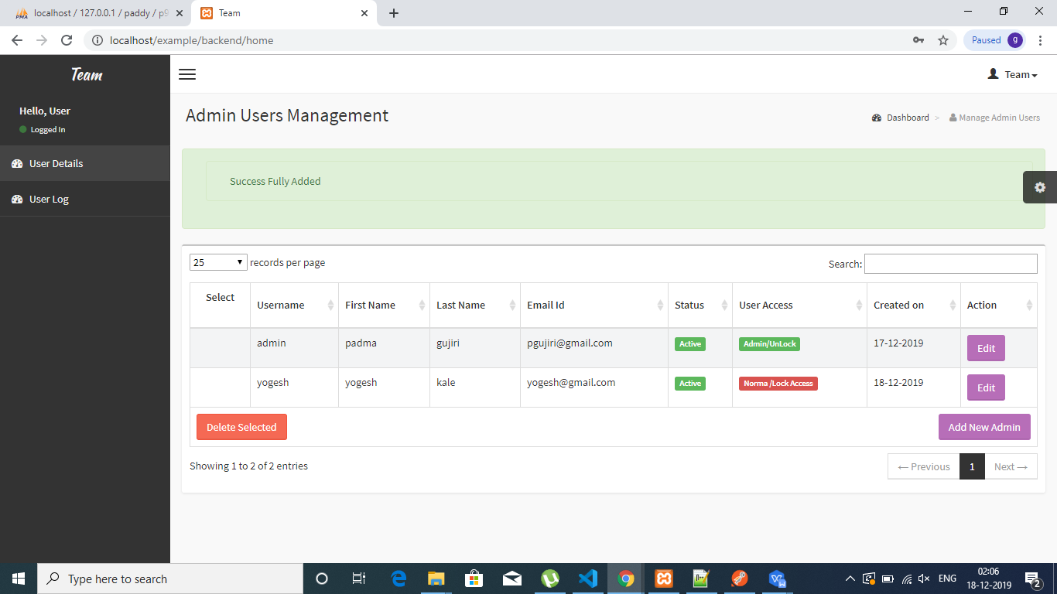

Screen 4: Normal Use Block the add,edit,delete button

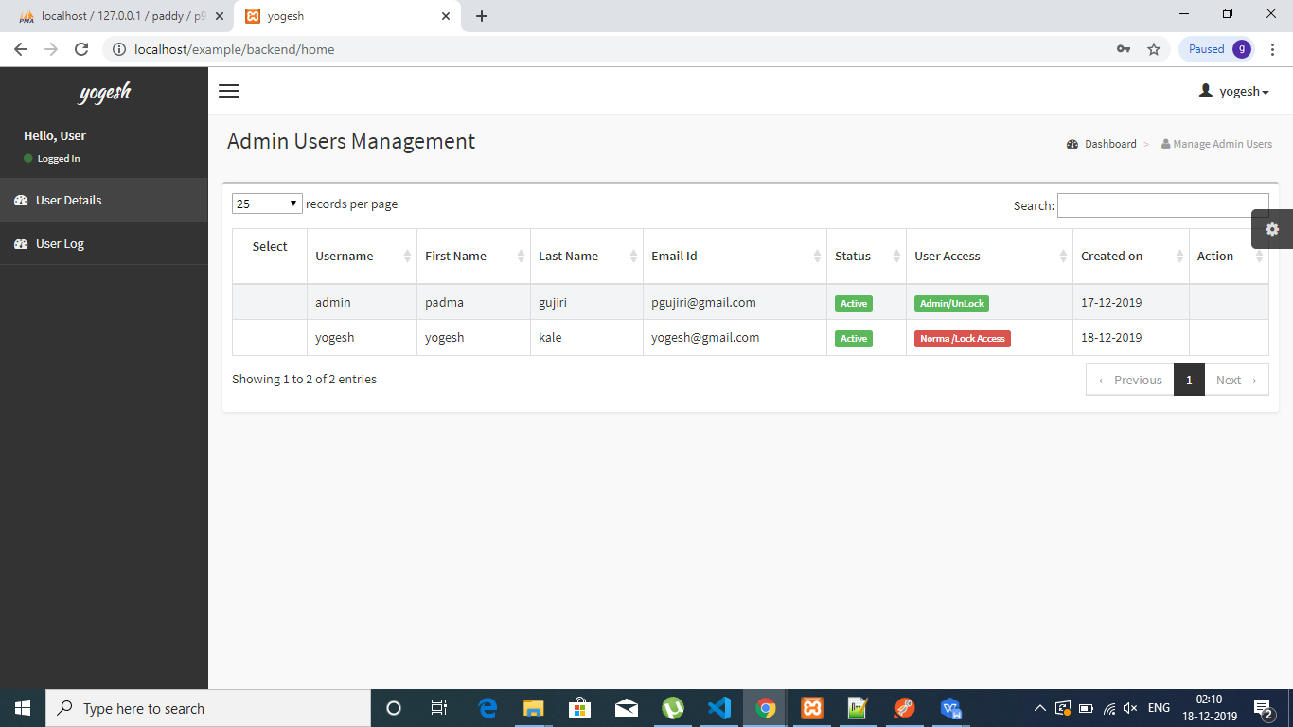

Screen:5 Update User Details

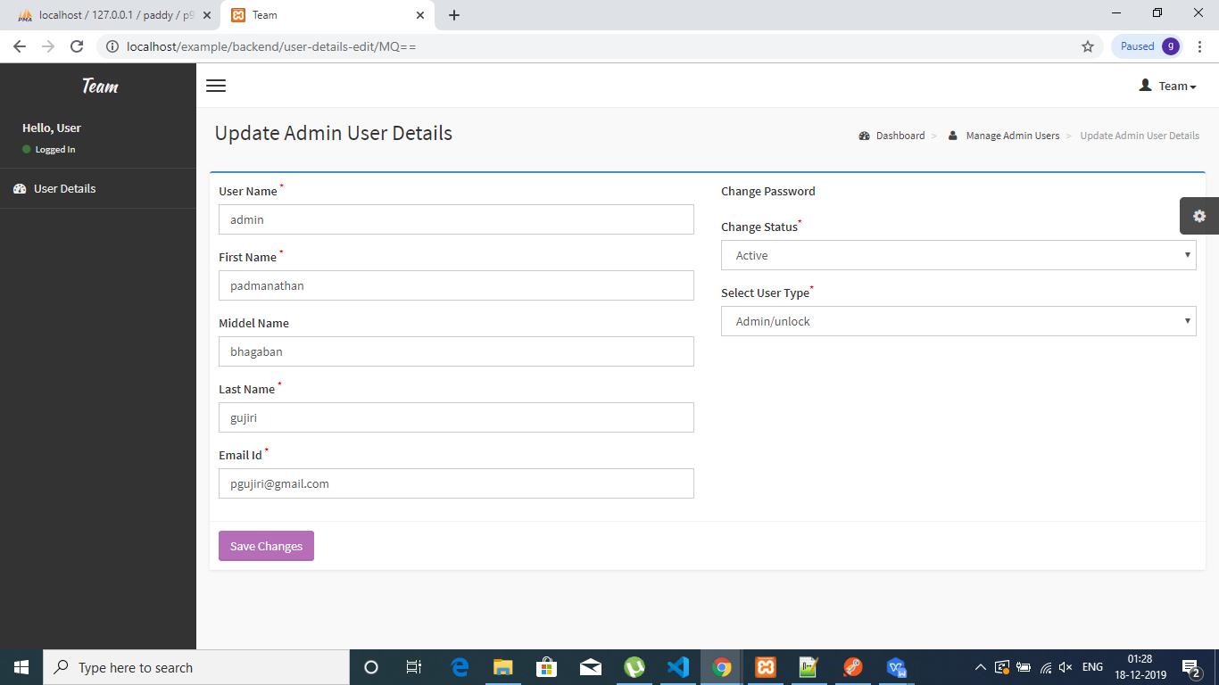

Screen 6:User Form Validation

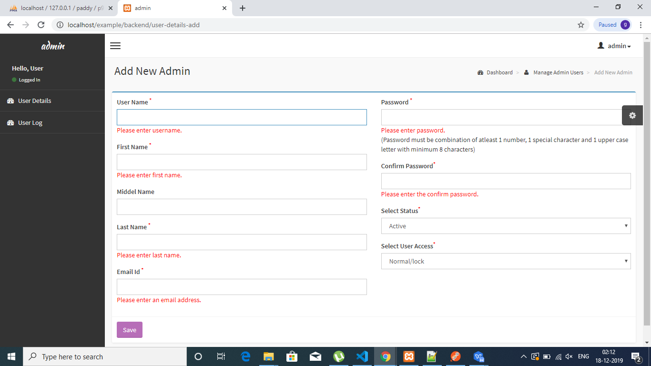

Screen 7 :Show Log user details

