**Automation Test Task**

Software Specification: Java, Selenium, Test NG, Maven, Apache POI, JFairy, Log 4j

Project Structure

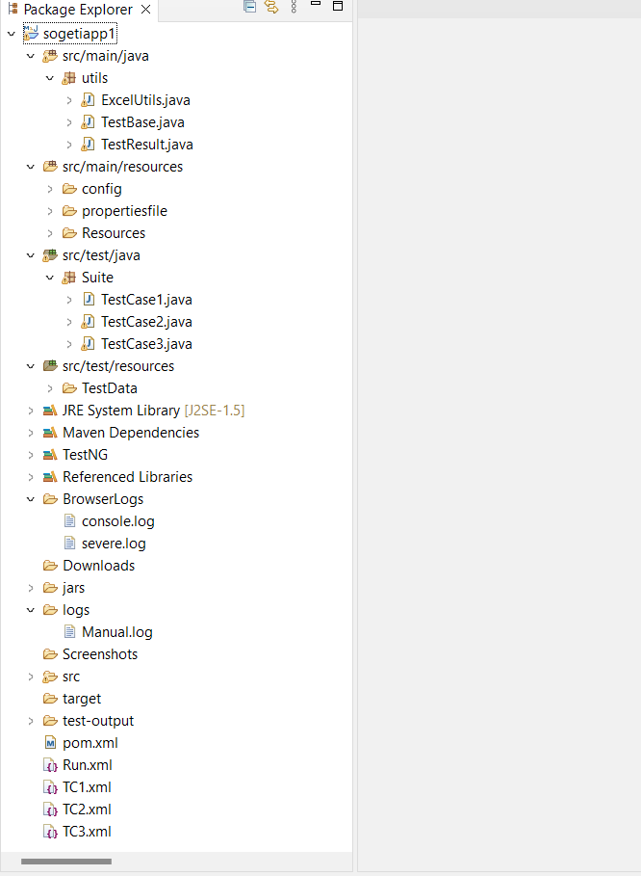

src/main/java – has common functions, read and write excel and function to get result.

→ ExcelUtils.java

→ TestBase.java

→ TestResult.java

src/main/resources – has properties file and config file and resources used in project.

→ config folder – config.properties → url is configured

→ properties folder – Log 4j and Object Repository properties file

→ Resources folder – chromedriver.exe

src/test/java → has the test cases

Task1

-------

TestCase1.java

Hover over Services Link (see Image below) and then Click **Automation** link.

Verify that **Automation** link is displayed, and **Automation** text is visible in Page.

Hover again over Services Link. Verify that the **Services** and **Automation** are selected (see selected).

TestCase2.java

→ Get all randomly generated data through JFairy

→ Fill all the data's in Fields

→ Workaround to handle Captcha in Selenium:

1. By disabling the Captcha in the testing environment

2. By adding a delay to the Webdriver and manually solve Captcha while testing

3. Use API of external services such as http://www.deathbycaptcha.com for text Image

→ Submit the Form

→ Verify the Message.

TestCase3.java

→ After clicking **Worldwide,** Assert that all the Country specific Sogeti links are working.

src/test/resources

Test Data Folder

resultstatus.xlxs → Write result status of each test cases

testdata.xlxs → Data's read from this sheet

BrowerLogs Folder → Holds all console logs

Screenshots Folder → Holds failed test cases screenshots

Downloads Folder → Holds the document downloaded

logs folder → Manually entered application logs are written.

Pom-xml → contains info about the project configuration details used by Maven to build the project.

Test-output Folder → Holds Report of executed test cases.

→ TC1.xml → Xml file for TestCase1.java

→ TC2.xml → Xml file for TestCase2.java

→ TC3.xml → Xml file for TestCase3.java

Run.xml → Combines all xml file in single suite.