1. pwd -->To display the present working directory path.

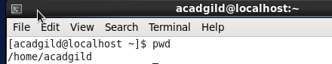

1. vi --> vi filename 🡪 To create a file using Vi Editor.

If the file named filename exists, then the first page (or screen) of the file will be displayed; if the file does not exist, then an empty file and screen are created into which we enter text and save.

1. 
2. Write the contents in the file & save and Quit using Shift ZZ

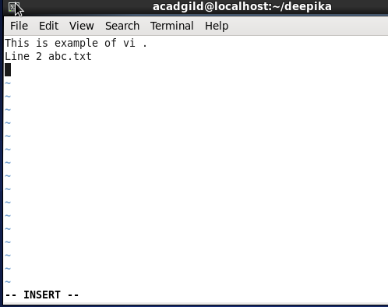

iii)Check if the contents are saved

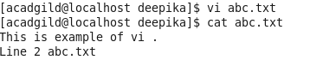

1. Touch 🡪 touch file1.txt --> To create new file named file1

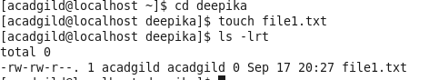

1. mkdir 🡪 To create new directory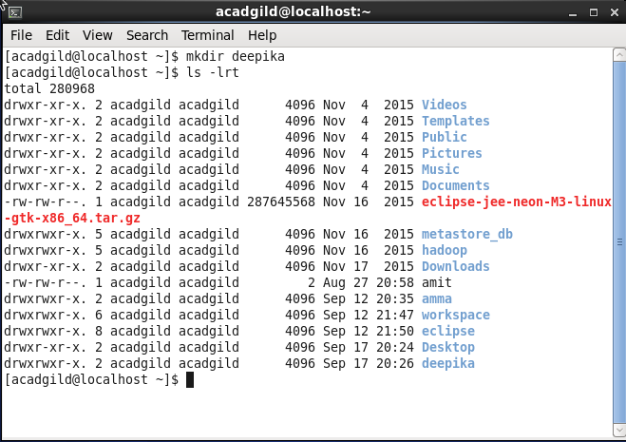
2. rm 🡪 rm file1.txt 🡪 to remove file1.txt from the directory

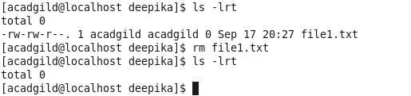

1. ls 🡪 To listing the contents of the directory. Within amma directory 3 .txt files are present.



1. echo -->. To display a line of text.



1. cat 🡪 cat > filename to create a new file with the given filename

cat filename 🡪 To display the contents of the specific file.

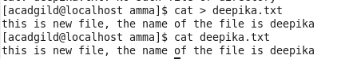

1. who --> To retrieve the information on currently logged in users
2. cd 🡪 To navigate into a directory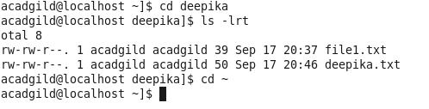
3. date --> To display the current time in the given FORMAT, or set the system date.
4. cal --> To Display a conveniently-formatted calendar from the command line.

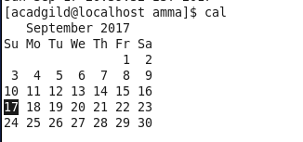

1. mv -->mv srcfilename /directory/subdirectory/ 🡪 To move a file from one directory to another 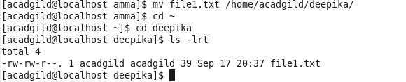
2. cp --> cp srcfilename /directory/subdirectory/ To copy a file into another directory:

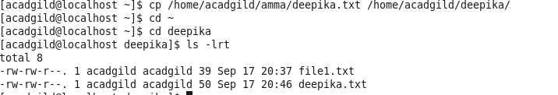

1. which --> To display the path of the given executable file

