Task 1: Creating a directory called hadoop in hdfs

1. Checking is /user/acadgild exists in HDFS
2. Creating a directory /user/acadgild/hadoop/ in HDFS using -mkdir

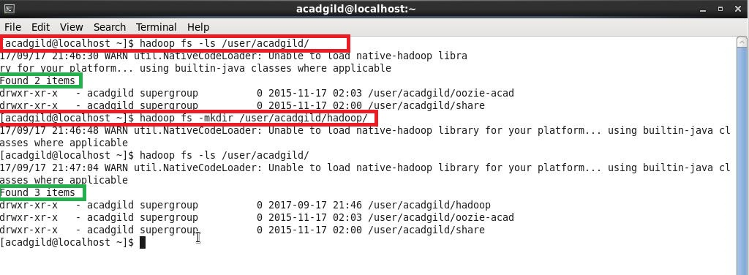

Task 2: creating a file word_count.txt in HDFS (appending some text in the file)

1. Creating a file word_count.txt in HDFS /user/acadgild/hadoop/ using touchz command.
2. Inserting some lines in the file using echo “ Lines to append” using –appendToFile command
3. Displaying the content of /user/acadgild/hadoop/word_count.txt
4. Inserting few more lines to the word_count.txt
5. Displaying the contents of /user/acadgild/hadoop/word_count.txt ( we can see HDFS maintained the order of insertion).

