**Task 3**

1. Creating a file in the local FS with name max-temp.txt
2. Move the file into /user/acadgild/hadoop/

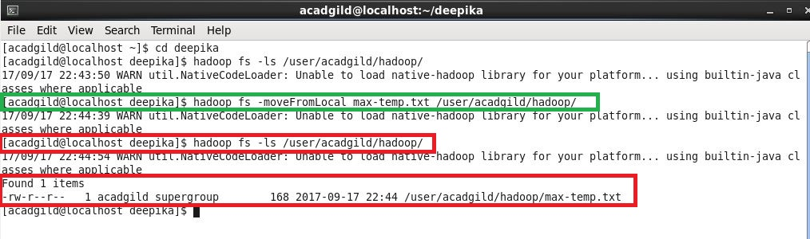

**Task 4**

1. Changed the file permission for max-temp.txt in hdfs such that only user and usergroup has full permission and others have no permission.

