**Version Control:**

Version control allows you to keep track of your work and helps you to easily explore the changes you have made, be it data, coding scripts, notes, etc.

Some of the version control tools are GIT, SVN, Mercurial  etc..

**Difference between svn and git:**

|  |  |
| --- | --- |
| Git has a Distributed Model. | SVN has a Centralized Model. |
| In git every user has their own copy of code on their local like their own branch. | In SVN there is central repository has working copy that also make changes and committed in central repository. |
| In git we do not required any Network to perform git operation. | In SVN we required Network for runs the SVN operation. |

**GIT Structure**



Some of the GIT services providers are GITHUB, Bitbucket, GITLAB etc.

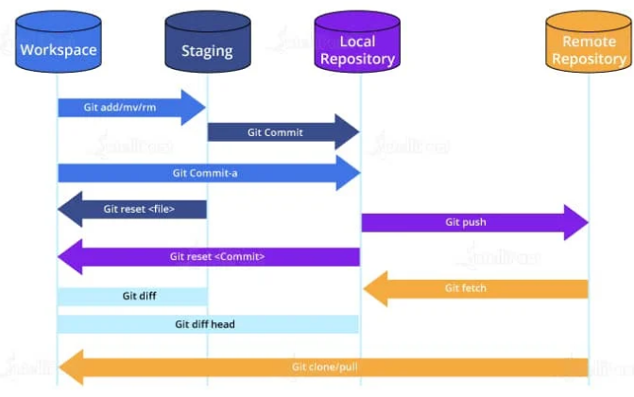

Git Commands When Working with Remote Repositories

1. git remote: This Git command allows you to connect a remote repository to a local repository.
2. git clone: You can use the clone command to create a local copy of an already existing remote repository. This allows you to copy and download the required repository to the system. It is similar to the init command while working with remote repositories as it allows you to build a local directory, consisting of all the necessary files and history of the repository.
3. git pull: The pull command is used to run the latest version of any repository. This pulls all the changes made from the remote to the local repository.
4. git push: This command sends local commits to the respective remote repository. It needs two parameters, i.e., the remote repository and the specific branch where it needs to be pushed.

Your Local repository is made up of three layers:

The three layers are:

* **Working directory**: This is created when a Git project is initialized onto your local machine and allows you to edit the source code copied.
* **Staging area**: Post the edits, the code is staged in the staging area by applying the command, git add. This displays a preview for the next stage. In case further modifications are made in the working directory, the snapshots for these two layers will be different. However, these can be synced by using the same ‘git add’ command.
* **Local repository**: If no further edits are required to be done, then you can go ahead and apply the git commit command. This replicates the latest snapshots in all three stages, making them in sync with each other.