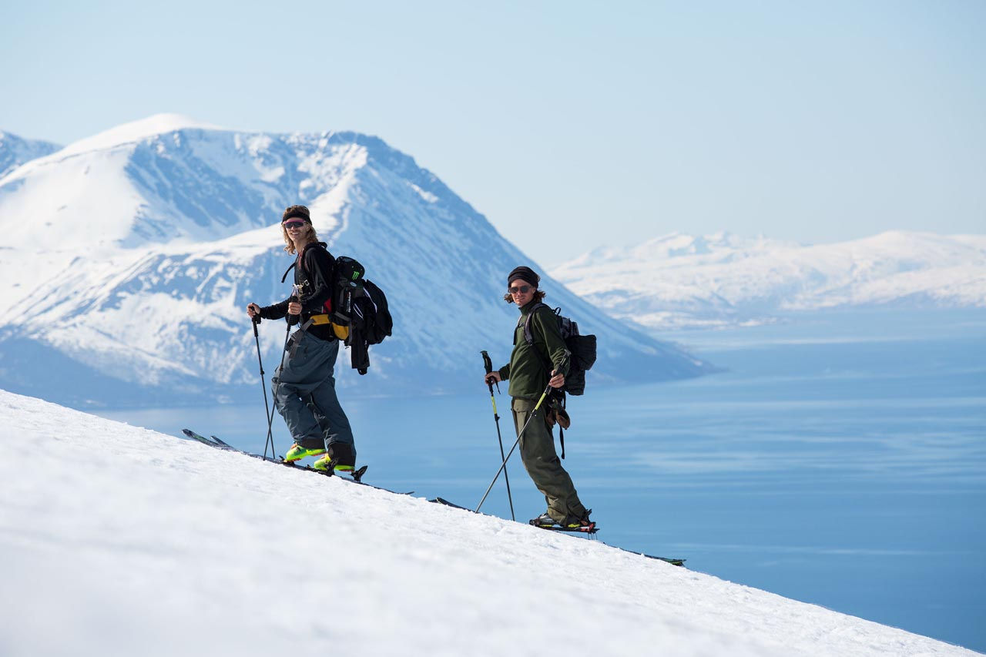

# Ski Touring

#### By Sofia Sjöberg

### Ski Touring

My backpack feels heavier for every meter, slowly deforming my spine and wearing down my shoulders. My mouth tastes like blood, while salty pearls of sweat find their way to my eyes. I look back up, I’m not there yet, just a few hundred more steps, keep walking, keep counting, block out the pain. On shaking legs, I reach the summit and I’m immediately humbled by the uninterrupted panorama before me. Before I know it, serotonin receptors are firing, emotions bursting out from the deep, reigniting me with vigor from within. Below my feet is a mountain face stretching out for a thousand meters covered by a smooth blanket of powder, with the evening sun replicated thousand-fold in the uncountable snow crystals. Making high-speed turns down the run, I no longer feel any pain. My mind is as clear as it ever has been, unadulterated joy spreading through my nervous system, and the minutes seem like hours. Back at the bottom, I start counting the hours until I get to do it again.

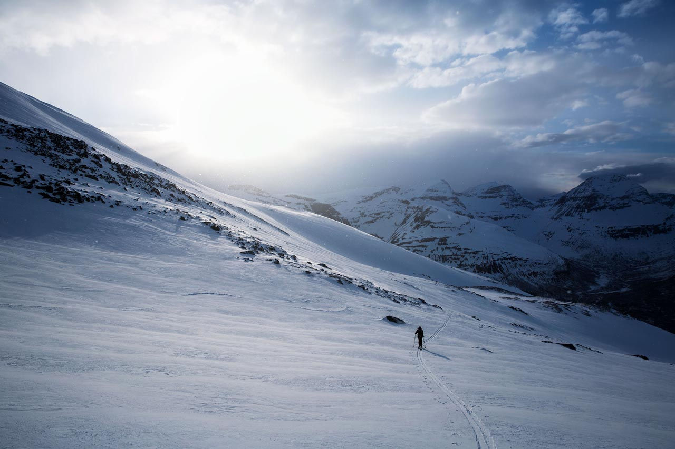

"...a mountain face stretching out for a thousand meters covered by a smooth blanket of powder, with the evening sun replicated thousand-fold in the uncountable snow crystals"

- Sofia Sjöberg

The pastime us earthlings refer to as “skiing”, must seem peculiar, if not laughable if observed by an extraterrestrial species. We give hard-earned money to amusement park-like mountain resorts, where intricate cable systems transport us to the top, allowing us to slide down snow in near friction-less conditions on wooden planks strapped to our feet, only to start over, again and again and again. Like hairless apes, freed by technology from the natural dangers of living, we race down miles of groomed trails, carving our signatures in the glistening snow with sharp metal edges. When our legs give up and food money runs out, we get back in our cars and migrate back to our urban hives and desk jobs, our bodies for the moment reignited by signal substances we no longer have use for in modern civilization, but still so eagerly seek.

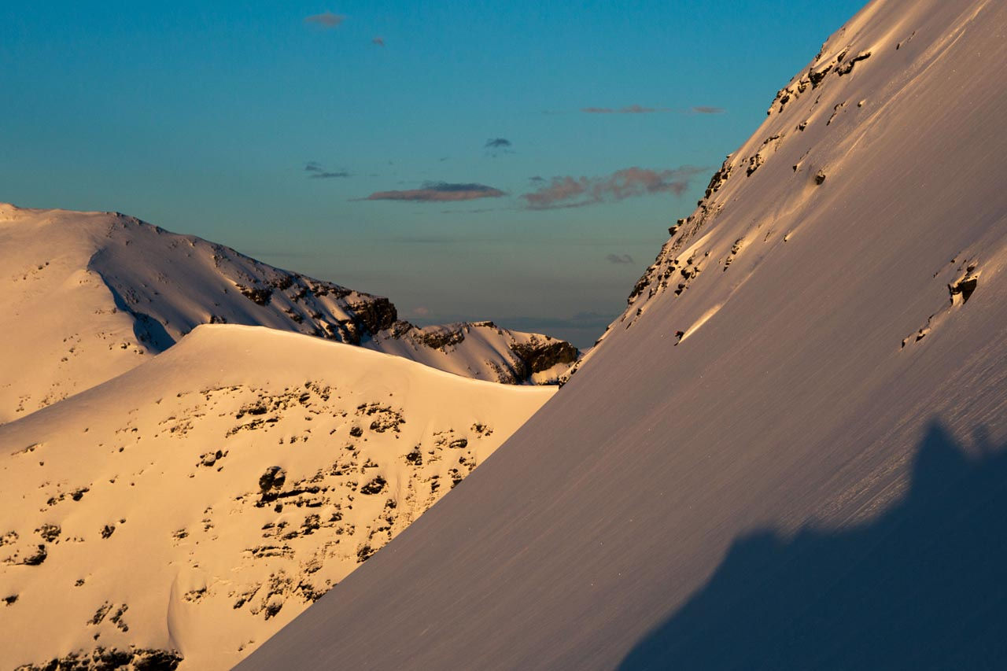

However, this is a very modern interpretation of skiing. Long before the first p-tex base or metal edge was ever conceived of, and before anyone ever got the idea of hauling people up a mountain on a cable for payment, crafty Scandinavians began strapping their feet to wooden planks, allowing them a more efficient means of transportation through deep snow. Over time, steady improvement of gear and technique evolved this new phenomenon into a practical way of hunting, gathering, and communicating, as our animal-hide clad ancestors unknowingly invented what we today call ski-touring.

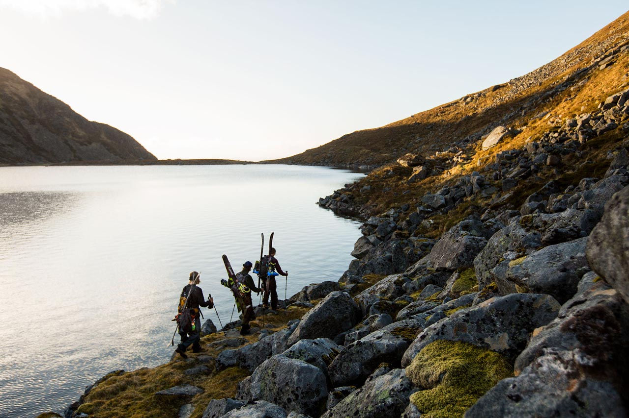

Fast forward 5000 years, and although human ingenuity, competition and spirit for invention has further evolved this once crude way of transportation, the principles remain the same. We designed our now countless different models of wooden planks to float on top of powder snow, crafted metal edges to cut through ice, we shaved off every superfluous gram we could find to help us on our journeys, to reach farther, higher and steeper. And today, when in many places, multi-billion dollar corporations charge us big money to ride down over-crowded slopes, many of us are returning to the original way of skiing. Exchanging lift queues for solitude, quantity for quality, and apres-ski beer for trail mix, a new generation of skiers are rediscovering the virtue of earning one’s turns, the silence of the mountains, and how far into the unknown a little off-season cardio training can get you.

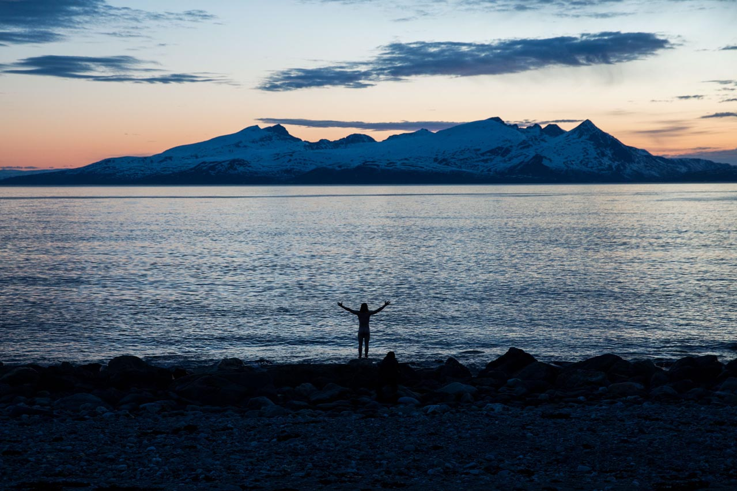

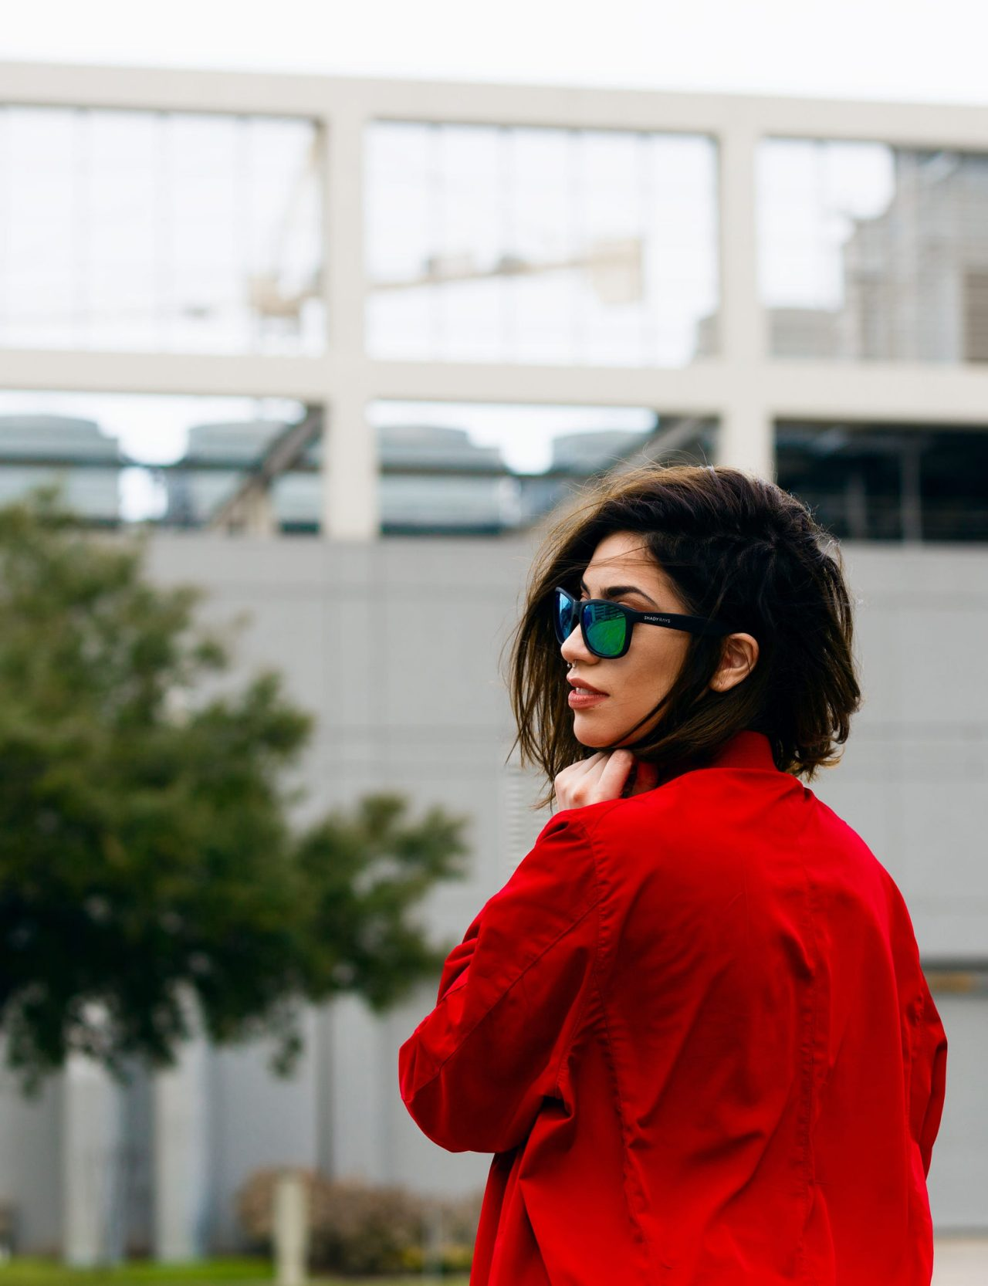

## Sofia Sjöberg

Photographer, Skiier, Youtuber

Facebook

Twitter

Instagram

##### SHARE THIS STORY

* [Ultimate Guide to LA Skateparks Wednesday, 30 Sep 2020](/us/en/magazine/guide-la-skateparks.html)
* [Ski Touring Wednesday, 30 Sep 2020](/us/en/magazine/ski-touring.html)
* [Western Australia Thursday, 9 Jul 2020](/us/en/magazine/western-australia.html)
* [San Diego Surf Spots Thursday, 9 Jul 2020](/us/en/magazine/san-diego-surf.html)

| Metadata | |
| --- | --- |
| Title | Ski Touring |
| Description | Learn about our ski touring experience and how it differs from traditional downhill skiing and even backcountry skiing. |