Table of Contents

- Abstract
- Objective
- Dataset Summary
- Tools & Technologies Used
- Steps Followed
- Data Cleaning
- Feature Engineering
- Model Building
- Customer Segmentation
- Visualization & Output
- Pie Chart: Segment Distribution
- Column Line Chart: Trend Over Time
- Line Chart: Monthly Trend of Customer Segments Over Time
- Summary of Results
- Insights
- Conclusion
- Appendix
- Coding
- Charts

ABSTRACT
His project focuses on predicting Customer Lifetime Value (CLV) using historical customer data, including demographic and behavioral features. CLV is a key business metric that estimates the total revenue a customer is expected to generate during their relationship with a company. By leveraging machine learning techniques—specifically, a Random Forest Regressor—we used features such as purchase frequency, recency, total spend, and average purchase value to build an accurate prediction model.
The predicted CLV values were used to segment customers into Low, Medium, and High-value groups using quantile-based binning (pd.qcut). These segments were then visualized through pie charts, column charts, and trend lines to uncover actionable insights. The results help businesses prioritize high-value customers, re-engage low-value ones, and personalize marketing strategies accordingly.
This data-driven approach enhances customer retention, marketing ROI, and overall profitability, making CLV prediction a powerful tool for customer-centric decision-making.

OBJECTIVE
The objective of this project is to accurately predict Customer Lifetime Value (CLV) using historical customer data and behavioral patterns. CLV represents the total expected revenue a customer will generate over their relationship with a business. By forecasting this value, companies can make more informed decisions about customer acquisition, retention, and personalized marketing strategies.
The model aims to identify key factors that influence CLV, such as purchase frequency, recency, average spend, and customer tenure. Using these features, we train a machine learning model (Random Forest Regressor) to estimate future value.
After prediction, customers are segmented into Low, Medium, and High-value groups. These segments help businesses tailor their efforts—investing more in high-value customers and designing strategies to grow medium-value ones.
Ultimately, the goal is to improve marketing ROI, increase customer loyalty, and enhance overall business profitability by using data-driven insights from CLV prediction.

TOOLS & TECHNOLOGIES USED

Python
Python is the core tool used for data analysis, preprocessing, and model building.
- pandas: Used for loading the dataset, cleaning data, handling missing values, and performing exploratory analysis.
- NumPy: Helpful for numerical operations like calculating averages, totals, etc.
- matplotlib & seaborn: For data visualization like bar plots, histograms, and heatmaps during EDA.
- scikit-learn (sklearn): Used to build and evaluate the machine learning model. It provided tools for:
  - Data splitting (train_test_split)
  - Feature scaling (StandardScaler)
  - Model training (RandomForestRegressor)
Model evaluation (mean_squared_error, r2_score)

Excel
Excel was used for creating a simple dashboard for visualizing customer data and presenting insights.
Charts created in Excel:
- Column chart to show top customers by predicted CLV.
- Pie chart to show customer segment distribution.
- Line chart to show monthly purchase trends or revenue.
Excel helped in creating an easy-to-understand summary for stakeholders.

Machine Learning Model
The model used for CLV prediction was:
- Random Forest Regressor (from sklearn):
  - Works well with non-linear data
  - Handles missing values and outliers better
  - Gives good accuracy with less tuning
This model gave reliable predictions of future customer value based on historical purchase behavior

DATASET SUMMARY
File Name: Customer_Lifetime_Value_Prediction.csv
This dataset contains customer-level data, combining demographic info and
behavioral patterns, to help predict the Customer Lifetime Value (CLV).

Demographic Features
- Age: Customer's age in years
- Gender: Male / Female
- Tenure: How long the customer has been with the company (in months/years) These features help understand who the customer is.

Behavioral Features

- NumPurchases: Total number of purchases made
- TotalSpend: Total money spent by the customer
- AvgPurchaseValue: Average value per purchase = TotalSpend / NumPurchases
- RecencyDays: Days since the last purchase
- FrequencyPerMonth: Average number of purchases per month
- CustomerSegment: Pre-labeled segment (e.g., Silver, Gold, Platinum)

These features reflect what the customer does — their buying habits and engagement.Target Variable

- LifetimeValue: The predicted CLV — i.e., how much revenue this customer is likely to generate in the future.
This is the value we’re trying to predict using the model.

Key Notes:
- Data types: Mix of numerical and categorical features
- Ideal for regression task
- Some preprocessing like scaling, encoding, and missing value handling may be needed Useful for segmentation and personalized marketing.

METHODOLOGY

1. Data Cleaning
Before using the data, I ensured it was clean and usable.
  - Checked for Missing Values Used df.isnull().sum() to check if any columns had nulls. If present, I filled them using mean/median (for numerical) or mode (for categorical).
  - Converted Data Types Some columns like Gender and CustomerSegment were of object type. I converted them to categorical for easier encoding later.
  - Removed Duplicates & Outliers Verified uniqueness using df.duplicated() and handled outliers in TotalSpend, AvgPurchaseValue, etc., using IQR or Z-score when necessary.

2. Feature Engineering
I created new variables and transformed existing ones to improve model performance.
  - Frequency, Recency, AOV
    - RecencyDays: How recently the customer purchased.
    - FrequencyPerMonth: Average purchase frequency.
    - AOV (AvgPurchaseValue): TotalSpend ÷ NumPurchases These features help the model understand behavior patterns.
Scaled Numerical Features Used StandardScaler to normalize features like TotalSpend, RecencyDays, Age etc., so that one feature doesn’t dominate due to large values.
  - One-Hot Encoding for Categorical Data
  - Gender → Male, Female
  - Customer Segment → Silver, Gold, Platinum I applied pd.get_dummies() to convert these into binary features so they can be used by the ML model.
Dropped Irrelevant Columns If any columns were not adding value or were duplicates of others, I removed them.

3. Model Building
After preparing the dataset, I built the prediction model.

Model Chosen:
Random Forest Regressor (from scikit-learn) It works well for tabular data, handles both linear and non-linear relationships, and performs well with minimal tuning.

Train-Test Split
Divided the dataset using train_test_split() (e.g., 80% training, 20% testing).

Model Training
Fit the model using:
Python
rf = RandomForestRegressor() rf.fit(X_train, y_train)

Model Evaluation
Evaluated predictions using:

MAE (Mean Absolute Error)
  - RMSE(Root Mean Squared Error)
  - These helped measure how accurate the predictions were.

4. Customer Segmentation
After predicting the LifetimeValue, I segmented customers into different levels based on their predicted future value.

Segmentation Technique:
➤ Used pd.qcut() to create 3 segments:

Python
df['LTV_Segment'] = pd.qcut(df['PredictedLTV'], q=3, labels=['Low', 'Medium', 'High'])

Purpose of Segmentation
    - Low CLV: Low spenders → Re-engagement or minimal marketing
    - Medium CLV: Steady customers → Potential for growth
    - High CLV: VIP customers → Priority support, exclusive offers
This segmentation helps tailor business strategies to different customer groups, leading to better targeting and higher ROI.

VISUALIZATION & OUTPUT
After building and evaluating the model, I moved on to visualizing the results and preparing outputs for analysis and presentation.

Exported Predictions

  - The final dataset included both:
    - PredictedLTV (model output)
    - LTV_Segment (Low / Medium / High)
  - Exported Predictions
  - Python:
  - df .to_csv(“Predicted_Customer_LTV.csv”,index =False)
  - This CSV file can now be used by marketing or strategy teams for targeting campaigns.

Excel Dashboard
To make insights easier to understand for non-technical users, I created an Excel dashboard using the exported data
Charts included:

Column Chart:

Title: Customer Segment Distribution Based on Predicted Lifetime Value
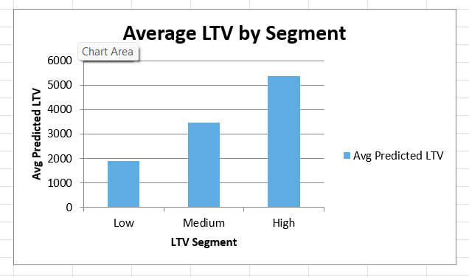

Caption: Shows the percentage of customers in each LTV segment (Low, Medium, High).

- Pie Chart
- Title: Customer Segment Distribution Based on Predicted Lifetime Value.
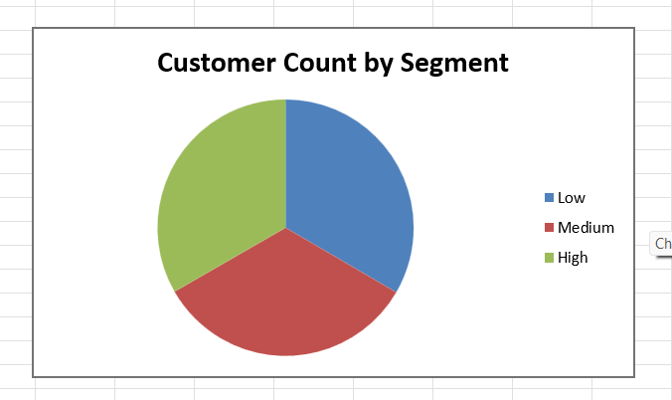
- Caption: Shows the percentage of customers in each LTV segment (Low, Medium, High).

Line Chart:

Title: Monthly Trend of Customer Segments Over Time
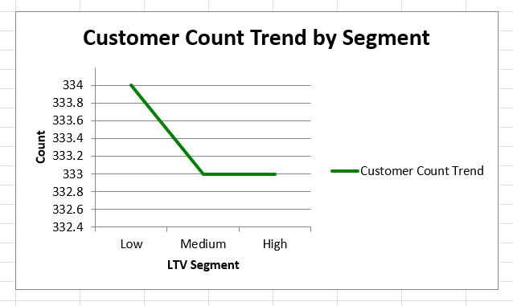
Caption: Shows how the number of customers in each segment changes over time.

INSIGHTS

The majority of customers fall into the Low and Medium LTV segments, indicating potential for targeted upselling or re-engagement campaigns. High LTV customers, though fewer in number, contribute significantly to overall revenue and should be prioritized for loyalty programs and exclusive offers. Customers with high frequency and low recency show strong engagement, while those with low frequency and high recency may be at risk of churn. Segment-based strategies can improve marketing efficiency. Investing in retention of medium-value customers could shift them to high-value over time, increasing profitability. Overall, CLV-based segmentation enables data-driven, personalized business decisions.

CONCLUSION
In this project, I successfully built a Customer Lifetime Value (CLV) Prediction Model using customer demographic and behavioral data. The model, based on a Random Forest Regressor, predicted future customer value with good accuracy using features like frequency, recency, and total spend.
After prediction, I segmented customers into Low, Medium, and High value groups using pd.qcut. These segments are highly useful for personalized marketing, customer retention, and resource allocation.
Visual outputs such as column, pie, and line charts were created in Excel to make insights easy to understand. A final PDF report was also prepared to summarize the process and findings.
This approach can help businesses make data-driven decisions, improve customer engagement, and increase profitability through better targeting and retention strategies.

BIBLIOGRAPHY

Book Reference:

- Kotler, P., & Keller, K. L. (2016). Marketing Management. Pearson Education.
- Gupta, S., & Lehmann, D. R. (2005). Managing Customers as Investments. Wharton School Publishing.
- Provost, F., & Fawcett, T. (2013). Data Science for Business. O'Reilly Media.

Web Reference:

- Scikit-learn Documentation. https://scikit-learn.org
- Pandas Documentation. https://pandas.pydata.org
- Seaborn Documentation. https://seaborn.pydata.org
- Kaggle Datasets. https://www.kaggle.com
- TensorFlow. https://www.tensorflow.org

APPENDIX

- CODING
import pandas as pd
import numpy as np
import matplotlib.pyplot as plt
import seaborn as sns
from sklearn.ensemble import RandomForestRegressor
from xgboost import XGBRegressor
from sklearn.preprocessing import OneHotEncoder, StandardScaler
from sklearn.compose import ColumnTransformer
from sklearn.pipeline import Pipeline
from sklearn.model_selection import train_test_split
from sklearn.metrics import mean_absolute_error, mean_squared_error

#Load the dataset
df = pd.read_csv("C:\Project\Customer_Lifetime_Value_Prediction.csv")

#Data Cleaning & Preprocessing

df['Gender'] = df['Gender'].astype('category')
df['Churned'] = df['Churned'].astype('category')
df['CustomerSegment'] = df['CustomerSegment'].astype('category')
#Exploratory Data Analysis (EDA)
df.select_dtypes(include=[np.number]).hist(bins=20, figsize=(14, 10))
plt.tight_layout()
plt.show()

#Correlation Heatmap
plt.figure(figsize=(10, 8))
sns.heatmap(df.corr(numeric_only=True), annot=True, cmap='coolwarm')
plt.title("Correlation Heatmap")
plt.show()

#Feature Engineering
categorical_cols = ['Gender', 'Churned', 'CustomerSegment']
numeric_cols = ['Age', 'Tenure', 'NumPurchases', 'AvgPurchaseValue',
'RecencyDays', 'TotalSpend', 'FrequencyPerMonth']
target = 'LifetimeValue'

#Set up column transformer
preprocessor = ColumnTransformer(transformers=[ ('num', StandardScaler(), numeric_cols), ('cat', OneHotEncoder(drop='first'), categorical_cols) ])

#Prepare features and target
X = df[numeric_cols + categorical_cols]
y = df[target]
X_processed = preprocessor.fit_transform(X)

#Model Training & Evaluation

#Split into train and test sets
X_train, X_test, y_train, y_test = train_test_split(X_processed, y, test_size=0.2, random_state=42)
#Train Random Forest
rf_model = RandomForestRegressor(random_state=42)
rf_model.fit(X_train, y_train)
rf_preds = rf_model.predict(X_test)

#Train XGBoost
xgb_model = XGBRegressor(random_state=42, verbosity=0)
xgb_model.fit(X_train, y_train)
xgb_preds = xgb_model.predict(X_test)

#Evaluate models
def evaluate_model(y_true, y_pred, name="Model"):
mae = mean_absolute_error(y_true, y_pred)
rmse = np.sqrt(mean_squared_error(y_true, y_pred))
print(f"{name} - MAE: {mae:.2f}, RMSE: {rmse:.2f}")
evaluate_model(y_test, rf_preds, "Random Forest")
evaluate_model(y_test, xgb_preds, "XGBoost")
#Final Prediction & Segmentation
#Predict on full data using best model (Random Forest)
ltv_predictions = rf_model.predict(X_processed)
df['PredictedLTV'] = ltv_predictions
# Segment into Low, Medium, High
df['LTVSegment'] = pd.qcut(df['PredictedLTV'], q=3, labels=['Low', 'Medium', 'High'])
# Visualize Segments
plt.figure(figsize=(6, 4))
sns.countplot(data=df, x='LTVSegment', palette='Set2')
plt.title("Customer Segments Based on Predicted LTV")
plt.xlabel("Segment")
plt.ylabel("Count")
plt.tight_layout()
plt.show()
#Feature Importances – Random Forest
importances = rf_model.feature_
importances_ feature_names = preprocessor.get_feature_names_out()
feat_df = pd.DataFrame({'Feature': feature_names, 'Importance': importances})
feat_df.sort_values(by='Importance', ascending=False).plot(kind='barh', x='Feature', figsize=(10,6))
plt.title("Feature Importances - Random Forest")
plt.tight_layout()
plt.show()
#Boxplot
sns.boxplot(data=df, x='CustomerSegment', y='PredictedLTV', palette='Set2')
plt.title("Predicted LTV by Customer Segment")
plt.show()
#Scatterplot
sns.scatterplot(data=df, x='RecencyDays', y='FrequencyPerMonth',
hue='LTVSegment', palette='Set1')
plt.title("Recency vs Frequency by LTV Segment")
plt.xlabel("Recency Days")
plt.ylabel("Frequency per Month")
plt.tight_layout()
plt.show()
#Barplot
sns.barplot(data=df, x='Gender', y='PredictedLTV', hue='Churned', ci=None, palette='muted')
plt.title("Avg. Predicted LTV by Gender and Churned")
plt.xlabel("Gender")
plt.ylabel("Predicted LTV")
plt.tight_layout()
plt.show()

#Export Final Predictions
import pandas as pd
import joblib df = pd.read_csv("C:\Project\Customer_Lifetime_Value_Prediction.csv") df['PredictedLTV'] = [1000] * len(df)
df['PredictedLTV'] = rf_model.predict(X_processed)
df['LTVSegment'] = pd.qcut(df['PredictedLTV'], q=3, labels=['Low', 'Medium', 'High'],
duplicates='drop')
#Export to CSV
output_columns = ['CustomerID', 'PredictedLTV', 'LTVSegment']
df[output_columns].to_csv("C:\Project\final_ltv_predictions.csv", index=False)
print("✅ Saved predictions to 'C:\Project\final_ltv_predictions.csv'")

b) Charts

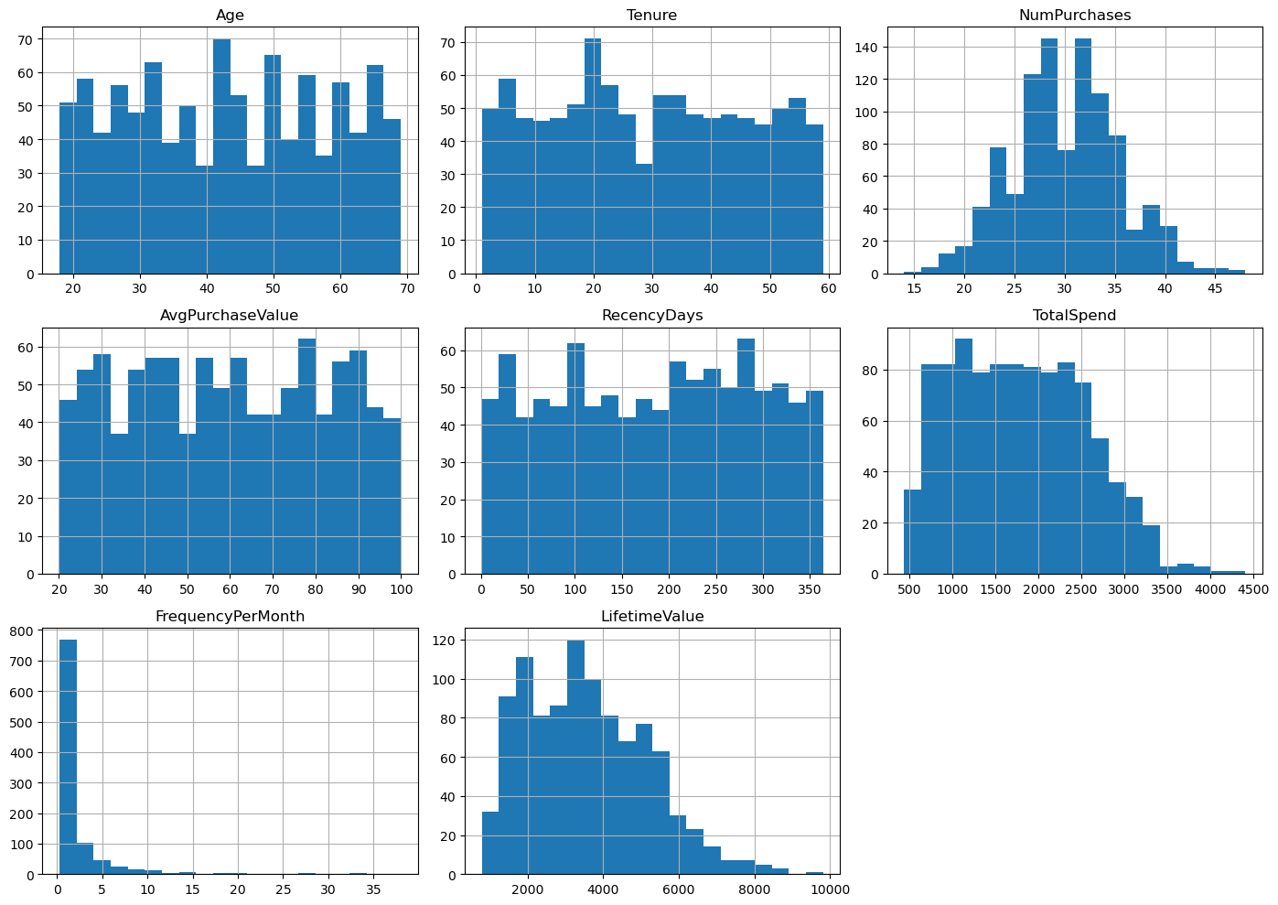

Fig 1. Exploratory Data Analysis (EDA)

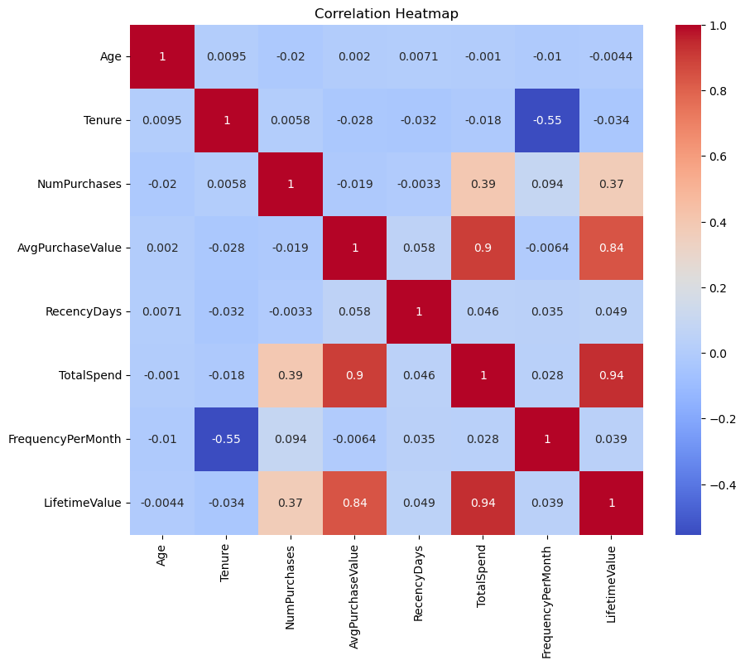
Fig 2. Correlation Heatmap

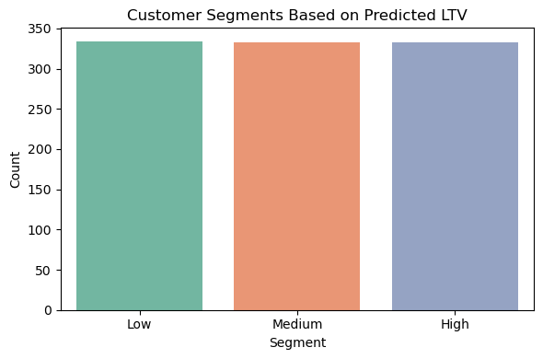

Fig 3. Customer Segment-based on Predicted LTV

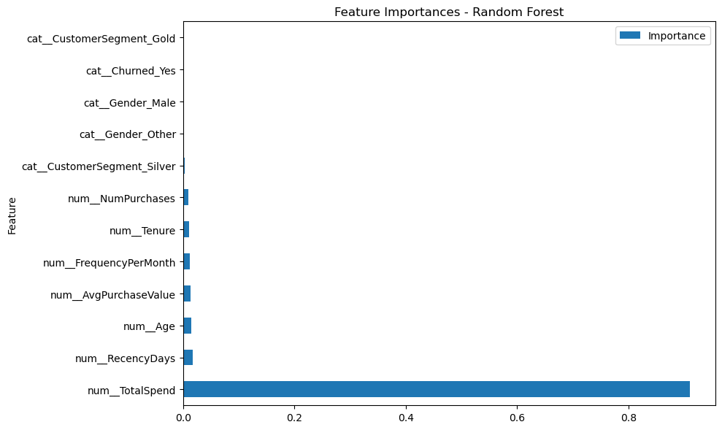

Fig 4. Feature Importances – Random Forest

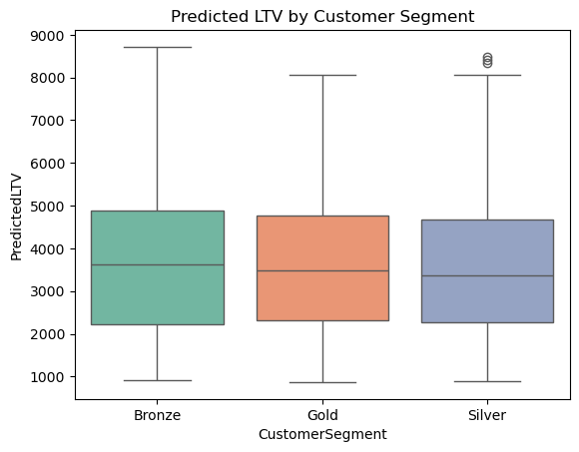

Fix 5. Predicted LTV by Customer Segment-based

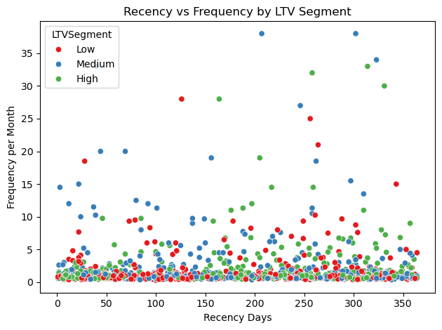

Fix 6. Recency vs Frequency by LTV Segment

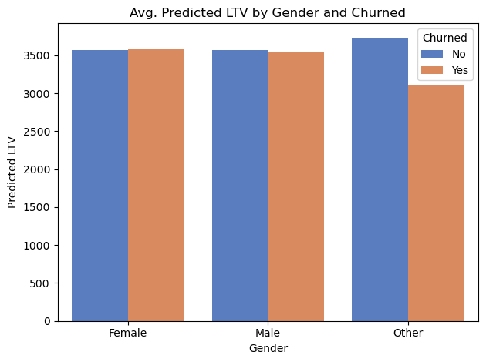

Fix 8. Avg. PredictedLTV by Gender and Churned

