Building GANs and Applying Them to Retinal, Network-Traffic and Sketch Data

Name: Padma Sri Veeramachaneni
Student ID: 24073859
Github Repo Link: https://github.com/padmasriveeramachaneni/Generative_Adversarial_Networks

1. Aims and approach
The structure of this report is based on one design question: what kind of structure does the kind of data require as a generative architecture, and is the evidence supportive of the choice? A generative adversarial network pits a discriminator that evaluates the similarity of samples generated by the generator against a discriminator which looks at how real a sample generated by the generator is, with a non-saturating binary cross-entropy loss (Goodfellow et al., 2014). That aim is fixed everywhere in this work; and that which shift voluntarily, with each successive dataset, is the architecture, and the report concerns each architectural choice as a hypothesis to be subjected to the findings. Part 1 sets up the machinery on synthetic 2D data, and Part 2 subsequently aligns an architecture to three domains, medical imaging, network-security traffic and hand-drawn sketches. It has two frameworks intentionally: PyTorch in the case of the from-scratch work and sketch and TensorFlow/Keras in the case of the medical and tabular models. Seeds \ are stuck in such a way that each number lower can be reproduced.
The re-emerging rule is that the local spatial structure in image data is powerful, is utilized by convolution, whereas 2D coordinates and tabular feature vectors are not and therefore an honest decision in that case would be to use a dense network. The convolutional DCGAN of Radford et al. (2016) and the tabular model a fully-connected variant are the image models accordingly and each section below justifies why, then shows what has happened.

2. Learning simple distributions from scratch
In Part 1 both networks are small MLPs, the right architecture in cases where the data are bare 2D coordinates with no grid on which a convolution should be performed. They are configured with BCEWithLogitsLoss, one discriminator step every generator step and Adam as suggested to make GAN stable (Radford et al., 2016; Kingma and Ba, 2015). The three tasks are performed by a single configurable pair of classes, thus the comparison between Task 3 is fair since the hyper-parameters are the only aspect that is modified.

2.1 Task 1: reproducing the sine-wave GAN
The objective is sin(x) points; training was done in 6000 steps on 32-D latent vectors.
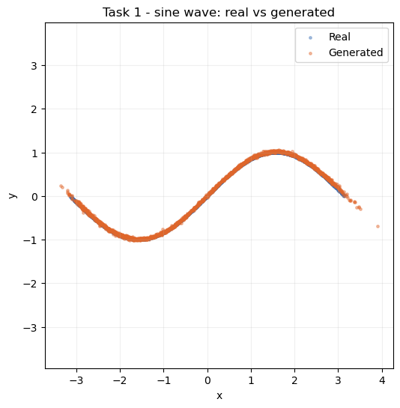
Figure 1: Real (blue) versus generated (orange) samples for the sine-wave GAN after 6000 steps.
Figure 1 and the numbers indicate that the generated cloud is nearly placed on the curve, and the losses are consistent: the discriminator goes to 1.35-1.39 (final 1.3796) and the generator to 0.68-0.76 (final 0.6979) which is near to the equilibrium of this objective (around 2ln2 = 1.386 of D and ln2 = 0.693 of G). Neither loss is dominant, and this means that there is a real convergence with neither network dominating.

2.2 Task 2: a noisy parametric curve
The new target is y = sin(2x) + 0.3cos(5x) + e (e a small band of Gaussian noise), more difficult than the sine due to the higher frequency term and the noise band; 8000 steps.
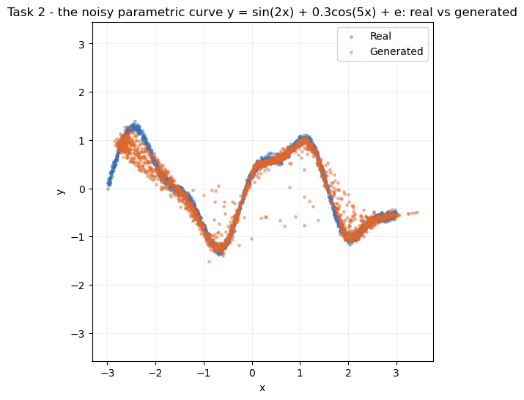
Figure 2: Real versus generated samples for the noisy parametric curve y = sin(2x) + 0.3cos(5x) + ε.
Figure 2 demonstrates that the generator follows the double-bump pattern and interpolates its points to the same band of noise, as the real data, thus it not only reproduces the overall trend of the target but also reproduces its variance and is not reduced to a narrow line. Losses stay healthy (D 1.1652-1.3705, G 0.7229-0.8429), a little noisier than Task 1 as expected for a more oscillatory target.

2.3 Task 3: does deeper, smoother architecture help?
The depth 2 baseline generator (with ReLU) is compared to a deeper version (depth 4, ELU) run on the same target and budget, which only swaps the generator, and therefore any difference will be due to the depth and activation alone.
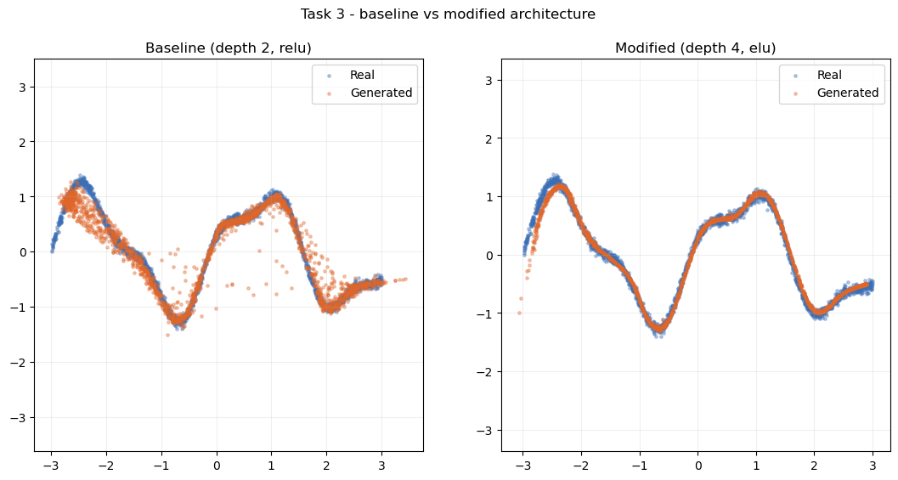
Figure 3: Generated samples from the baseline (depth 2, ReLU) and modified (depth 4, ELU) generators against the real curve.
Figure 3 depicts an appreciated and slight increase: the deeper ELU generator fits the curve a little more closely with a reduced number of stray points, and the losses remain constant (final D 1.3821, G 0.7089), thus the increased depth did not raise any issues with optimisation. It is informative in itself that the gain is small, as a 2D curve is not so complicated that its base is already shallow enough to capture most of the structure, and architecture does not matter at the very point where the target is the easiest to attack; and Part 2 datasets are designed to test this hard.

3. Matching architecture to the data

3.1 Convolutional generation for retinal scans (OCTMNIST)
OCTMNIST (Yang et al., 2023) has 97,477 training scans of 28x28 pixels in 4 diagnostic classes (choroidal neovascularisation, diabetic macular oedema, drusen, normal) rescaled to 32x 32 pixels in the range of -1, 1) to fit the tanh of the generator. This design issue self-answers when one looks at the data the design here is a scan, which is a curved retinal band on a dark background, high local structure that convolutions can capture much more effectively than a dense network, a DCGAN (Radford et al., 2016) therefore is the obvious choice. The generator converts a 100-D latent code to a bigger image through transposed convolutional upsampling and the discriminator learns to match it through strided convolutional upsampling and 0.3 dropout. Manual tf was used as training.The loop of GradientTapes 35 epochs with one-sided label smoothing (real labels 0.9) which prevents the discriminator to over-optimize the generator by starving it with the gradient (Salimans et al., 2016).
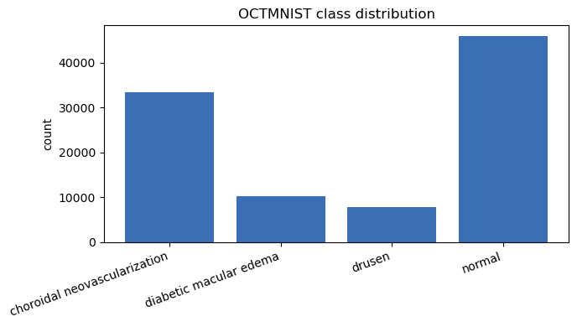
Figure 4: OCTMNIST diagnostic-class counts in the training split.
Figure 4 indicates that the four classes do not reflect the sample well as they are unevenly distributed. This becomes applicable hereafter, since the case of an uneven quality is when a class-conditional generator is used with an imbalanced training set.
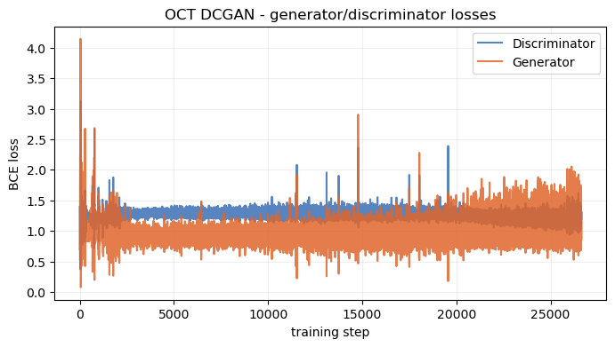
Figure 5: Generator and discriminator loss curves over the 35-epoch DCGAN run.
Figure 5 indicates that both of the networks do not diverge: the discriminator remains within the range 0.9-1.55 and the generator within the range 0.4-1.66 with a stable band of oscillations. It is by virtue of that stability that makes the sample quality less than a product of real learning.
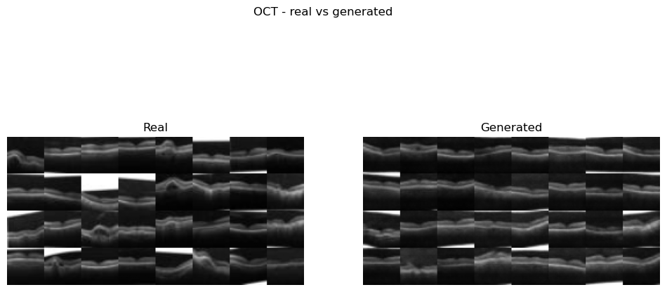
Figure 6: Real (left) versus generated (right) OCT scans from the trained generator.
Fig. 6 reveals that the generator recreates the original anatomy with real variation in position and curvature of the bands, which suggests that the generator is not learning individual images but its strength is in the fine details, as the fakes become softer and lose sub-layers texture and speckle. Its FID = 39.23 (Heusel et al., 2017), which is a believable mid-range score of a 35-epoch DCGAN, will pass FID = 28x28 greyscale (upscaled) with InceptionV3 trained on ImageNet (Szegedy et al., 2016), into which it is not actually even attempted to be calibrated. To control the classes, the DCGAN was conditionalized (Mirza and Osindero, 2014) by embedding a label on the latent vector and pass it to the discriminator as an additional channel.
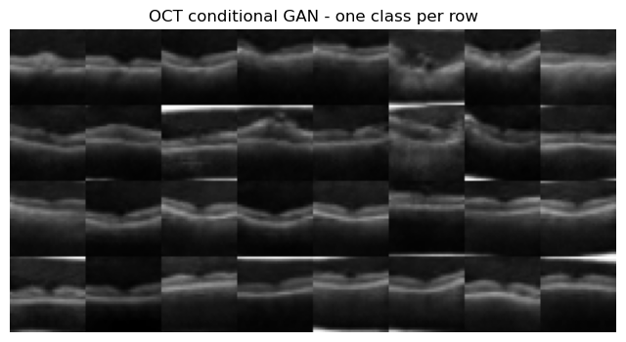
Figure 7: Class-conditional samples, one diagnostic class per row.
The difference in scans per row in Figure 7 is visibly different, thus the label directs the output and does not go through the air, whereas the classes that are better represented appear sharper, which is the direct result of the imbalance in Figure 4. The duck test, when it looks and quacks like a duck, so assume it is one, isolates a true risk, that the discriminator only makes judgments about whether an image is real, not whether it is anatomically accurate, and so there is no incentive against the generator creating realistic structure which bears no resemblance to any actual scan. They should not, however, be used to diagnose ground truth and synthetic OCT images are good enough to either augmentation or teaching but not diagnostic, and any model that was trained on mixed data must be re-validated on pure (real-only) data.

3.2 A dense architecture for network traffic (CICIDS 2017)
CICIDS 2017 (Sharafaldin et al., 2018) was retrieved through kagglehub and 2830743 flows comprising 80 columns (78 numeric features) were merged into 80 columns. In this case the design question compels the converse response to the image portions: since every flow is a feature space with no spatial axis then a convolution has nothing to manipulate thus requiring a dense GAN to take the place of the DCGAN. Because the number of standardised features is unlimited and a tanh would trim them, the generator expands 96 to 192 to 384 (Dense with batch norm and ReLU) and the discriminator reduces 384 to 192 to 96 (Dense with LeakyReLU and 0.3 dropout). Latent dimension is 48 with training being 60 epochs.
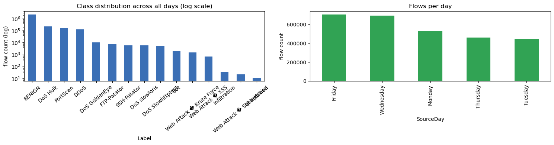
Figure 8: Class distribution across all days (log scale) and flows per day.
Figure 8 presents violent imbalance: BENIG has the highest number (2,273,097 flows), and Heartbleed (11), SQL Injection (21) and Infiltration (36) insignificantly show up, therefore the log scale. After training, only the Wednesday file (691,404 rows: 440,031 BENIGN plus DoS Hulk, GoldenEye, slowloris and Slowhttptest) was used as the test sample with a sampled 20,000 rows. As opposed to a crude z-score, the features get run through a Yeo-Johnson power transform which is far more tolerant of the heavy right-skewness of the flow statistics than plain standardisation and then are scaled to lie between -5 and +5 so that rare outliers (and 4,376 infinity and 1,358 missing values) do not upset training.
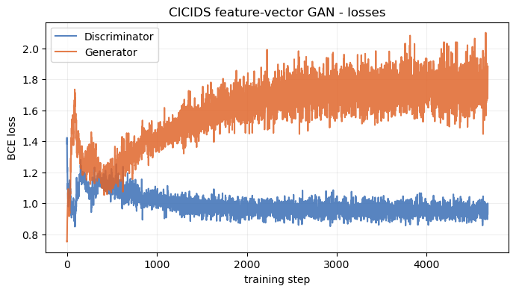
Figure 9: Discriminator and generator loss curves for the Wednesday feature-vector GAN.
Figure 9 depicts the stabilized training: the discriminator peaks between about 0.90 and 0.99 and the generator increases between about 1.60 and 1.88, a growing generator loss and a stable discriminator, which is characteristic of a dense GAN stabilizing.
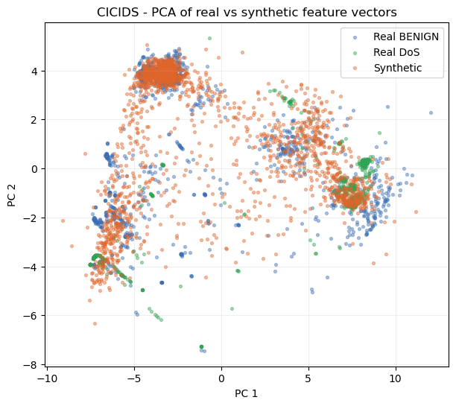
Figure 10: PCA projection of real BENIGN, real DoS and synthetic feature vectors.
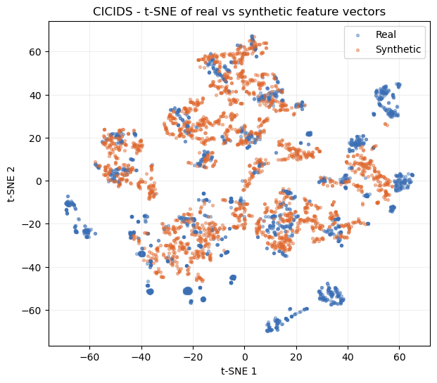
Figure 11: t-SNE projection of real versus synthetic feature vectors.
Both figures 10 and 11 concur that, in both the linear PCA and non-linear t-SNE space the synthetic points lie within the bulk of real traffic and not in an individual blob, hence the dense generator has located the appropriate area of feature space. However, synthetic cloud is smaller than the actual one and lacks the tails. This is measured by the alignment gaps, the average error between the means is 0.1576 per feature, and the average error between the standard deviations is 0.2067 per feature and thus averages are matched and spread is underemphasized. The gaps between all eight days (30,000 rows) retraining produced a better result (0.1300 / 0.1483 against 0.1576 / 0.2067), suggesting that the increased data volume compensated the increased diversity; the model continues to bias towards BENIGN and attacks with high volume and the infrequent classes remain under-represented. On the label in the brief of 'DDoS' Wednesday attacks are single-source DoS only, and the real DDoS is not said anywhere, other than in the Friday file, which is listed below. This duck test is more demanding of tabular data: one needs to generate a flow that only appears statistically similar to traffic, and is not required to act as in a real attack, and these per-feature gaps, notably on the standard deviation where such drift manifests first, provide the primary protection.

3.3 Convolutional generation for sketches (QuickDraw)
There are 144,982 bitmaps of 28x28 sizes that come in the QuickDraw birthday cake set (Ha and Eck, 2018). The same definition of a sketch again in terms of the local structure of strokes gives an image answer of a convolutional model, which is trained on 30 epochs, initialised with DCGAN weight initialisation of Radford et al. (2016) and labelling smoothing.
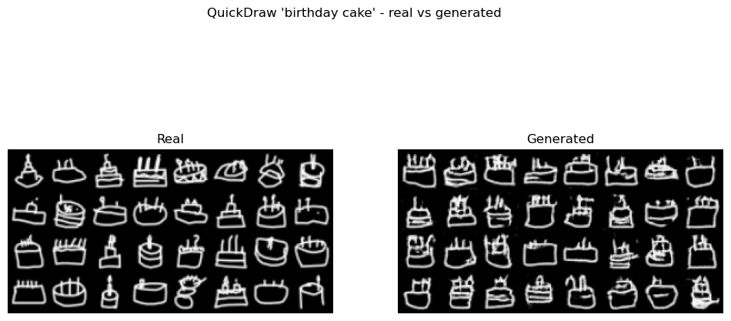
Figure 12: Real (left) versus generated (right) 'birthday cake' sketches.
The cakes produced are easily recognized, as shown in Figure 12: a body shape, surmounted by candle-like marks, some with a plate line or bottom line, but a few have discontinued strokes, or are speckled. The didier is same as in the grid with no mode collapse. Training was consistent, other than an episodic-13 spike (D 1.633, G 11.493) that died off, and with FID = 34.29. Snapshots during the run on five epochs reveal the outline and candles developing initial and continuing to fine-tune afterwards, in correspondence with the stable loss curve. The identical pipeline was applied to cat and house, with FID being compared to an ink-density complexity proxy.
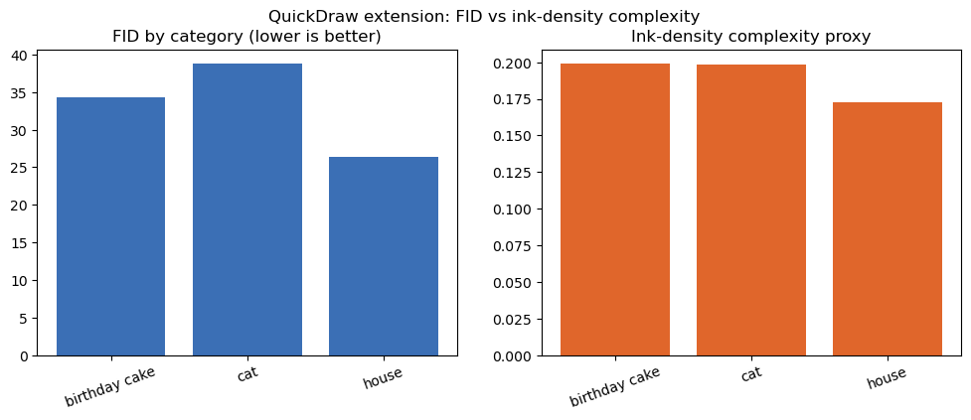
Figure 13: FID by category alongside the ink-density complexity proxy.
Figure 13 orders ink density as house (0.1725) < cat (0.1986) < cake (0.1989) and FID as house (26.44) < cake (34.29) < cat (38.79). The lightest category, house, is the simplest, which illustrates the notion that the sketches that contain fewer pictures are the simplest ones. Cat and cake are almost exactly equal in ink density but cat is less good and hence ink does not significantly explain the difference, which is that the structural diversity among the sketches: of pose and detail (ears, whiskers and body angle, etc.) and structural range, is the main factor that effects the category.

4. What the results tell us
Coming back to this question of design we can indicate that there is evidence to match architecture to data structure. The convolutational DCGANs generated recognisable OCT scans (FID 39.23) and cake drawings (FID 34.29) with local spatial structure rewarded convolution, and the dense GAN placed synthetic flows in the correct place (gaps 0.1576 / 0.2067, better 0.1300 / 0.1483 as day to day) because it did not require a spatial prior that the data do not have. The from-scratch MLPs converged to near-theoretical equilibria on the 2D targets and Task 3 demonstrated that the architecture has the least influence when the target is simplest. Under-dispersion, wherein central tendency is fidelitiously reproduced compared to variance and fine detail, and with inconsistent quality on infrequent classes, is the common limitation of all architectures.

5. Limitations and next steps
It is the next steps that we are into due to the weaknesses. The same conditioning as to OCT with CICIDS generator would be to condition the generator on attack family: this should condition the generator so that it can serve rare classes without default to BENIGN and (to a better degree) tail coverage and the standard-deviation gap; and a domain-appropriate feature extractor would provide a enhanced image score compared to ImageNet InceptionV3. Most importantly, the analysis of the duck-test implies that any downstream usage of this synthetic data, be it medical augmentation or intrusion-detection training, should be confirmed to be checked on real-only data before it is relied on.

References
Goodfellow, I., Pouget-Abadie, J., Mirza, M., Xu, B., Warde-Farley, D., Ozair, S., Courville, A. and Bengio, Y. (2014) 'Generative adversarial nets', Advances in Neural Information Processing Systems, 27, pp. 2672-2680.
Ha, D. and Eck, D. (2018) 'A neural representation of sketch drawings', International Conference on Learning Representations (ICLR).
Heusel, M., Ramsauer, H., Unterthiner, T., Nessler, B. and Hochreiter, S. (2017) 'GANs trained by a two time-scale update rule converge to a local Nash equilibrium', Advances in Neural Information Processing Systems, 30, pp. 6626-6637.
Kingma, D. P. and Ba, J. (2015) 'Adam: a method for stochastic optimization', International Conference on Learning Representations (ICLR).
Mirza, M. and Osindero, S. (2014) 'Conditional generative adversarial nets', arXiv preprint arXiv:1411.1784.
Radford, A., Metz, L. and Chintala, S. (2016) 'Unsupervised representation learning with deep convolutional generative adversarial networks', International Conference on Learning Representations (ICLR).
Salimans, T., Goodfellow, I., Zaremba, W., Cheung, V., Radford, A. and Chen, X. (2016) 'Improved techniques for training GANs', Advances in Neural Information Processing Systems, 29, pp. 2234-2242.
Sharafaldin, I., Lashkari, A. H. and Ghorbani, A. A. (2018) 'Toward generating a new intrusion detection dataset and intrusion traffic characterization', Proceedings of the 4th International Conference on Information Systems Security and Privacy (ICISSP), pp. 108-116.
Szegedy, C., Vanhoucke, V., Ioffe, S., Shlens, J. and Wojna, Z. (2016) 'Rethinking the Inception architecture for computer vision', Proceedings of the IEEE Conference on Computer Vision and Pattern Recognition (CVPR), pp. 2818-2826.
van der Maaten, L. and Hinton, G. (2008) 'Visualizing data using t-SNE', Journal of Machine Learning Research, 9, pp. 2579-2605.
Yang, J., Shi, R., Wei, D., Liu, Z., Zhao, L., Ke, B., Pfister, H. and Ni, B. (2023) 'MedMNIST v2 - a large-scale lightweight benchmark for 2D and 3D biomedical image classification', Scientific Data, 10(1), p. 41.

