03 – System Architecture
High-level design and processing sequence
Team T080 | Pavan Neelappa Mirji – 1AT24CG060 | Padmavathi B – 1AT24CG059 | Section CSD

1. Architecture Overview
The application is organised as a deterministic processing pipeline. Input files are parsed and validated first. The core engine applies the specified business-rule precedence. Accounting and reporting then use the final order, station and event outcomes.
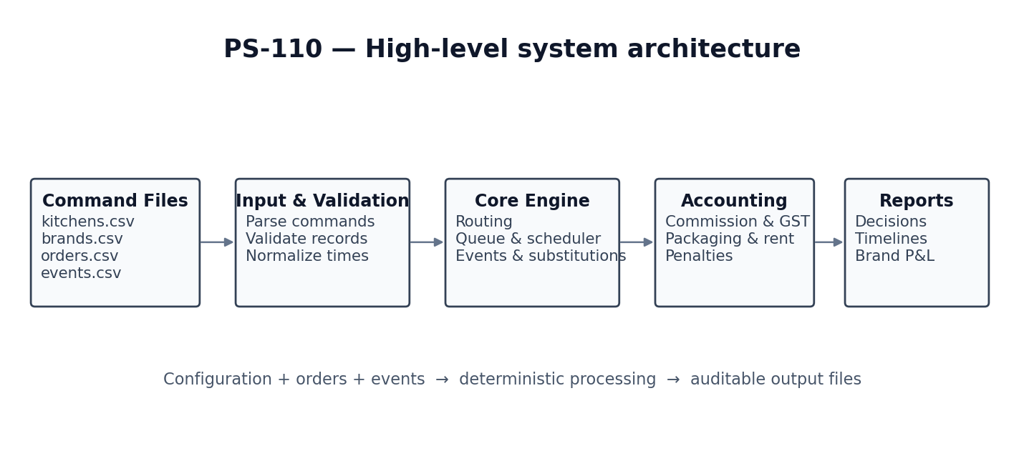

2. Processing Sequence
- Read and validate kitchen, brand, order and event command files.
- Apply stock-out state and substitution decisions before an affected order is scheduled.
- Determine kitchen eligibility for each order.
- Apply throttling rules to eligible kitchens and select a kitchen using projected ready time and tie-breaks.
- Sequence accepted orders using FIFO and the constrained RUSH-jump rule.
- Batch eligible recipe items and schedule station work while respecting capacity and dependencies.
- Calculate packaging completion, ready time, promised time and late-risk.
- Process cancellations and hand-off events at their timestamps and calculate applicable charges or penalties.
- Calculate channel economics, rent and brand-level P&L; print required reports.

3. Design Principles
- Separate domain data from routing, scheduling, event processing, accounting and reporting logic.
- Make rule evaluation deterministic so identical inputs produce identical outputs.
- Keep timestamps and rounding consistent across all modules.
- Record routing and scheduling decisions so outputs can be audited.
- Trace each implemented behaviour to a BR-ID and test case.

