04 – Class Diagram and Responsibilities
Conceptual domain model for PS-110
Team T080 | Pavan Neelappa Mirji – 1AT24CG060 | Padmavathi B – 1AT24CG059 | Section CSD
The following conceptual diagram shows the principal domain entities and service classes. The final implementation may use classes, records or equivalent data structures, but responsibilities should remain separately testable.
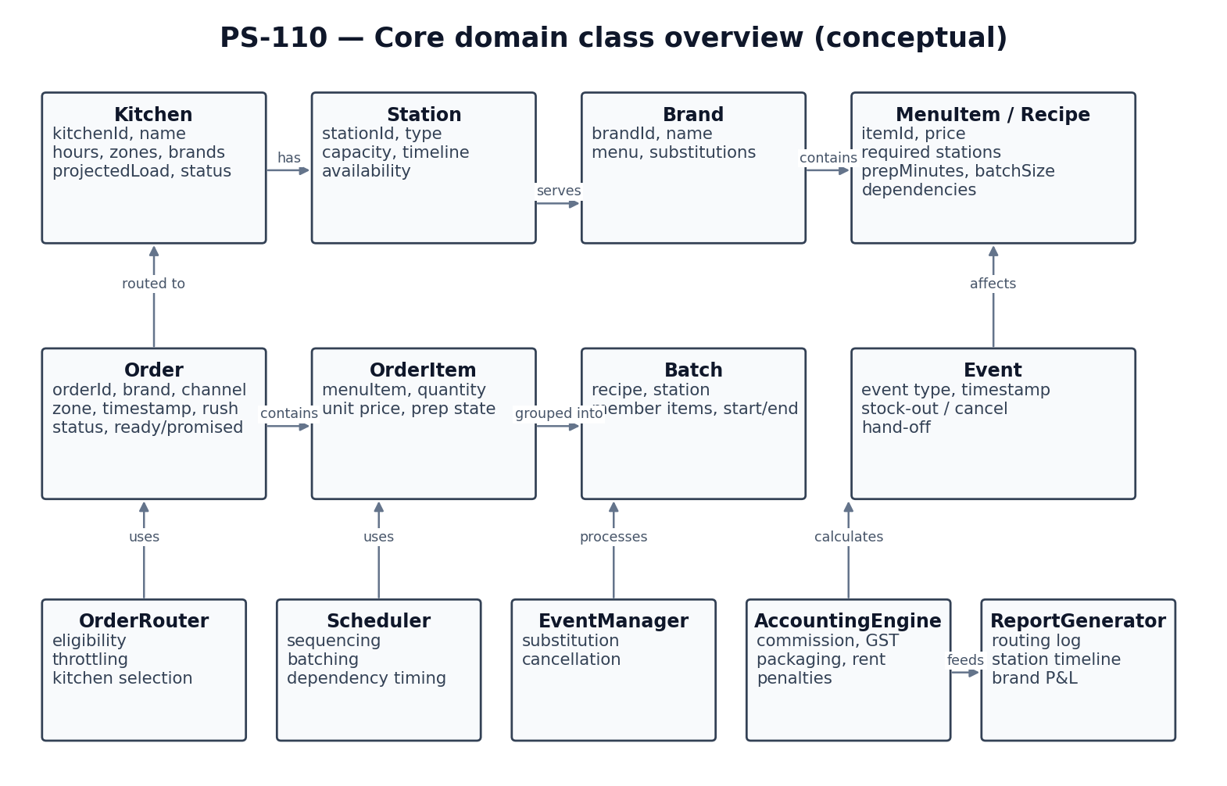
Class | Key attributes | Main responsibilities / methods
Kitchen | kitchenId, name, operatingHours, serviceZones, supportedBrands, stations, status | isOpenAt(time), supportsBrand(brand), servesZone(zone), projectedReadyTime(order)
Station | stationId, type, capacity, timeline | findAvailableSlot(time), reserveSlot(start, duration), getAvailableTime()
Brand | brandId, name, menu, substitutionTable | getMenuItem(itemId), findSubstitute(itemId)
MenuItem | itemId, name, foodPrice, recipe | getRecipe(), getPrice()
Recipe | recipeId, requiredStations, prepMinutes, batchSize, dependencies | isBatchCompatible(other), getPredecessors()
Order | orderId, brandId, channel, zone, orderTime, items, rushFlag, status | calculateReadyTime(), calculatePromisedTime(), updateStatus()
OrderItem | itemId, quantity, unitPrice, prepState, selectedRecipe | markStarted(), markCompleted(), applySubstitute()
OrderRouter | eligibility and selection policy | findEligibleKitchens(), applyThrottling(), selectKitchen()
Scheduler | queue sequencing, station allocation, batching and dependency scheduling | sequenceOrders(), formBatches(), scheduleOrder()
Batch | recipeId, stationId, itemReferences, startTime, endTime | canAccept(item), addItem(item)
SubstitutionManager | stock-out and substitution decisions | resolveUnavailableItem(), repriceOrder()
EventManager | event queue and event-time processing | processStockOut(), processCancellation(), processHandOff()
AccountingEngine | commission, payment fee, packaging, GST and rent | calculateOrderCharges(), calculateBrandRent()
PenaltyCalculator | late duration, penalty amount and cost-centre allocation | calculatePenalty(), assignResponsibility()
ReportGenerator | routing decisions, timelines and daily brand P&L | printRoutingReport(), printStationTimeline(), printBrandPnL()

Relationships
- One Kitchen contains multiple Stations.
- A Kitchen can serve multiple Brands; a Brand can be served by multiple Kitchens.
- One Brand owns multiple MenuItems; each MenuItem refers to a Recipe.
- One Order contains one or more OrderItems and belongs to one Brand.
- An OrderRouter evaluates Kitchens and assigns an Order to one selected Kitchen.
- A Scheduler uses Station timelines and Recipe requirements to schedule OrderItems and create Batches.
- An EventManager applies events to Orders, Kitchens, stock availability and hand-off records.
- AccountingEngine and PenaltyCalculator calculate financial outcomes consumed by ReportGenerator.

