05 – Order State Diagram
Order lifecycle, transitions and state descriptions
Team T080 | Pavan Neelappa Mirji – 1AT24CG060 | Padmavathi B – 1AT24CG059 | Section CSD
The state diagram shows the normal order lifecycle and the principal cancellation/rejection paths. Late-risk is modelled as an order flag rather than a separate lifecycle state. Stock-out substitution is processed before scheduling.
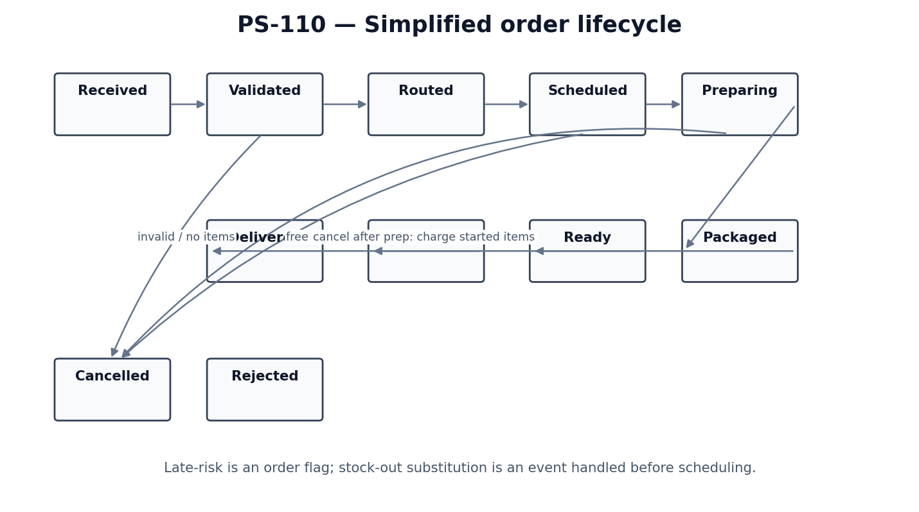
State | Meaning
RECEIVED | Order record has been read from the order input.
VALIDATED | Required fields and item references have been checked; substitution checks are applied before scheduling.
ROUTED / ACCEPTED | An eligible kitchen has been selected and the order is accepted there.
SCHEDULED | Queue position, station assignments and planned start/end times are determined.
PREPARING | At least one item has started preparation.
PACKAGED | All required preparation is complete and packaging work is complete.
READY | Order is ready for pickup; ready time is recorded.
HANDED_OFF | Order has been handed to the delivery channel/rider at the hand-off point.
DELIVERED | Delivery completion has been recorded, if the input/event model provides it.
CANCELLED | Order is cancelled; charges depend on whether any item had started preparation.
REJECTED | Order cannot be accepted, for example because validation fails or no valid items remain.

State and event notes
- At the exact prep-start timestamp, preparation is considered started for cancellation charging.
- A cancellation before any item starts prep is free.
- A cancellation after prep starts charges started items to the customer, unless an aggregator initiated the cancellation, in which case the channel is charged 100% of started items.
- Late-risk is an attribute/flag and does not replace the order lifecycle state.
- The assignment bases penalty on actual hand-off time. If no delivery-complete event exists in the input format, use hand-off as the operational event for penalty evaluation; do not invent an event type.

