**Full Stack Development with MERN**

**1. Introduction**

**Project Title:** House Rent App using MERN

**Team Members:**

* Dharshini A
* Indumathi M
* Jerlin Angel P
* Padmavathi K (Team Leader)
* Pavithra P

**2. Project Overview**

**Purpose:** A house rent app is typically a mobile or web application designed to help users find rental properties, apartments, or houses for rent. These apps often offer features to make the process of searching for and renting a property more convenient and efficient.

**Features:**

**Property Listings**: The app provides a database of available rental properties, complete with detailed descriptions, photos, location, rent amount, and other relevant information.

**Search Filters**: Users can apply various filters to narrow down their search results based on criteria such as location, rent range, property type (apartment, house, room, etc.), number of bedrooms, amenities, and more.

**Contact Landlords/Property Managers**: The app might provide a way for users to contact the property owners or managers directly through the app, often through messaging or email.

**3. Architecture**

* **Frontend:** Built using UI(React), Stock API, the frontend provides a dynamic user interface. It includes components for user authentication, course browsing, and content consumption, leveraging React Router for seamless navigation.
* **Backend:** The backend is built with Node.js and Express.js. It handles requests, manages authentication, and connects with MongoDB for data storage. Controllers manage course data and user interactions.
* **Database:** MongoDB and Mongoose stores information about users, courses, quizzes, and progress. It is structured with collections for each major feature (e.g., users, courses), enabling quick retrieval and updates.4. Setup Instructions

**4. Setup Instructions**

**Prerequisites:**

* Node.js v14+
* MongoDB v4+
* Antd
* npm

**Installation:**

1. Clone the repository: git clone <repository-url>
2. Navigate to both the backend and frontend directories and install dependencies:

For Backend: cd backend

npm install

For Frontend: cd ../frontend

npm install

**5. Folder Structure**

**Client:**  
The frontend directory contains:

* src/components - Contains reusable React components.
* src/pages - Different pages
* src/utils - Utility functions and API calls.
* src/styles - CSS files for styling.

**Server:**  
The backend directory is organized as follows:

* config - Database connection configuration.
* controllers - Functions to handle business logic.
* routers - Defines routes for various API endpoints.
* middlewares - Middleware for authentication and error handling.
* schemas - MongoDB schemas and models.

**6. Running the Application**

**Frontend:**  
Start the frontend server: npm start

**Backend:**  
Start the backend server: npm start

**7. API Documentation**

The backend exposes several endpoints, including:

* Setup express server

1. Create index.js file in the server (backend folder).
2. define port number, mongodb connection string and JWT key in env file to access it.
3. Configure the server by adding cors, body-parser.

* Add authentication: for this,

You need to make middleware folder and in that make authMiddleware.js file for the authentication of the projects and can use in.

**8. Authentication**

You need to make middleware folder and in that make authMiddleware.js file for the authentication of the projects and can use in.

**9. User Interface**

The interface includes:

* A login and registration form.
* Course catalog page displaying available courses.
* Dashboard page where users can search for more options.

**10. Testing**

Testing is performed using tools like Jest and Postman for API testing. Unit tests cover component functionality and API response validation.

**11. Screenshots**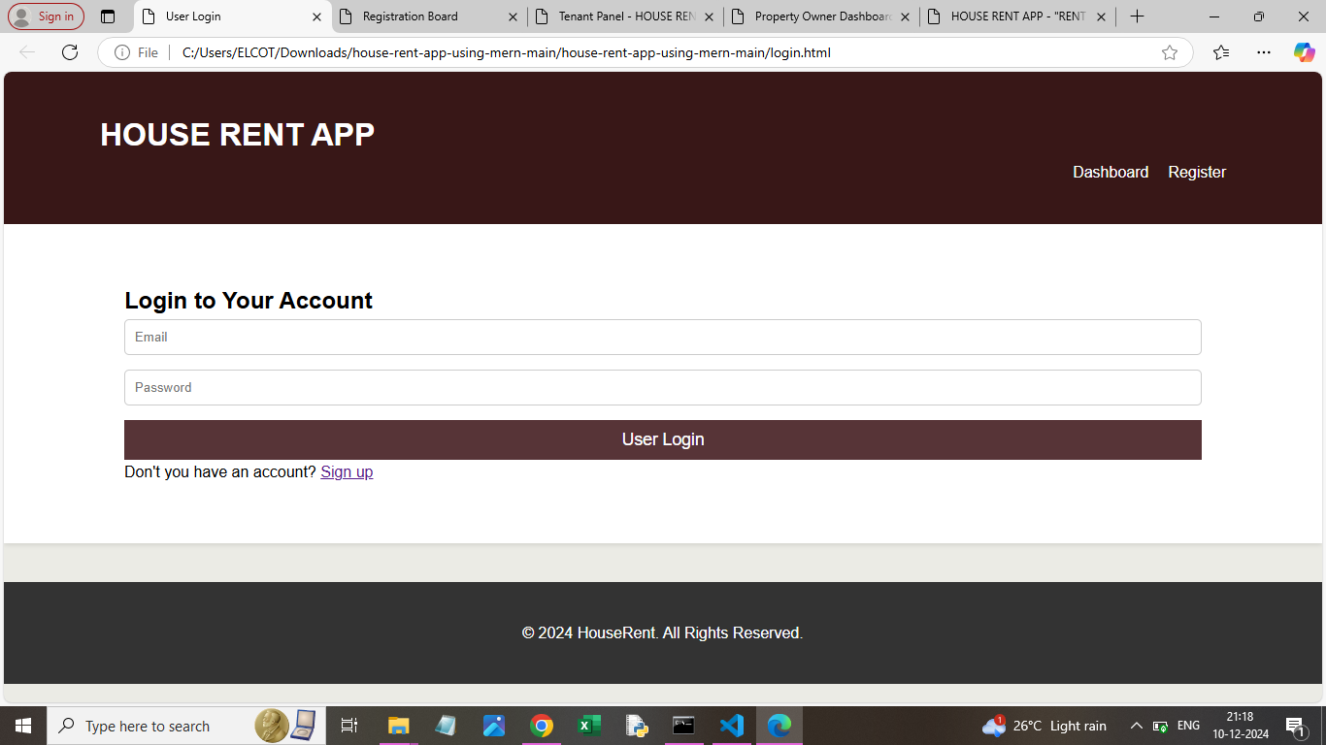

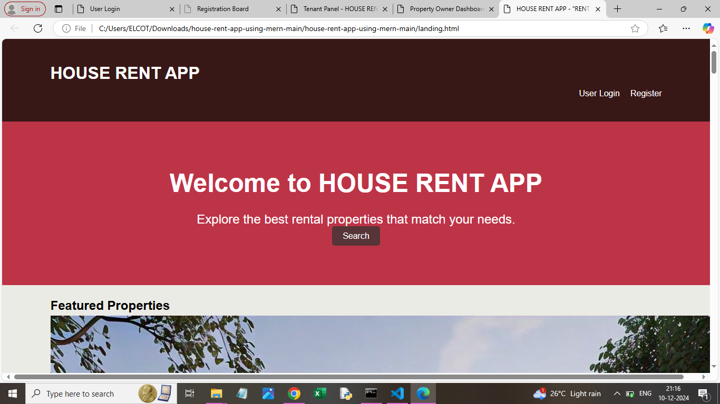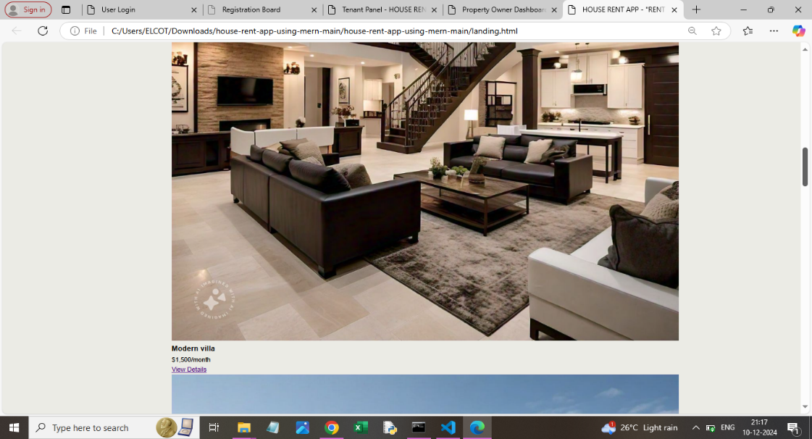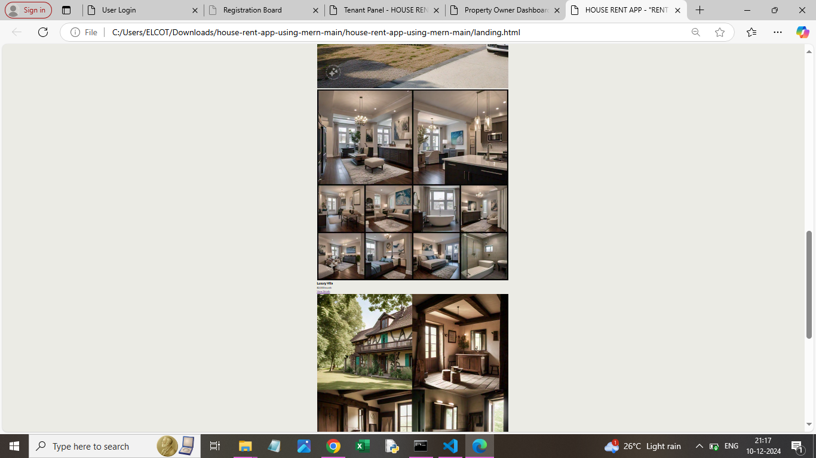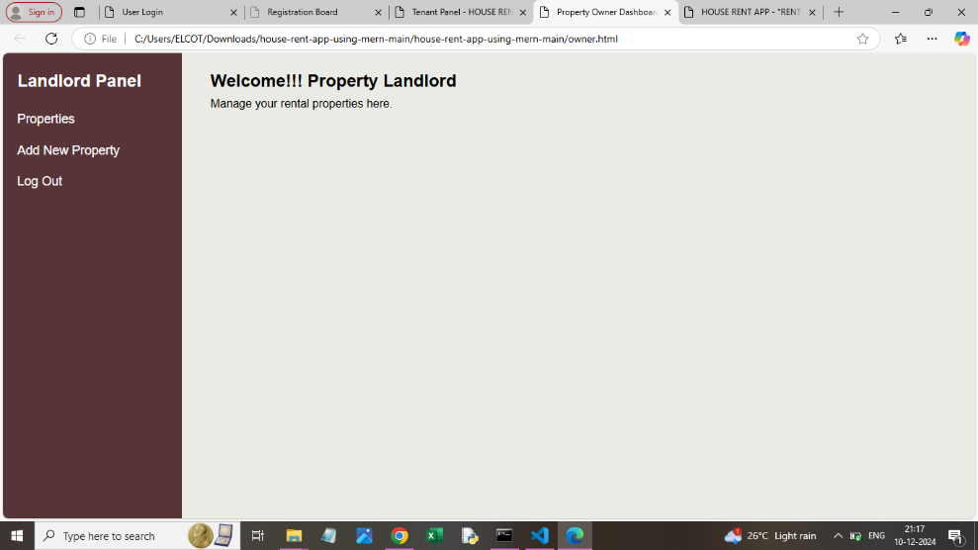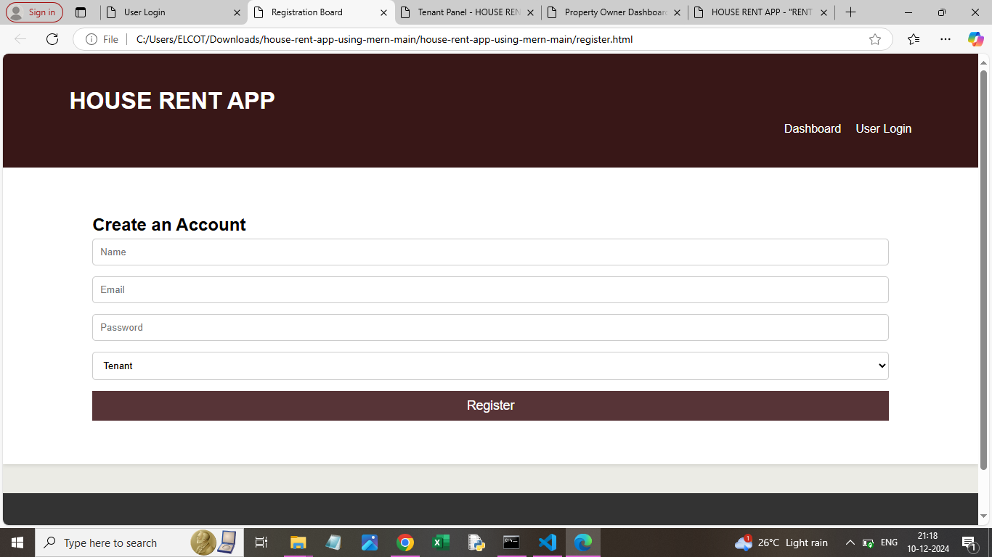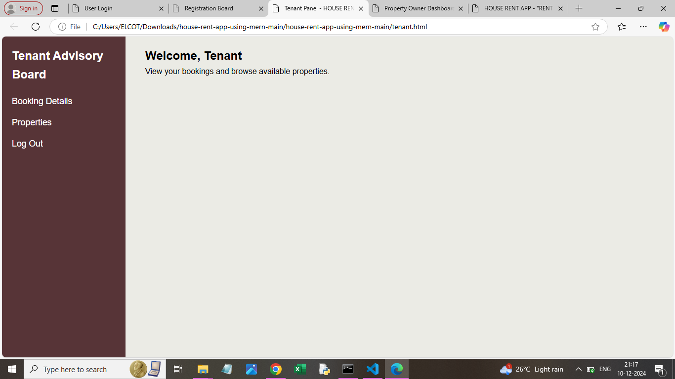

.

**12. Known Issues**

* The buyer feel lack of real-time experiences.
* Occasional delays in real-time messaging.

**13. Future Enhancements**

* Add support for user to view property in 360 Degree view.
* Implement a Token Advance payment gateway.
* Enhance real-time chat with video conferencing with the dealer or onwers.