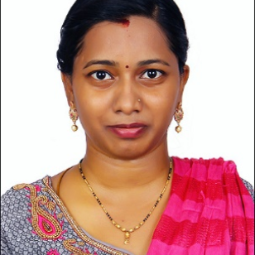  Padmavathy Gangadaran  Python Full Stack Developer  Contact  Address  Brickfields, Kuala Lumpur, Malaysia  Phone  E-mail  Portfolio Website  https://padmafolio-sbfb.vercel.app/  Skills  - Front-end Development –  Html, Css, Bootstrap, JavaScript,  React.js  - Back-end Development –  Python, Django, MY-SQL  - Teaching  - MS Office  - Typing  - Designing  Software  - Python  - HTML, CSS  - JavaScript  Languages  - Tamil  - English  - Telugu | Looking for a challenging role so that I can use my skills and capabilities through sincere dedication and hard work for successful career.  Experience  2026-02 - Current Junior Python Full Stack Developer - Intern Vetri Technology Solutions, Tamil Nadu, India - Developed and maintained responsive frontend web applications using React.js, JavaScript, Bootstrap, HTML, and CSS. - Developed backend components for full-stack web applications using Django, MySQL, and RESTful APIs. - Worked in many live projects like ecommerce ,travel booking and healthcare websites etc.,  2023-03 - 2023-05 Admin Executive Trident Capital Ventures Sdn Bhd., Kuala Lumpur, Malaysia - Involve attending calls, hall booking for the trainings/meetings - Send invoice to customers - Contributed in form design for the company  2019-06 - 2020-02 Teacher Annie Besant Matriculation School, Kanchipuram, Tamil Nadu - Have handled 1st Std to 5th Std for Science, Mathematics, English, Computer Science, Tamil - Involved in Smart Class teaching method.  Education  2022-06 B.Ed: Teaching ESSM College of Education - Tamil Nadu  2019-06 Master of Science: Chemistry Bharathi Women College - Tamil Nadu  2017-06 Bachelor of Science: Chemistry Justice Basheer Syed Ahamed College For Women - Tamil Nadu  Certifications  Diploma in MS-Office  Junior typewriting in English  Montessori training  Internship training in Quality control at Rumi herbals Pvt ltd  Personal Information  - Father's Name: N.S. Gangadaran  - Mother's Name: G. Shanthi  - Husband's Name: V. Prasanna Kumar  - Date of Birth: 09/01/1997  - Gender: Female  - Nationality: Indian  - Marital Status: Married
.
#HRJ#0f7466f6-8c5e-468d-8c65-9e91abff8105#

