RÉSUMÉ
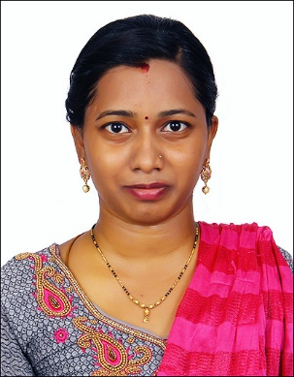
PADMAVATHY GANGADARAN
28-12A-10 Scott Sentral, Jalan Scott, Brickfields
Kuala Lumpur – 50470.
Mobile No: +601126464426
Email Id: padmavathy911997@gmail.com
- CAREER OBJECTIVE
Looking for a challenging role so that I can use my skills and capabilities through sincere dedication and hard work for successful career.

- PERSONAL DETAILS
Name : G. Padmavathy
Father Name : N.S. Gangadaran
Mother Name : G. Shanthi
Husband Name: V. Prasanna Kumar
DOB : 09/01/1997
Gender : Female
Nationality : Indian
Marital status : Married
Languages known : Tamil, English and Telugu.

- EDUCATION
- B.Sc. Chemistry from Justice Basheer Syed Ahamed College for Women Affiliated to University of Madras (2014 – 2017) with aggregate of 80%.
- M.Sc. Chemistry from Bharathi Women’s College for Women Affiliated to University of Madras (2017 – 2019) with aggregate of 80%.
- B.Ed. from E.S.S.M College of Education Affiliated to Tamilnadu Teachers Education University (2020 – 2022) with aggregate of 75%.

- CERTIFICATION
- Diploma in MS-Office.
- Junior typewriting in English.
- Montessori training
- I have attended an internship training in Quality control at Rumi herbals Pvt ltd.

- PERSONAL STRENGTHS
- Honest, Punctual, Team works and Good in communication.
- Confident and positive attitude.

- SKILLS
- Teaching
- MS Office
- Typing
- Designing

- REFERENCE
- A.M Chakrapani, Principal, “ESSM college of Education, Thiruthani”,
Phone No: +91-9443644200
- Anuradha, Assistant Principal, “Annie Besant Matriculation school, Kanchipuram”, Phone No: +91 9944029009

PADMAVATHY GANGADARAN

