Executive Summary
This project focuses on analyzing mutual fund performance, investor behaviour, and industry trends using data analytics and visualization techniques. The objective was to gain meaningful insights from mutual fund data and present them through interactive dashboards and analytical reports.
The project started with data cleaning and preprocessing of multiple datasets such as NAV history, fund performance, benchmark indices, SIP inflows, portfolio holdings, and investor transactions. Exploratory Data Analysis (EDA) was then performed to understand trends, identify patterns, and evaluate the overall growth of the mutual fund industry.
Several performance metrics including CAGR, Sharpe Ratio, Sortino Ratio, Alpha, Beta, Tracking Error, and Maximum Drawdown were calculated to compare funds based on risk and return. Advanced analytics such as VaR, CVaR, Rolling Sharpe Ratio, Investor Cohort Analysis, SIP Continuity Analysis, Fund Recommendation Logic, and Sector Concentration Analysis were also implemented to gain deeper insights.
To make the analysis easy to understand, a Power BI dashboard was developed with multiple interactive pages covering industry overview, fund performance, investor analytics, and SIP market trends.
Overall, this project helped in understanding how data analytics can be applied in the financial domain to evaluate mutual funds, analyze investor behaviour, and support better investment decisions.

Data Description
The Mutual Fund Analytics project uses multiple datasets covering fund performance, industry trends, investor transactions, benchmark indices, and portfolio holdings. These datasets were cleaned, transformed, and integrated to perform analysis and build interactive dashboards.
The main datasets used in the project are:
- Fund Master Data – Contains information about mutual fund schemes such as AMFI code, scheme name, fund house, category, risk grade, expense ratio, and assets under management (AUM).
- NAV Data – Contains historical Net Asset Value (NAV) records for mutual fund schemes. This dataset was used to calculate returns, CAGR, Sharpe Ratio, Sortino Ratio, VaR, and CVaR.
- Performance Data – Includes key performance indicators such as returns, risk measures, expense ratios, and benchmark-related metrics used for fund evaluation.
- Benchmark Indices Data – Contains benchmark index values used to compare mutual fund performance and calculate Alpha, Beta, and Tracking Error.
- Monthly SIP Inflows Data – Provides monthly SIP contribution data used to analyze SIP growth trends and investor participation.
- Category Inflows Data – Contains category-wise mutual fund inflows, helping identify investor preferences across different fund categories.
- Portfolio Holdings Data – Includes stock-level holdings, sector allocation, portfolio weights, and market values. This dataset was used for sector concentration analysis using the Herfindahl-Hirschman Index (HHI).
- Investor Transactions Data – Contains transaction details such as investor ID, transaction type, transaction amount, location, age group, and transaction date. This dataset was used for investor analytics, cohort analysis, and SIP continuity analysis.
- Industry Folio Count Data – Contains information about the number of mutual fund folios over time, helping analyze industry growth and investor participation trends.
- AUM by Fund House Data – Provides fund-house-wise Assets Under Management (AUM) information, enabling comparison of market share and industry positioning among asset management companies.

ETL Process
The ETL (Extract, Transform, Load) process was performed to prepare the raw mutual fund datasets for analysis and dashboard development. Since the data originated from multiple sources and contained inconsistencies, several preprocessing steps were required before analysis.
1. Extract
The raw datasets were collected in CSV format and included information related to mutual fund schemes, NAV history, benchmark indices, SIP inflows, category inflows, portfolio holdings, investor transactions, folio counts, and AUM statistics.
These datasets were loaded into Python using the Pandas library for further processing and analysis.
2. Transform
Several data cleaning and transformation steps were performed:
- Removed duplicate records from all datasets.
- Handled missing and null values where applicable.
- Standardized column names and data formats.
- Converted date columns into datetime format for time-series analysis.
- Corrected inconsistent categorical values.
- Verified data types for numerical and categorical attributes.
- Created calculated fields required for performance analytics.
- Generated daily returns from historical NAV data.
- Aggregated portfolio holdings for sector-level analysis.
- Prepared transaction data for investor and SIP analytics.
Additional analytical datasets were generated during this stage, including:
- CAGR Report
- Sharpe Ratio Report
- Sortino Ratio Report
- Alpha-Beta Report
- Maximum Drawdown Report
- Tracking Error Report
- VaR & CVaR Report
- Investor Cohort Analysis
- SIP Continuity Analysis
- Sector HHI Analysis
3. Load
The transformed datasets and analytical outputs were stored in the processed data folder and used as inputs for Power BI dashboards and advanced analytics modules.
The final processed datasets ensured consistency, improved data quality, and enabled accurate performance evaluation, investor analysis, and dashboard visualization.

EDA Findings
Exploratory Data Analysis was performed to understand the structure of the datasets, identify patterns, detect anomalies, and gain insights into mutual fund industry trends. Various statistical summaries and visualizations were used during this phase.
Industry Growth Analysis
The industry folio count data indicated a steady increase in investor participation over time. The growing number of folios suggests increasing awareness and adoption of mutual funds among retail investors.
Assets Under Management (AUM) Analysis
Analysis of AUM by fund house showed that a few major asset management companies managed a significant share of total industry assets. This highlights the concentration of market share among leading fund houses.
SIP Inflow Trends
Monthly SIP inflow analysis revealed consistent growth in systematic investments. The upward trend reflects increasing investor confidence in long-term wealth creation through disciplined investing.
Category Inflow Analysis
Different mutual fund categories attracted varying levels of investor interest. Equity-oriented categories generally recorded higher inflows, indicating a preference for growth-oriented investment opportunities.
NAV Trend Analysis
Historical NAV analysis showed that most funds experienced long-term growth despite short-term market fluctuations. The NAV trends also highlighted the impact of market cycles on fund performance.
Investor Demographics
Transaction data was analyzed based on age group, state, city tier, and transaction type. The analysis showed differences in investment behaviour across demographic segments and geographical regions.
Portfolio Holdings Analysis
Portfolio holdings data revealed sector-wise allocation patterns across funds. Some funds maintained diversified sector exposure, while others showed higher concentration in specific sectors.
Key EDA Findings
- Investor participation increased steadily over the analysis period.
- SIP inflows showed consistent growth, indicating strong retail investor engagement.
- Equity-focused categories attracted a larger share of investments.
- Leading fund houses controlled a significant portion of industry AUM.
- Investor behaviour varied across age groups and geographical locations.
- Portfolio allocation patterns differed considerably across mutual fund schemes.
The EDA phase provided the foundation for performance analytics, advanced risk analysis, and dashboard development carried out in later stages of the project.

Performance Analysis
Performance analysis was performed to evaluate mutual funds based on both returns and risk. Multiple financial metrics were calculated to compare fund performance and identify top-performing schemes.
CAGR
CAGR was used to measure the annualized growth rate of funds over a specific period. It helped compare the long-term return potential of different schemes.
Sharpe Ratio and Sortino Ratio
Sharpe Ratio was used to evaluate risk-adjusted returns, while Sortino Ratio focused specifically on downside risk. Higher values indicated better performance relative to risk.
Alpha and Beta
Alpha measured a fund's excess return over its benchmark, whereas Beta measured its sensitivity to market movements. These metrics helped assess fund efficiency and market exposure.
Tracking Error and Maximum Drawdown
Tracking Error was used to measure how closely a fund followed its benchmark. Maximum Drawdown measured the largest decline experienced by a fund during the analysis period.
Fund Ranking
A fund scorecard was created using key performance metrics such as CAGR, Sharpe Ratio, Alpha, Expense Ratio, and Maximum Drawdown. Based on the overall score, funds were ranked to identify the best-performing schemes.
Key Findings
- Some funds consistently delivered strong long-term returns.
- Higher Sharpe and Sortino Ratios indicated better risk-adjusted performance.
- Positive Alpha values highlighted funds that outperformed their benchmarks.
- Lower drawdowns indicated better stability during market downturns.
- The fund scorecard provided an effective framework for comparing mutual fund performance.

Advanced Analytics
In addition to traditional performance metrics, advanced analytics techniques were applied to gain deeper insights into fund risk, investor behaviour, and portfolio characteristics.
Historical VaR and CVaR
Value at Risk (VaR) and Conditional Value at Risk (CVaR) were calculated to measure the potential downside risk of mutual funds. These metrics helped identify funds that were more vulnerable during adverse market conditions.
Rolling Sharpe Ratio
A 90-day Rolling Sharpe Ratio was calculated to track changes in risk-adjusted performance over time. This analysis helped identify funds with improving or declining performance trends.
Investor Cohort Analysis
Investors were grouped based on the year of their first transaction. The analysis compared average investment amounts, total investments, and fund preferences across different investor cohorts.
SIP Continuity Analysis
SIP transaction patterns were analyzed to identify investors who may discontinue their SIPs. Investors with an average transaction gap greater than 35 days were classified as at-risk.
Fund Recommendation Model
A simple recommendation engine was developed to suggest funds based on an investor's risk appetite. The model recommends the top-performing funds within the selected risk category using Sharpe Ratio rankings.
Sector Concentration Analysis
The Herfindahl-Hirschman Index (HHI) was used to measure sector concentration within mutual fund portfolios. Higher HHI values indicated greater concentration in a few sectors, while lower values indicated better diversification.
Key Findins
- VaR and CVaR highlighted funds with higher downside risk.
- Rolling Sharpe Ratio helped identify performance trends over time.
- Investor cohorts showed differences in investment behaviour.
- SIP continuity analysis identified investors at risk of discontinuing their SIPs.
- HHI analysis revealed varying levels of portfolio diversification across funds.

Dashboard Overview
An interactive Power BI dashboard was developed to present the insights generated during the analysis. The dashboard consists of four pages covering industry trends, fund performance, investor analytics, and SIP market trends.
Page 1: Industry Overview
This page provides a high-level overview of the mutual fund industry. It includes key metrics such as total AUM, SIP inflows, folio count, and category-wise inflows. The page helps users understand overall industry growth and investment trends.
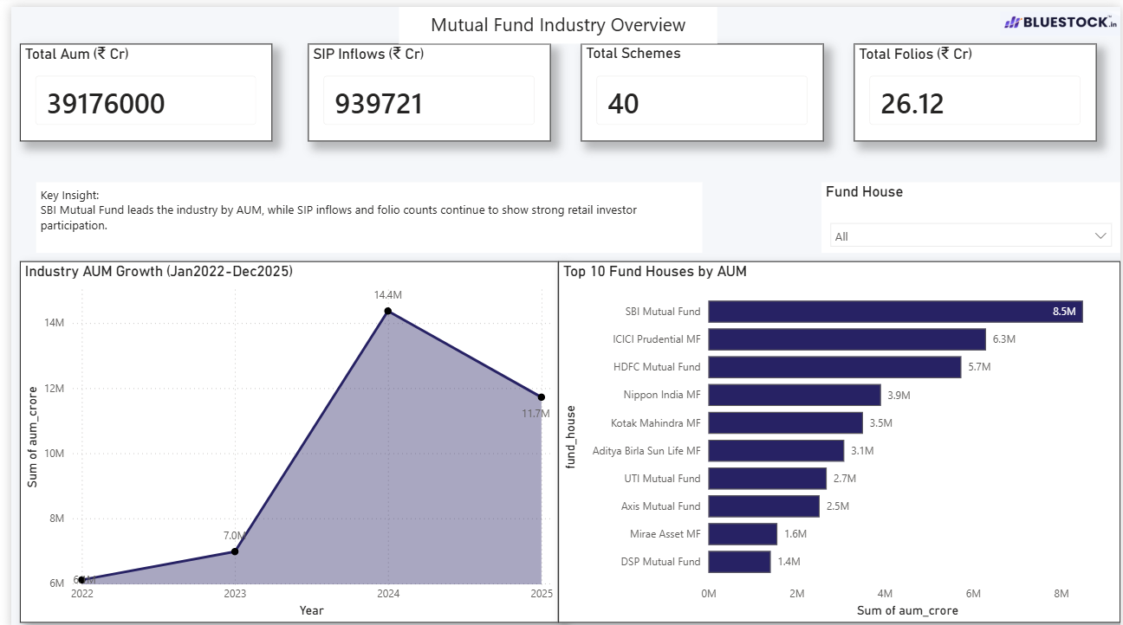
Page 2: Fund Performance Analysis
This page focuses on evaluating mutual fund performance using metrics such as CAGR, Sharpe Ratio, Alpha, Beta, and Maximum Drawdown. It also includes fund rankings and risk-return analysis to compare different schemes.
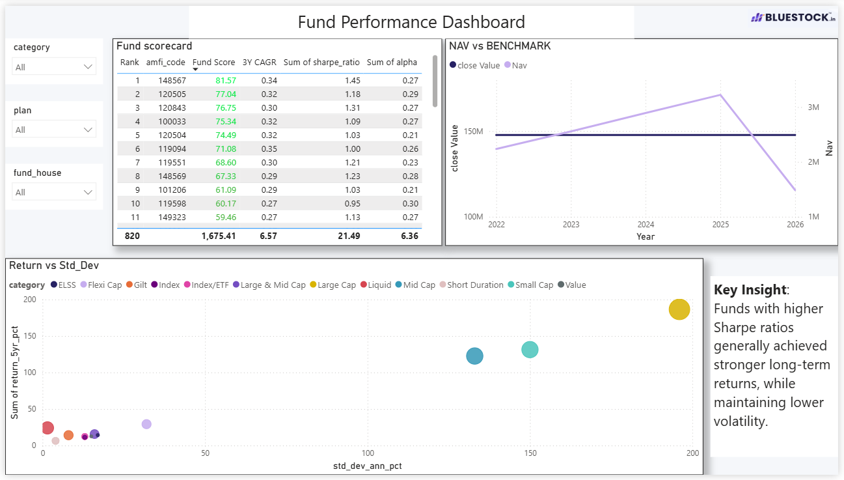
Page 3: Investor Analytics
This page analyzes investor behaviour using transaction data. Visualizations include investment patterns across states, age groups, city tiers, and transaction types. The page provides insights into investor demographics and participation trends.

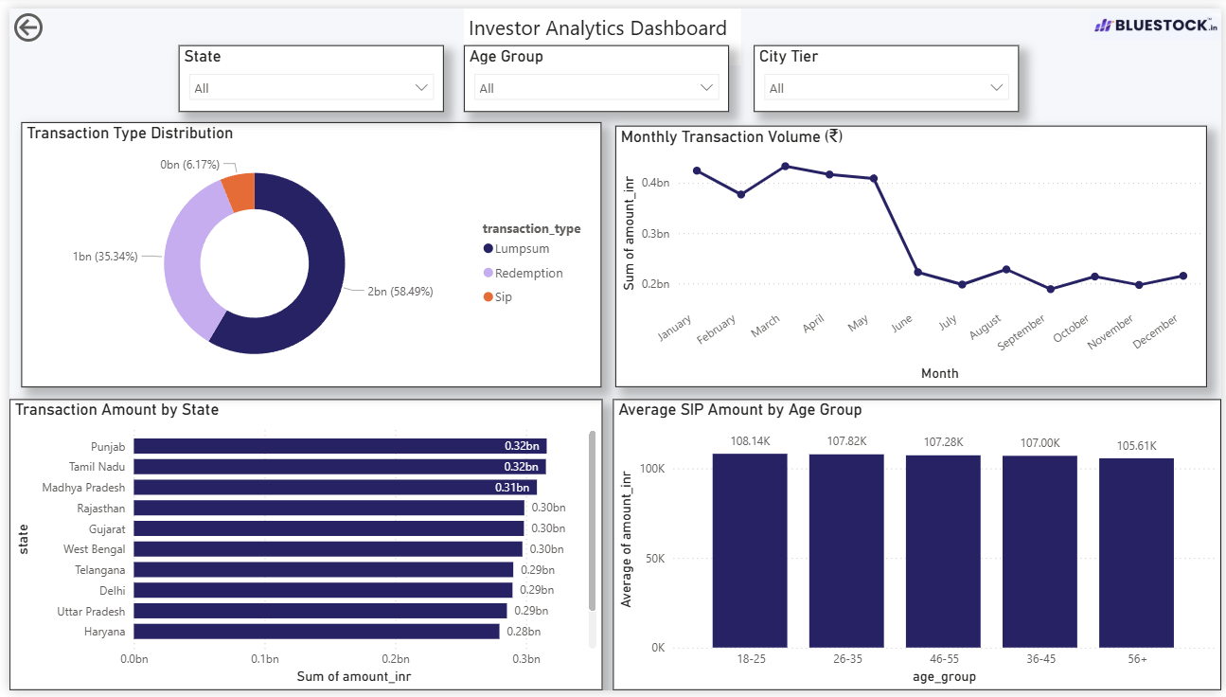
Page 4: SIP & Market Trends
This page highlights SIP growth trends and market indicators. It includes SIP inflow analysis, benchmark trends, category inflows, and other indicators that help understand changing investment behaviour and market movement.
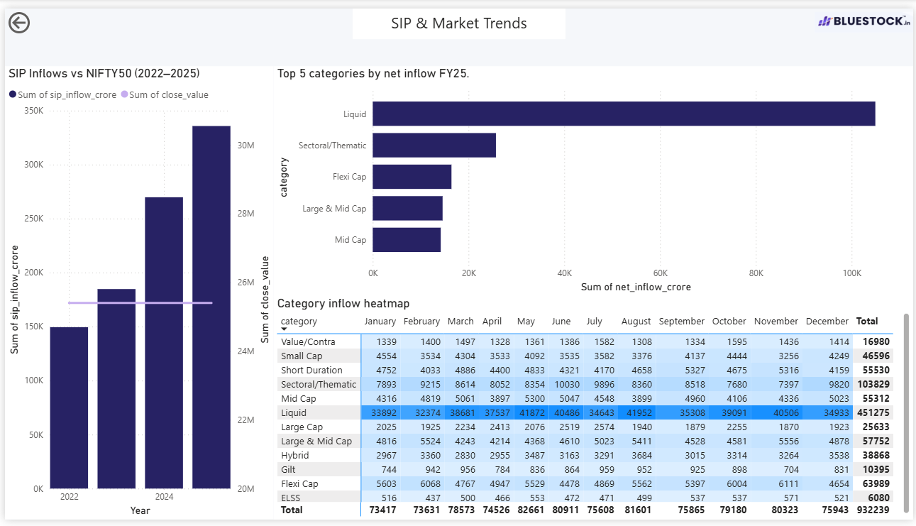
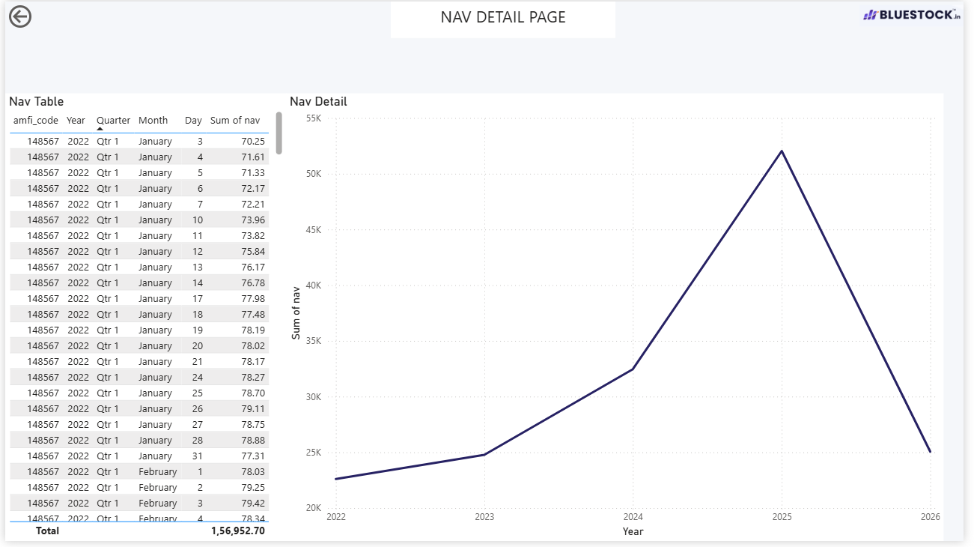

Recommendations
- Investors should not evaluate funds based only on returns. Risk metrics such as VaR, CVaR, Maximum Drawdown, and Sharpe Ratio should also be considered before making investment decisions.
- Funds showing consistently improving Rolling Sharpe Ratios may be monitored as potential investment opportunities, as they demonstrate improving risk-adjusted performance over time.
- Fund houses can use SIP Continuity Analysis to identify investors with irregular contribution patterns and proactively engage them through reminders or awareness campaigns.
- Investor cohorts with higher investment activity can be studied to understand investment preferences and design more targeted financial products.
- Funds with high sector concentration (high HHI values) should be monitored closely, as their performance may be heavily affected by sector-specific market events.
- Rule-based recommendation systems can be integrated into investment platforms to suggest suitable funds based on an investor's risk appetite and historical fund performance.
- Combining traditional performance metrics with advanced analytics can provide a more comprehensive evaluation framework for both investors and fund managers.

Limitations
- The project uses a limited set of mutual fund schemes and investor records. A larger and more diverse dataset could provide broader industry insights.
- Investor behaviour analysis was based only on transaction history. Factors such as financial goals, risk tolerance, and investment experience were not available in the dataset.
- The fund recommendation model uses a simple rule-based approach based on risk appetite and Sharpe Ratio. In a real-world scenario, recommendations would require additional factors such as investment horizon, age, income, and financial objectives.
- Portfolio holdings were analyzed using a single available portfolio snapshot. Changes in portfolio allocation over time were not considered.
- The SIP Continuity Analysis identifies investors with irregular investment patterns but does not capture the actual reasons behind missed or delayed SIP contributions.
- Market conditions, economic events, and regulatory changes can significantly impact mutual fund performance, but these external factors were outside the scope of this project.
- The Power BI dashboard provides a snapshot of the available data and insights. Real-time data integration was not implemented in the current version of the project.

Conclusion
The Mutual Fund Analytics Project successfully applied data analytics and business intelligence techniques to analyze mutual fund performance, investor behaviour, and industry trends. Through data cleaning, transformation, exploratory analysis, and performance evaluation, meaningful insights were generated from multiple mutual fund datasets.
Key financial metrics such as CAGR, Sharpe Ratio, Sortino Ratio, Alpha, Beta, Tracking Error, and Maximum Drawdown were used to evaluate fund performance. Advanced analytics techniques including VaR, CVaR, Rolling Sharpe Ratio, Investor Cohort Analysis, SIP Continuity Analysis, Fund Recommendation Logic, and Sector Concentration Analysis provided deeper insights into risk and investor behaviour.
The Power BI dashboard enabled interactive visualization of industry trends, fund performance, investor demographics, and SIP growth patterns, making the analysis easier to understand and explore.
Overall, the project demonstrated how data analytics can be used to transform raw financial data into actionable insights. It also provided practical experience in data processing, financial analysis, dashboard development, and business intelligence, while highlighting the importance of data-driven decision-making in the mutual fund industry.

