
DEPARTMENT OF CSE
PROJECT ABSTRACT SUBMISSION
COURSE: COMPLIER DESIGN (24CS2235F)
A.Y. 2026 - 2027
TITLE OF THE PROJECT | AI-Powered Intelligent Syntax Error Detection and Correction System
S. No. | University ID | Name
1 | 2420030665 | M.VAISHNAVI
2 | 2420030462 | VOKITHA T
3 | 2420030019 | RAGA PADMINI
4 | 2420030531 | HARSHITHA
Name of the Guide |  | B DWARAKANATH

Abstract
The rapid advancement of Artificial Intelligence (AI) and Internet of Things (IoT) technologies is transforming the healthcare industry by enabling data-driven decision-making and continuous patient monitoring. The proposed AI-Driven Personalized Healthcare Decision Support and Remote Patient Monitoring Platform aims to integrate AI-based analytics with real-time physiological data to provide personalized health insights, early risk prediction, and continuous remote monitoring.
The platform collects vital health parameters such as heart rate, blood pressure, oxygen saturation (SpO₂), body temperature, and ECG through IoT-enabled wearable devices and medical sensors. The collected data is securely transmitted to a cloud environment, where it is stored, processed, and analyzed using machine learning techniques. AI models analyze patient data to identify abnormal health patterns, predict potential health risks, and provide personalized health, lifestyle, and treatment recommendations.
The proposed system also includes an intelligent decision support system that assists healthcare professionals in making accurate and timely decisions. Doctors can access comprehensive patient dashboards containing health trends, real-time alerts, risk predictions, and AI-generated recommendations. Patients can use the platform to access their health reports, receive medication and health reminders, monitor their vital signs, and communicate with healthcare professionals through telemedicine support.
The system is designed to be scalable, secure, and user-friendly, with a strong focus on protecting sensitive healthcare information. Security mechanisms such as secure data transmission, user authentication, and controlled access can be incorporated to protect patient data and support compliance with healthcare privacy requirements. By combining AI, IoT, cloud computing, and remote monitoring, the platform aims to enable proactive and personalized healthcare delivery.
Overall, the proposed platform bridges the gap between patients and healthcare providers by providing continuous health monitoring, intelligent data analysis, early risk identification, and decision support. It can help healthcare professionals respond to potential health issues at an earlier stage while allowing patients to actively monitor and manage their health. The project demonstrates how AI and IoT technologies can contribute to the development of smart, personalized, and data-driven healthcare systems.

PROJECT ARCHITECTURE/OVERVIEW
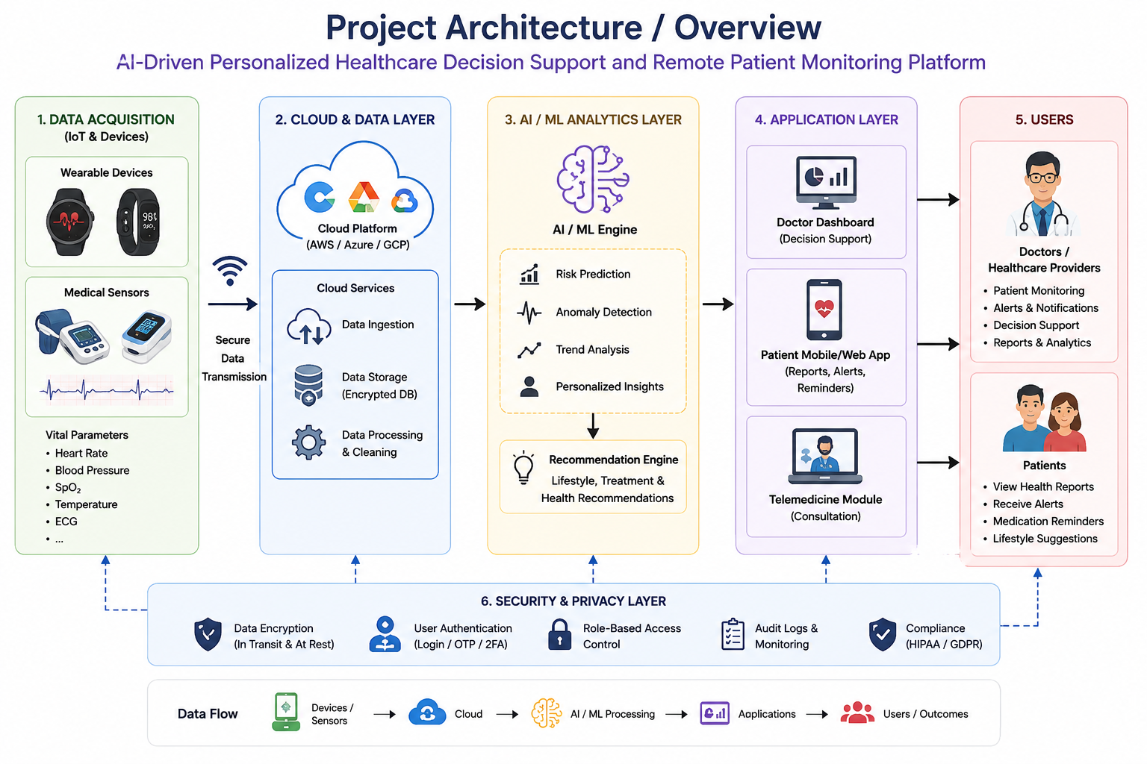

Signature of the Guide HOD

