Peter the Great Saint Petersburg Polytechnic University

Institute of Biomedical Systems and Biotechnologies

High School of Biomedical Systems and Technologies

|  |  |
| --- | --- |
|  | Report accepted: __________  Galina F Malykhina |

**LABORATORY REPORT #1**

**Image Types and Image Coding**

on subject ‘Image Processing’

Variant 10

Author

student, group 4741201/10501 Fedor Y Kabachenko

Instructor

professor, DScTech Galina F Malykhina

Saint Petersburg

2021

**THE PURPOSE** of the laboratory work is to get knowledge about types of images, its processing and representation in MATLAB.

**NECESSARY DATA**: Images - *pears.png*, *rice.png*, *spine.tif*;

Image Processing Toolbox (built-in).

**DESCRIPTION OF WORK PROGRESS:**

Defining the array of strings containing names of required images:

imArray = {'pears.png', 'rice.png', 'spine.tif'}

Let’s iterate through the each image to get information about it’s color type, logical description, resolution and other applied attributes:

for i = 1:length(imArray)

im = imArray{i};

picture = imread(im);

info = imfinfo(im);

figure(i), imshow(picture);

% checking for gray or rgb or indexed

if isequal(info.ColorType, 'truecolor')

isgray = false;

isrgb = true;

isind = false;

elseif isequal(info.ColorType, 'grayscale')

isgray = true;

isrgb = false;

isind = false;

else isequal(info.ColorType, 'indexed')

isgray = false;

isrgb = false;

isind = true;

end

Due to absence of isgray(), isrgb() and isind() functions in new versions of MATLAB, we can extract same data from imfinfo() function that returns ‘struct’-typed variable. Moreover, it is possible to combine several attributes of imfinfo() output if necessary.

In the above part of the code, I have also plotted these images and saved them into figures.

Get the output of the image using f-string and put it into our loop:

txt1 = 'Params of image %d: \n isLogical: %d \n isGray: %d \n isRGB: %d \n isIndexed: %d';

logic = islogical(picture);

str = sprintf(txt1, i, logic, isgray, isrgb, isind);

disp(str);

txt2 = ' Image Info:';

disp(txt2);

disp(info);

Example of the Output:

Params of image 1:

isLogical: 0

isGray: 0

isRGB: 1

isIndexed: 0

Image Info:

Filename: 'C:\Program Files\MATLAB\R2021b\toolbox\images\imdata\pears.png'

FileModDate: '03-May-2003 21:53:57'

FileSize: 554554

Format: 'png'

FormatVersion: []

Width: 732

Height: 486

BitDepth: 24

ColorType: 'truecolor'

FormatSignature: [137 80 78 71 13 10 26 10]

Colormap: []

Histogram: []

InterlaceType: 'none'

Transparency: 'none'

SimpleTransparencyData: []

BackgroundColor: []

RenderingIntent: []

Chromaticities: []

Gamma: []

XResolution: []

YResolution: []

ResolutionUnit: []

XOffset: []

YOffset: []

OffsetUnit: []

SignificantBits: []

ImageModTime: '20 Feb 2003 20:53:33 +0000'

Title: []

Author: []

Description: []

Copyright: 'Copyright Corel'

CreationTime: []

Software: []

Disclaimer: []

Warning: []

Source: []

Comment: []

OtherText: []

Secondly, let’s do some image conversing. I have made to examples with RGB to Grayscaled improved by jet-colormap and RGB to Black & White.

Code of the conversing process:

% RGB to Grayscaled with Sliced colors and jet-colormap

X = imread(imArray{1});

X_gray = rgb2gray(X);

X_ind = grayslice(X_gray, 8);

figure(4),

subplot(311), imshow(X); title('Original image'); hold on;

subplot(312), imshow(X_gray); title('Grayscaled image'); hold on;

subplot(313), imshow(X_ind, jet(8)); title('8-colors colormap of grayscaled image'); hold on;

% RGB to B&W

Y = imread(imArray{2});

Y_bw = im2bw(Y, 0.75);

figure(5),

subplot(211), imshow(Y); title('Original image'); hold on;

subplot(212), imshow(Y_bw); title('Black & White Conversion with 0.75-level'); hold on;

That’s what we have in the output:

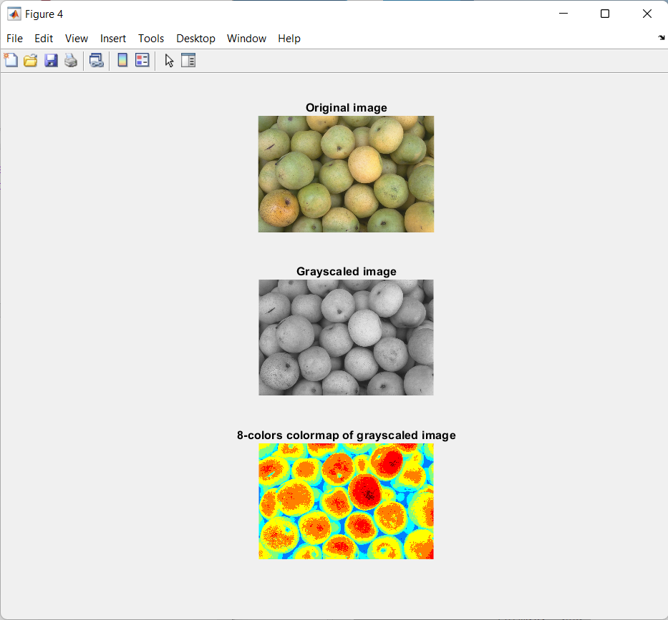

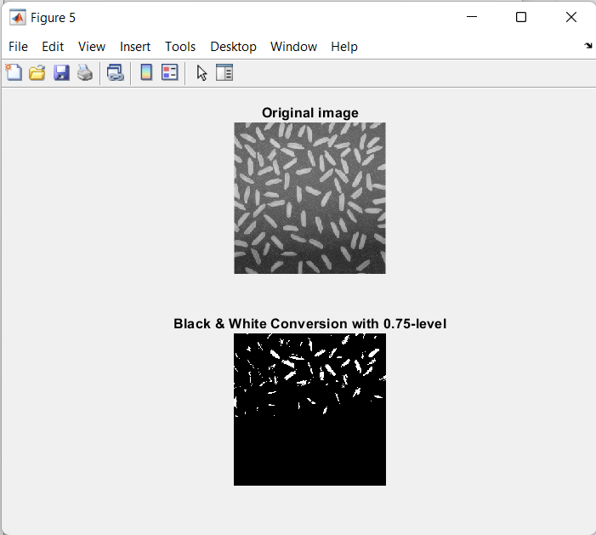

At the request of the teacher, colormaps of different levels were built for a black and white image:

[X_out1, map1] = gray2ind(X_gray, 3);

[X_out2, map2] = gray2ind(X_gray, 4);

[X_out3, map3] = gray2ind(X_gray, 5);

figure(6),

subplot(311), imshow(X_out1, map1); title('Indexed with 3 colors'); hold on;

subplot(312), imshow(X_out2, map2); title('Indexed with 4 colors'); hold on;

subplot(313), imshow(X_out3, map3); title('Indexed with 5 colors'); hold on;

Therefore, the output:

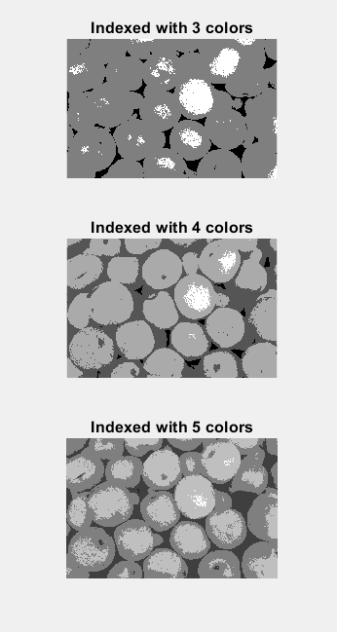

**CONCLUSIONS**

There were described and processed three built-in images in MATLAB according to description process, conversion and colormap levels iteration. As a result, we have got information about main parameters of the each image, its types, transformation approaches and edition possibilities.

**FULL PROGRAM CODE:**

clear;

close all hidden;

% Making array of image names

imArray = {'pears.png', 'rice.png', 'spine.tif'};

% Iterating through the each image to get main information about it

for i = 1:length(imArray)

im = imArray{i};

picture = imread(im);

info = imfinfo(im);

figure(i), imshow(picture);

% checking for gray or rgb or indexed

if isequal(info.ColorType, 'truecolor')

isgray = false;

isrgb = true;

isind = false;

elseif isequal(info.ColorType, 'grayscale')

isgray = true;

isrgb = false;

isind = false;

else isequal(info.ColorType, 'indexed')

isgray = false;

isrgb = false;

isind = true;

end

% preparing string output using f-string

txt1 = 'Params of image %d: \n isLogical: %d \n isGray: %d \n isRGB: %d \n isIndexed: %d';

logic = islogical(picture);

str = sprintf(txt1, i, logic, isgray, isrgb, isind);

disp(str);

txt2 = ' Image Info:';

disp(txt2);

disp(info);

end

% Examples of conversing images

% RGB to Grayscaled with Sliced colors and jet-colormap

X = imread(imArray{1});

X_gray = rgb2gray(X);

X_ind = grayslice(X_gray, 8);

figure(4),

subplot(311), imshow(X); title('Original image'); hold on;

subplot(312), imshow(X_gray); title('Grayscaled image'); hold on;

subplot(313), imshow(X_ind, jet(8)); title('8-colors colormap of grayscaled image'); hold on;

% RGB to B&W

Y = imread(imArray{2});

Y_bw = im2bw(Y, 0.75);

figure(5),

subplot(211), imshow(Y); title('Original image'); hold on;

subplot(212), imshow(Y_bw); title('Black & White Conversion with 0.75-level'); hold on;

% Working with colormaps

[X_out1, map1] = gray2ind(X_gray, 3);

[X_out2, map2] = gray2ind(X_gray, 4);

[X_out3, map3] = gray2ind(X_gray, 5);

figure(6),

subplot(311), imshow(X_out1, map1); title('Indexed with 3 colors'); hold on;

subplot(312), imshow(X_out2, map2); title('Indexed with 4 colors'); hold on;

subplot(313), imshow(X_out3, map3); title('Indexed with 5 colors'); hold on;