COLLEGEOFENGINEERINGANDTECHNOLOGY

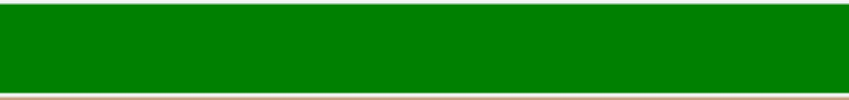



Name: Paul Angelo Adoremos Course/Yr/Section: BSIT – 2A
Title of Assignment: WEBSITE LAYOUTAND STRUCTURE WITH CONTENT PER MENUan

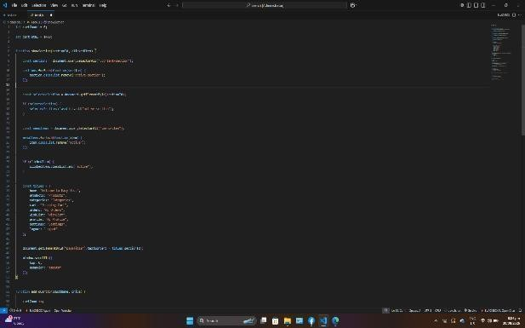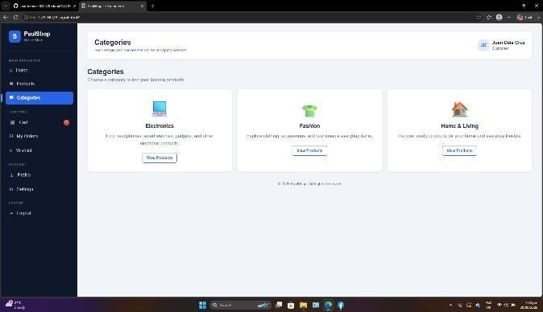
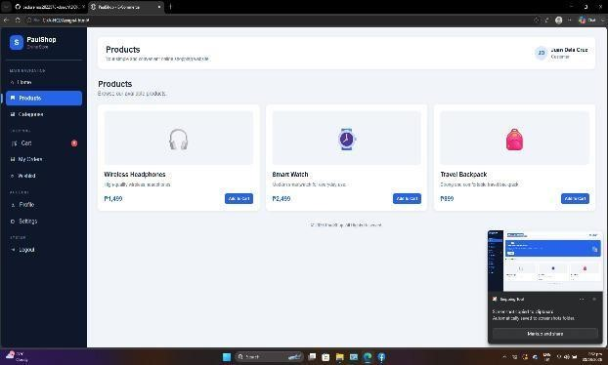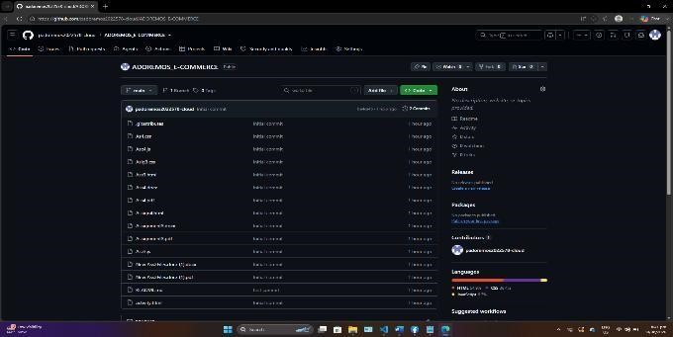
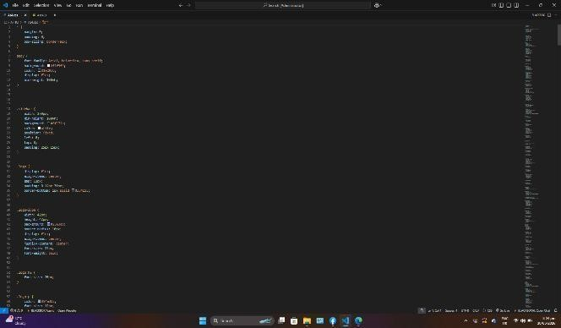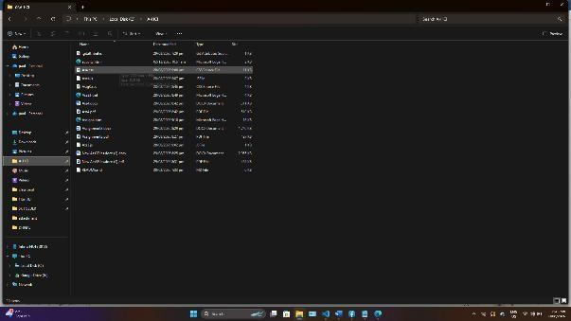

COLLEGEOFENGINEERINGANDTECHNOLOGY
Name: Paul Angelo Adoremos Course/Yr/Section: BSIT – 2A
Title of Assignment: WEBSITE LAYOUTAND STRUCTURE WITH CONTENT PER MENUan

Descripton: The output is an e-commerce website layout with a side menu containing Home, Products, Categories, Cart, My Orders, Wishlist, Profile, Settings, and Logout. Each menu has its own content and an active menu indicator to show the currently selected section. The website uses cards, buttons, spacing, hover effects, and a consistent color theme to create a clean and organized interface.
OBJECTIVE: To create a clean and organized e-commerce website layout. To implement a side menu with properly grouped menu items. To provide content for each required menu section. To apply HTML and CSS for the website structure and design. To use JavaScript to add basic website interactions.To practice organizing website files and uploading the project to GitHub.
EXPLANATION:
The HTML code provides the basic structure of the website. It contains the side menu, menu groups, main content area, cards, buttons, and individual sections for each menu item. The side menu is divided into Main Navigation, Shopping, Account, and System groups. Each section contains the required information for that menu.
The CSS is used to create a clean, organized, and readable design. It controls the layout, spacing, alignment, fonts, colors, cards, buttons, hover effects, and active menu indicator. The design uses a consistent color theme and responsive layout to make the website easier to navigate. These design features follow the requirements of the activity.
JavaScript is used to add interaction and functionality to the website. It can change the active menu when a user clicks a menu item, display different content, handle the side menu, provide logout

COLLEGEOFENGINEERINGANDTECHNOLOGY
Name: Paul Angelo Adoremos Course/Yr/Section: BSIT – 2A
Title of Assignment: WEBSITE LAYOUTAND STRUCTURE WITH CONTENT PER MENUan

CONCLUSION:
This activity helped me understand how to create a structured e-commerce website with multiple menu sections. I learned how HTML provides the structure, CSS improves the appearance and layout, and JavaScript adds interaction and functionality. I also learned the importance of organizing project files and uploading a complete project to GitHub. Overall, the activity improved my skills in front-end web development and helped me understand how different parts of a website work together.

