COLLEGE OF ENGINEERING AND TECHNOLOGY

Name: PAUL ANGELO R. ADOREMOS
Course/Yr/Section: BSIT – 2D





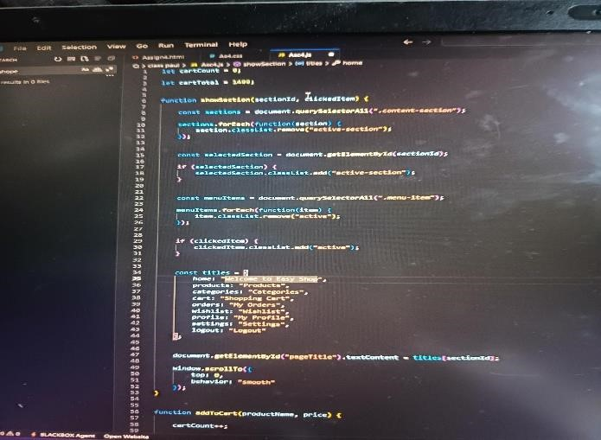
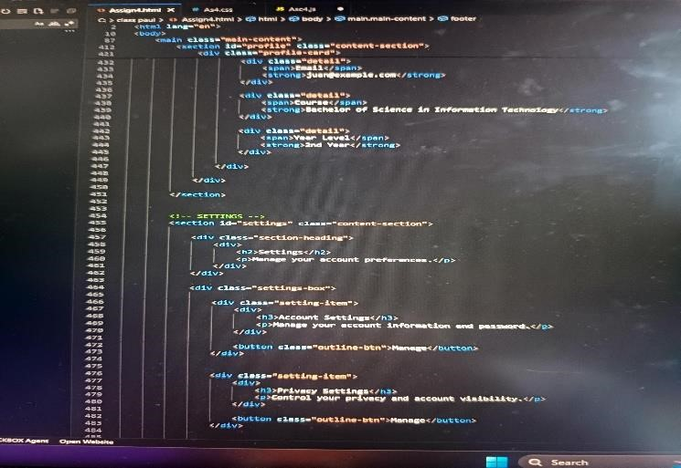
Title of Assignment: WEBSITE LAYOUT AND STRUCTURE WITH CONTENT PER MENU

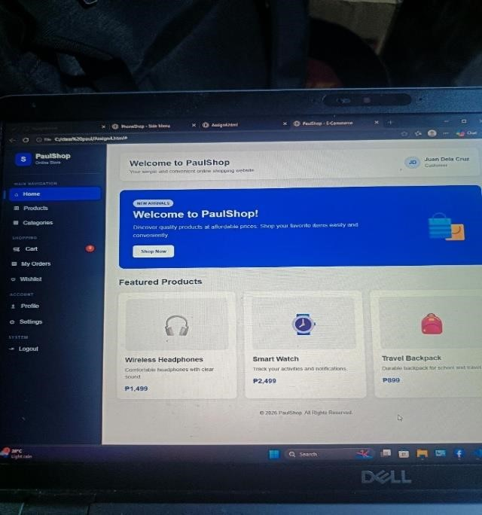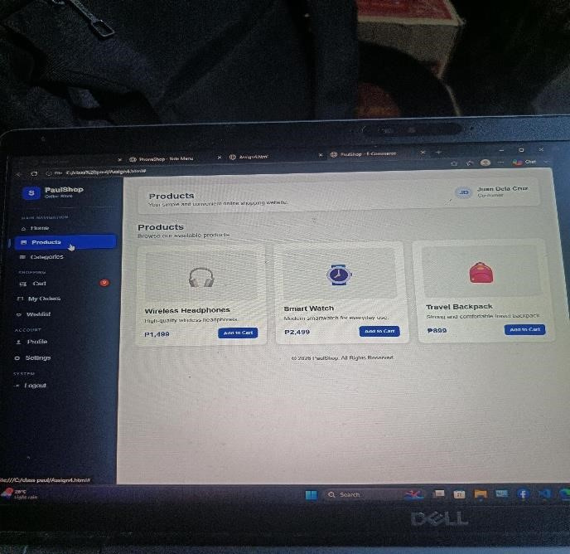

https://github.com/padoremos2022578-cloud/--ADOREMOS_E-COMMERCE.git

