**Developing a mobile CT game**

**Bebras App**

**Padraig Sean Connolly**

**13528563**

Final Year Project – **2016/2017**

B.Sc. Single Honours in

Computer Science/Computer Science and Software Engineering



Department of Computer Science

Maynooth University

Maynooth, Co. Kildare

Ireland

A thesis submitted in partial fulfilment of the requirements for the B.Sc.

Single Honours in Computer Science/Computer Science and Software

Engineering.

Supervisor: **Aiden Mooney***.*

Contents

Declaration i

Acknowledgements ii

Abstract iii

List of Figures iv

List of Tables iv

**Chapter one: Introduction** 1

Summary 1

1.1 Topic addressed in this project 1

1.2 Motivation 1

1.3 Problem statement 1

1.4 Approach 1

1.5 Metrics 2

1.6 Project 2

**Chapter two: Technical Background** 3

Summary 3

2.1 Topic material 3

2.2 Technical material 3

**Chapter three: The Problem** 4

Summary 4

3.1 Project UML documentation 4

3.2 Problem analysis 4

**Chapter four: The Solution** 5

Summary 5

Depending on your type of project, you may not need to include all of these: 5

4.1 Analytical Work 5

4.2 Architectural Level 5

4.2 High Level 5

E.g. Packages, Class Diagrams, etc. 5

4.2 Low Level 5

E.g. Method specifications, Algorithms, etc. 5

4.2 Implementation 5

**Chapter five: Evaluation** 6

Summary 6

5.1 Solution Verification 6

E.g. use your equations to verify the correctness of your solution 6

5.2 Software Design Verification 6

5.3 Software Verification 6

5.3.1 Your test approach (i.e. unit testing, sub-system testing, system testing) 6

5.3.2 Your tests (e.g. scenarios, test cases, test data, etc.) 6

5.3.3 Your test results 6

5.3.4 An interpretation of the results 6

5.4 Validation/Measurements 6

5.4.1 Results 6

5.4.2 Explanation of Results 7

5.4.3 Analysis of Results 7

5.4.4 Comparison with previous solutions (if relevant) 7

**Chapter five: Conclusion** 8

**Summary** 8

**5.1** **Contribution to the state-of-the-art** 8

**5.2** **Results discussion** 8

**5.3** **Project Approach** 8

**5.3** **Future Work** 8

**References** 9

**Appendices** 10

Appendix 1 Schematic of the hardware associated with this project. 11

Appendix 2 Code developed for this project. 12

Appendix 3 UML Class, Use Case and sequence diagrams for this project. 13

Appendix 4 Screen shots of the project implementation 14

## Declaration

I hereby certify that this material, which I now submit for assessment on the program of study as part of my B.Sc. Single Honours in Computer Science/Computer Science and Software Engineering qualification is *entirely* my own work and has not been taken from the work of others - save and to the extent that such work has been cited and acknowledged within the text of my work.

Signed: Padraig Connolly Date: 01/02/2017

## Acknowledgements

I would like to thank the CoderDojo students and teachers for allowing me to take the time to test my application on real students of the optimum age group, which is the most valuable group of subjects to evaluate the use of the application. The data observed from this group of individuals gave me an understanding of how useful the application was and also gave me feedback on how well it performed and how it can be improved.

I would like to thank my fellow students in fourth year computer science in Maynooth University for their feedback, cooperation and of course friendship. In addition, I would like to express my gratitude to the staff of the Eolas Building for the use of the facilities.

Nevertheless, I am also grateful to the Mr Aidan Mooney, PhD, Computer Science and Software Engineering Lecturer and my project supervisor for his invaluable advice, feedback and above all else guidance.

I would like to thank my friends for accepting nothing less than excellence from me. Last but not the least, I would like to thank my family: my parents and to my brothers and sister for supporting me spiritually throughout writing this thesis and my life in general.

## Abstract

To develop a gaming application that will help improve the Computational Thinking skills in young children will be available across multiple devices including tablets, phone (iOS, Android) and on PC’s via a web application. The application will also hopefully provide insightful feedback that will alert children into thinking about the areas of logic they may need to improve on and why they may need to improve on it. The background of this project was based on the new Lithuanian competition introduced in 2004 known as Bebras, the competitions purpose was to promote Informatics (or Computer Science, or Computing) and Computational Thinking especially among teachers and pupils of all ages, but also to the public at large by extent. The big challenge of Bebras is to organise easily accessible and highly motivating online challenge in many countries. This challenge will prove much easier for a gaming application that can be played on multiple devices that is available on different marketplaces. Given a problem sheet from my supervisor, I started developing the game problems on a SDK known as App Game Kit, the reason being the choice for this software was due to the fact that it could easily port the project into the required Operating Systems that proved to be a major obstacle. As well as the fact that I had previously used the software before for personal reasons.

## List of Figures

Figure 3‑1 UML class diagram overview for this project. 4

## List of Tables

Table 2‑1 Table of interest: Aspect of your implementation 2

Table 2‑2 Data sources used in your implementation 2

# **Chapter one: Introduction**

## Summary

This chapter will introduce the main topic proposed in this project, the motivation for me undertaking this project and why I undertook the project give my reasons and background, the natural problems that this task will have to overcome and my approach in how I will solve these problems. This chapter will also conclude how I evaluated my performance during this assignment and will list and describe the achievements made during this endeavour.

## 1.1 Topic addressed in this project

In everyday life people are dealt with problems that are solved through the fundamental use of logic. The definition of logic is stated by the Cambridge Dictionary as “a particular way of thinking, especially one that is reasonable and based on good judgment”. Seen as each different real world problem is unique and not all solutions to these problems are the same but the approach to a lot of real dilemmas will require a sense of reasoning and logic. This form of thinking is of course the foundations of many different and important fields today particularly computer science and Mathematics. Then it is of utmost importance to make sure that logic is a part of our education system and is applied to the problems given to today’s students. However, it has been noted of late that students that have come out of the education system cannot apply what they’ve learned from their studies to their field as problems that naturally erupt occur that can be solved easy with a logical way of thinking, particularly for those in the field of computer science and software engineering which is a very practical subject. To address this issue, A European Organisation known as Bebras was set up in 2004

as a new non-school activity in Informatics education, which currently has the largest amount of participants for studying this field. The goal of Bebras is to try and promote Computational thinking within not only students but also to teachers and the public as well. The application developed in this project is an interactive game that will help develop computational thinking and creativity in the brain so that real world problems can be solved using a logical basis.

## 1.2 Motivation

Bebras has the challenge of organising events and challenges across Europe for young students to take part in and help develop their computational thinking, which was hosted in certain countries in Europe such as Lithuania and has gained attention ever since with many countries participating in the challenge particularly France and Germany who are currently leading in the most participants in the Bebras community from 2015 to 2011 as seen in the graphs below.

**Participants in 2016 Bebras challenge and No. of students from countries who attended**

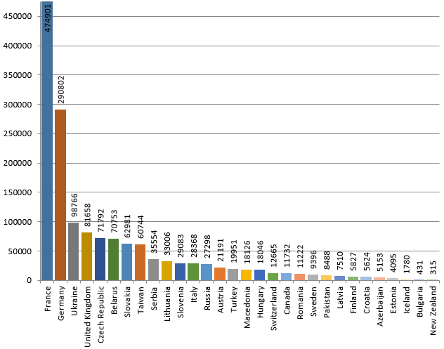

**Participants in 2014 Bebras challenge and No. of students from countries who attended**

**Last time Ireland attended**

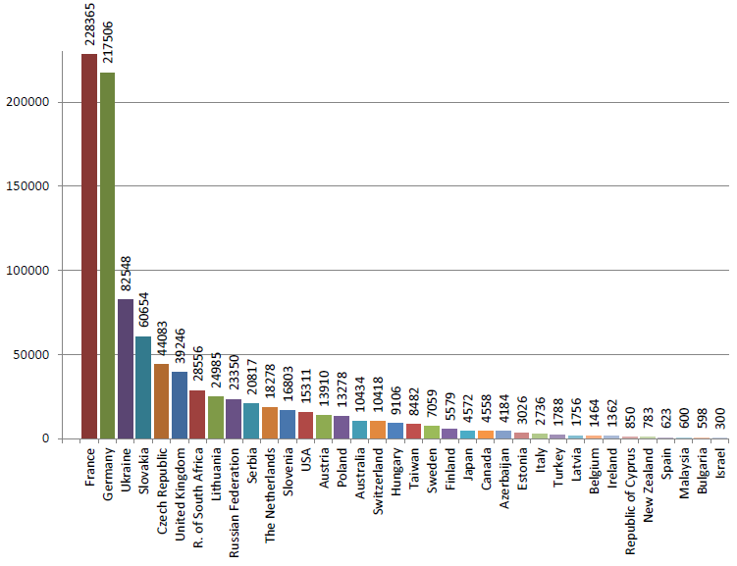

However, we can see that over the years Ireland’s participation in this organisation has been declining to the point of nonexistence. The last time Ireland has been recorded in participating in Bebras was in 2014 with 1362 participants.(Bebras, 2016) This statistic is somewhat worrying as you have to consider that Ireland has a desire to be one of the leading and most attracting countries for technology companies to settle offshore (as Ireland is the second largest exporter of computer and IT services in the world) as well as for future start-up companies.(Enterprise Ireland, 2015) These companies will want the new generation to be educated in Computational and logic so that this new workforce is adept at handling problems involving software. If Ireland continues to turn a blind eye to this need of educating students (particularly young children) then the current Technology companies in Ireland, as well as future, will continue in exporting these positions for Software roles to people from other countries as the engineering talent required to service the expansion of the industry is simply not available in big enough quantities within this country. One of the reasons for this may be due to the fact that dropout rates are between a quarter and a third in Computer Science and Computational Thinking courses. (Will Goodbody, 2014). Irelands lack of participation in the Bebras challenge may be due to lack of funding in this area for young people, and so Bebras has a problem of not creating enough opportunity for students from across the globe to take part in this event. To solve this problem Bebras has developed mini-games and challenges on their website so that there is some experience for people to practice some of the Bebras problems.(Bebras, n.d.) However, immediately after solving the first few problems you will notice that there is not a lot of variability of the games and recur around the one problem with the same concept, making this not as engaging which is a must for students who have not been exposed to this way of thinking. As well as that, the challenge is primarily for web browsers and does not translate as well to mobile platforms and the only available mobile app from Bebras is on Google Play(Android) and is only in German (Google Play, n.d.). Most games played by adolescents and children are played on mobile applications and tablets. In fact a reason statistic shows that the average weekly time children aged two to 17 spent playing mobile games in 2011 and 2013 has increased from five hours to seven hours a week (statista, n.d.) . This is hardly a surprising statistic given the late trend of mobile gaming and the investment in this development. So how do we invigorate the useful skill of computation and informatics in today’s students if there is not enough being done in Ireland’s schools to develop this rational behaviour? The idea of this project is to develop a fun and interactive game that will naturally develop a person’s (particularly children and adolescent) mind.

## 1.3 Problem statement

The problem with developing an application that must develop the Computational thinking in children and invest an interest in this analytical way of thinking is that the front must be engaging and enticing. There is very little chance in gaining interest in most modern day applications with a poor User Interfaces. Thus the look and feel plays a big role in the project. To help with this problem the Software tool I used to create this game is App Game Kit. I have purchased this Development kit before the project announcement as I have made games previously using this software and I am fairly familiar with the language used for scripting these game files, known as AGK. Alongside this scripting language, Games can also be programmed with C++ and can be written in other IDE’s such as visual studio. (“AppGameKit,” 2011) Another technical problem with designing this application is that it must handle at least more than one platform to be played on. Bebras have yet to address this issue with their application as it only on android. Another problem this project was dealt with was the integration of a backend that would store a database table containing all the information about how well each of the user’s faired in the problem’s they were given. This is probably the most difficult task as the process of actually collecting this data from the front end is difficult.

## 1.4 Approach

The reason that App Game Kit helps with solving the task regarding the User Interface is due to the fact that it can handle, render and display various graphics and animations seamlessly in a desired resolution and Frame Rate. With regards to the problem of developing an application/game to develop Computational Thinking that is multi-platform, App Game Kit helps solve this problem as it was designed to be make games across many platforms including iOS, Android and as Web page. (Does this by exporting finished project into whatever format the platform is required to be in e.g. Android – APK) I have analysed both these issue by weighing up the possibility of using other different frameworks that could provide a nice alternative for handling a nice User Experience and providing the nice addition of being Cross Platform as well. A mobile framework that immediately came to mind was Ionic as I have used it before for making web applications during my work placement and the Graphical User Interface was seamless, however one ironic problem for this framework was that although developed for cross platform transitions, once it was tailored made for desktop users, the transition to a mobile phone was not what was hoped for as it didn’t adjust to different screen sizes as well. Foundation 6 for apps was a better alternative as from experience the transition from desktop to phone was better than Ionic. However although these frameworks are great for making modern day UI’s for web applications, there was still a major problem when it came to animation and graphics rendering as JavaScript was not intended to handle these features and although it can be used for game development (as there are many JavaScript flash games) the amount of effort and libraries of code needed still wouldn’t compare to having an actual tried and tested game engine to develop these games. Having also been advised Phone gap as an alternative solution it faced the same problems as although the project would have been formatted for different mobile platforms such as Android and iOS, the code formatted from the project is still Web based (JavaScript). When it comes to the problem of getting feedback to the users App game kit has helped in the fact that it has prebuilt in methods of obtaining in game data, such as time spent and screen input. So thankfully App Game Kit has a way of storing these values. However even still getting this data to and from back to front end has been difficult as although app game kit has HTTP connections to and from the database, this problem must be handled in a quick manner.

## 1.5 Metrics

To evaluate my work, I have tested the application on many participants, ranging from all ages and genders to see how well each individual faired. Most of these participants should be young students however as they are the ones who are targeted for this game, which is why I have trialled the app on the Maynooth CoderDojo students which I am a part of. The results obtained are the best standard as these are young children currently in the process of exercising themselves with these activities that the game helps promote. They are also part of the education system where they should be currently exposed to this way of thinking, so in this I can evaluate how well they are performing. The age group within these CoderDojo classes is between 8 – 12 years old. I have also allowed other members of society to play this game, as it would be unwise to adjudge the games on just children while people of all ages may also have problems too.

## 1.6 Project

The goals achieved during this project have been that I have successively made a game that helps develop Computational Thinking. This has been tried and tested on young children how have also given feedback on the game, and the results have been helpful in providing an insight to how well todays children fair in real problems that can only be solved using logic.

Another goal that has been achieved is that the game is also cross platform, which is something Bebras have yet to add. The game can be played on mobile devices such as Android and iOS as well as any PC as it is hosted on a web page. Making a game for Computational Thinking far more accessible.

Another accomplishment is that the game has successively been linked to a backend, a MySQL database which has stored the scores of the individuals that have played it. This feedback is retrieved and sent from the front end, and can be accessed in the ‘My Profile’ page of the app’s main menu. TBD

# **Chapter two: Technical Background**

## Summary

The purpose of this chapter is to show your depth and breadth of reading and understanding of the problem domain

## 2.1 Topic material

T

(Research material, if used, from published journals and conference proceedings; less academic publications, if required by the project, from other sources) – for example, what other work researchers have done already in this area, what results they have produced, what work has been done in related areas, what software already exists to solve this or similar problems, etc.

## 2.2 Technical material

(From any source: including books, websites) – for example, how to write a web server, how to use specific Java features, how to use Ajax, how to use UML to validate your design, etc.

NB: Note that material relating to the motivation or non-technical background should **NOT** go here, but rather in the introduction

Table 2‑1 Table of interest: Aspect of your implementation

|  |  |
| --- | --- |
| **Column description 1** | **Column description 2** |
| A | Text 1 |
| B | Text 2 |
| C | Text 3 |

Table 2‑2 Data sources used in your implementation

|  |  |  |
| --- | --- | --- |
| **Column description 1** | **Column description 2** | **Column description 3** |
| X | 22 | 33 |
| Y | 33 | 456 |
| Z | 17 | 22 |

# **Chapter three: The Problem**

## Summary

The purpose of this chapter is to clearly explain the technical problem and/or identify the user requirements.

## 3.1 Project UML documentation

Provide any model(s) of the problem (e.g. equations, ERD’s, UML Use Cases & Scenarios, Activity Diagrams, etc.)

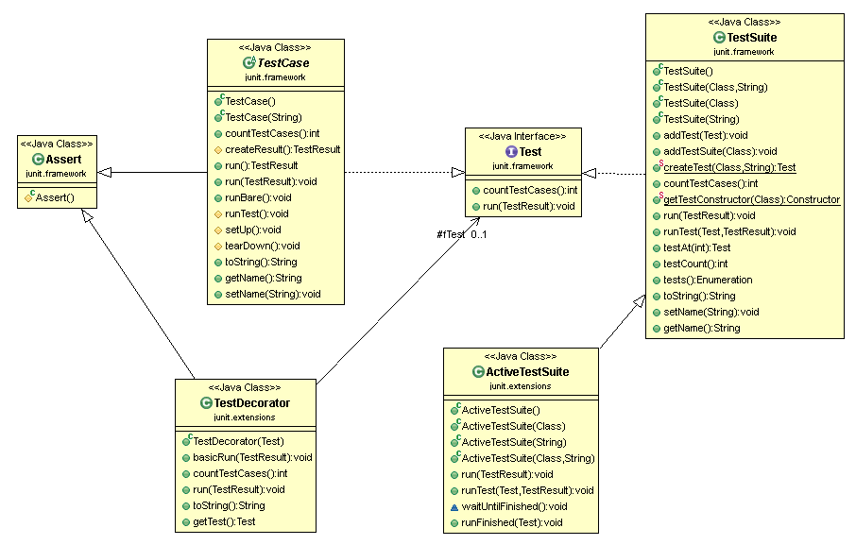

Figure 3‑1 UML class diagram overview for this project.

## 3.2 Problem analysis

Provide any analysis of the problem, leading to a greater understanding

There should be no decisions made in this chapter

# **Chapter four: The Solution**

## Summary

The purpose of this chapter is to clearly identify, discuss, and justify the decisions you make

## Depending on your type of project, you may not need to include all of these:

## 4.1 Analytical Work

E.g. Equations, etc. that describe your solution

## 4.2 Architectural Level

E.g. Implementation Diagrams

## 4.2 High Level

## E.g. Packages, Class Diagrams, etc.

## 4.2 Low Level

## E.g. Method specifications, Algorithms, etc.

## 4.2 Implementation

Discuss anything interesting here; put full source code in an appendix or attachment

# **Chapter five: Evaluation**

## Summary

Chapter 5 describes……..

## 5.1 Solution Verification

## E.g. use your equations to verify the correctness of your solution

## 5.2 Software Design Verification

How did you show that your design worked properly?

Using a model of your solution. E.g. use UML interaction diagrams to verify each scenario.

## 5.3 Software Verification

How did you demonstrate your software worked properly?

If you have not tested your software, then you cannot rely on your results. Clearly describe:

### 5.3.1 Your test approach (i.e. unit testing, sub-system testing, system testing)

### 5.3.2 Your tests (e.g. scenarios, test cases, test data, etc.)

### 5.3.3 Your test results

### 5.3.4 An interpretation of the results

## 5.4 Validation/Measurements

How did you measure how well your solution solved the problem.

### 5.4.1 Results

### 5.4.2 Explanation of Results

### 5.4.3 Analysis of Results

### 5.4.4 Comparison with previous solutions (if relevant)

**Chapter five: Conclusion**

**Summary**

Chapter 5 identifies and discuss the implications of your work.

**5.1 Contribution to the state-of-the-art**

If you made a contribution to the state-of-the-art, clearly identify it here.

**5.2 Results discussion**

Discuss whether your results are general, potentially generalizable, or specific to a particular case. Identify threats to the validity of your results (e.g. limitations, risks introduced by your approach, etc.)

**5.3 Project Approach**

Discuss your project approach

**5.3 Future Work**

Discuss future work, based on what you have done (and not done)

# **References**

AppGameKit. (2011). Retrieved February 22, 2017, from https://www.appgamekit.com/

Bebras. (n.d.). www.bebras.org. Retrieved February 22, 2017, from http://www.bebras.org/

Bebras. (2012). What is Bebras | www.bebras.org. Retrieved February 21, 2017, from http://www.bebras.org/?q=about

Bebras. (2016). Statistics | www.bebras.org. Retrieved February 22, 2017, from http://www.bebras.org/?q=statistics

Enterprise Ireland. (2015). Information &amp; Communications Technology (ICT) sector profile - Enterprise Ireland. Retrieved February 22, 2017, from https://www.enterprise-ireland.com/en/Start-a-Business-in-Ireland/Startups-from-Outside-Ireland/Key-Sectors-and-Companies-in-Ireland/ICT-sector-profile.html

Google Play. (n.d.). Bebras - Android Apps on Google Play. Retrieved February 22, 2017, from https://play.google.com/store/apps/details?id=org.bebras&hl=en

statista. (n.d.). • Time children spend playing mobile games 2011-2013 | Statistic. Retrieved February 22, 2017, from https://www.statista.com/statistics/271930/time-children-spend-playing-mobile-games/

Will Goodbody. (2014). The hard reality of the Irish software industry - RTÉ News. Retrieved February 22, 2017, from https://analysis.rte.ie/business/2014/07/14/the-hard-reality-of-the-irish-software-industry/

(Bebras, 2012)

**Appendices**

Include here all extra material, e.g. your source code, project management (optional) including: the task list, Gantt Chart diagrams (or equivalent), discussion of any significant deviations from plan, and how you managed them, discussion of what you would do differently if you repeated the project.

## Appendix 1 Schematic of the hardware associated with this project.

## Appendix 2 Code developed for this project.

## Appendix 3 UML Class, Use Case and sequence diagrams for this project.

|  |
| --- |
|  |
| Appendix 4 Screen shots of the project implementation |
|  |