There are total 6 shapes :

1) Title : Input File

O/P : Read

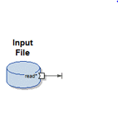

2) Block

Title : Variable

I/P :

1. In

O/P:

1. Out
2. Reject
3. Error
4. log

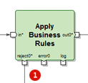

3) Demux

In

Multiple Out



4) Record stack

Title : variable

I/P : Write



5) Function Sort

I/P : In

O/P : out

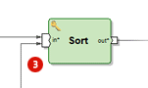

6) MQ Publish

I/P :

1. In

O/P:

1. Reject
2. Error
3. log

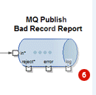

7) Connection

Unidirectional Arrow

Out to Input

Multi out

Multi In

