This program was developed for a doctor’s clinic to manage doctor, nurse and patient interactions as well as appointments. The application was developed using python along with Object Oriented Programming techniques such as inheritance, polymorphism, etc.

In order to run the application, the main.py acts as the interface to interact with all the classes and functions.

The healthcareprofessional class is handling the ViewAppointment and Consultation functions. The consultation function will look for the next available appointment (logic in appointmentSchedule). If there's still appointments scheduled for today, we will 'consult', mark the appointment as complete, and return our 'consultation'. Since it is not clearly defined what exactly consultation should do and because patients can sometimes require prescriptions, I decided to return a random set of prescriptions. These are just "suggestions'' as the nurse cannot actually issue prescriptions. Doctor class contains the IssuePrescription function which verifies if the patient belongs to said doctor, if so then issues the prescription, the RegisterPatient function will check if the patient has a doctor if not the doctor will register the patient to themselves if they have less than 500 patients.

The Patient class can requestRepeat which checks if the patient has a pre-existing prescription, if so, it will issue a refill request. A patient can request a new appointment or cancel an existing one. Once requested, the receptionist will have the ability to book/cancel and confirm the dates.

The appointmentschedule class acts as the scheduler. The AddAppointment function will call the GetNextAvailability function which if it is a standard appointment, book within 7 days, and if it is a emergency book for today. I added the ability to override and book standard appointments for today so I can test standard appointments. The FindNextAvailable function will first sort by the appointmentType (getting emergency first) and then check if the appointment is not completed as well as check if it is booked for today, after which it will assign the staff member. CancelAppointment function will remove the appointment from the appointments list.

The receptionist interacts with patients and confirms/cancels their appointments through the makeAppointment and cancelAppointment functions which interact with the appointmentschedule class.

The first test will register a patient to a doctor who gets a prescription assigned after which, they requests refile, the count will increment.

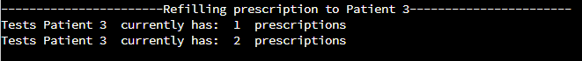

Second test will show the appointments booked, Emergency getting an appointment within a day and standard appointments in the following days. 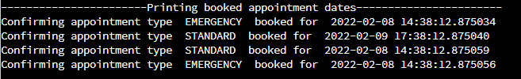

Canceling appointment test will show the total appointments decreasing. 

Consultation information test will present information about the appointment and the drugs assigned in the appointment. Drugs are only issued once/if the consultation recommends them and only issued through the doctor. (In the first screenshot, the nurse does the consultation and the doctor ‘oversees’ it and issues the prescriptions).

Drugs assigned

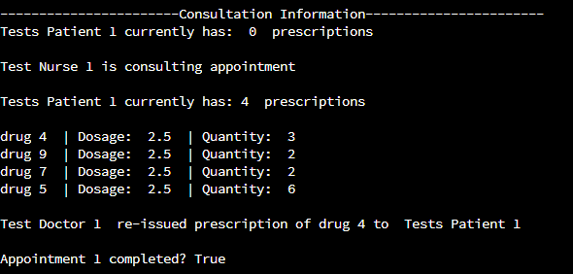

No drugs assigned

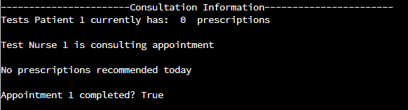

There is also a test to show that each doctor can only have a maximum of 500 patients, in this case we try to add 500+ patients.



The following test will show that the staff members have completed their assigned appointments for that date.

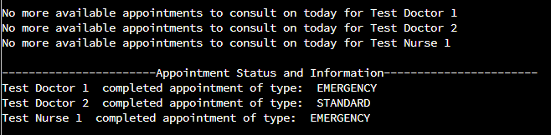

One of the interesting findings I found in the development process was, when the appointment scheduler is trying to schedule an EMERGENCY type appointment, I originally attempted to book it randomly within three hours but upon testing the code around 10.00 PM I found that it will sometimes throw an exception while trying to do a consultation because my tests was expecting it to have two booked appointments and two outcomes but the second appointment was not scheduled for today so the code was returning None instead of the appointment consultation results.