Examining spatial equity and accessibility to a public bicycle share program using a balanced floating catchment area approach

Elise Desjardins∗,1, Christopher D. Higgins∗∗,1, Antonio Paez∗∗,1

*aSchool of Earth, Environment & Society, 1280 Main Street West, Hamilton, ON L8S4L8*

*bDepartment of Geography & Planning, 1265 Military Trail, Toronto, ON M1C1A4*

# Abstract

Public bicycle share programs are implemented to promote cycling as a convenient and sustainable mode of transportation. These systems can also play a role in addressing transportation needs and advancing transportation equity if they make cycling more accessible to lower income or disadvantaged populations. Recent studies assessing equity in bike sharing have found differences in ridership or membership based on income, education, and trip purpose. In Ontario, the City of Hamilton launched a public bicycle share program in 2015 that currently has over 900 operational bicycles and 130 docking stations. In 2018, the non- profit organization that operates the program launched an equity initiative to provide subsidized memberships and to expand service by adding twelve docking stations. Previous research found that Hamilton’s public bicycle share program targeted well disadvantaged areas in the city compared to programs in other Canadian cities. Since the time or distance that members of the population need to reach a bicycle share station decreases the potential of accessing the program, the location of stations matters. Unlike other public amenities with greater ability to adapt to crowding, the utility of stations is limited by the number of bicycles that they can hold, which makes crowding effects critical; the system may not necessarily be improved if stations are easy to reach but offer only a small number of bicycles. In this research, we revisit the case of Hamilton and investigate equity differentials in accessibility to bicycle share stations. We compare accessibility in the program with and without the equity stations to assess the effect of the initiative. Previous research on cycling equity or accessibility has used a macro-level approach with entire neighbourhoods or census tracts as the unit of analysis, although there are recent exceptions. In contrast, we implement our analysis parting from microscopic zones to better reflect travel to a docking station, which often happens at the sub-neighborhood level, and conduct a sensitivity analysis at several walking thresholds. We then

∗Corresponding Author

∗∗Equal contribution

*Email addresses:* [desjae@mcmaster.ca](mailto:desjae@mcmaster.ca) (Elise Desjardins), [cd.higgins@utoronto.ca](mailto:cd.higgins@utoronto.ca)

(Christopher D. Higgins), [paezha@mcmaster.ca](mailto:paezha@mcmaster.ca) (Antonio Paez)

*Preprint submitted to Transportation Research Part D: Transport and EnvironmentMarch 20, 2021*

reaggregate the estimated accessibility to dissemination areas for further analysis using census data. Equity analysis of this type is possible thanks to a newly developed approach for accessibility using balanced floating catchment areas. The addition of equity stations achieved its goal to increase accessibility for lower income populations, although the increase was relatively modest (2.10 bicycles/person with equity stations vs 1.97 bicycles/person without equity stations). Further research is needed to determine whether this encouraged more cycling.

# Background

Public bicycle share programs (PBSP) have been implemented in over 800 cities worldwide and a great deal has been learned about their typical users (Fishman, 2016). In many cities, males use bike share more than females (Brey et al., 2017; Nickkar et al., 2019; Reilly, S. M. Wang, et al., 2020; Winters et al., 2019) as do younger age cohorts (Brey et al., 2017; Buck et al., 2013; Fuller et al., 2011). However, one study found that bike share users in Washington, DC were more likely to be female (Buck et al., 2013), which suggests that the gender gap among cyclists who use bike share is less disparate than the gap for personal bicycle use (Fishman, 2016). There is some evidence that bike share users are less likely to own a car (Buck et al., 2013; Reilly, Noyes, et al., 2020). However, the relationship between income or education and bike share use is less clear. Stations in disadvantaged communities in Chicago generated most of the average annual trips (Qian and Jaller, 2020) and individuals from minority or lower socioeconomic status neighbourhoods in Minneapolis-St. Paul used the city’s PBSP more (J. Wang and Lindsey, 2019a). Being university educated was also a significant correlate of bike share use in Montreal, Canada (Fuller et al., 2011). On the other hand, members who reside in minority-concentrated and lower socioeconomic status neighbourhoods use the Minneapolis-St Paul bike share more frequently (J. Wang and Lindsey, 2019a). Financial savings have been found to motivate those on a low income to use bike share (Fishman, 2016). Many studies have found that proximity to a bike share station, either living or working near one, is an important determinant of use or having a membership (Fishman, 2016; Fuller et al., 2011). This makes sense given that individuals are more likely to use services or programs that they can easily access. Finally, the potential of bike share programs to increase cycling levels has also been explored recently (Hosford et al., 2018, 2019), but more longitudinal evidence is needed to determine their impact on encouraging more cycling and offering more opportunities for physical activity. On the whole, these findings highlight the need for bike share systems to be more highly accessible for diverse populations in order to increase use beyond the “typical” users, which has been the focus of recent research (Auchincloss et al., 2020; Hull Grasso et al., 2020; MacArthur et al., 2020), and to offer more people the option of using sustainable and active transportation.

Several studies have recently explored the equity of PBSP in North American cities by primarily examining who has access to bike share (e.g., differences by

demographics or socioeconomic status) and where stations are located. Equity can be achieved in two different ways: equal spatial distribution across a re- gion (e.g., horizontal equity) or greater access for vulnerable or disadvantaged populations (e.g., vertical equity) (Chen et al., 2019). Both are of interest to researchers and transport planners since they are often linked in that advantage, or conversely disadvantage, has spatial patterns. Using a negative binomial regression model, Qian and Jaller (2020) estimated ridership in Chicago’s PBSP among disadvantaged communities and found some disparities. While annual members in disadvantaged communities have a significantly lower share of trips compared to other areas in the city, they make longer trips. This suggests that they may be using PBSP for work commuting, which points to the importance of ensuring equitable access (Qian and Jaller, 2020). Similar results were found in Philadelphia, where lower income areas generate fewer trips and efforts to increase equity within the program have not been as successful as intended (Caspi and Noland, 2019). In the case of Seattle, all neighbourhoods had some level of access to dockless bikes but those with higher incomes and more residents of higher education had more bikes (Mooney et al., 2019). Babagoli et al. (2019) found that neighbourhoods in New York City with higher affluence had the greater proportion of Citi Bike stations. Overall, these findings suggest that hori- zontal equity can be achieved while vertical equity is harder to attain. Exploring transport equity by investigating where bicycle share stations are located, often using neighbourhoods or census tracts as the spatial unit of analysis, can ignore or miss the benefits that may be derived from adjacent zones. Meaning that, stations may be lacking in certain neighbourhoods but there may be stations accessible within a reasonable walking cutoff time. This is where accessibility becomes an important consideration.

Accessibility has been applied in both a positive and normative way to inform transportation planning (Páez et al., 2012), but its utility to this field has evolved since its conceptualization and become linked with recent interest in prioritizing local proximity and modes that are suitable for local trips like walking and cycling (Levine, 2020). As a measure of the ease of reaching potential destinations spread spatially in a given area, accessibility is relevant to PBSPs because it can identify current inequities in usage, as well as guide interventions that increase access for groups that are under-serviced or address gaps in transportation options. It also addresses some of the challenges of other performance measures such as level of service within a transportation network by measuring person-based indicators and exploring differences in use between population groups (Páez et al., 2012). In the context of PBSPs, accessibility refers to the distance an individual must travel to reach a bicycle share station (Kabra et al., 2020; J. Wang and Lindsey, 2019b). Since the time or distance that members of the population need to reach a bicycle share station decreases the potential of accessing the program and ultimately use of the program, the location and size (e.g., maximum number of bicycles available) of stations matters. Indeed, distance to bicycle share stations is associated with use (Fuller et al., 2011; J. Wang and Lindsey, 2019b) and can be a barrier to using PBSPs (Fishman et al., 2014). Kabra et al. (2020) found that the majority of bike share usage in Paris comes from areas

within 300m of stations. Furthermore, unlike other public amenities with greater ability to adapt to crowding, like health care services, the utility of stations is limited by the number of bicycles that they can hold, which makes crowding effects critical. The program may not necessarily be improved if stations are easy to reach but offer only a small number of bicycles. Likewise, more people may not opt to use the program if the supply of bicycles available at the nearest station is insufficient to meet demand. The location and size of stations is important to increase the utility of this public transportation option for more people, thus achieving vertical equity. Accessibility analyses for PBSPs constitute a positive and evaluation-based approach that also has the potential to inform equity efforts. For instance, Wang and Lindsey (2019b) investigated whether new or relocated bicycle share stations increased accessibility and use, which offered important insights to improve the performance of the program.

Several approaches have been commonly used for measuring accessibility: cumulative opportunities, gravity, and utility-based (Handy and Niemeier, 1997). Paez et al (2012) provide a recent overview of various formulations and appli- cations of accessibility in transportation research. Briefly, the gravity-based approach involves weighting opportunities, for example the quantity of bicycle share stations, as measured by a function of time, using a negative exponential form (Handy and Niemeier, 1997). It takes both demand and congestion into account (Páez et al., 2012). Floating catchment area (FCA) methods are a type of gravity measure that have been used in healthcare accessibility research but that are applicable to transportation case studies. This approach involves producing flexible catchment areas for populations, recognizing that people may be willing to travel to access particular services (Páez et al., 2012). Thus, this model does a good job of considering potential crowding of services using a binary distance function (Páez et al., 2012). A recent improvement to this approach was achieved through a simple and intuitive adjustment to the allocation of supply and demand, which addressed the effects of demand and service inflation from the conventional approach (see Paez et al., 2019).

Researchers have also taken different approaches when it comes to aggregation of data, either by using the individual or household as the smallest unit of analysis or larger spatial zones. Previous research on bike share equity has typically used a macro-level approach with aggregate data from entire neighbourhoods or census tracts (Babagoli et al., 2019; Mooney et al., 2019; Qian and Jaller, 2020;

J. Wang and Lindsey, 2019a), although there are recent exceptions (Chen et al., 2019; Chen and Li, 2021). This is also true for studies examining correlates of bike share demand (J. Wang and Lindsey, 2019b). Handy and Niemeier (1997) note that using disaggregated data in accessibility analyses provides a more accurate estimate for individuals, which is useful for addressing vertical inequities in PBSP usage.

Using balanced floating catchment area methods, a novel approach that has not been used yet in cycling research, we examine accessibility to a public bicycle share program in Hamilton, Ontario. Using disaggregate population-level data, we (1) conduct a sensitivity analysis by measuring accessibility and level of service to bike share stations at different thresholds of walking to reach a station:

3 minutes, 5 minutes, 10 minutes, and 15 minutes; (2) explore the contribution of specific stations that were added to Hamilton’s PBSP to reducing both horizontal and vertical inequities; and (3) examine whether disparities in accessibility exist according to median household income of dissemination areas within the core service area.

# Case Study

This paper uses the city of Hamilton, located in Ontario, Canada, as a case study. The city launched a public bicycle share program, Hamilton Bike Share, in March 2015 with 115 stations and 750 bicycles (Hamilton, 2015). Before June 2020, the program was known as SoBi Hamilton. Stations are spaced between 300 and 600 metres apart (Scott et al., 2021). The core service area spans 35 kmˆ2 of the city and roughly 138,000 can reach a bike share hub within 30 minutes of walking see Figure [1]. This represents roughly one fifth of the population in Hamilton, according to the 2016 Canadian Census. The program was enthusiastically welcomed in the city - within three weeks of launching, 10,000 trips had been made (Hamilton, 2015). In 2017, Hamilton Bike Share Inc., the non-profit organization that operates the program, initiated an equity program, Everyone Rides Initiative (ERI), to remove barriers that may prevent individuals from accessing bike share in Hamilton. An additional 75 bicycles and 15 stations were added to the program, which expanded it to more disadvantaged areas in the core service area [see Figure 2]. The program also offers subsidized memberships to individuals who identify as low income. A comparable program can be found in Philadelphia (see Caspi and Noland, 2019). As of June 2020, the bike share program has 900 bikes and 130 stations see Figure [2], and over 26,000 active memberships (Hamilton, 2015).

Hamilton Bike Share has conducted one membership survey to date in 2018 (Civicplan, 2017), and the findings from 420 members are broadly in line with the trends that were discussed above (see Fishman, 2016 for a recent review of the literature). The majority of respondents live within the core service area and the gender split is typical: 57% of respondents are male and 41% are female. The majority of respondents, both male and female, are between 25 and 34 years of age, but the percentage of male respondents is higher in the subsequent age groups. Respondents use bike share for commuting (40% of trips) or errands and meetings (24% of trips), and nearly 50% of trips have an average length of 11 to 20 minutes. As a result of having a bike share membership, 49% of respondents report that they use their private vehicle less often or much less often but 48% report that their private vehicle use has remained about the same. This suggests that SoBi Hamilton has been useful for certain kinds of trips but not all, meaning that some trips continue to require a private vehicle.

Further research has provided insights about the behaviour and route choice of bike share users in Hamilton. The routes most frequently travelled are longer than the shortest distance route from origin to destination (Lu et al., 2018; Scott et al., 2021). Ridership is influenced by weather conditions, temporal factors such as university terms, employment, and proximity to important destinations like

43.5N

43.4N

43.3N

43.2N

43.1N

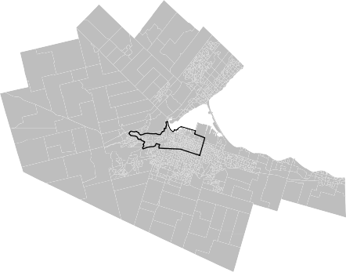

80.2W 80.1W 80W 79.9W 79.8W 79.7W 79.6W 79.5W

Figure 1: The core service area of Hamilton Bike Share is outlined in black. Hamilton Census Metropolitan Area (CMA) is shown in grey.

the local university, but is not influenced by population and most transportation infrastructure variables (Scott and Ciuro, 2019). Bike share users prefer to deter from the shortest distance route to travel on streets with cycling facilities or lower volumes of traffic (Lu et al., 2018) and avoid steep slopes and busy roads (Scott et al., 2021). It is important to note that these studies used daily ridership or GPS data from trips taken before the equity stations were implemented, so these findings are informative with respect to the conventional stations.

Our analysis builds upon a previous and recent study (Hosford and Winters, 2018), which found that disadvantaged areas in Hamilton are better served by the city’s PBSP compared to other Canadian cities [i.e., Toronto, Vancouver, Montreal, and Ottawa-Gatineau] with PBSPs where advantaged areas have greater access. Hosford and Winters (2018) acknowledge that “Hamilton stands out in that the lower income neighborhoods are located near the city center and wealthier neighborhoods are in the surrounding suburban areas”. Therefore, the core service area for the PBSP in Hamilton is by default in more disadvantaged areas compared to other Canadian cities, but there is also a great deal of variation in income in the city center as well because of the local university and increasing gentrification in the downtown area. In their analysis, Hosford and Winters (2018) did not differentiate between the conventional stations and those added to increase equity, which we refer to as equity stations in this paper. Therefore, this paper continues their work and makes an important contribution to the growing body of literature that examines equity issues in PBSPs.

# Methods

*Floating Catchment Area*

Floating catchment area (FCA) methods are an approach commonly used in the healthcare accessibility literature. This approach is more appropriate

43.29N

43.28N

43.27N

43.26N

43.25N

43.24N

Number of racks

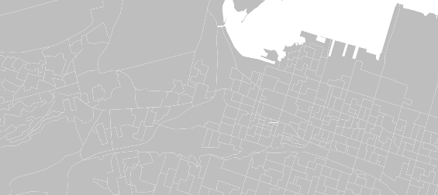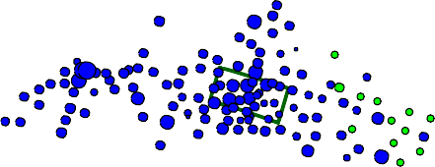

5

10

15

20

25

30

79.95W 79.9W 79.85W

Figure 2: The spatial distribution of bike share stations in Hamilton, Ontario. The service area of Hamilton Bike Share is outlined in black and the city’s downtown core is outlined in dark green. Hamilton CMA is shown in grey.

and informative than calculating the provider-to-population ratio (PPR) which simply divides the level of supply of a service (e.g., the number of bicycle racks at a station) by the population who have access to the service (Paez et al., 2019). In particular, the Two-Step Floating Catchment Area method produces flexible catchment areas for populations accessing a service rather than using rigid boundaries like PPR, which provides more useful information because it takes into account individual behaviour and doesn’t assume that people stay within the pre-defined boundaries (Paez et al., 2019). This is an important property that supports our rationale for applying this method to measure accessibility to Hamilton Bike Share. The City of Hamilton has positioned stations between 300 and 600 metres apart, which would lead to boundaries around these buffers, but it would be reasonable to assume that people are willing to walk beyond this threshold to access other stations if the ones nearest them have no supply of bicycles.

More recently, the *balanced* floating catchment area approach was developed to address issues with demand and supply inflation that are a result of the overlapping catchment areas produced by the Two-Step Floating Catchment Area (Paez et al., 2019). This overlap inflates the demand and generates inaccurate or misleading accessibility estimates (Paez et al., 2019). By adjusting the impedance weights, both supply and demand are proportionally allocated which eliminates the double-counting of population that leads to demand and supply inflation (Paez et al., 2019). Other benefits of this adjusted method include consideration of competition which can occur when catchment areas overlap, as well as the preservation of system-wide population and level of service. Balanced floating catchment area methods have been used to explore accessibility to health care providers (Paez et al., 2019) and COVID-19 health care services (Pereira et al., 2021), but have not yet been used in the cycling literature to explore issues of accessibility.

In their review of accessibility measures, Geurs and van Wee (2004) highlight the need for greater inclusion of individual spatio-temporal constraints but ac- knowledge the challenges of acquiring and analyzing person-based data. This comes after Kwan’s (1998) work to show that space-time measures are more capable of capturing interpersonal differences, especially the effect of space-time constraints on individual behaviour, and are more helpful for unraveling gen- der/ethnic differences. Applying the balanced floating catchment area approach to examine accessibility to Hamilton Bike Share constitutes a location-based mea- sure with an individual component by stratifying according to median household income (Geurs and van Wee, 2004), but conducting a further sensitivity analysis by adjusting distance thresholds would introduce additional spatio-temporal constraints to evaluate equitable accessibility.

The first step in the balanced floating catchment area method is to allocate the population to be serviced by each Hamilton Bike Share station:

*n*

*Pj* = '\" *Piwij*

*i*=1

Next, the level of service at each station (i.e., the maximum number of bicycle racks) is divided by its estimated service population within the established catchment area:

*L* = *Sj*

*j Pj*

= *Sj*

*i*=1 *Piwij*

*n*

Finally, the accessibility of population cell *i* is calculated as the weighted sum of the level of service of all stations that can be reached from there according to normalized weights:

*J J S w*

*Ai* = '\" *Lj wji* = '\" *n*

*j*

*ji*

*j*=1

*j*=1

*i*=1 *Piwij*

The approach uses instead a set of suitably normalized weights as follows:

*wi*  *wij*

and

*ij* =

*j*=1 *wji*

*J*

*wj*  *wij*

*ij* =

*J*

*j*=1 *wji*

These weights satisfy the following properties:

*J*

'\" *wi*

*ji* = 1

and

*j*=1

*n*

'\" *wj*

*ji* = 1

*i*=1

Finally, accessibility is calculated without risk of demand or supply inflation:

*J Sj wj*

*Ai* = '\"

*ij*

*n* *i*

*j*=1

*i*=1 *Piwij*

*Pycnophylactic Interpolation*

Following the method first presented by Tobler (1979), we used pycnophylactic interpolation to disaggregate population from each dissemination area to smaller polygons that are 50 by 50 metres. This method involves smoothing out the population from each dissemination area while preserving total volume see Figure [3]. Since pycnophylactic interpolation occurs at such a micro scale, we had to ensure that population numbers were not reallocated or smoothed out to areas where people do not live in Hamilton (i.e., where schools or parks are located). To do so, we retrieved shapefiles for various geographic features see Table [1] from Open Hamilton. Next, we extracted these features from the PBSP core service area and used pycnophylactic interpolation to disaggregate and reallocate population see Figure [4].

Table 1: Landscape features extracted from the Hamilton Bike Share core service area before population is interpolated.

Feature

Description

|  |  |
| --- | --- |
| **Hamilton Bike Share Stations** | The location of stations and the number of racks available at each station. |
| **Golf Courses** | The location of City and privately owned golf courses. |
| **Parks** | The location of parks and other green spaces. |
| **Designated Large Employment Areas** | The location of large business parks and industrial lands. |
| **Municipal Parking Lots** | The location of municipal car parks. |

|  |  |
| --- | --- |
| **Cemeteries** | The location of cemeteries. |
| **Environmentally Sensitive Areas** | The location of either land or water areas containing natural features or significant ecological functions. |
| **Streets** | The street network in Hamilton, including road classification for highways. |
| **Educational Institutions** | The location of all educational institutions and schools. |
| **Places of Worship** | The location of buildings used for religious congregations. |

|  |  |
| --- | --- |
| **Municipal Service Centres** | The location of all municipal service centres, including City Hall. |
| **Recreation and Community Centres** | The location of all recreation and community centres. |
| **Arenas** | The location of all indoor arenas. |
| **Emergency Stations** | The location of all Emergency Management Services (EMS) Ambulance stations. |
| **Fire Stations** | The location of all fire stations. |

|  |  |
| --- | --- |
| **Police Stations** | The location of all police stations. |
| **Railways** | The railway network in Hamilton. |
| **Hospitals** | The location of all hospitals. |

43.32N

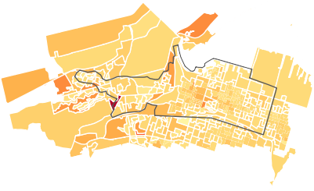

43.3N

43.28N

43.26N

43.24N

43.22N

43.2N

80W 79.95W 79.9W 79.85W 79.8W

population



2000

1000

0

Figure 3: Population in all dissemination areas (outlined in white) in the Hamilton Bike Share core service area (outlined in black) and within 30 minutes of walking to the service area.

43.29N

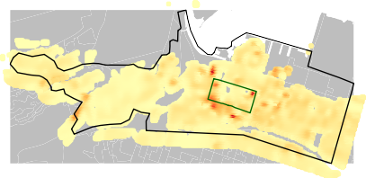

43.28N

43.27N

43.26N

43.25N

population

160



120

80

40

43.24N

43.23N

79.95W 79.9W 79.85W 79.8W

Figure 4: Interpolated population in the Hamilton Bike Share core service area (outlined in black) and within 30 minutes of walking to the core service area (outlined in blue). The down- town area is outlined in dark green. Geographic features have been extracted. Dissemination area polygons are outlined in grey.

*Travel Time Matrix*

[BBBike](https://download.bbbike.org/osm/bbbike/) is an online cycle route planner that interfaces with OpenStreetMap. We extracted OpenStreetMap data for SoBi Hamilton’s service area to calculate walking times from each population cell to nearby bike share stations, using a walking distance of 10km and a walking time of 30 minutes as a threshold. A travel time matrix was created with the origins as the coordinates of the population cells and the destinations as the coordinates of the bike share stations within the maximum threshold.

*Data*

All data for this research were accessed from Open Hamilton1, an online repository of data curated by the City of Hamilton.

# Results

*Accessibility by Distance Thresholds*

Consensus regarding the distance that individuals are willing to walk to access a PBSP is lacking, therefore the literature on walking behaviour was consulted to determine the thresholds for the sensitivity analysis. Previous studies have found that living within 250 metres (Fuller et al., 2011) and 300 metres (Kabra et al., 2020) is correlated with bike share use, while other research has found that walking trips are less than 600 metres and rarely more than 1200 metres (Millward et al., 2013) or a median distance of 650 metres (Larsen et al.,

1https://open.hamilton.ca/

5



43.24N

4

43.23N

3

43.29N

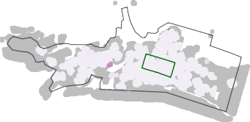

2

43.28N 1

43.27N

Conventional

43.26N

43.25N

43.24N

43.23N

79.95W 79.9W 79.85W 79.8W

All stations

Figure 5: Accessibility at 3 minutes walk (minimum threshold) compared between current system with equity stations and the original system without equity stations.

2010). We found that accessibility increases with a threshold between two and four minutes, but is then maximized at 5 minutes. At some stations, Hamilton Bike Share will depict a map to show the user the locations of the other nearest stations within a five minute walk, which suggests that this is an average distance that people are anticipated to walk. Accessibility decreases significantly after eight minutes, which is intuitive given that demand on a limited supply increases as more people can reach each bike share station.

For this reason, we experiment with various walking thresholds by conducting a sensitivity analysis to calculate accessibility at different walking times: 3 minutes, 5 minutes, 10 minutes, and 15 minutes. We categorize these thresholds as minimum, average, maximum, and extreme, respectively. At each threshold, we compare accessibility between the current system and the original system to examine the contribution of the additional equity stations.

*Three Minutes*

At the minimum threshold, we find that there are 25.2 bicycle racks per person in the original system. With the addition of equity stations, there are now 25.4 bicycles per person. Figure 5 presents a comparison of accessibility between the systems. Accessibility is fairly uniform, with the exception of two small areas near the university and the waterfront park where accessibility is slightly higher.

*Five Minutes*

At the average threshold, we find that there are 68.6 bicycle racks per person in the original system. With the addition of equity stations, there are now 68.8 bicycles per person. Figure 6 presents a comparison of accessibility between the systems. Again, accessibility is fairly uniform, with the exception of one very small area near the waterfront park where accessibility is higher.

43.24N 50



43.23N 40

43.29N 30

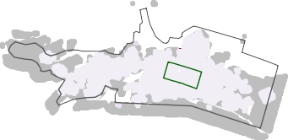

20

43.28N 10

43.27N

Conventional

43.26N

43.25N

43.24N

43.23N

79.95W 79.9W 79.85W 79.8W

All stations

Figure 6: Accessibility at 5 minutes walk (average threshold) compared between current system with equity stations and the original system without equity stations.

*Ten Minutes*

At the maximum threshold, we find that there are 3.61 bicycle racks per person in the original system. With the addition of equity stations, there are now 3.74 bicycles per person. Figure 7 presents a comparison of accessibility between the systems. We begin to see differences in accessibility across the service area, with users near the university and its adjacent neighbourhoods, as well as neighbourhoods north of the downtown area, have slightly higher accessibility. While the differences are modest, they are more apparent at this threshold than at shorter walking distances.

*Fifteen Minutes*

At the extreme threshold, we find that there are 2.44 bicycle racks per person in the original system. With the addition of equity stations, there are now 2.55 bicycles per person. Figure 8 presents a comparison of accessibility between the systems. Users near the university and the neighbourhoods north of the downtown area (outlined in green) have the highest accessibility, followed by those who live in the city’s downtown area. Accessibility in the east end of the core service area remains low.

*Accessibility by Median Total Income*

Approximately 138,000 people live within Hamilton Bike Share’s core service area or within a 30 minute walk to the service area. We find that over 118,000 people can access a bicycle share station within a 15 minute walk, which represents roughly 85% of the total population in the core service area see Table [2]. While previous research found that neighbourhoods with more disadvantage are better serviced by Hamilton Bike Share (Hosford and Winters, 2018), the authors used the Pampalon Deprivation Index from 2011 as a measure of socioeconomic status for dissemination areas across the city not just within the core service area.

43.29N

10 min

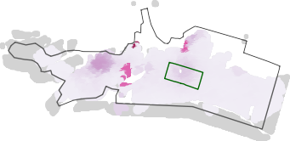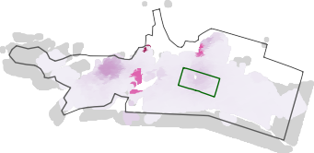

43.28N

43.27N

All stations

43.26N

43.25N

43.24N

43.23N

43.29N

43.28N

accessibility



0.010

0.005

43.27N

Conventional

43.26N

43.25N

43.24N

43.23N

79.95W 79.9W 79.85W 79.8W

Figure 7: Accessibility at 10 minutes walk (maximum threshold) compared between current system with equity stations and the original system without equity stations.

43.29N

15 min

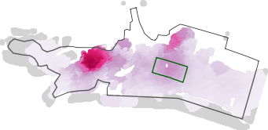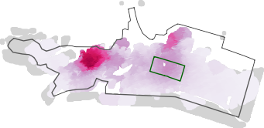

43.28N

43.27N

All stations

43.26N

43.25N

43.24N

43.23N

43.29N

accessibility

0.0020



0.0015

0.0010

43.28N

0.0005

43.27N

Conventional

43.26N

43.25N

43.24N

43.23N

79.95W 79.9W 79.85W 79.8W

Figure 8: Accessibility at 15 minutes walk (extreme threshold) compared between current system with equity stations and the original system without equity stations.

Instead, we use median total income for each dissemination area in the core service area to examine whether disparities in accessibility exist between income groups for those who live in or near the core service area. We divide income by quantiles: bottom 20%, second 20%, third 20%, fourth 20%, and top 20%. One of the unique properties of the balanced floating catchment area method is that data can be reaggregated from small to larger polygons while preserving the total population and supply at each station. This avoids demand and supply inflation, and also enables us to present findings in a way that is easier to interpret (i.e., across dissemination areas instead of 50 by 50 metre population cells).

Panels 1[9], 2 [10], 3 [11], and 4 [12] depict bivariate choropleth maps with the combined spatial distribution of accessibility and median total income per household for the different thresholds. Our analysis demonstrates that the extreme threshold of fifteen minutes allows the most people to access a station. We find that stations added to Hamilton’s public bicycle share program to increase equity for disadvantaged neighbourhoods achieved their goal by increasing accessibility, albeit only modestly see Table [2]. By implementing equity stations in more areas with lower median total income in Hamilton, the PBSP has achieved greater horizontal equity by extending the spatial distribution of bicycles across the city. This is particularly evident at the minimum and average thresholds of three and five minutes, respectively. The largest gains were made for dissemination areas in the second 20%, where an additional 3,073 and 5,395 people could reach a bicycle share station within three and five minutes walk, respectively, after the addition of the equity station.

However, we found that dissemination areas with the lowest total household income do not have much greater access to the program [see Table **??**]. Income disparities still persist, however only at certain thresholds. With and without equity stations, people in the top 20% of income have the highest level of accessibility at a threshold of ten and fifteen minutes. Although dissemination areas in the second 20% have the highest level of accessibility by a significant amount at lower thresholds, the bottom 20%, who may benefit the most from Hamilton Bike Share’s equity initiatives, have the lowest accessibility at three minutes threshold and the second lowest accessibility at all other thresholds. Panels 1[9], 2 [10], 3 [11], and 4 [12] reveal specific areas where accessibility is low or zero, which are good candidates for additional equity stations.

On the whole, we find that areas that have less than their equitable share of the level of service are some of the most socioeconomically disadvantaged areas in the city. While the addition of equity stations increases accessibility for all income groups at all thresholds, they did not increase accessibility significantly for any single income group. This finding aligns with other studies that have found disparities in station or bike location along income lines in New York City (Babagoli et al., 2019), Tampa (Chen et al., 2019), and Seattle (Mooney et al., 2019), where people who have greater advantage have better access to PBSPs.

Higher income 

Figure 9: Bivariate map of accessibility and income (threshold: 3 min): without equity stations (top panel) and with equity stations (bottom panel)

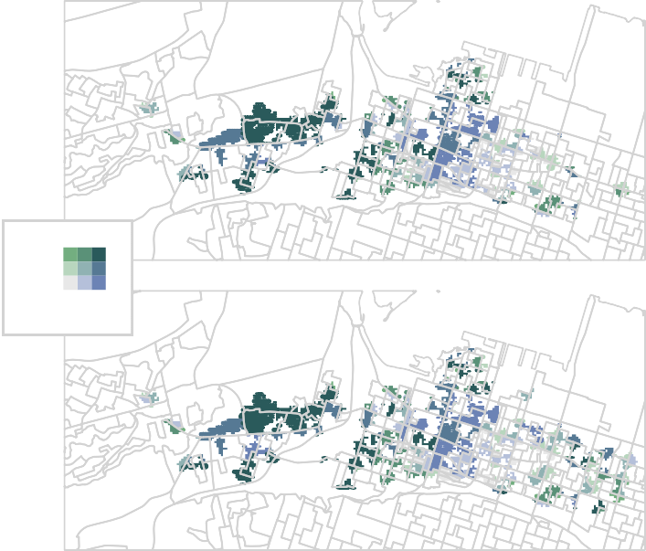

Higher accessibility 

Higher income 

Figure 10: Bivariate map of accessibility and income (threshold: 5 min): without equity stations (top panel) and with equity stations (bottom panel)

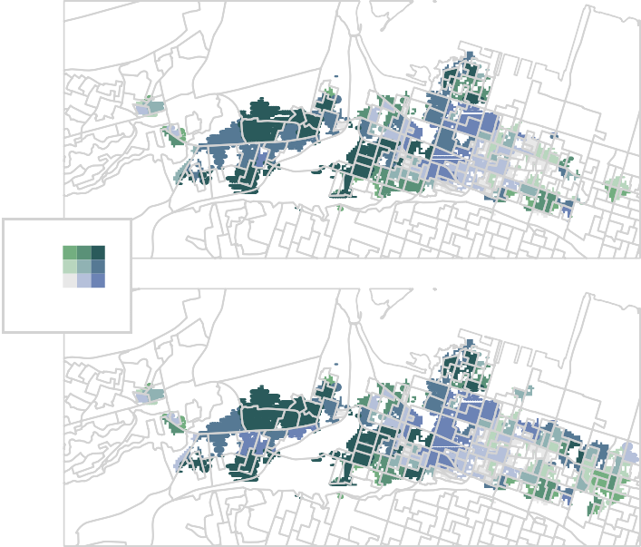

Higher accessibility 

Higher income 

Figure 11: Bivariate map of accessibility and income (threshold: 10 min): without equity stations (top panel) and with equity stations (bottom panel)

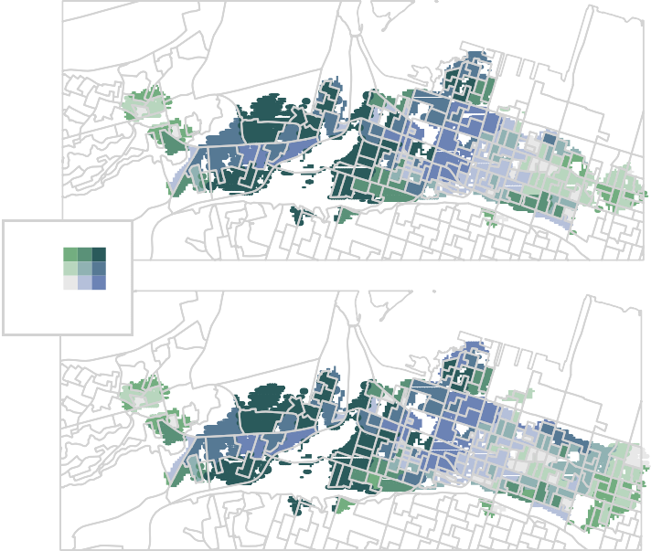

Higher accessibility 

Higher income 

Figure 12: Bivariate map of accessibility and income (threshold: 15 min): without equity stations (top panel) and equity stations (bottom panel)

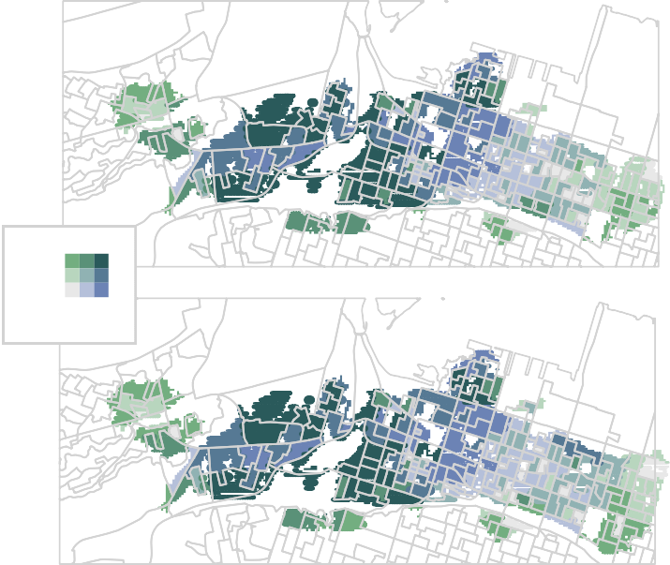

Higher accessibility 

Table 2: Accessibility and population serviced by income quintile and between systems (with and without equity stations).

Without Equity Stations With Equity Stations Difference

|  |  |  |  |  |  |  |
| --- | --- | --- | --- | --- | --- | --- |
| Income Quintile | Accessibility | Population | Accessibility | Population | Accessibility | Population |
| **Threshold - 3** | **minutes** |  |  |  |  |  |
| Bottom 20% | 2.377 | 22359 | 2.424 | 22798 | 0.047 | 439 |
| Second 20% | 12.203 | 9347 | 12.281 | 12420 | 0.078 | 3073 |
| Third 20% | 3.093 | 7745 | 3.156 | 9455 | 0.063 | 1710 |
| Fourth 20% | 4.119 | 1673 | 4.119 | 1673 | 0.000 | 0 |
| Top 20% | 3.408 | 2114 | 3.434 | 2379 | 0.026 | 265 |
| **Threshold - 5 minutes** | | | | | | |
| Bottom 20% | 1.302 | 35477 | 1.357 | 35803 | 0.055 | 326 |
| Second 20% | 56.048 | 17513 | 56.137 | 22908 | 0.089 | 5395 |
| Third 20% | 4.258 | 15117 | 4.291 | 18309 | 0.033 | 3192 |
| Fourth 20% | 1.094 | 2867 | 1.095 | 3116 | 0.001 | 249 |
| Top 20% | 5.925 | 4052 | 5.933 | 4518 | 0.008 | 466 |
| **Threshold - 10 minutes** | | | | | | |
| Bottom 20% | 0.603 | 41824 | 0.621 | 41981 | 0.018 | 157 |
| Second 20% | 0.860 | 27546 | 0.927 | 30503 | 0.067 | 2957 |
| Third 20% | 0.772 | 22394 | 0.799 | 25128 | 0.027 | 2734 |
| Fourth 20% | 0.225 | 4544 | 0.227 | 4989 | 0.002 | 445 |
| Top 20% | 1.160 | 7989 | 1.162 | 9078 | 0.002 | 1089 |
| **Threshold - 15 minutes** | | | | | | |
| Bottom 20% | 0.534 | 42208 | 0.554 | 42327 | 0.020 | 119 |
| Second 20% | 0.551 | 30507 | 0.611 | 31069 | 0.060 | 562 |
| Third 20% | 0.546 | 26108 | 0.573 | 26660 | 0.027 | 552 |
| Fourth 20% | 0.093 | 6312 | 0.096 | 7435 | 0.003 | 1123 |
| Top 20% | 0.712 | 10209 | 0.714 | 11089 | 0.002 | 880 |

*Note:*

a With equity stations = Hamilton Bike Share current system (118 conventional stations, 12 equity stations)

b Without equity stations = Hamilton Bike Share original system (118 conventional stations, no equity stations)

# Study Limitations

This paper did not examine or compare ridership data between conventional and equity stations. Therefore, further research is needed to determine whether the addition of equity stations encouraged more cycling for low-income individuals living near them. Other studies have specifically looked at differences in trip type, frequency, or length among users from disadvantaged neighbourhoods (Caspi and Noland, 2019; Qian and Jaller, 2020; J. Wang and Lindsey, 2019a), but our analysis is limited by the lack of accessible route or user data to conduct similar analyses for Hamilton Bike Share.

# Conclusion

The addition of specific equity stations to the public bicycle share program in Hamilton, Ontario had the net effect of increasing accessibility and reducing both horizontal and vertical inequities. In particular, accessibility improved the most for the second 20% median total income groups at all thresholds, but the gains were only modest for all income groups. Dissemination areas with the bottom 20% had the lowest accessibility at three minutes, and second lowest level of accessibility at five, ten, and fifteen minutes. Congestion effects were observed at higher thresholds, with accessibility decreasing significantly once the catchment area is increased to 10 minutes walking. Based on our analysis, we identified specific areas that have both low accessibility and low income which would benefit from an increased supply of bicycles. These are ideal candidates for new equity stations. In this way, our paper has made contributions in a positive way by applying an intuitive and useful approach to measure accessibility to a PBSP, and in a normative way by serving to inform future investments in cycle infrastructure for Hamilton Bike Share.

Wang and Lindsey (2019b) have noted that there is a lack of research that examines how bike share users’ behaviour changes as a result of program changes to station locations or improvements in accessibility. As such, a logical next step to this research is to examine whether Hamilton Bike Share’s equity stations increased ridership or resulted in new memberships in areas that were previously under-served. An examination of the types of trips undertaken by residents in these areas would also be informative, such as the study undertaken by Caspi and Norland (2019) after bike share stations were implemented in low-income Philadelphia neighbourhoods. The bulk of cycling facilities that have been built in Hamilton to date located in the core service area near the conventional stations. It would be worthwhile to explore the route choice of bike share trips departing or ending at the equity stations and to identify factors that specifically influence trips from these stations, which would extend existing studies conducted by Scott and colleagues (Lu et al., 2018; Scott and Ciuro, 2019; Scott et al., 2021). This paper, combined with additional studies such as those conceptualized above, would serve as a valuable case study for Hamilton and other cities with PBSPs who wish to evaluate and address spatial inequities in accessibility and transportation options in urban areas.

# References

Auchincloss, A.H., Michael, Y.L., Fuller, D., Li, S., Niamatullah, S., Fillmore, C.E., Setubal, C., Bettigole, C., 2020. Design and baseline description of a cohort of bikeshare users in the city of Philadelphia. Journal of Transport & Health 16, 100836. [doi:10.1016/j.jth.2020.100836](https://doi.org/10.1016/j.jth.2020.100836)

Babagoli, M.A., Kaufman, T.K., Noyes, P., Sheffield, P.E., 2019. Exploring the health and spatial equity implications of the New York City Bike share system. Journal of Transport & Health 13, 200–209. [doi:10.1016/j.jth.2019.04.003](https://doi.org/10.1016/j.jth.2019.04.003)

Brey, R., Castillo-Manzano, J.I., Castro-Nuño, M., 2017. “I want to ride my bicycle”: Delimiting cyclist typologies. Applied Economics Letters 24, 549–552. [doi:10.1080/13504851.2016.1210760](https://doi.org/10.1080/13504851.2016.1210760)

Buck, D., Buehler, R., Happ, P., Rawls, B., Chung, P., Borecki, N., 2013. Are Bikeshare Users Different from Regular Cyclists?: A First Look at Short-Term Users, Annual Members, and Area Cyclists in the Washington, D.C., Region. Transportation Research Record 2387, 112–119. [doi:10.3141/2387-13](https://doi.org/10.3141/2387-13)

Caspi, O., Noland, R.B., 2019. Bikesharing in Philadelphia: Do lower-income

areas generate trips? Travel Behaviour and Society 16, 143–152. [doi:10.1016/j.tbs.2019.05.004](https://doi.org/10.1016/j.tbs.2019.05.004) Chen, Z., Guo, Y., Stuart, A.L., Zhang, Y., Li, X., 2019. Exploring the

equity performance of bike-sharing systems with disaggregated data: A story of southern Tampa. Transportation Research Part A: Policy and Practice 130, 529–545. [doi:10.1016/j.tra.2019.09.048](https://doi.org/10.1016/j.tra.2019.09.048)

Chen, Z., Li, X., 2021. Unobserved heterogeneity in transportation equity analysis: Evidence from a bike-sharing system in southern Tampa. Journal of Transport Geography 91, 102956. [doi:10.1016/j.jtrangeo.2021.102956](https://doi.org/10.1016/j.jtrangeo.2021.102956)

Civicplan, 2017. SoBi Hamilton Membership Survey. Civicplan | Planning Engagement Research.

Fishman, E., 2016. Bikeshare: A Review of Recent Literature. Transport Reviews 36, 92–113. [doi:10.1080/01441647.2015.1033036](https://doi.org/10.1080/01441647.2015.1033036)

Fishman, E., Washington, S., Haworth, N., Mazzei, A., 2014. Barriers to bikesharing: An analysis from Melbourne and Brisbane. Journal of Transport Geography 41, 325–337. [doi:10.1016/j.jtrangeo.2014.08.005](https://doi.org/10.1016/j.jtrangeo.2014.08.005)

Fuller, D., Gauvin, L., Kestens, Y., Daniel, M., Fournier, M., Morency, P., Drouin, L., 2011. Use of a New Public Bicycle Share Program in Montreal,

Canada. American Journal of Preventive Medicine 41, 80–83. d[oi:10.1016/j.amepre.2011.03.002](https://doi.org/10.1016/j.amepre.2011.03.002) Geurs, K.T., van Wee, B., 2004. Accessibility evaluation of land-use and

transport strategies: Review and research directions. Journal of Transport Geography 12, 127–140. [doi:10.1016/j.jtrangeo.2003.10.005](https://doi.org/10.1016/j.jtrangeo.2003.10.005)

Hamilton, C. of, 2015. Hamilton Bike Share.

Handy, S.L., Niemeier, D.A., 1997. Measuring Accessibility: An Exploration of Issues and Alternatives. Environment and Planning A: Economy and Space 29, 1175–1194. [doi:10.1068/a291175](https://doi.org/10.1068/a291175)

Hosford, K., Fuller, D., Lear, S.A., Teschke, K., Gauvin, L., Brauer, M., Winters, M., 2018. Evaluation of the impact of a public bicycle share program on population bicycling in Vancouver, BC. Preventive Medicine Reports 12, 176–181. [doi:10.1016/j.pmedr.2018.09.014](https://doi.org/10.1016/j.pmedr.2018.09.014)

Hosford, K., Winters, M., 2018. Who Are Public Bicycle Share Programs Serving? An Evaluation of the Equity of Spatial Access to Bicycle Share Service Areas in Canadian Cities. Transportation Research Record 2672, 42–50. [doi:10.1177/0361198118783107](https://doi.org/10.1177/0361198118783107)

Hosford, K., Winters, M., Gauvin, L., Camden, A., Dubé, A.-S., Friedman, S.M., Fuller, D., 2019. Evaluating the impact of implementing public bicycle share programs on cycling: The International Bikeshare Impacts on Cycling and Collisions Study (IBICCS). International Journal of Behavioral Nutrition and Physical Activity 16, 107. [doi:10.1186/s12966-019-0871-9](https://doi.org/10.1186/s12966-019-0871-9)

Hull Grasso, S., Barnes, P., Chavis, C., 2020. Bike Share Equity for Underrep- resented Groups: Analyzing Barriers to System Usage in Baltimore, Maryland. Sustainability 12, 7600. [doi:10.3390/su12187600](https://doi.org/10.3390/su12187600)

Kabra, A., Belavina, E., Girotra, K., 2020. Bike-Share Systems: Accessibility and Availability. Management Science 66, 3803–3824. doi:[10.1287/mnsc.2019.3407](https://doi.org/10.1287/mnsc.2019.3407) Kwan, M.-P., 1998. Space-Time and Integral Measures of Individual Accessi-

bility: A Comparative Analysis Using a Point-based Framework. Geographical Analysis 30, 191–216. [doi:10.1111/j.1538-4632.1998.tb00396.x](https://doi.org/10.1111/j.1538-4632.1998.tb00396.x)

Larsen, J., El-Geneidy, A., Yasmin, F., 2010. Beyond the Quarter Mile: Re-examining Travel Distances by Active Transportation. Canadian Journal of Urban Research 19, 70–88.

Levine, J., 2020. A century of evolution of the accessibility concept. Trans-

portation Research Part D: Transport and Environment 83, 102309. doi:10.[1016/j.trd.2020.102309](https://doi.org/10.1016/j.trd.2020.102309) Lu, W., Scott, D.M., Dalumpines, R., 2018. Understanding bike share cyclist

route choice using GPS data: Comparing dominant routes and shortest paths. Journal of Transport Geography 71, 172–181. [doi:10.1016/j.jtrangeo.2018.07.012](https://doi.org/10.1016/j.jtrangeo.2018.07.012) MacArthur, J., McNeil, N., Cummings, A., Broach, J., 2020. Adaptive Bike Share: Expanding Bike Share to People with Disabilities and Older Adults. Transportation Research Record 2674, 556–565. [doi:10.1177/0361198120925079](https://doi.org/10.1177/0361198120925079) Millward, H., Spinney, J., Scott, D., 2013. Active-transport walking behavior: Destinations, durations, distances. Journal of Transport Geography 28, 101–110.

[doi:10.1016/j.jtrangeo.2012.11.012](https://doi.org/10.1016/j.jtrangeo.2012.11.012)

Mooney, S.J., Hosford, K., Howe, B., Yan, A., Winters, M., Bassok, A., Hirsch, J.A., 2019. Freedom from the station: Spatial equity in access to dockless bike share. Journal of Transport Geography 74, 91–96. [doi:10.1016/j.jtrangeo.2018.11.009](https://doi.org/10.1016/j.jtrangeo.2018.11.009)

Nickkar, A., Banerjee, S., Chavis, C., Bhuyan, I.A., Barnes, P., 2019. A spatial-temporal gender and land use analysis of bikeshare ridership: The case

study of Baltimore City. City, Culture and Society 18, 100291. [doi:10.1016/j.ccs.2019.100291](https://doi.org/10.1016/j.ccs.2019.100291) Paez, A., Higgins, C.D., Vivona, S.F., 2019. Demand and level of ser-

vice inflation in Floating Catchment Area (FCA) methods. PLoS ONE 14. [doi:10.1371/journal.pone.0218773](https://doi.org/10.1371/journal.pone.0218773)

Páez, A., Scott, D.M., Morency, C., 2012. Measuring accessibility: Positive and normative implementations of various accessibility indicators. Journal of Transport Geography, Special Section on Accessibility and Socio-Economic Activi-

ties: Methodological and Empirical Aspects 25, 141–153. [doi:10.1016/j.jtrangeo.2012.03.016](https://doi.org/10.1016/j.jtrangeo.2012.03.016) Pereira, R.H.M., Braga, C.K.V., Servo, L.M., Serra, B., Amaral, P., Gouveia,

N., Paez, A., 2021. Geographic access to COVID-19 healthcare in Brazil using a

balanced float catchment area approach. Social Science & Medicine 273, 113773. [doi:10.1016/j.socscimed.2021.113773](https://doi.org/10.1016/j.socscimed.2021.113773)

Qian, X., Jaller, M., 2020. Bikesharing, equity, and disadvantaged commu- nities: A case study in Chicago. Transportation Research Part A: Policy and Practice 140, 354–371. [doi:10.1016/j.tra.2020.07.004](https://doi.org/10.1016/j.tra.2020.07.004)

Reilly, K.H., Noyes, P., Crossa, A., 2020. From non-cyclists to frequent cyclists: Factors associated with frequent bike share use in New York City. Journal of Transport & Health 16, 100790. [doi:10.1016/j.jth.2019.100790](https://doi.org/10.1016/j.jth.2019.100790)

Reilly, K.H., Wang, S.M., Crossa, A., 2020. Gender disparities in New York City bike share usage. International Journal of Sustainable Transportation 0, 1–9. [doi:10.1080/15568318.2020.1861393](https://doi.org/10.1080/15568318.2020.1861393)

Scott, D.M., Ciuro, C., 2019. What factors influence bike share ridership? An investigation of Hamilton, Ontario’s bike share hubs. Travel Behaviour and Society 16, 50–58. [doi:10.1016/j.tbs.2019.04.003](https://doi.org/10.1016/j.tbs.2019.04.003)

Scott, D.M., Lu, W., Brown, M.J., 2021. Route choice of bike share users: Leveraging GPS data to derive choice sets. Journal of Transport Geography 90, 102903. [doi:10.1016/j.jtrangeo.2020.102903](https://doi.org/10.1016/j.jtrangeo.2020.102903)

Tobler, W.R., 1979. Smooth Pycnophylactic Interpolation for Geograph- ical Regions. Journal of the American Statistical Association 74, 519–530. [doi:10.1080/01621459.1979.10481647](https://doi.org/10.1080/01621459.1979.10481647)

Wang, J., Lindsey, G., 2019a. Neighborhood socio-demographic characteris- tics and bike share member patterns of use. Journal of Transport Geography 79, 102475. [doi:10.1016/j.jtrangeo.2019.102475](https://doi.org/10.1016/j.jtrangeo.2019.102475)

Wang, J., Lindsey, G., 2019b. Do new bike share stations increase member use: A quasi-experimental study. Transportation Research Part A: Policy and Practice 121, 1–11. [doi:10.1016/j.tra.2019.01.004](https://doi.org/10.1016/j.tra.2019.01.004)

Winters, M., Hosford, K., Javaheri, S., 2019. Who are the “super-users” of public bike share? An analysis of public bike share members in Vancouver, BC. Preventive Medicine Reports 15, 100946. [doi:10.1016/j.pmedr.2019.100946](https://doi.org/10.1016/j.pmedr.2019.100946)