An AI is Haunting Campus

## Background

*Mission Statement: Our organization seeks to level up on all matters related.*  
– An Organization Run by its Marketing Department

On November 30, 2022, OpenAI released what became its flagship product, [ChatGPT](https://en.wikipedia.org/wiki/ChatGPT), a chatbot based on [Large Language Models](https://en.wikipedia.org/wiki/Large_language_model) (LLMs) designed and trained to mimic natural language. The launch of the chatbot was an impressive feat of marketing (Cowen 2023), and it took less than two weeks for the hype to reach stratospheric levels: by early December, ChatGPT was being panned as “the best artificial intelligence chatbot ever released to the general public” (Roose 2023), and a tool able to generate “impressively detailed” and “human-like” text, leading some to wonder whether it could “replace humans” (Lock 2022).

Universities, much like every other organization dealing with information, had to respond in a compressed span of time to the rapid release of generative AI (GenAI) tools like ChatGPT, most of them created and unleashed in the wild by a handful of large American corporations including [Meta](https://en.wikipedia.org/wiki/Meta_Platforms) (or were we to deadname it, facebook), [OpenAI](https://en.wikipedia.org/wiki/OpenAI), [Google](https://en.wikipedia.org/wiki/Alphabet_Inc.), and [Microsoft](https://en.wikipedia.org/wiki/Microsoft).

GenAI was hailed as nothing short of revolutionary. McMaster, for example, [stated](https://provost.mcmaster.ca/office-of-the-provost-2/generative-artificial-intelligence-2/generative-ai-for-staff/provisional-guidelines-on-the-use-of-generative-ai-in-operational-excellence/) that:

[u]nderstanding how generative AI works, and how it can support work within organizations represents an ongoing area of exploration and innovation. The opportunities of generative AI are exciting: creating workplace efficiencies to allow for different kinds of work, adding capabilities for individuals and teams, and offering personalized uses.

AI was quickly painted as an *innovative* and *exciting* technology, that moreover can lead to *efficiencies*[1]. It seemed inevitable that universities *had to do something* with it, at the risk of being let behind.

The fear of missing out, combined with a modicum of concern for the ethical implications of GenAIs[2], has led to institutional responses that have been less than coherent. A case in point is Emory University, where the university gave a $10,000 prize to a group of students who proposed developing an AI tool for an Entrepreneurship Summit, only for the students to be subsequently suspended by the school’s Honor Council for the potential of their tool for cheating[3] (Koebler 2024b).

For its part, McMaster was a leader in responding to the rapid, and disruptive, release of these *revolutionary* tools, and its provisional [guidelines](https://provost.mcmaster.ca/office-of-the-provost-2/generative-artificial-intelligence-2/generative-ai-for-staff/provisional-guidelines-on-the-use-of-generative-ai-in-operational-excellence/) (released under a Creative Commons Licence) have since inspired those of other post-secondary institutions in Canada, including the University of Guelph (2023) and Trent University (2024).

The aim of the provisional guidelines was to inform the university community about the use of AI in “operational excellence”. As we approach the Fall Term of 2024, with almost two years of cohabitation experience with AI for the masses at our backs, the time has come to update these guidelines. Pertinently, the institution, via its Office of the Provost, launched a committee to explore the use of AI across campus. This committee is composed of three sub-committees tasked with examining the use of AI in 1) teaching and learning, 2) research, and 3) operational excellence in “our work”.

The sub-committees, in turn, convened panels to provide recommendations on updates to the [Provisional Guidelines](https://provost.mcmaster.ca/office-of-the-provost-2/generative-artificial-intelligence-2/generative-ai-for-staff/provisional-guidelines-on-the-use-of-generative-ai-in-operational-excellence/). The priority initiatives for the members of the AI Teaching and Learning Panel are to help shape the guidelines for teaching and learning at McMaster, a consequential task “for how educators take up generative AI in their course and assessment design and how students approach the use of this technology”.

According to the announcement of this AI Committee at McMaster:

AI is a powerful tool and I believe that universities have an important role to play in its adoption.  
– Susan Tighe, Provost

Notice that this statement (like the definition of the work before the panels above), takes for granted that 1) AIs are powerful tools, and 2) universities can be leading players in their adoption. This attitude is almost fatalistic[4] in its enthusiasm, and perfectly consistent with the hype observed around AI this time[5] (Angwin 2024).

To put things in perspective, hammers are powerful tools. Word processors are powerful tools. Lasers are powerful tools. And yet we do not have high-level university committees for each and every tool that is used at the institution. What is it about AIs that, unlike many other tools, requires a pan-university consultation on an “*ethical approach to shaping policies and developing new ways of using AI to ensure a responsible and beneficial integration where it makes sense*”?

(The last part of the statement above carries quite a bit of weight here: where does adoption of AI make sense? Presumably this is what the Committee on AI will try to answer.)

To understand why many organizations, including McMaster University, have decided to spend considerable resources studying the adoption and responsible use of AIs, it is essential to understand what the technology claims to do that sets it apart from other tools, and what it in actuality does.

In doing this, it is essential that we remain alert to the fact that technologies are *never* politically neutral, and therefore it is important to ask two questions when considering their adoption:

* What does a specific technology do for whom?
* And what does it do to whom?

We also need to understand the goals of the organization that considers using the technology. When does it make sense for a university like McMaster to “integrate” AIs as part of its core mission, accounting for what the technology does for some people and what it does to others?

Let us begin with the mission of McMaster as an institution of higher education.

# The university’s mission

McMaster’s [mission](https://president.mcmaster.ca/mission-vision/) is “the discovery, communication and preservation of knowledge,” accomplished with a commitment to “creativity, innovation and excellence”. These aspirations must respond to some underlying values, and indeed, the university explicitly values “integrity, quality, inclusiveness and teamwork”. Ultimately, the university aims to “inspire critical thinking, personal growth, and a passion for lifelong learning” and to serve “the social, cultural, and economic needs of our community and our society.”

A mission statement is like an onion, and one needs to peel multiple layers to try to understand the core principles enunciated there. Why are things like “integrity” and “critical thought” valued? Or, what happens when “integrity”, “quality”, and/or “excellence” clash with “the economic needs of our society” (say, a mandate by democratically elected governments to spend as little as possible in post-secondary education[6])?

Clearly, there is some tension implicit in the mission of a university. But being generous, we can take the mission statement at face value and assume that the highest priorities are those related to knowledge obtained, preserved, and communicated with creativity, integrity, excellence, and quality.

And so, what do AIs do that can advance the mission of the university?

## What do AIs do?

At this point, we might as well ask “what do AIs *not* do”?

A key reason why many organizations have decided to spend substantial resources considering the adoption of AIs is that, unlike most other tools, they have been presented quite deliberately as *everything tools*[7]. While hammers are understood to have a limited range of uses that mostly have to do with concentrating force, and word processors are generally only used to record words, the release of GenAIs to the masses was accompanied by innumerable lofty promises[8].

The public was promised that GenAI would “accelerate sustainability” (Nakagawa 2023).

Also, that LLMs would transform sectors as diverse as health care, finance, human resources, insurance, “and beyond” by “automating customer self-service, accelerating response times on an increasing number of tasks as well as providing greater accuracy, enhanced routing and intelligent context gathering” (IBM 2023).

According to Allerin[9], AI-powered self-driving cars would reduce accidents, car ownership, pollution and noise, and would automate logistics and make parking tickets obsolete (Joshi 2022; Garsten 2024). But why stop at self-driving vehicles? McMaster University’s Canada Excellence Research Chair Laureate Ali Emadi “hopes to help revolutionize and influence everything from personal travel to city planning” by putting AI directly into our transportation systems (Dorey 2023).

In mental health care, chatbots could complement human therapists “via comprehensive data access and [analysis of] behavioral patterns” to “mimic practitioner questions and subsequently make recommendations based on a user’s inputs” (Silva and Henderson 2023).

AIs will even write code, perhaps helping themselves to some self-programming along the way: AIs that write themselves, or AI self-help?

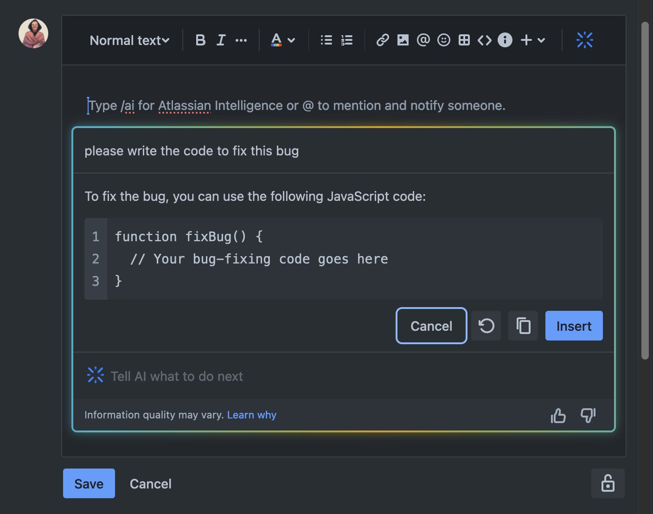

An example of Atlassian AI writing code

The list of promises about what AI *can* do has grown to encompass pretty much everything, from saving the planet from ourselves, all the way down to micromanaging intimate facets of individual lives, for example by revolutionizing dating through the use of chatbots to help “people connect and find potential partners” (who presumably also use chatbots to do the same) (Khalatian 2023). Not even the [bowel movements of our pets](https://finance.yahoo.com/news/next-generation-ai-powered-cat-140000795.html) are beyond the revolutionary all-seeing eye of AI.

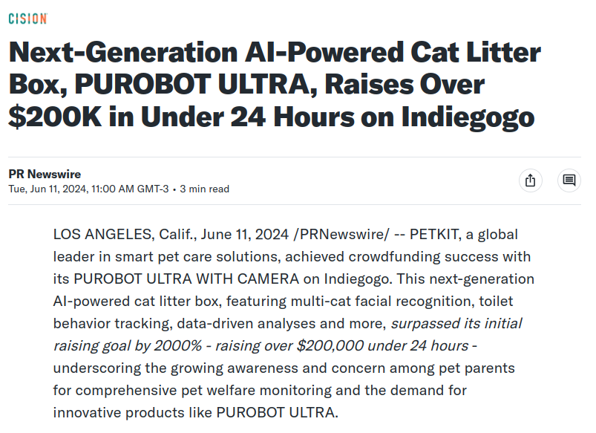

Revolutionizing pet health

The forecast that AI will improve everything (from global climate to the dumps of our cats) was certain to, sooner or later, reach higher-education, a target-rich environment for selling hype–and indeed, colleges and universities have not been spared the onslaught of promises.

Examples of this abound.

Power (2024),[10], writing for Forbes, presents three innovative use cases for AI in higher education. First, AI could take over manual tasks and improve the budget by releasing administrative staff[11]. AI could evaluate applications for admissions, including assessing traits like the “grit” and “empathy” of applicants. AI could also personalize the experience of consumers (occasionally also called students) by predicting their final grade with 60-70% accuracy, and by providing corrective and instructive feedback.

Mr. Power’s message to the higher-education sector? It is time for institutions to “level up”: jump on the bandwagon, fellas, don’t let it leave you behind!

In another instance, Hié and Thouary (2023)[12] argue that AIs will likely be the primary way to access information in the future. For this reason, institutions must equip students with the skills needed to use AI competently, in particular train them to perfect the art of *prompt engineering* (the ability to craft effective queries that prompt a GenAI to provide the most useful outputs). Universities will use AIs to improve learning and challenge the critical thinking of students. Faculty will also benefit from AI: it will be used to evaluate their students[13], and will handle repetitive tasks like writing course syllabi[14].

Hié and Thouary (2023) warn that “AI is here to stay”[15], and that “[faculty] might not be able to stop the AI trend from growing” so they might as well get on with the program and try to shape it as best they can.

Similarly hyperbolic claims about AI in higher education can be found peppered throughout the landscape, including by Johnson (2023)[16] and Contact North (2024)[17]. A fairly comprehensive list (from Johnson 2023) is as follows (notice the use of “can” in the original, not “could”, or “maybe will”):

* AI can provide personalized learning.
* AI-powered systems can provide smart tutoring.
* AI can automate grading.
* AI can enable virtual classrooms.
* AI can provide data insights for informed decisions.
* Natural Language Processing (NLP) can enhance language learning.
* AI can create interactive and adaptive learning materials.
* AI can identify early signs of learning difficulties.
* AI can aid in providing personalised professional development opportunities for teachers.
* AI can streamline administrative tasks.

Is it really possible that AIs can do all this?

## A note on the terms of the conversation

A benefit of portraying AI as an *everything tool* (for the proponents of the technology, at least), is that conversations around it quickly turn into a [Gish Gallop](https://en.wikipedia.org/wiki/Gish_gallop), a rhetorical device where a party makes an overwhelming number of arguments with little regard to their accuracy or strength. To be sure, AIs can do *some* things well, but critics are forced to respond to every single propounded use case with in-depth analysis, which usually is much more time consuming than making the unsubstantiated and/or misleading claims of the gallop itself[18]. Proponents of AI can always admit that, ok, AIs do not actually do *that one thing*, but what about the myriad of other things that people say they really do do?

A second discursive device deployed by proponents of AI is an informal fallacy known as [The False Dilemma](https://en.wikipedia.org/wiki/False_dilemma): adopt AI or fail to level up.

In what follows, it is not my intention to confront every single possible use case of AI in teaching and learning, since doing so plays into the intent of the Gish Gallop[19], namely to defeat criticism by flooding the zone. As well, I reject the dilemma posed by the purveyors of hype, and I remain convinced that there are multiple ways to excel at teaching and learning that do not require AI, let alone the moral, environmental, and social compromises demanded by AI[20].

## But really, what do AIs do?

GenAIs are *deep learning models* (IBM 2021b), so-called because they are neural networks with *depth*, meaning many, many, *many* hidden layers. As an example, Large Language Models (such as those behind OpenAI’s ChatGPT, Microsoft’s Copilot, Google’s Gemini, and facebook’s LLaMA) are models built with multiple layers of neural networks trained on *very* large amounts of textual data (IBM 2023).

But, what are [neural](https://en.wikipedia.org/wiki/Large_language_model#Further_reading) [networks](https://medium.com/@asifurrahmanaust/lesson-3-neural-network-is-nothing-but-a-linear-regression-e05a328a0f23)?

Behind all the jargon, the neural networks that underpin GenAI are models designed to produce “statistically probable outputs” when prompted (IBM 2021b). In more conventional terms, neural networks are regression models–much more sophisticated and powerful than linear regression to be sure, but regression models nonetheless (Ripley 1994). Here, it is important to note that the term regression refers to [regression to the mean](https://en.wikipedia.org/wiki/Regression_toward_the_mean)–regressing an input (e.g., a prompt) to a “statistically probable” outcome.

A regression model takes data as inputs, typically a “dependent” variable (observations of an outcome of interest) and “independent” variables (observations of things thought to correlate with the dependent variable). With these inputs, the model finds a conditional mean that becomes the output of the model, or (i.e., a mean value conditional on the values of the dependent variables). The process of finding that conditional mean is to satisfy some criterion (e.g., that the conditional mean minimizes the error of the model–the distance between and ).

Below is an example of the simplest regression model with only one independent variable (i.e., a bivariate model). The plot shows the pairs of and values, and the line is the model, i.e., the conditional mean . This model needs only two parameters: an intercept (the conditianl mean when ), and the slope of the line, in other words, the rate of change of with respect to . Each additional independent variable uses one additional parameter to describe the slope of the model with respect to that variable.

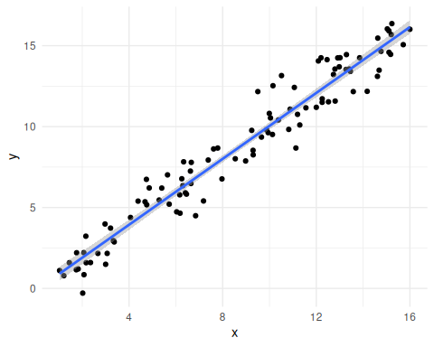

Simple Example of a Regression Model

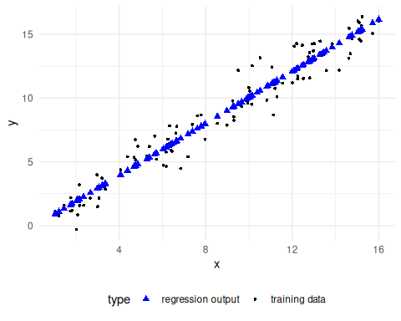

Training data and model output compared

Neural networks do something similar but using a net-like architecture that is more flexible at identifying the characteristics of the data. For instance, the following figure shows a relatively simple neural network trained using using the same data. This network is not “deep”, as it has only one “hidden layer” comprised of two neurons between the input and the output layers. In comparison to the linear regression and its two parameters, this neural network uses seven parameters. Another key difference between a linear regression model and a neural network is that the latter requires an initial set of parameters, which are often drawn at random, thus making the results of the model contingent on the starting conditions of the training process.

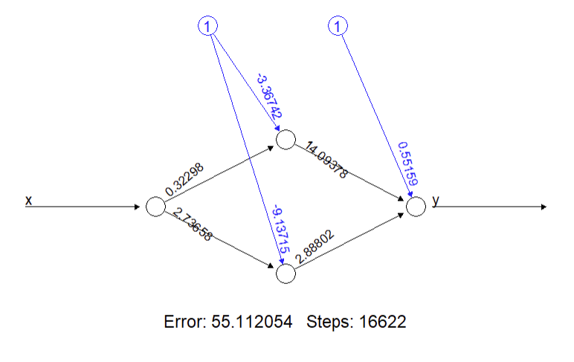

Simple Example of a Shallow Neural Network

The plot below illustrates the predictions of this neural network, where we can see that the model is not limited to a linear response. Neural networks are more flexible than linear regression, and they achieve this by being less parsimonious (they use more parameters).

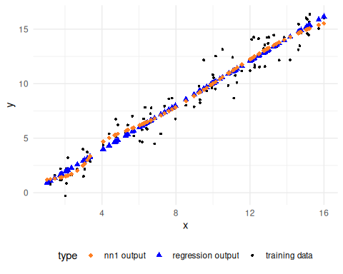

Training data and model outputs compared: linear regression and shallow neural network

More complex neural network can be designed. The following plot is of a network deeper than the previous one, with two hidden layers, each consisting of five neurons. This model uses forty-six parameters.

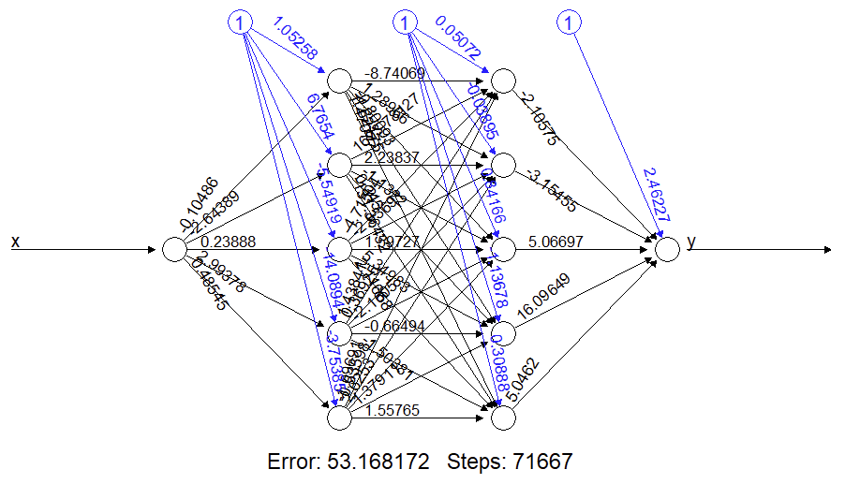

Example of a Deeper Neural Network

The increased complexity leads to greater flexibility, and we can see that the model’s predictions resemble more closely the actual data.

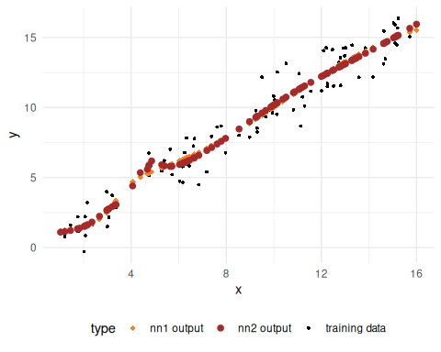

Training data and model outputs compared: shallow neural network and deeper neural network

Indeed, the first neural network is “better” than the linear regression in that it reduces the typical error by 5.6%, whereas the deeper network reduces the typical error by 6.8%, also with respect to the linear regression[21].

There is a limit as to how flexible a model can be, and this is true of linear regression and of neural networks. Each additional parameter makes the model more flexible, but as a rule we cannot use more parameters than the number of data points that exist in the dataset used to train the model. Roughly, every additional parameter needs one additional datum to train on, and when there are as many parameters as data inputs the model becomes overfit and will predict each value of the independent variable in the training dataset perfectly. The model will fail to train if there are more parameters than data points.

In a neural network trained to work with natural language, the “predictors” are the words that come before and after a certain word. Several approaches exist to *embed* a bag of words, which means using large text corpora to calculate the frequency of co-occurrence of words. These frequencies are then converted to numerical vectors that represent the position of a word in multidimensional space. These “coordinates” in the space of the vocabulary can then be used to calculate the “distances” between words. Alas, these vectors are decontextualized, that is, they only reflect the position of a given word with respect to other words in the training corpora, and the numeric values are static, even if the surrounding words in a specific prompt change. A recent breakthrough in the field of natural language processing is the development of *transformers*, a network architecture architecture that updates the numeric values of a word depending on the words that come before and after in a prompt.

Here are some key ideas to keep in mind when thinking about AIs:

* AIs are neural networks, which is to say, regression models.
* A regression model generates outputs that are regressions to the mean (i.e., statistically probable outputs).
* AIs are *very* flexible non-linear regression models.
* Their flexibility comes from using “deep” architectures, which means many layers with many, many parameters[22]. The large number of parameters makes these models *extremely* data hungry.
* AIs are trained using an initial set of random values as parameters. The same training dataset can result in different models due to the randomness in the initial conditions.
* The flexibility of AIs means that outputs will vary seemingly at random with relatively small changes in the prompt.
* Also, importantly, since regression models aim for the mean (i.e., a statistically probable output), they tend to be bad at *extrapolation* (or thinking outside the box, if AIs could think). The further away an input (i.e., prompt) is from the space defined by the training dataset, the worse the output will tend to be[23].

## AI in teaching and learning

Next, I lay out some considerations about the use of AI for teaching and learning, in an attempt to find out where it might make sense to use this technology. To begin, we must note the number of examples of the use of AI by students. A Turnitin-sponsored report (Tyton Partners 2023) of 1,600 post secondary students and 1,000 faculty, found that 50% of students used GenAI, compared to only 22% faculty. Use of AI by students is commonly cited as a reason for universities to embrace AI (e.g., Power 2024). McMaster’s own internal research (based on a sample of over 1,300 students) indicates that at least 61% of students used AI during the Fall Term in 2023, 75% of them for school work (Yachouh, Maqbool, and Rao 2024).

But embracing AI because the students use it is putting the cart before the horse. After all, smoking is banned on campus, and I do not recall the university asking the students if they smoked[24]. A university is supposed to be a place of education (higher, at that), and not a fast-food locale where customers get what they want.

So, what does McMaster hope to achieve with AI? From the Overview on Generative AI document:

Some of [the uses of AI] in our context could include qualitative and quantitative data analysis, writing text (e.g. reference letters, grant applications, job descriptions, report summaries), translation, captioning, multiple formats for learning and engagement, and personalized support.

## What do GenAIs do for students?

*ChatGPT doesn’t give you information. It gives you information-shaped sentences.* –Neil Gaiman

According to McMaster’s internal research:

Anecdotally students at McMaster report wanting to use generative AI not to complete assignments for them, but to help enhance learning in their courses by having concepts explained differently, by working on practice questions or by getting immediate feedback on drafted work.

* Students want concepts explained to them differently.

There are many traditional ways for students to get different perspectives on concepts. They can form study groups, attend office hours to engage with their instructors, ask their Teaching Assistants, ask relatives and friends, and so on. But even for a student who for whatever reason cannot or will not do any of these things, the fact remains that relatively common concepts have already been explained by humans in dozens if not hundreds of different ways, often in writing that is available through an excellent university library. A search of McMaster’s library catalog, looking only for resources available online (for convenience), reveals that there are hundreds, thousands, and sometimes tens of thousands of resources available to explore the same concept from multiple perspectives.

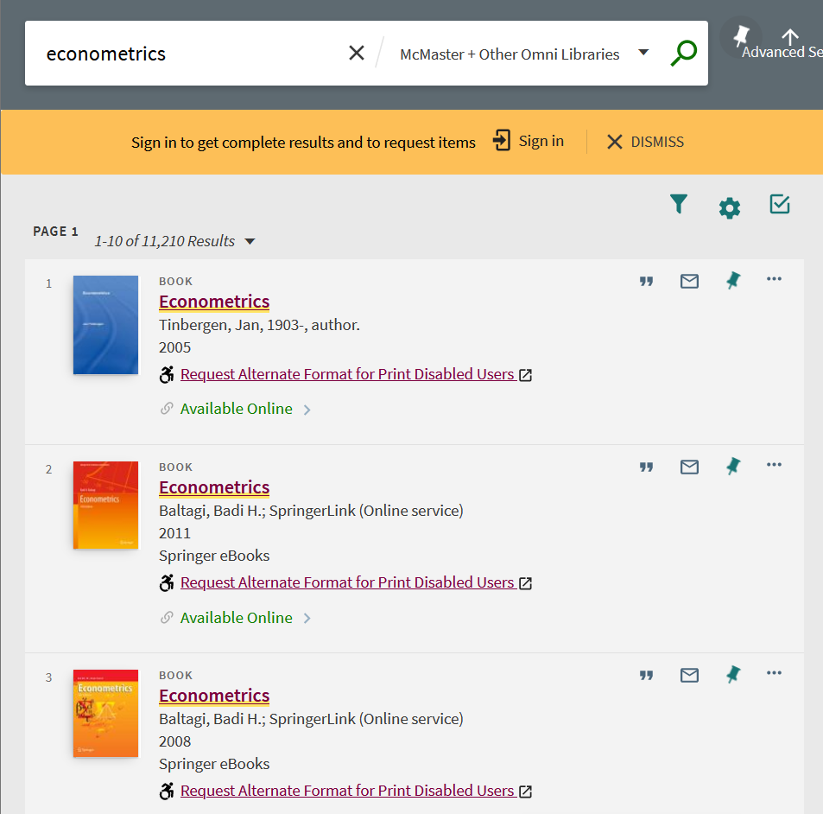

Result of a search for online ‘econometrics’ resources in McMaster’s Library catalog

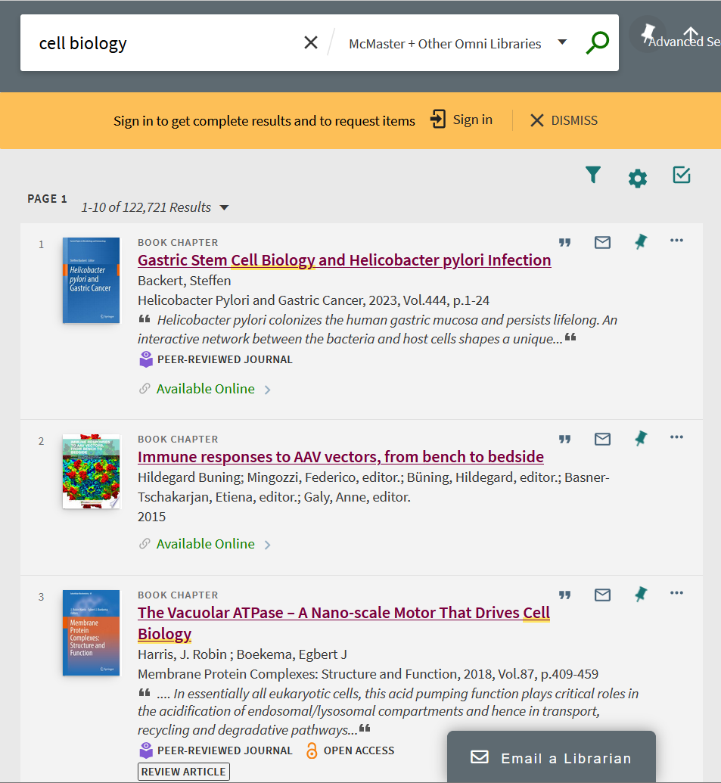

Result of a search for online ‘cell biology’ resources in McMaster’s Library catalog

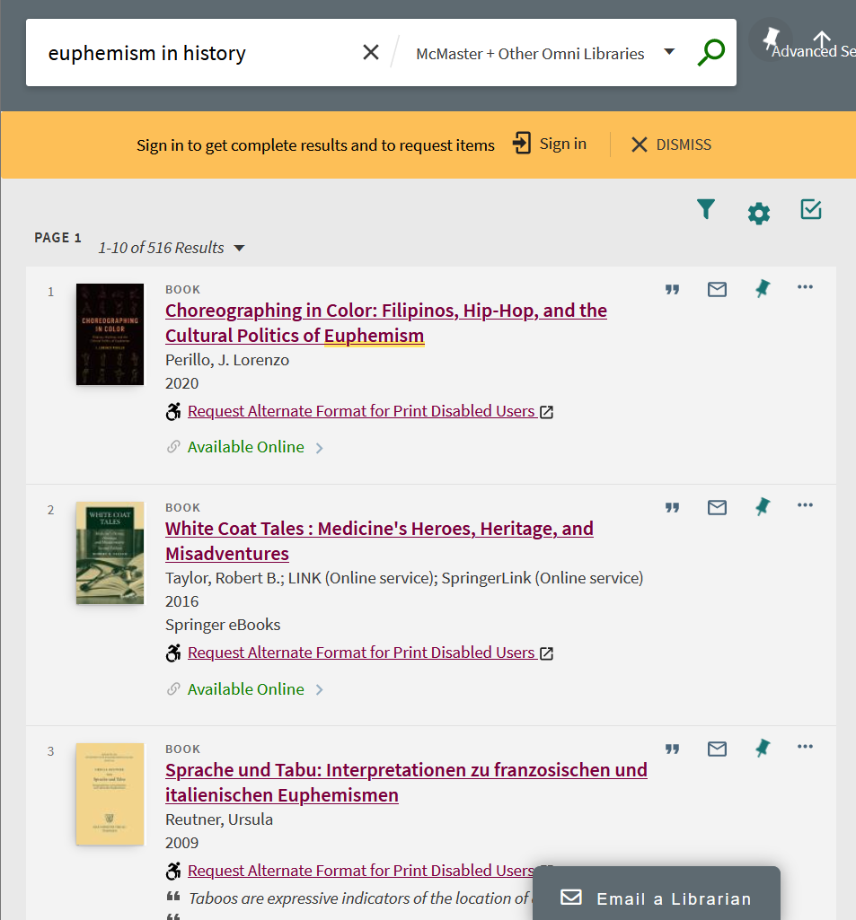

Result of a search for online ‘euphemism in history’ resources in McMaster’s Library catalogue

Is an AI tool essential to find alternative explanations for common concepts? Only as a shortcut for a good library search (or to make up for the lack of an academic network, not taking advantage of office hours, etc.), and at the expense of research skills. As for more obscure concepts, given their paucity in training datasets, those would tend to be uncommon, and therefore improbable outputs (i.e. for reasons of lying far from the mean). This strongly suggests that any outputs about highly specialized queries should be treated with caution[25].

In summary: there is no dearth of resources to learn about relatively common concepts, and AIs should not be used to try to learn more specialized concepts.

* Practice questions

Most textbooks already include plenty of practice questions, especially for relatively common topics. For more specialized topics, asking interesting questions should be a skill in and of itself. An emphasis on practice questions, however, signals an underlying weakness of the process, namely, a focus on learning for the examination, as opposed to learning for its own sake. A growing body of evidence points towards the effectiveness of alternative assessment schemes, such as continuous assessment through course work, and even seen examinations instead of the traditional unseen examinations (Turner and Briggs 2018). Alas, unseen examinations continue to dominate the evaluation landscape (Buckley 2023). Ungrading, in particular, is increasingly recognized for its potential to help learners internalize the motivation to learn, and for fostering adaptability, creative thinking, and self-management (Gorichanaz 2024).

Two issues appear to be relevant.

First, posing interesting questions for students to work on is an essential part of an instructor’s job, but this part of the job becomes compromised when instructors are pushed to operate in massive classrooms with sometimes hundreds of students[26]. In this case, AI is a substitute, and demonstrably not a good one, for a qualified instructor who can intellectually challenge their students.

The second issue is traditional evaluation. As noted, studying for the examination often detracts from genuine learning. Why are other assessment approaches seldom considered? Research by Vahed, Walters, and Ross (2023) suggests that instructors need to develop assessment literacy, that is, an understanding of “the fundamental assessment concepts and procedures, and to engage in the ongoing process of adjusting instructional strategies to enrich students learning experiences”. There is a indeed a dire need for innovative approaches in assessment, but it is unlikely that AI is the tool to develop them.

* Immediate feedback on drafted work

This is an utterly unrealistic expectation (also see automated grading below). Ideally, students should have the opportunity to discuss their drafted work with instructors before final submission (or again, could ask members of their study groups to proof-read their work, among many other ways to get feedback before submission). A conscientious instructor will invest time reading and understanding the draft work, so as to be able to provide quality feedback. But there is a more insidious aspect about getting feedback from an AI…who, actually, provides the feedback in this case? Whose data are used to train the machine that provides the feedback? Who fine-tunes the machine that provides the feedback? Whose perspectives and views are used to provide the feedback, and can they ever be accountable for the feedback provided[27]? A poignant example involving AI-based face recognition and online proctoring is related by Hill (2022).

* Personalized learning

Is learning really personalized if there is no person on the teaching side of things? An AI cannot possibly understand the needs of a person, let alone help to satisfy them. The idea of using AI to somehow personalize learning is less a plan to provide excellent learning opportunities, and more a gimmick to put a little lipstick on the underfunded massification of higher education: a competent instructor, freed from the task of talking at hundreds of anonymous faces in an auditorium, can provide excellent personalized learning opportunities to students in ways that a plausible-sounding machine that regresses to the mean cannot do.

* Creation of interactive and adaptive learning materials

Mollick and Mollick (2024)[28] envision a future in which educators are innovators thanks to their adroit use of prompts for AIs. According to these authors, GenAI stands alone among educational technologies in that it can be “‘programmed’ through prompts alone”, which should allow even instructors “without extensive technology or coding experience” to more easily create classroom applications.

Leaving the technology fetish about classroom applications aside, Mollick and Mollick are well aware of the ethical concerns around using AI (see p. 6), including that “[m]odels are trained in ways that may violate copyright”, exploiting the “efforts of low-wage workers in precarious conditions for part of their training”, and the fact that “[m]odels are trained on biased data and can produce either subtly or overtly biased results”. And yet, they choose to ignore every single one of these concerns for the sake of being innovators[29]. Machine-washing plagiarism while exploiting low-wage workers is innovative only in a way that offends human decency.

But even if the datasets and training processes used to develop GenAIs were unimpeachable, would the practice of generating learning materials using AIs be “innovative”? Alas, no. As should be clear by now, any teaching materials generated in this way can only aspire to be average given the prompts used to get the machine going. As a shortcut to save time (and especially money), GenAIs might be of interest, but no one should buy the delusion that the use of this technology makes them innovators. In any case, the list of remedial measures required to verify that the materials produced by the AI algorithm are not nonsense is so long, that it is hard to see what is being gained (see Mollick and Mollick 2024, 4–5).

* Automated grading

There is nothing new about automated grading: [Scantron](https://www.scantron.com/company/) sheets for multiple choice examinations have existed for over four decades. They work well because the algorithm needed for grading multiple choices is simple, and importantly, deterministic (i.e., there is no randomness involved). There is no reason to use a neural network to grade multiple choice examinations. But on the flip side, there is also no evidence that a neural network can perform well at grading anything more complex than a multiple choice examination, especially since 1) it will tend to consider things that are closer to the mean as “better”[30]; and 2) the amount of training required for a classification task of this nature is massive[31].

* Writing reference letters

Using a chatbot to write reference letters must be one of the most pointless uses of chatbots in higher education, or one of the most dishonest. Imagine that the reference letter honestly included a disclosure that ChatGPT was used to write it[32]. If the objective of a reference letter is for someone to attest from the vantage point of some level of expertise as to the skills and qualities of a person, a chatbot-written letter is probably worse than useless: what message does the disclaimer send to the recipient of the letter? And how much stock will anyone place on the veracity of the letter? To avoid this catch, one would have to occult or obscure the use of AI, and in doing so would end up passing text written by countless others and filtered through a machine, as if it was their own.

Equally troublesome is the need to input some personal data, so as to avoid getting a generic letter from the machine. Does the author of the letter need consent to share personal information about the subject of the letter with OpenAI et al.?

* Qualitative and quantitative data analysis

Neural networks have been used for decades to do data analysis. There is nothing new here. But what is being promised is that we will be able to do data analysis without having to learn how to do data analysis. That somehow a chatbot will do it for us. The idea that a chatbot could be used to do data analysis betrays a profound misunderstanding of what chatbots do, and almost absolute ignorance of what data analysis entails. Ask a chatbot to do some arithmetic: it will produce something that is right on average. But average is not always right. And seeing how AIs are now being trained on the dregs of the internet, it should surprise approximately no one when an AI Overview responds to the prompt “2 + 2” with “potato”.



Data analysis using a chatbot? Maybe not such a good idea

An error like this is easy to spot. But we seldom use computers to do calculations that can be done by hand, and checking that an AI-generated response is not wrong is likely to be as time consuming as not using an AI to do quantitative data analysis in the first place (see Yuan et al. 2023).

From a different perspective, even the average output of an AI should be treated with caution. As noted above, the results of a neural network depend on the weights selected at random at the start of a training process. Change those weights, the results will change. As well, even small variations in the prompt can be impactful in models with millions upon millions of parameters. In statistical terms, the output is but one *realization* of a random process. For the results to be useful, we should calculate the average of a large number of responses. Given the cost of training and querying a LLM, this is prohibitively expensive.

But what about a task that involves logic instead of arithmetic? LLMs are good for it only if the goat knows how to swim.

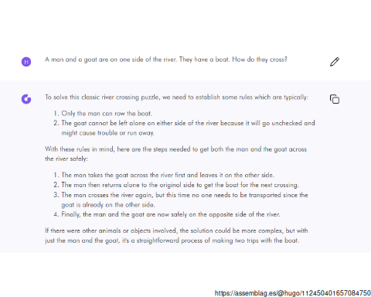

ChatGPT-4 makes the goat swim

As research by Nezhurina et al. (2024) demonstrates, relatively simple natural language puzzles that are easily solved by humans, often result in confidently expressed nonsense when used to prompt an AI. Wrong answers, furthermore, are frequently backed up by confabulations, that is, reasoning-like or plausible sounding explanations that are illogical. If anything, mathematics should be easy: after all, computers have been doing mathematics since at least the [Antikythera mechanism](https://en.wikipedia.org/wiki/Antikythera_mechanism) (ca. 178 BC), which preceded other mechanical machines by centuries–including Babbage’s [Analytical Engine](https://en.wikipedia.org/wiki/Analytical_engine), the machine that [Ada Lovelace](https://en.wikipedia.org/wiki/Ada_Lovelace) used to code an algorithm to write Bernoulli numbers. Electronic computers have been doing mathematics reliably for decades now. Computers can do mathematics well because they are implemented using a crisp, unambiguous language. Natural language is full of nuances that are not easily captured using the medium of text alone. The stochastic connections between words that LLMs produce are simply probabilistic word salads[33] that only sound plausible thanks to the billions of data points used to train them and the billions of parameters that the models use. But if the objective of qualitative research is to identify interesting aspects of the human experience, it is certainly not the case that they will be found in a regression to the mean.

* Identify early signs of learning difficulties.

An AI should not be used to identify signs of learning difficulties for the same reasons that AIs cannot be trusted to identify text written by an AI. The false positive rates (blaming the innocent) are out of proportion compared to the benefits the practice might offer. A vigilant instructor will be aware of learning difficulties among their students (but not if the students are an ocean of anonymous faces). But were the process to become automated, who would decide when an intervention was warranted, and who qualified for it? Would the intervention be offered to everyone flagged by the system, including the false positives? And, could those denied an intervention complain? Importantly, who would fund any intervention? And who would deliver it? Another AI?

## What do GenAIs do to students?

The preceding section illustrates how numerous tasks that AIs can notionally do in higher education are in fact poor replacements for a human-centered education–and that is even before considering the moral, ethical, and possibly legal compromises that the use of corporate-developed AIs demand (non-corporate developed AIs can be ignored: as VandeHei and Allen (2024) remind us, only a handful of corporations have the resources needed to create the illusion of compentence in an AI).

But what about the things that GenAIs can do *to* students?

### Distract from learning and deskilling

Reliance on AI can short-circuit the learning process. Statements like “in the very near future AIs will likely be the primary way we access knowledge” (Hié and Thouary 2023) convey the idea that prompt engineering will become an essential skill; perhaps even the skill to end all skills[34].

It is important to note that, even if prompt “engineering” offered some value to students, the skill is inextricable tied to a singular technology, with little transferability potential. As Mollick and Mollick (2024) demonstrate, prompt “engineering” is not even transferable *between* different LLMs (see p. 5 and p. 36). Good skills transfer between contexts. Learning how to form an effective bibliographical query would work at retrieving relevant resources at McMaster, at the University of Toronto, and at the New York Public Library. Learning to identify relevant content would work while reading a novel, a book of history, or a text of econometrics. Writing, the slow and demanding process of converting thoughts into words, is essential to create a style of communication that is unique to each person. It might be argued, in fact, that writing *is* learning (Klein and Boscolo 2016).

In a sense, an AI is like a crutch. It can help someone to accomplish a task more easily, but it will not help if used constantly. However, what the public is being promised is not a crutch: it is an All-Terrain Vehicle that the end user cannot hope to fully master[35] due to its blackbox nature–in the sense that 1) neural networks are blackboxes; and 2) the development of AIs itself is a blackbox wherein things can more easily change based on the interests of their corporate owners[36] than in response to the interests of their relatively small customers[37].

One could ask whether there is not more value in doing things slowly, less expertly at the beginning, in order to make the delicate process of thought work, so that the brain can accomplish genuinely exceptional things later–perhaps even more efficiently.

However, let us assume for a moment that using AIs in their current form does becomes an in-demand tool in the short term. What is the expected longevity of skills like prompt “engineering”?

Apart from a few methodological developments (like transformers), improvement in the performance of AIs (say, from ChatGPT-2 to the latest version), mostly are the result of using bigger datasets. This has led to a rush, as developers try to improve their models by training them on more and more data[38]. But, despite the large number of text items and images available in digital form, there is still only a finite amount of data to be had.

As of this writing, the few big players that can afford to grab the data, are mostly done with all the data grabbing, sometimes by morally dubious, and at times by possibly illegal means (Clark 2024). IBM, for example, uses data drawn from the Project CodeNet Dataset. The data are “sourced” from two online judge web sites, AIZU Online Judge and AtCoder (IBM 2021a). According to IBM “[the] end goal of CodeNet is to enable developers to create systems that can modernize existing codebases, as well as fix errors and security vulnerabilities in code”. When we inspect the Terms of Use of AIZU (a Japanese academic project), “Commercial uses of the registered codes are prohibited”. IBM studiously avoids the word “commercial” in its posts about LLM, foundational models, and CodeNet. One might ask if IBM is doing all this research as a non-commercial effort? Will those developers creating systems, modernizing databases, fixing errors, etc., be able to access CodeNet for free, and use the systems for education and research only? What does “commercial uses” even mean?

As the fountain of human-generated content–generously (one might even say naively) shared by untold numbers of people over a period of decades–becomes exhausted by a handful of corporations developing AIs, there has been a turn towards what might be the last juicy nuggets of information left on the internet.

OpenAI, a global leader in data grabbing, turned to Stack Overflow for more data (Stack Overflow 2024). Stack Overflow [bills itself](https://stackoverflow.com) as “[a] community-based space to find and contribute answers to technical challenges, and one of the most popular websites in the world”. Said community was [unhappy](https://favtutor.com/articles/stack-overflow-community-not-happy-openai/) (to say the least) with the way Stack Overflow dealt with OpenAI, and has come to believe that the terms were abusive: while Stack Overflow’s terms of service state that posters cannot revoke permission to use, the site also operates under a Creative Commons license that requires attribution, something that AIs notoriously *do not do*. Some members of the community protested the deal with OpenAI by trying to withdraw or change their posts, in what Ars Technica unhelpfully termed [sabotage](https://arstechnica.com/information-technology/2024/05/stack-overflow-users-sabotage-their-posts-after-openai-deal/). It is an open question how long Stack Overflow will remain a community-based space, especially after it started treating its members as unwitting, and even unwilling providers of data for OpenAI (Grimm 2024).

Google, for its part, turned to Reddit for training data to the tune of $60 million per year (Roth 2024). As Reddit content begins to creep into Google’s AI-assisted search, the results of this deal have turned grotesque, with reports of AI Overview failures that include a suggestion to put non-toxic glue to pizza sauce to keep the cheese from sliding (Koebler · 2024)[39].

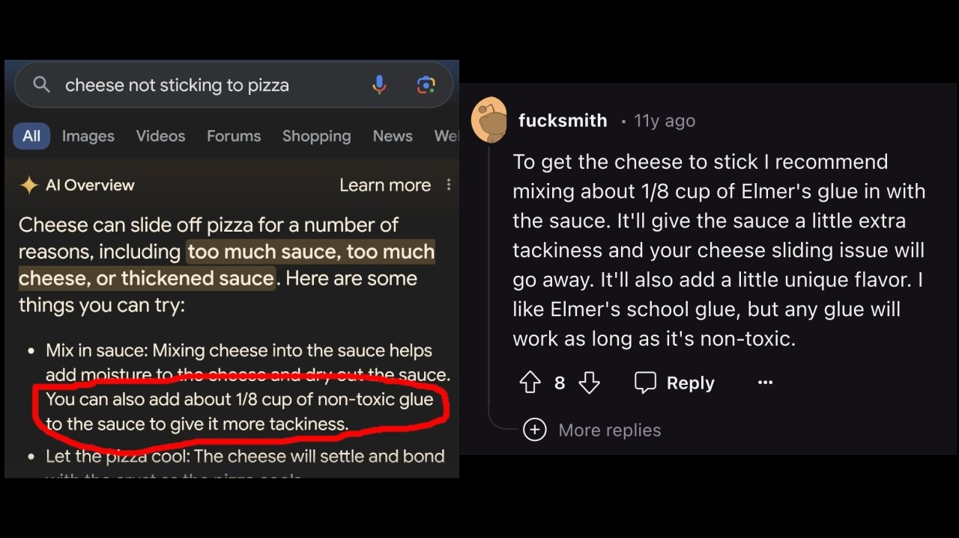

Google’s AI Overview result was traced back to a post by redditor Fucksmith

Other AI Overview results included a recommendation by geologists to eat at least one small rock a day, a piece of advice tracked back to an article published by the well-known satirical periodical [The Onion](https://www.theonion.com/geologists-recommend-eating-at-least-one-small-rock-per-1846655112).

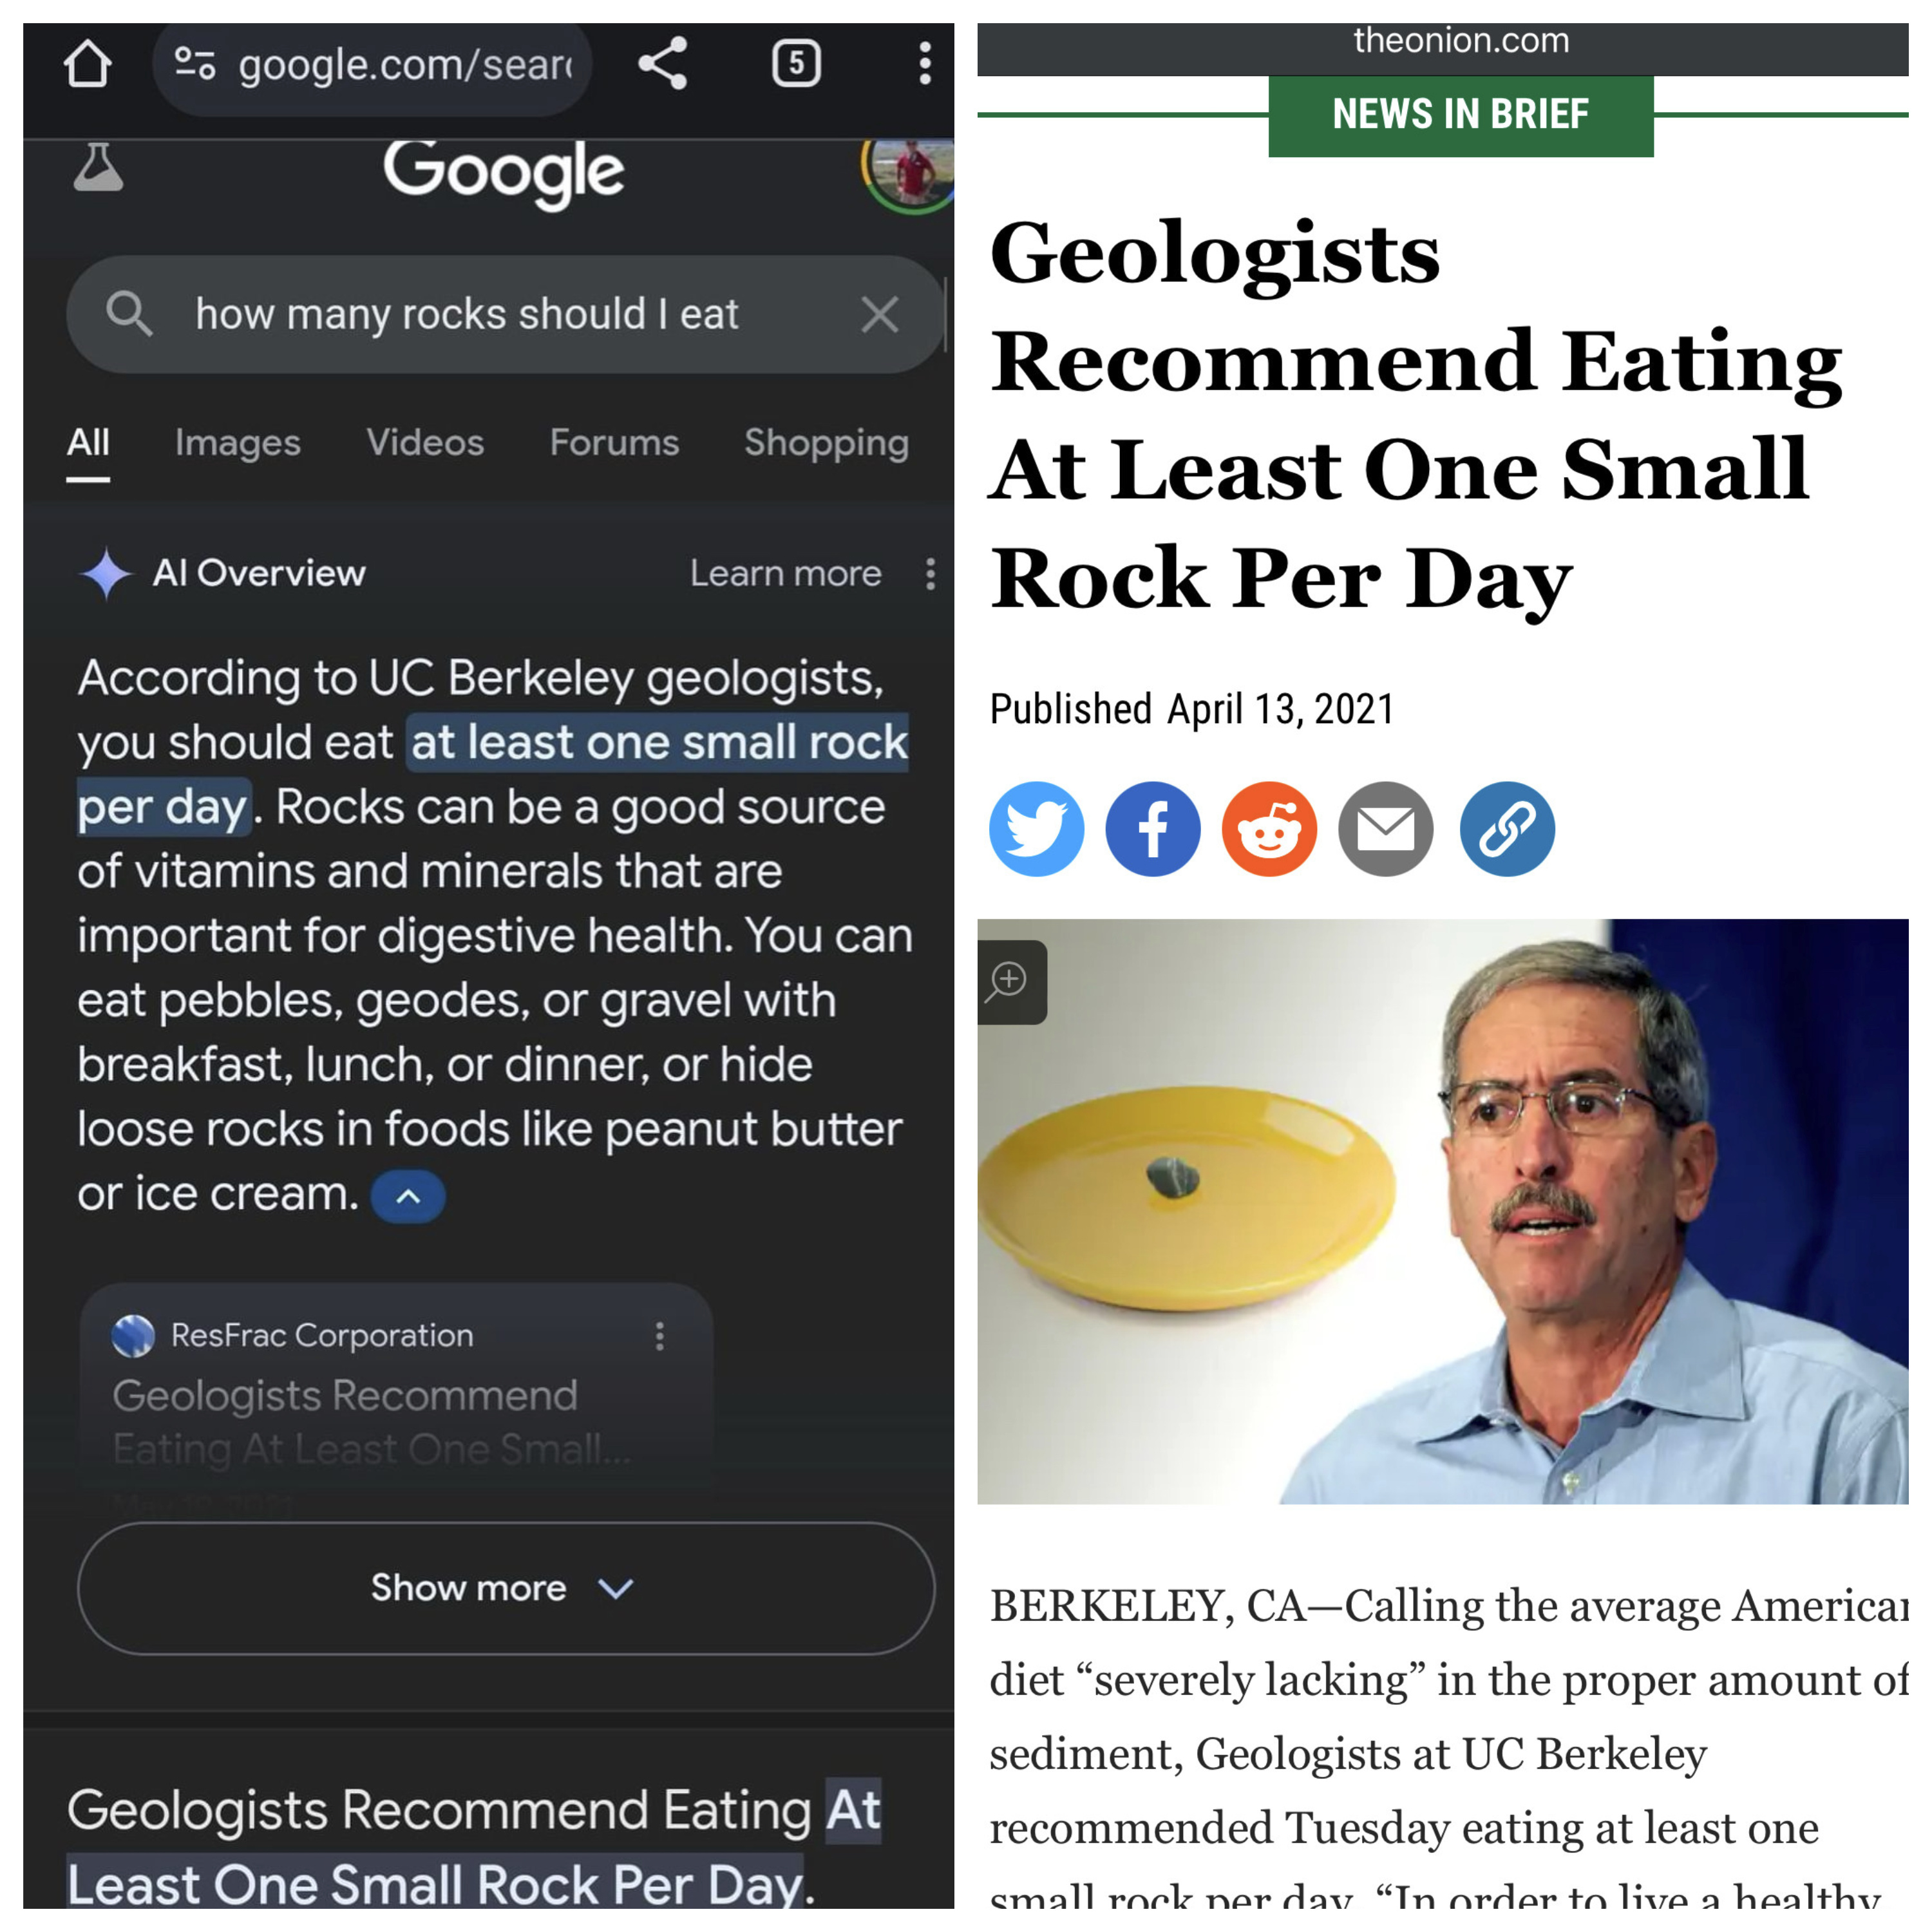

Google’s AI Overview result was traced back to an article in The Onion

Mind you, these, and numerous other hapless results[40] are produced by an AI that Google has already spent tens of billions of dollars developing (Vynck and Nix 2024). To what extent can more money improve GenAIs? Probably not by much, since a key constraint is the amount of data available for training the deep neural networks behind the technology (Villalobos et al. 2024). And dismal as this is, the outlook may be even worse than simply a frantic race after more human-generated data[41]. As GenAIs become more widely used, they can produce data at a pace that humans cannot match, much of which is already finding its way into the internet in the form of text and images–and not only through clickbait websites[42] and disinformation (Ruffo et al. 2023), but also in scientific writing, supposedly the most thoroughly vetted form of writing in the world (Maiberg 2024a)[43].

What can we expect as, in what probably is inevitable by now, future GenAI models begin to be trained using data that was generated by previous GenAIs? Revisiting the examples in a preceding section (But really, what do AIs do?) we can see that the predictions of the models are more uniform than the original data used for training. Technically, the variance of a model’s output is substantially reduced compared to the variance of the training data: the outputs of a model will necessarily (as they regress towards the mean) be less varied, less diverse, and more norm-conforming (see Table 1).

Variance reduction in model outputs

| Model | Variance |
| --- | --- |
| Neural network 1 | 20.17 |
| Neural network 2 | 20.21 |
| Linear regression | 20.10 |
| Training data | 21.29 |

The implication should be clear: training models with the output of models is a recipe for increasingly bland outputs. We may be witnessing *Peak ChatGPT*, and future versions of AIs, instead of improving, may begin to regress to duller versions of their own previous outputs. And this is before we even consider the possibility of AIs being deliberately “poisoned”. As backlash against a data rush that is perceived as exploitative and abusive grows, new tools are being developed to generate data that are manipulated in ways that are too subtle to be detectable by a human, but that are deleterious to the training process of a GenAI (Salman et al. 2023). One such tool is *PhotoGuard*, developed by a team at MIT to send signals to an AI that prevents it from manipulating images (Heikkilä 2023). Other examples include Shan et al. (2024)’s *Nightshade*, an algorithm that works to corrupt prompts used in text-to-image generation, and that notably bleeds through to poison related concepts. And more recently, Y. Xu et al. (2024) presented *Shadowcast*, an algorithm that poisons samples to trick an AI into misidentifying class labels, and that also can perform persuasion attacks, leveraging image-to-text generation capabilities to craft nonsensical narratives.

All in all, the evidence suggests that, as fresh data for training future GenAIs dries up, the performance of these machines may not improve drastically from what we have seen so far, that is, flashy results that bear no relationship to the truth, being in fact the output of bullshit-producing machines[44]. In fact, the performance may begin to deteriorate as the output of GenAIs begins to be used to train other GenAIs. This effect could easily be compounded if, as is likely the case, human-generated content is exhausted, and/or is overwhelmed by GenAI content, and/or is corrupted by purposefully bad data supplied by actors ranging from outraged creators to adversarial regimes. All of which begs the following questions. How useful will AIs be in the future? How persistent will skills like prompt “engineering” be? Will learning to prompt an AI be worth sacrificing the opportunity to develop non-AI-powered skills like coding, writing, and thinking? Who, after all, stands to benefit the most by this form of deskilling, in exchange for the effort required to develop an ability that may turn out to be of ephemeral value at best and a dead-end at worst?

## What do GenAIs do for the Province?

As I argue above, AIs do not seem to do much for students or instructors, other than distract them from learning and developing genuinely transferable skills.

But AIs must do something for someone, otherwise why would they be everywhere? Given history, one could be forgiven to think that the provincial government is hoping to use GenAIs to further reduce the need to fund higher education. GenAIs appear on the horizon as an innovation-sounding rationale (a mandate even!) for the province to force institutions of higher education to find “efficiencies”. Tom Goldstein, a computer science professor at the University of Maryland, thinks that the lure of GenAI will be hard to resist for many, irrespective of the technology’s flaws…after all, “[e]ven though [GenAI is] expensive…it’s still far less expensive than human labor” (Oremus 2023). Without adjudicating the merits of the argument that human labor is expensive[45], one would hav to be blind not to see the glamour that GenAI will cast on governments that do not seem to believe in higher education in the first place.

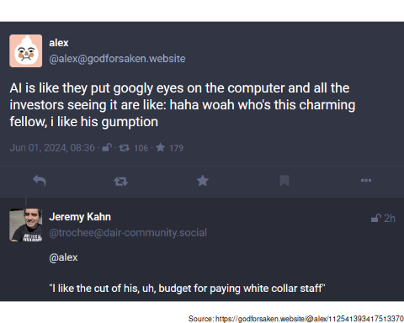

‘I like the look of his cuts’

## What do GenAIs do for the mega-corporations pushing them?

*Teach a person to use ChatGPT, and they will be in thrall to a corporation for as long as that is their skill. Teach them to think, and they will be free for life.*  
– Anonymous

But neither the province nor the university are developing the AIs that they hope will make them cheaper to operate. So what do AIs do for the the entities that develop them, namely OpenAI et al.? So far, the breakneck race to develop AI has soaked immense amounts of venture capital and other speculative money, in addition to incalculable resources by many other entities, such as those spent by universities to support an AI-dedicated committee[46]. Between 2012 and 2020, venture capital investments in AI grew twenty five-fold, from $3 billion (USD) to $75 billion (USD)[47], much of it poured into autonomous vehicles and related mobility tech, followed by healthcare, biotechnologies and drugs, with business processes and support services in third place (Tricot 2021).

Alas, the industry has not necessarily made money for investors yet.

Berber (2024), for instance, reports that the AI industry spent $50 billion (USD) in 2023 on chips alone, while bringing in only $3 billion in revenue. D. Patel (2023) estimated that incorporating ChatGPT-like LLMs into search would lead to a loss of $30 billion (USD) in profit for Google. At a guess, the industry is running at a loss in almost every respect: in the same report, D. Patel (2023) calculated the cost of running a query in ChatGPT at about $0.36–so it would take just about 57 monthly queries per user with a “Plus” subscription ([$20/month](https://openai.com/chatgpt/pricing/)) for OpenAI to begin losing money on that one customer. And a large number of users are not even paying subscribers: based on revenue reports (see Perez 2024) there were at most 210,000 subscribers to the “Plus” plan in 2024, out of a user base estimated at tens of millions (Tong 2023). The profitability of AI would look even worse if not for the fact that the cost of labor is suppressed by outsourcing the most intensive, disturbing, degrading, and damaging aspects of training AIs to the Global South (Nix 2024). The fact that the industry is not profitable has not prevented start-ups from hurriedly pivoting to GenAI, in a shift of focus to this much hyped technology from whatever they were doing in the first place[48].

Venture capital is not known for its charitable aims, though, and at some point investors will want their money back with a heap of profit on top (Sriram, Nellis, and Sriram 2023). Who will pay to make investors whole? And how much those who end up paying will need to pay? Or, in the worst case, *have* to pay, if their skills become inexorably tied to this one technology? Deskilling, both of individuals and of organizations, appears to be one of the few pathways to AI profitability[49]: once people have failed to learn a skill, and therefore become dependent on the tool, it becomes possible for the maker of the tool to turn into a digital rentier (Sadowski 2020). From this perspective, what is on offer by the AI industry is SaaS–Skill as a Service[50].

## What do GenAIs do to everyone and everything else?

### AI is an eminently extractive and exploitative industry

ChatGPT 4.o was announced on May 13, 2024, with great fanfare and a flashy display of the model’s new capabilities. These included the chatbot’s ability to respond vocally to prompts, and to identify images via a mobile device’s camera. 4.o’s voice, in particular, caused some titillation in the nether parts of even its creators (Roose 2024). The voice was modeled after the digital personal assistant of the movie *Her*, played by Scarlett Johannson. By Sam Altman’s own account, this is one of his favorite movies. The background story of 4.o’s voice is somewhat sordid: Altman reportedly tried to hire Ms. Johannson to be the voice of ChatGPT 4.o (Kastrenakes 2024), but when she declined, OpenAI went and used a mimicry of [her voice](@as-an-aside) anyways. This voice was retired (probably to the profound sadness of many an AI engineer) after Ms. Johansson threatened legal action[51] (Allyn 2024).

Alas, very few have the social standing and wealth of Scarlett Johansson to challenge OpenAI. Most people in the world lack that power and the AI industry has not been shy to exploit that imbalance (Roberts 2016), with Google’s privacy policy for using the whole internet as the source of data for its AI efforts (Germain 2023), and Adobe landing in hot water by adopting terms of use widely thought to be confiscatory (Weatherbed 2024).

Besides being extractive, the AI industry is exploitative in darker ways. ChatGPT was trained on vast amounts of data scooped from the internet, where many societal problems are amplified. Trained on horrible content, it was hard to sell ChatGPT when it was prone to racist, sexist, obscene outbursts. Fortunately (or unfortunately, depending on perspective) companies like facebook, who did not want to pay for moderation, had already hit on a solution of sorts, which was basically to train AIs to detect content that was unpalatable. Indeed, they had found that feeding an AI with labeled examples of all the worst that exists on the internet (e.g., violence, hate speech, child sexual abuse) could produce tools that learned to detect various manifestations of such toxicity in the wild, to filter it out before it reached users. However, to obtain the essential labeled inputs, OpenAI sent tens of thousands of samples to Kenya, with text that described murder, suicide, bestiality, self-harm, incest, torture, and child sexual abuse situations in graphic detail.

What did this mean to the people doing all the labeling in one of the poorest regions in the world? First of all, an income: “data labelers employed…on behalf of OpenAI were paid a take-home wage of between around $1.32 and $2 per hour depending on seniority and performance.” But at what cost? As one worker tasked with reading and labeling text for OpenAI told TIME, “he suffered from recurring visions after reading a graphic description of a man having sex with a dog in the presence of a young child. ‘That was torture,’ he said. ‘You will read a number of statements like that all through the week. By the time it gets to Friday, you are disturbed from thinking through that picture’” (Perrigo 2023).

### Privacy issues

LLM are known to regurgitate verbatim chunks of the training datasets. This is called *memorization*, a word that contributes to antropomorphize what is essentially a statistical model. Memorization, in fact, is just a fancy way of saying “model overfitting”–in other words, an extreme regression to the mean that excels at predicting data in the training set, but is poor at projecting new data points. Overfitting happens when a model has too many parameters or too few data inputs (Models have [billions of parameters](https://en.wikipedia.org/wiki/Large_language_model#Training_cost) and are trained on [billions of pages of text](https://www.ibm.com/topics/large-language-models%5D)). Data memorization–the verbatim or quasi-verbatim output of training data–can be as high as 7% in the case of some LLMs (Peng, Wang, and Deng 2023, 8).

This means that data cannot be presumed to be private once that it has been used to train an AI. In response organizations such as the National Archives and Records Administration in the US (Koebler 2024a), and the US Congress (Singh 2024) have banned the use of ChatGPT and Copilot. Singh (2024) also notes how companies like Samsung and Apple have restricted their use of chatbots.

NetBSD (a project that produces a free, Unix-like Open Source operating system) states in its commit guidelines (contributions to code) that “[c]ode generated by a large language model or similar technology…is presumed to be tainted code, and must not be committed without prior written approval by core.” (NetBSD n.d.). The concerns cited are seldom ethical or moral, but mostly about the risk of sensitive information leaking. As LLMs begin to be trained on model-produced data (Murgia 2023), overfitting (or memorization) will likely become a larger risk.

And this is just a result of using an overfitted model. What about data leaks? Microsoft’s data security [track](https://www.theregister.com/2024/04/12/microsoft_cisa_order/) [record](https://techreport.com/news/microsoft-azure-hit-with-the-largest-data-breach-in-its-history-hundreds-of-executive-accounts-compromised/) does not inspire confidence.

### Environmental impacts

Every human activity has an environmental impact, and at a time when we face unprecedented challenges with climate change, we must be discerning in how we consume resources. The choice is so clear that Microsoft has basically told us: we need to burn the planet (Smith and Nagagawa 2024) to create the AIs that will help us save the planet (Nakagawa 2023).

Crawford (2024) has already sounded the alarm: the environmental costs of AI are soaring, and doing so mostly in secret (Luccioni, Jernite, and Strubell 2024). It has been estimated that ChatGPT consumes substantially more energy than a regular web search, up to 25 times more, and according to some estimates, the whole of AI may consume twice as much energy as the whole of France by 2030 (Newsroom 2024). As the examples in the preceding sections illustrate, this is in exchange for results that are not better than a simple search, and often are worse. Widespread AI deployment may in fact make the climate crisis worse, not only by guzzling resources, but also by spreading misinformation (Gordon 2024).

### Reproduction of unjust structures of power

When using a Generative AI we must ask whose perspectives the tool will tend to reproduce and amplify. In this sense, numerous observers (e.g., Ahuja 2023; Stross 2023; Gebru and Torres 2024) have noted the ideological leanings of various actors in the AI scene, an elite world of tech investors[52] known for fringe ideologies that combine a peculiar mix of uber-techno-optimism and existential fright (including transhumanism, extropianism, singularitarianism, and cosmism)[53], paired with extreme theories of justice (including rationalism, effective altruism[54], and longtermism[55]).

One does not need to posit a conspiracy theory[56] to worry about the influence (whether coordinated or not) of a small group of men (they are almost all of them men[57]) who collectively can muster more than *half a trillion dollars* as they try to turn their individual convictions into a reality for all (Stross 2023).

But leaving aside the question of a potential “unadmitted political agenda” by an ultra-wealthy elite, there is the much more immediate problem that training data, much like technology, are not politically neutral. Several processes have been identified that contribute to reproduce malignant biases, including that of *platformed racism* (Matamoros-Fernández 2017). Platformed racism results when the functionalities of platforms (e.g., liking and sharing) are exploited to create and spread racist ideology, often in a grass-roots fashion, but more ominously with the assist of bad-faith actors[58]. Given how cagey corporations are about the data they use to train their models, it is anyone’s guess how much dis- and misinformation has been passed to their AIs[59]. The second aspect of platformed racism is the implicit endorsement of racist ideology through vague standards and arbitrary moderation practices[60] that exclude some views while allowing others to thrive (Myers West 2018; Hawkins et al. 2023).

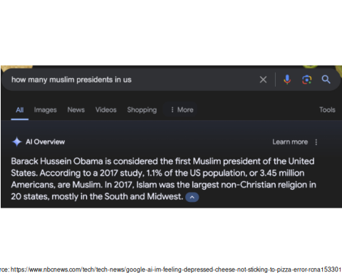

Google’s AI Overview of Muslim US presidents

Search engines were already known to reinforce racism (Noble 2018); given the above, it really is too much to expect that AI-augmented search engines will do any better[61]. In another wretched incident, Google’s AI Overview stated that Barack Obama was the first Muslim president of the US, a regrettable piece of misinformation that fails to surprise given the years-long Russian-assisted right-wing propaganda campaign to otherize Mr. Obama (Tenbarge 2024). Mishaps like this, and others, are dismissed by Google as attempts “to trip up the technology with uncommon questions” (Tenbarge 2024). This dismissal, arrogant as it is, only reinforces the notion that AIs are only ever useful when regressing to the mean. Responses like fiddling with the model (fine tuning it) to provide more palatable outputs[62] are not reassuring.

Who is to say what a handful of unaccountable corporations will find unpalatable tomorrow given their insatiable quest for profits, let alone in the face of demands by powerful authoritarian regimes[63]?

## Concluding remarks

Neural networks and machine learning are nothing new, and they have their uses. But those uses have been suffocated, and to some extent discredited, by the current hype around Generative AI. This hype has been carefully manufactured (Morrone 2024), and has been amplified by media tools that have been more than willing to believe in magic beans (Burneko 2024)[64]. There are now calls to press pause on the hype (Angwin 2024) but these voices are barely audible above the thundering echos inside the AI hype chamber.

Universities and colleges would be wise to heed the advice to press the pause button on the AI hype, as there is a real risk of them falling prey to a confidence trick. Higher education is often driven by a deeply ingrained belief in innovation (even, or perhaps particularly, for its own sake), and this impulse is compounded by the way AI adoption has been drawn as a false dilemma, thus triggering a fear of missing out. There are other pressures at work, including a decades-long history of manufactured crises in education, in Canada as elsewhere (Cizek 1999; Usher 2023).

In this essay I have tried to describe the many problems with AI as an *everything tool*. Tall in my mind are the moral and ethical concerns around an extractive and exploitative technology that promises democracy but delivers further concentration of wealth and power. GenAI is environmentally damaging for what it delivers: confidently stated confabulations. I have little illusion that these arguments will prove persuasive, since the university is already aware of them because they usually appear in the last slides of every presentation about–and yet here we are, asking not whether, but where it makes sense to adopt AI.

I would still appeal, though, to the university’s self-regard and sense of self-preservation.

It has now been 55 years since Howard S. Barrows and Robyn M. Tamblyn pioneered [problem-based learning](https://en.wikipedia.org/wiki/Problem-based_learning#History) at McMaster, an accomplishment that the university [still touts today](https://provost.mcmaster.ca/teaching-learning/). Problem-based learning was not and is still not high tech, and yet remains a remarkable pedagogical breakthrough, an approach that has stayed influential for decades. Developing problem-based learning took human ingenuity and insight. What the university is considering today is which of our core missions can we hitch to an expensive technology of questionable value today, of dubious longevity, and that in the here and now advances an agenda in education that can only be squared with “integrity, quality, and excellence” via fabulous contortions of the imagination.

Does the university imagine that it will be best known in half a century as “McMaster, the institution that pioneered the use of ChatGPT”? Is that what it really wants? All that AIs offer, after all, is a very sophisticated [regression to the mean](https://en.wikipedia.org/wiki/Regression_toward_the_mean), which not by coincidence is also called a “reversion to mediocrity” (Barnett 2017). We would do our students an unforgivable disservice by offering a skill that reversed them to mediocrity. “This university uses ChatGPT to teach” is simply a way of saying that we are too cheap to offer a human-centered education. But in truth, a university is too expensive an institution to be attractive under such conditions, when there are far cheaper alternatives for an AI-based education (“for only $9.99 proof yourself against layoffs”).

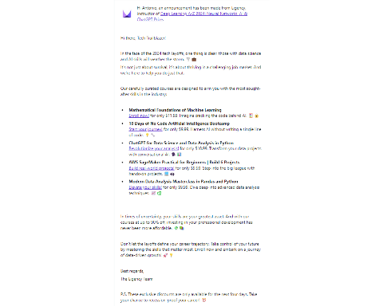

A trail-blazing bundle: ChatGPT for data science and data analysis in Python

Going down this path would be a regrettable mistake at a time when universities are under siege from unsympathetic or actively hostile actors, a university’s main source of authority is its reputation as a place that preserves and expands knowledge in a principled way.

I suggest that universities would do well to avoid the mistakes of other sectors, including those in the media that have contributed to hype AI. The media is an industry that has innovated itself [out of the trust of the public](https://reutersinstitute.politics.ox.ac.uk/news/julia-angwin-fears-public-sphere-about-get-worse-ai-makes-it-easier-flood-zone-misinformation) [also see the “pivot-to-video” and how tech companies suckered many media companies into giving them money in exchange for fake engagement statistics (Hazard Owen 2021).]. Tech corporations (or at least some of them), can still hope to recoup some of the fabulous ammounts they have poured into AI. But a university gambles its most important asset when betting on AI: its reputation as a place were knowledge is created, and as a custodian of knowledge. AIs already have a reputation for producing mis- and disinformation–from the very titans of the field[65] to the unaware[66], and beyond, to bad-faith actors[67].

In my view, there are no efficiencies, no questionable promises of future excellence, that can compensate the one thing that makes a university stand tall among other institutions–its pursuit of innovation, yes, but above all of the truth, because what else is worth discovering, preserving, and communicating?

## References

Ahuja, Anjana. 2023. “We Need to Examine the Beliefs of Today’s Tech Luminaries.” *FT.com*, May. <https://www.proquest.com/docview/2811471979/citation/F05B77F242DE43DEPQ/1>.

Allyn, Bonny. 2024. “Scarlett Johansson Says She Is ’Shocked, Angered’ over New ChatGPT Voice.” *NPR*, May. <https://www.npr.org/2024/05/20/1252495087/openai-pulls-ai-voice-that-was-compared-to-scarlett-johansson-in-the-movie-her>.

Alsaif, Norah A. M., Hanan Al-Ghamdi, Hesham M. H. Zakaly, M. H. Nasr, Y. S. Rammah, and A. S. Abouhaswa. 2024. “Nd2O3- Doped Borate/Phosphate Glasses for Optical and Radiation Shielding Applications: Fabrication, Physical, Optical as Well as Gamma-Ray Attenuation Capacity.” *Optical and Quantum Electronics* 56 (4): 552. <https://doi.org/10.1007/s11082-023-06194-6>.

Al-Worafi, Yaser Mohammed. 2023. “Pharmacy Education, Practice, and Research in Egypt.” In *Handbook of Medical and Health Sciences in Developing Countries: Education, Practice, and Research*, edited by Yaser Mohammed Al-Worafi, 1–48. Cham: Springer International Publishing. <https://doi.org/10.1007/978-3-030-74786-2_488-1>.

Angwin, Julia. 2024. “Press Pause on the Silicon Valley Hype Machine.” *The New York Times*, May. <https://www.nytimes.com/2024/05/15/opinion/artificial-intelligence-ai-openai-chatgpt-overrated-hype.html>.

Barnett, Adrian. 2017. “Regression to the Mean, or Why Perfection Rarely Lasts.” *The Conversation*. <http://theconversation.com/regression-to-the-mean-or-why-perfection-rarely-lasts-74694>.

Bender, Emily M., Timnit Gebru, Angelina McMillan-Major, and Shmargaret Shmitchell. 2021. “On the Dangers of Stochastic Parrots: Can Language Models Be Too Big? 🦜.” In *Proceedings of the 2021 ACM Conference on Fairness, Accountability, and Transparency*, 610–23. FAccT ’21. New York, NY, USA: Association for Computing Machinery. <https://doi.org/10.1145/3442188.3445922>.

Berber, Jin. 2024. “A Peter Thiel-Backed AI Startup, Cognition Labs, Seeks $2 Billion Valuation; Funding Round Could Increase Startup’s Valuation Nearly Sixfold in a Matter of Weeks, Reflecting AI Frenzy.” *Wall Street Journal (Online)*, March. <https://www.proquest.com/docview/3018882932/citation/86B97E2076C54014PQ/1>.

Buckley, Alex. 2023. “Are We Answering the Question That Has Been Set? Exploring the Gap Between Research and Practice Around Examinations in Higher Education.” *Studies in Higher Education* 0 (0): 1–17. <https://doi.org/10.1080/03075079.2023.2283784>.

Burke, Renee Dudley, Doris. 2024. “Microsoft Refused to Fix Security Flaw That Russians Later Used to Hack U.S. Government.” *ProPublica*. <https://www.propublica.org/article/microsoft-solarwinds-golden-saml-data-breach-russian-hackers>.

Burneko, Albert. 2024. “If Kevin Roose Was ChatGPT With A Spray-On Beard, Could Anyone Tell? Defector.” *Defector*. <https://defector.com/if-kevin-roose-was-chatgpt-with-a-spray-on-beard-could-anyone-tell>.

Cabanac, Guillaume, Cyril Labbé, and Alexander Magazinov. 2021. “Tortured Phrases: A Dubious Writing Style Emerging in Science. Evidence of Critical Issues Affecting Established Journals.” arXiv. <https://doi.org/10.48550/arXiv.2107.06751>.

Carter, Adam. 2017. “McMaster University Banning Smoking on All Campuses.” *CBC News*, September. <https://www.cbc.ca/news/canada/hamilton/mcmaster-smoking-ban-1.4294924>.

CAUT. 2024. “Provincial Government Expenditures (Operating) on Post-Secondary Education as a Share of Total Government Spending.” <https://www.caut.ca/resources/almanac/2-canada-provinces>.

Center for Countering Digital Hate. 2021. “Failure to Protect.” Center for Countering Digital Hate. <https://counterhate.com/research/failure-to-protect/>.

———. 2023. “Google’s New Bard AI Generate Lies.” *Center for Countering Digital Hate CCDH*. <https://counterhate.com/research/misinformation-on-bard-google-ai-chat/>.

Cizek, Gregory J. 1999. “Give Us This Day Our Daily Dread: Manufacturing Crises in Education.” *The Phi Delta Kappan* 80 (10): 737–43. <https://www.jstor.org/stable/20439557>.

Clark, Lindsay. 2024. “Ex-Amazon AI Exec Claims She Was Asked to Ignore IP Law.” *The Register*. <https://www.theregister.com/2024/04/22/ghaderi_v_amazon/>.

Contact North, Contact Nord. 2024. “Five Ways AI Is Challenging the Model of Higher Education Welcome to TeachOnline.” *Teachonline.com*. <https://teachonline.ca/tools-trends/five-ways-ai-challenging-model-higher-education>.

Cook, Jodie. 2024. “5 ChatGPT Prompts To Sell Anything (a $10,000 Sales Script).” *Forbes*. <https://www.forbes.com/sites/jodiecook/2024/06/04/5-chatgpt-prompts-to-sell-anything-a-10000-sales-script/>.

Cowen, Tyler. 2023. “ChatGPT Is Also an Impressive Feat of Marketing.” *Bloomberg*. <https://web.archive.org/web/20240218161940/https://www.bloomberg.com/opinion/articles/2023-05-23/chatgpt-is-also-an-impressive-feat-of-marketing>.

Crawford, Kate. 2024. “Generative AI’s Environmental Costs Are Soaring — and Mostly Secret.” *Nature* 626 (8000): 693–93. <https://doi.org/10.1038/d41586-024-00478-x>.

Crook, Clive. 2023. “Effective Altruism Is as Bankrupt as Sam Bankman-Fried’s FTX.” *Bloomberg.com*, October. <https://www.bloomberg.com/opinion/articles/2023-10-18/effective-altruism-is-as-bankrupt-as-samuel-bankman-fried-s-ftx>.

Davis, Dominic-Madori, Amanda Silberling, and Kyle Wiggers. 2024. “Meta’s New AI Council Is Composed Entirely of White Men.” *TechCrunch*. <https://techcrunch.com/2024/05/22/metas-new-ai-council-is-comprised-entirely-of-white-men/>.

Dorey, Jesse. 2023. “Driving Change: Rethinking Mobility to Build the Transportation System of the Future.” <https://brighterworld.mcmaster.ca/articles/emadi-marc-cubic-partnership/>.

Farag, Wael A., and Magdy Helal. 2023. “Exploring Key Aspects: Structure, Properties, Production, and Oil & Gas Applications of Graphene and Its Nanoribbons − A Comprehensive Review.” *Geoenergy Science and Engineering* 231 (December): 212416. <https://doi.org/10.1016/j.geoen.2023.212416>.

Frankfurt, Harry G. 2005. *On Bullshit*. Princeton University Press.

Garcia, Marisa. 2024. “What Air Canada Lost In ‘Remarkable’ Lying AI Chatbot Case.” *Forbes*. <https://www.forbes.com/sites/marisagarcia/2024/02/19/what-air-canada-lost-in-remarkable-lying-ai-chatbot-case/>.

Garsten, Ed. 2024. “What Are Self-Driving Cars? The Technology Explained.” *Forbes*. <https://www.forbes.com/sites/technology/article/self-driving-cars/>.

Gatell, Ignacio S., and Lucia Avella. 2024. “Impact of Industry 4.0 and Circular Economy on Lean Culture and Leadership: Assessing Digital Green Lean as a New Concept.” *European Research on Management and Business Economics* 30 (1): 100232. <https://doi.org/10.1016/j.iedeen.2023.100232>.

Gebru, Timnit, and Émile P. Torres. 2024. “The TESCREAL Bundle: Eugenics and the Promise of Utopia Through Artificial General Intelligence.” *First Monday*, April. <https://doi.org/10.5210/fm.v29i4.13636>.

Germain, Thomas. 2023. “Google Says It’ll Scrape Everything You Post Online for AI.” *Gizmodo*. <https://gizmodo.com/google-says-itll-scrape-everything-you-post-online-for-1850601486>.

Goel, Shubhangi. 2024. “Meta Names Four Men to a New Tech Advisory Council Months After Disbanding Its Responsible AI Division.” *Business Insider*. <https://www.businessinsider.com/meta-new-advisory-group-four-men-tech-executives-diversity-representation-2024-5>.

Gordon, Aaron. 2024. “The Multiple Faces of Claude AI: Different Answers, Same Model.” *Proof*. <https://www.proofnews.org/email/257dd8df-8ee1-4717-9f3d-6e7c1218b82d/>.

Gorichanaz, Tim. 2024. “‘It Made Me Feel Like It Was Okay to Be Wrong’: Student Experiences with Ungrading.” *Active Learning in Higher Education* 25 (1): 67–80. <https://doi.org/10.1177/14697874221093640>.

Griffith, Eric. 2023. “GPT-4 Vs. ChatGPT-3.5: What’s the Difference?” *PCMAG*. <https://www.pcmag.com/news/the-new-chatgpt-what-you-get-with-gpt-4-vs-gpt-35>.

Grimm, Dallin. 2024. “Stack Overflow Bans Users En Masse for Rebelling Against OpenAI Partnership — Users Banned for Deleting Answers to Prevent Them Being Used to Train ChatGPT.” *Tom’s Hardware*. <https://www.tomshardware.com/tech-industry/artificial-intelligence/stack-overflow-bans-users-en-masse-for-rebelling-against-openai-partnership-users-banned-for-deleting-answers-to-prevent-them-being-used-to-train-chatgpt>.

Hawkins, Ian, Jessica Roden, Miriam Attal, and Haleemah Aqel. 2023. “Race and Gender Intertwined: Why Intersecting Identities Matter for Perceptions of Incivility and Content Moderation on Social Media.” *Journal of Communication* 73 (6): 539–51. <https://doi.org/10.1093/joc/jqad023>.

Hazard Owen, Laura. 2021. “Facebook’s Pivot to Video Didn’t Just Burn Publishers. It Didn’t Even Work for Facebook.” *Nieman Lab*. <https://www.niemanlab.org/2021/09/well-this-puts-a-nail-in-the-news-video-on-facebook-coffin/>.

Heikkilä, Melissa. 2023. “This New Tool Could Protect Your Pictures from AI Manipulation.” *MIT Technology Review*. <https://www.technologyreview.com/2023/07/26/1076764/this-new-tool-could-protect-your-pictures-from-ai-manipulation/>.

Henderson, Peter, Ben Klayman, and Steve Scherer. 2022. “Elon Musk Tweets, Then Deletes, Meme Comparing Trudeau to Hitler.” *Reuters*, February. <https://www.reuters.com/world/elon-musk-tweets-then-deletes-meme-comparing-trudeau-hitler-2022-02-17/>.

Hié, Anthony, and Claire Thouary. 2023. “How AI Is Reshaping Higher Education AACSB.” *AACSB*. <https://www.aacsb.edu/insights/articles/2023/10/how-ai-is-reshaping-higher-education>.

Hill, Kashmir. 2022. “Accused of Cheating by an Algorithm, and a Professor She Had Never Met.” *The New York Times*, May. <http://global.factiva.com/redir/default.aspx?P=sa&an=NYTFEED020220527ei5r001s1&cat=a&ep=ASE>.

Hiskes, Jonathan. 2007. “Woodward: ‘Journalism Is Not Stenography’.” *The Media School Indiana University Bloomington*. <https://mediaschool.indiana.edu/news-events/news/item.html?n=woodward-journalism-is-not-stenography/>.

Hunter, Ellen. 2023. “Did Ancient Rome Have Windows? - Ancient Rome.” *Ancient Rome*. <https://www.learnancientrome.com/did-ancient-rome-have-windows/>.

IBM. 2021a. “Automatic AI Code Development with the CodeNet Dataset.” *IBM Research*. <https://research.ibm.com/blog/codenet-ai-neurips-2021>.

———. 2021b. “What Is Generative AI?” *IBM Research*. <https://research.ibm.com/blog/what-is-generative-AI>.

———. 2023. “What Are Large Language Models (LLMs)?” <https://www.ibm.com/topics/large-language-models>.

Johnson, Olivia. 2023. “AI in Education: How AI Will Empower Education, Not Discredit It Gridserve.” <https://www.gridserve.co.uk/ai-in-education-how-ai-will-empower-education-not-discredit-it/>.

Joshi, Naveen. 2022. “5 Ways Autonomous Cars Will Reshape Our World.” *Forbes*. <https://www.forbes.com/sites/naveenjoshi/2022/07/22/5-ways-autonomous-cars-will-reshape-our-world/>.

Kastrenakes, Jacob. 2024. “Scarlett Johansson Told OpenAI Not to Use Her Voice — and She’s Not Happy They Might Have Anyway.” *The Verge*. <https://www.theverge.com/2024/5/20/24161253/scarlett-johansson-openai-altman-legal-action>.

Kelner, Braden. 2022. “Level Up Your Learning.” *Wharton Magazine*. <https://magazine.wharton.upenn.edu/issues/fall-winter-2022/level-up-your-learning/>.

Khalatian, Igor. 2023. “Matchmaking 2.0: How AI Is Revolutionizing Online Dating.” *Forbes*. <https://www.forbes.com/sites/forbestechcouncil/2023/03/17/matchmaking-20-how-ai-is-revolutionizing-online-dating/>.

Klein, Perry D., and Pietro Boscolo. 2016. “Trends in Research on Writing as a Learning Activity.” *Journal of Writing Research* 7 (3): 311–50. <https://doi.org/10.17239/jowr-2016.07.03.01>.

Koebler ·, Jason. 2024. “Google Is Paying Reddit $60 Million for Fucksmith to Tell Its Users to Eat Glue.” *404 Media*. <https://www.404media.co/google-is-paying-reddit-60-million-for-fucksmith-to-tell-its-users-to-eat-glue/>.

Koebler, Jason. 2024a. “National Archives Bans Employee Use of ChatGPT.” *404 Media*. <https://www.404media.co/national-archives-bans-employee-use-of-chatgpt/>.

———. 2024b. “University Suspends Students for AI Homework Tool It Gave Them $10,000 Prize to Make.” *404 Media*. <https://www.404media.co/university-suspends-students-for-ai-homework-tool-it-paid-them-10-000-to-make/>.

Komljenovic, Janja. 2021. “The Rise of Education Rentiers: Digital Platforms, Digital Data and Rents.” *Learning, Media and Technology* 46 (3): 320–32. <https://doi.org/10.1080/17439884.2021.1891422>.

Lambert, Fred. 2024. “Tesla Reveals Cybertruck’s Finger-Pinching Frunk Is Using a ’Learning Algorithm’.” *Electrek*. <https://electrek.co/2024/05/03/tesla-cybertrucks-finger-pinching-frunk-learning-algorithm/>.

Li, Kangyan, and Hada Yao. 2023. “Revitalizing Our Earth: Unleashing the Power of Green Energy in Soil Remediation for a Sustainable Future.” *Environmental Science and Pollution Research* 30 (50): 109007–20. <https://doi.org/10.1007/s11356-023-29672-6>.

Lock, Samantha. 2022. “What Is AI Chatbot Phenomenon ChatGPT and Could It Replace Humans?” *The Guardian*. <https://web.archive.org/web/20230116100346/https://www.theguardian.com/technology/2022/dec/05/what-is-ai-chatbot-phenomenon-chatgpt-and-could-it-replace-humans>.

Luccioni, Sasha, Yacine Jernite, and Emma Strubell. 2024. “Power Hungry Processing: Watts Driving the Cost of AI Deployment?” In *Proceedings of the 2024 ACM Conference on Fairness, Accountability, and Transparency*, 85–99. FAccT ’24. New York, NY, USA: Association for Computing Machinery. <https://doi.org/10.1145/3630106.3658542>.

Maclean’s. 2022. “Canada’s Best Universities 2023: Average Class Size.” *Macleans.ca*. <https://macleans.ca/education/canadas-best-universities-2023-average-class-size/>.

Maiberg, Emanuel. 2024a. “The AI Peer-Review Crisis.” *404 Media*. <https://www.404media.co/email/c36519c0-0930-47a2-808d-48631b597dc1/?ref=daily-stories-newsletter&action=signin&success=true>.

———. 2024b. “Google Researchers Say AI Now Leading Disinformation Vector (and Are Severely Undercounting the Problem).” *404 Media*. <https://www.404media.co/google-says-ai-now-leading-disinformation-vector-and-is-severely-undercounting-the-problem/>.

Matamoros-Fernández, Ariadna. 2017. “Platformed Racism: The Mediation and Circulation of an Australian Race-Based Controversy on Twitter, Facebook and YouTube.” *Information, Communication & Society* 20 (6): 930–46. <https://doi.org/10.1080/1369118X.2017.1293130>.

Matthews, Dylan. 2022. “How Effective Altruism Went from a Niche Movement to a Billion-Dollar Force.” *Vox*. <https://www.vox.com/future-perfect/2022/8/8/23150496/effective-altruism-sam-bankman-fried-dustin-moskovitz-billionaire-philanthropy-crytocurrency>.

Mollick, Ethan R., and Lilach Mollick. 2024. “Instructors as Innovators: A Future-Focused Approach to New AI Learning Opportunities, With Prompts.” {SSRN} {Scholarly} {Paper}. Rochester, NY. <https://doi.org/10.2139/ssrn.4802463>.

Morrone, Megan. 2024. “Signal’s Meredith Whittaker Sees AI as Another Big Data Grab.” *Axios*. <https://www.axios.com/2024/06/05/artificial-intelligence-meredith-whittaker-signal-telegram>.

Murgia, Mahmudita. 2023. “Why Computer-Made Data Is Being Used to Train AI Models.” *Financial Times*. <https://www.ft.com/content/053ee253-820e-453a-a1d5-0f24985258de>.

Myers West, Sarah. 2018. “Censored, Suspended, Shadowbanned: User Interpretations of Content Moderation on Social Media Platforms.” *New Media & Society* 20 (11): 4366–83. <https://doi.org/10.1177/1461444818773059>.

Nakagawa, Brad Smith, Melanie. 2023. “Accelerating Sustainability with AI: A Playbook.” *Microsoft On the Issues*. <https://blogs.microsoft.com/on-the-issues/2023/11/16/accelerating-sustainability-ai-playbook/>.

NetBSD. n.d. “NetBSD Commit Guidelines.” Accessed May 20, 2024. <https://www.netbsd.org/developers/commit-guidelines.html>.

Newsroom, The Brussels Times. 2024. “ChatGPT Consumes 25 Times More Energy Than Google.” *The Brussel Times*. <https://www.brusselstimes.com/1042696/chatgpt-consumes-25-times-more-energy-than-google>.

Nezhurina, Marianna, Lucia Cipolina-Kun, Mehdi Cherti, and Jenia Jitsev. 2024. “Alice in Wonderland: Simple Tasks Showing Complete Reasoning Breakdown in State-Of-the-Art Large Language Models.” arXiv. <https://doi.org/10.48550/arXiv.2406.02061>.

Nix, Naomi. 2024. “Analysis Tech Firms’ Kenyan Contractors Lobby Biden for Labor Protections.” *Washington Post*, May. <https://www.washingtonpost.com/politics/2024/05/23/meta-kenya-contractors-ruto-biden/>.

Noble, Safiya Umoja. 2018. “Algorithms of Oppression: How Search Engines Reinforce Racism.” In *Algorithms of Oppression*. New York University Press. <https://doi.org/10.18574/nyu/9781479833641.001.0001>.

O’Connell, Paul. 2012. “Let Them Eat Cake: Socio-Economic Rights in an Age of Austerity.” In *Human Rights and Public Finance*, Aoife Nolan, Rory O’Connell, Colin Harvey, eds. Rochester, NY: Hart Publishing. <https://papers.ssrn.com/abstract=1915221>.

Office of Teaching and Learning, University of Guelph. 2023. “Provisional Recommendations for the Use of Generative AI Office of Teaching and Learning.” <https://otl.uoguelph.ca/teaching-assessment-resources/teaching-context-ai/provisional-recommendations-use-generative-ai>.

Ontario Ministry of Colleges and Universities. 2023. “Expenditure Estimates for the Ministry of Colleges and Universities (2023–24) Ontario.ca.” <http://www.ontario.ca/page/expenditure-estimates-ministry-colleges-and-universities-2023-24>.

Oremus, Will. 2023. “ChatGPT Has a Problem No One Wants to Talk About.” *The Washington Post*, June, NA–. <https://go.gale.com/ps/i.do?p=AONE&sw=w&issn=01908286&v=2.1&it=r&id=GALE%7CA751811902&sid=googleScholar&linkaccess=abs>.

Patel, Dylan. 2023. “The Inference Cost Of Search Disruption – Large Language Model Cost Analysis.” *SemiAnalysis*. <https://www.semianalysis.com/p/the-inference-cost-of-search-disruption>.

Patel, Nilay. 2024. “Google CEO Sundar Pichai on AI-Powered Search and the Future of the Web.” *The Verge*. <https://www.theverge.com/24158374/google-ceo-sundar-pichai-ai-search-gemini-future-of-the-internet-web-openai-decoder-interview>.

Paul, Katie, Jessica DiNapoli, and Jessica DiNapoli. 2024. “Former Meta Engineer Sues Company Saying He Was Fired over Handling of Gaza Content.” *Reuters*, June. <https://www.reuters.com/technology/former-meta-engineer-sues-company-saying-he-was-fired-over-handling-gaza-content-2024-06-05/>.

Peng, Zhencan, Zhizhi Wang, and Dong Deng. 2023. “Near-Duplicate Sequence Search at Scale for Large Language Model Memorization Evaluation.” *Proceedings of the ACM on Management of Data* 1 (2): 179:1–18. <https://doi.org/10.1145/3589324>.

Perez, Sarah. 2024. “ChatGPT’s Mobile App Revenue Saw Its Biggest Spike yet Following GPT-4o Launch.” *TechCrunch*. <https://techcrunch.com/2024/05/20/chatgpts-mobile-app-revenue-saw-biggest-spike-yet-following-gpt-4o-launch/>.

Perrigo, Billy. 2023. “The $2 Per Hour Workers Who Made ChatGPT Safer.” *TIME*. <https://time.com/6247678/openai-chatgpt-kenya-workers/>.

Power, Rhett. 2024. “3 Innovative Use Cases For AI In Higher Education.” *Forbes*. <https://www.forbes.com/sites/rhettpower/2024/02/04/3-innovative-case-uses-for-ai-in-higher-education/>.

Remzan, Nihal, Younes El Hachimi, Karim Tahiry, and Abdelmajid Farchi. 2024. “Ensemble Learning Based-Features Extraction for Brain Mr Images Classification with Machine Learning Classifiers.” *Multimedia Tools and Applications* 83 (19): 57661–84. <https://doi.org/10.1007/s11042-023-17213-9>.

Reuters. 2024. “OpenAI’s Altman in Talks to Raise Funds for Chips, AI Initiative - WSJ.” *Reuters*, February. <https://www.reuters.com/technology/openais-altman-talks-raise-funds-chips-ai-initiative-wsj-2024-02-09/>.

Ripley, B. D. 1994. “Neural Networks and Related Methods for Classification.” *Journal of the Royal Statistical Society: Series B (Methodological)* 56 (3): 409–37. <https://doi.org/10.1111/j.2517-6161.1994.tb01990.x>.

Roberts, Sarah T. 2016. “Commercial Content Moderation: Digital Laborers’ Dirty Work.” In *The Intersectional Internet : Race, Sex, Class and Culture Online*, Noble, Safiya Umoja and Tynes, Brendesha M. (eds.). Peter Lang Publishing.

Robertson, Katie. 2024. “Axios Sees Artificial Intelligence Coming, and Shifts Its Strategy.” *The Seattle Times*. <https://www.seattletimes.com/business/axios-sees-artificial-intelligence-coming-and-shifts-its-strategy/>.

Roose, Kevin. 2023. “The Brilliance and Weirdness of ChatGPT.” *The New York Times*. <https://web.archive.org/web/20230118134332/https://www.nytimes.com/2022/12/05/technology/chatgpt-ai-twitter.html>.

———. 2024. “A.I.’s ‘Her’ Era Has Arrived.” *The New York Times*, May. <https://www.nytimes.com/2024/05/14/technology/ai-chatgpt-her-movie.html>.

Roth, Emma. 2024. “Google Cut a Deal with Reddit for AI Training Data.” *The Verge*. <https://www.theverge.com/2024/2/22/24080165/google-reddit-ai-training-data>.

Ruffo, Giancarlo, Alfonso Semeraro, Anastasia Giachanou, and Paolo Rosso. 2023. “Studying Fake News Spreading, Polarisation Dynamics, and Manipulation by Bots: A Tale of Networks and Language.” *Computer Science Review* 47 (February): 100531. <https://doi.org/10.1016/j.cosrev.2022.100531>.

Sadowski, Jathan. 2020. “The Internet of Landlords: Digital Platforms and New Mechanisms of Rentier Capitalism.” *Antipode* 52 (2): 562–80. <https://doi.org/10.1111/anti.12595>.

Salman, Hadi, Alaa Khaddaj, Guillaume Leclerc, Andrew Ilyas, and Aleksander Madry. 2023. “Raising the Cost of Malicious AI-Powered Image Editing.” arXiv. <https://doi.org/10.48550/arXiv.2302.06588>.

Salmon, Felix. 2024. “What Sam Altman’s Chimerical Trillions Say about AI Hype.” *Axios*. <https://www.axios.com/2024/02/17/sam-altman-openai-7trillion>.

Sennesh, Eli, and James J. Hughes. 2023. “Conspiracy Theories, Left Futurism, and the Attack on TESCREAL.” *Institute for Ethics and Emerging Technologies*. <https://medium.com/institute-for-ethics-and-emerging-technologies/conspiracy-theories-left-futurism-and-the-attack-on-tescreal-456972fe02aa>.

Shafiq, Muhammad, Zhihong Tian, Yuan Liu, Ahamed Aljuhani, and Yang Li. 2023. “ESC&RAO: Enabling Seamless Connectivity Resource Allocation in Tactile IoT for Consumer Electronics.” *IEEE Transactions on Consumer Electronics*, 1–1. <https://doi.org/10.1109/TCE.2023.3327136>.

Shan, Shawn, Wenxin Ding, Josephine Passananti, Stanley Wu, Haitao Zheng, and Ben Y. Zhao. 2024. “Nightshade: Prompt-Specific Poisoning Attacks on Text-to-Image Generative Models.” In, 212–12. IEEE Computer Society. <https://doi.org/10.1109/SP54263.2024.00182>.

Siegel, Eric. 2023. “The AI Hype Cycle Is Distracting Companies.” *Harvard Business Review*, June. <https://hbr.org/2023/06/the-ai-hype-cycle-is-distracting-companies>.

Silva, Lauren, and Lisa Henderson. 2023. “4 AI Therapy Options Reviewed: Do They Work?” *Forbes Health*. <https://www.forbes.com/health/mind/ai-therapy/>.

Singh, Priya. 2024. “After ChatGPT, US Congress Bans Use of Microsoft’s AI Tool Copilot for Staff Members.” *Business Today*. <https://www.businesstoday.in/technology/news/story/after-chatgpt-us-congress-bans-use-of-microsofts-ai-tool-copilot-for-staff-members-423693-2024-04-01>.

Smith, Brad, and Melanie Nagagawa. 2024. “Our 2024 Environmental Sustainability Report.” *Microsoft On the Issues*. <https://blogs.microsoft.com/on-the-issues/2024/05/15/microsoft-environmental-sustainability-report-2024/>.

Sriram, Akash, Stephen Nellis, and Akash Sriram. 2023. “AI Lesson for Microsoft and Google: Spend Money to Make Money.” *Reuters*, July. <https://www.reuters.com/technology/ai-lesson-microsoft-google-spend-money-make-money-2023-07-25/>.

Stack Overflow. 2024. “Stack Overflow and OpenAI Partner to Strengthen the World’s Most Popular Large Language Models - Press Release - Stack Overflow.” <https://stackoverflow.co/company/press/archive/openai-partnership/>.

Statistics Canada, Government Of Canada. 2022. “College and University Public Funding as a Percent of Total Revenue.” <https://www150.statcan.gc.ca/n1/daily-quotidien/220120/cg-c001-eng.htm>.

Stross, Charles. 2023. “Tech Billionaires Need to Stop Trying to Make the Science Fiction They Grew Up on Real.” *Scientific American*. <https://www.scientificamerican.com/article/tech-billionaires-need-to-stop-trying-to-make-the-science-fiction-they-grew-up-on-real/>.

Sumit, Rajender Singh Chhillar, Sandeep Dalal, Surjeet Dalal, Umesh Kumar Lilhore, and Sarita Samiya. 2024. “A Dynamic and Optimized Routing Approach for VANET Communication in Smart Cities to Secure Intelligent Transportation System via a Chaotic Multi-Verse Optimization Algorithm.” *Cluster Computing*, March. <https://doi.org/10.1007/s10586-024-04322-9>.

Švedkauskas, Žilvinas, Chonlawit Sirikupt, and Michel Salzer. 2020. “Analysis Russia’s Disinformation Campaigns Are Targeting African Americans.” *Washington Post*, July. <https://www.washingtonpost.com/politics/2020/07/24/russias-disinformation-campaigns-are-targeting-african-americans/>.

Swain, Debabrata, Viral Rupapara, Amro Nour, Santosh Satapathy, Biswaranjan Acharya, Shakti Mishra, and Ali Bostani. 2023. “A Deep Learning Framework for the Classification of Brazilian Coins.” *IEEE Access* 11: 109448–61. <https://doi.org/10.1109/ACCESS.2023.3321428>.

Temkin, Marina. 2024. “VCs Are Selling Shares of Hot AI Companies Like Anthropic and xAI to Small Investors in a Wild SPV Market.” *TechCrunch*. <https://techcrunch.com/2024/06/01/vcs-are-selling-shares-of-hot-ai-companies-like-anthropic-and-xai-to-small-investors-in-a-wild-spv-market/>.

Tenbarge, Kate. 2024. “Glue on Pizza? Google’s AI Faces Social Media Mockery.” *NBC News*. <https://www.nbcnews.com/tech/tech-news/google-ai-im-feeling-depressed-cheese-not-sticking-to-pizza-error-rcna153301>.

Thiel, Peter. 2009. “The Education of a Libertarian.” *Cato Unbound*. <https://www.cato-unbound.org/2009/04/13/peter-thiel/education-libertarian>.

Tong, Anna. 2023. “Exclusive: ChatGPT Traffic Slips Again for Third Month in a Row.” *Reuters*, September. <https://www.reuters.com/technology/chatgpt-traffic-slips-again-third-month-row-2023-09-07/>.

Trent University. 2024. “Generative Artificial Intelligence, Trent University Guidelines, 2024.” <https://otl.uoguelph.ca/teaching-assessment-resources/teaching-context-ai/provisional-recommendations-use-generative-ai>.

Treyger, Elina, Joe Cheravitch, and Raphael S. Cohen. 2022. “Russian Disinformation Efforts on Social Media.” RAND Corporation. <https://www.rand.org/pubs/research_reports/RR4373z2.html>.

Tricot, R. 2021. “Venture Capital Investments in Artificial Intelligence : Analysing Trends in VC in AI Companies from 2012 Through 2020 En OECD.” 319. Paris: OECD Publishing. <https://doi.org/10.1787/f97beae7-en>.

Turner, Jim, and Gemma Briggs. 2018. “To See or Not to See? Comparing the Effectiveness of Examinations and End of Module Assessments in Online Distance Learning.” *Assessment & Evaluation in Higher Education* 43 (7): 1048–60. <https://doi.org/10.1080/02602938.2018.1428730>.

Tyrangiel, Josh. 2024. “Opinion How Will Apple’s New AI Change Your Phone? I Asked Tim Cook.” *Washington Post*, June. <https://www.washingtonpost.com/opinions/2024/06/11/tim-cook-apple-interview/>.

Tyton Partners. 2023. “Generative AI in Higher Education: Fall 2023 Update of Time For Class Study.” <https://tytonpartners.com/app/uploads/2023/10/GenAI-IN-HIGHER-EDUCATION-FALL-2023-UPDATE-TIME-FOR-CLASS-STUDY.pdf>.

U.S. Department of State. 2024. “GEC Special Report: Russia’s Pillars of Disinformation and Propaganda.” <https://www.state.gov/russias-pillars-of-disinformation-and-propaganda-report/>.

Usher, Alex. 2023. “State of Postsecondary Education in Canada 2023.” *HESA*. <https://higheredstrategy.com/spec-2023/>.

Vahed, Anisa, Matthys Michielse Walters, and Ashley Hilton Adrian Ross. 2023. “Continuous Assessment Fit for Purpose? Analysing the Experiences of Academics from a South African University of Technology.” *Education Inquiry* 14 (2): 267–83. <https://doi.org/10.1080/20004508.2021.1994687>.

VandeHei, Jim, and Mike Allen. 2024. “Behind the Curtain: AI’s Ominous Scarcity Crisis.” *Axios*. <https://www.axios.com/2024/05/28/ai-power-energy-data-chips-talent>.

Verma, Pranshu, and Will Oremus. 2023. “ChatGPT Invented a Sexual Harassment Scandal and Named a Real Law Prof as the Accused.” *Washington Post*, April. <https://www.washingtonpost.com/technology/2023/04/05/chatgpt-lies/>.

Villalobos, Pablo, Anson Ho, Jaime Sevilla, Tamay Besiroglu, Lennart Heim, and Marius Hobbhahn. 2024. “Position: Will We Run Out of Data? Limits of LLM Scaling Based on Human-Generated Data.” In. <https://openreview.net/forum?id=ViZcgDQjyG>.

Vinsel, Lee. 2023. “Don’t Get Distracted by the Hype Around Generative AI.” *MIT Sloan Management Review*. <https://sloanreview.mit.edu/article/dont-get-distracted-by-the-hype-around-generative-ai/>.

Vynck, Gerrit De, and Naomi Nix. 2024. “After Spending Billions on AI, Big Tech Plans More Huge Investments in It.” *The Washington Post*, April, A13. <http://global.factiva.com/redir/default.aspx?P=sa&an=WP00000020240427ek4r00007&cat=a&ep=ASE>.

Weatherbed, Jess. 2024. “Adobe’s TOS ‘Update’ Isn’t the Problem — It’s Trust.” *The Verge*. <https://www.theverge.com/2024/6/7/24173838/adobe-tos-update-firefly-generative-ai-trust>.

Wilson, Jason, and Ali Winston. 2024. “Sam Bankman-Fried Funded a Group with Racist Ties. FTX Wants Its $5m Back.” *The Guardian*, June. <https://www.theguardian.com/technology/article/2024/jun/16/sam-bankman-fried-ftx-eugenics-scientific-racism>.

Xu, Yuancheng, Jiarui Yao, Manli Shu, Yanchao Sun, Zichu Wu, Ning Yu, Tom Goldstein, and Furong Huang. 2024. “Shadowcast: Stealthy Data Poisoning Attacks Against Vision-Language Models.” arXiv. <https://doi.org/10.48550/arXiv.2402.06659>.

Xu, Ziwei, Sanjay Jain, and Mohan Kankanhalli. 2024. “Hallucination Is Inevitable: An Innate Limitation of Large Language Models.” arXiv. <https://doi.org/10.48550/arXiv.2401.11817>.

Yachouh, Christine, Samarah Maqbool, and Surbhi Rao. 2024. “Student Perspectives on Generative AI in Teaching and Learning.”

Yang, Jinghang, Yuanyuan Xing, and Yuanyuan Han. 2023. “Utilization of E-Commerce for Fossil Fuels Allocation and Green Recovery.” *Resources Policy* 85 (August): 103980. <https://doi.org/10.1016/j.resourpol.2023.103980>.

Yuan, Zheng, Hongyi Yuan, Chuanqi Tan, Wei Wang, and Songfang Huang. 2023. “How Well Do Large Language Models Perform in Arithmetic Tasks?” arXiv. <https://doi.org/10.48550/arXiv.2304.02015>.

Zhang, Manshu, Liming Wu, Tao Yang, Bing Zhu, and Yangai Liu. 2024. “RETRACTED: The Three-Dimensional Porous Mesh Structure of Cu-Based Metal-Organic-Framework - Aramid Cellulose Separator Enhances the Electrochemical Performance of Lithium Metal Anode Batteries.” *Surfaces and Interfaces* 46 (March): 104081. <https://doi.org/10.1016/j.surfin.2024.104081>.

1. “Efficiencies”, to be clear, is the day’s euphemism for cutting costs (O’Connell 2012, 64). Cost-cutting is usually implemented by finding “redundancies” rather than finding better things for people to do.
2. Ethical concerns for the most part have had to do with policing academic dishonesty among students.
3. There was no evidence that cheating had happened.
4. In the sense of “fated to”.
5. The pattern of cyclical hypes around AI even has a name: [AI winters](https://en.wikipedia.org/wiki/AI_winter); the current one, with chatbots playing the loudest horn atop the bandwagon, is just the most recent of several cycles of hype (see Siegel 2023)–fundamentally a vastly overblown tech bubble (Vinsel 2023).
6. Between 2000-2020, Ontario had the lowest spending on post-secondary education of all provinces in Canada, relative to its share of spending (CAUT 2024). Public funding of universities in Ontario as percent of revenue fell from 45.6% in 2001/2 to 35.5% in 2019/20 (Statistics Canada 2022). As noted by Usher (2023), Ontario is “a province where underfunding [higher-education] institutions is a pan-partisan affair”. Is it any wonder that universities in the province are pushed to find “efficiencies”?
7. Almost as flexible as, well, a naturally intelligent human, but faster and supposedly cheaper. [Here](https://www.youtube.com/watch?v=yUoj9B8OpR8) is OpenAi’s Mira Murati talking about “AI Everywhere: Transforming Our World, Empowering Humanity”–just maybe not all of humanity: “some creative jobs maybe will go away, but maybe they shouldn’t have been there in the first place”. One can be sure she means the jobs that produced the materials that OpenAI stole to train its AIs.
8. Quite a few of them made by entities and individuals that had a stake in the adoption of the technology, ranging from “AI is inevitable, and I will sell it to you” to “AI is inevitable, and for a consulting fee I will tell you how to level up with it”.
9. Curiously, Allerin is not identified as an artificial intelligence company in Joshi (2022) but only in the much later article by Garsten (2024).
10. Rhett Power is a motivational speaker and executive coach.
11. Probably to work on something else, and not for the university, hence leading to “efficiencies”.
12. Anthony Hié is Chief Innovation and Digital officer at [Excelia](https://www.excelia-group.com/about-excelia/our-schools/excelia-business-school), a top business school in France. Claire Thouary is the founder of [QACE UP](http://qace-up.fr), a consulting firm that supports higher-education institutions in their quest for “quality excellence”, whatever that means.
13. A task of dubious legality, and clearly a way to cheat students of a learning experience.
14. In my 20+ years of experience as an educator, writing syllabi has been an activity essential to understand my own courses, what I teach and how I teach it; automating the task of writing syllabi is another way of degrading the quality of instruction that students can expect to receive.
15. Writing in 2022, Mr. Hié predicted that the metaverse would be a [revolution in higher education](https://www.linkedin.com/pulse/metaverse-dedicated-pedagogy-revolution-higher-education-anthony-hi%C3%A9). It did not take long for this prediction to turn sourer than beans in August: on February, 2023, Microsoft [disbanded](https://www.theinformation.com/articles/microsoft-kills-its-industrial-metaverse-team-after-4-months) its Industrial Metaverse Core Team scantly four months after launching it. Shortly after that, Meta, the main cheerleader of the eponymous metaverse, [slashed its own metaverse team](https://www.reuters.com/technology/meta-lay-off-employees-metaverse-silicon-unit-wednesday-2023-10-03/) in October, 2023.
16. [Gridserve](https://www.gridserve.co.uk/about-us/) is a UK company “dedicated to enhancing the technological capabilities of the education sector through customised information and communication technology (ICT) services”.
17. teachonline.ca by [Contact North/Contact Nord](https://teachonline.ca), is “a resource for post-secondary faculty and instructors…to find the latest information on new technology and new developments in online learning, as well as practical tools and resources to help them integrate technology in their teaching in a way that improves the learning experience for their students”. Contact North/Contact Nord is a not-for-profit corporation funded by the Government of Ontario, the province that has underfunded its post-secondary education sector for decades (Usher 2023).
18. This communication strategy is what Trump’s erstwhile and possibly future advisor Steve Bannon termed [“flooding the zone with shit”](https://www.vox.com/policy-and-politics/2020/1/16/20991816/impeachment-trial-trump-bannon-misinformation). Perhaps not coincidentally, AI is now a major vector of disinformation, flooding the zone at a rate that humans cannot hope to counteract (Maiberg 2024b).
19. I have already spent more than 90 hours working on this essay, and it is still nowhere in the vicinity of being an exhaustive apology or indictment of AI.
20. Most discussions of AI as an everything tool acknowledge that the use of AIs is not without problems. For instance, Mollick and Mollick (2024) note that “Large Language Models are trained in ways that may violate copyright, and often rely on the efforts of low-wage workers in precarious conditions for part of their training. Models are trained on biased data and can produce either subtly or overtly biased results. And because these biases seem to come from an objective machine, they can be especially pernicious. Using AI systems can mean sharing private data with the for-profit companies developing LLMs, and that data may be used to train further AIs.” Therefore, “educators may want to consider before deciding whether to use these systems”. This disclaimer, consuming fully one third of a page in a 76-page document dedicated to extolling an AI-enabled future in education, highlights the important role of institutions to provide the moral and ethical clarity that may elude individual instructors working under desperately under-resourced conditions, or simply willing to win a race to the bottom.
21. The “typical error” here is the mean absolute deviation of the predictions.
22. According to reports (see Griffith 2023), GPT-1 had 117 million parameters, GPT-2 1.5 billion, and GPT-3 175 billion parameters. OpenAI no longer reports the number of parameters of its newer models, but in the latest version this is estimated to be in the trillions.
23. Which is possibly why so-called hallucinations became less common as more and more data were used to train AIs. The increasingly large datasets essentially expand the space where the model can interpolate.
24. “A tobacco and smoke-free campus is the next important step towards fulfilling our responsibilities as educators, healthcare professionals and to the communities we serve” said then-president Patrick Deane (Carter 2017).
25. The Overview on Generative AI notes that “if you ask [a chatbot] about yourself or a more obscure topic, [it] will almost certainly make up nonsense.” This is true even when asking about a person with an extensive online presence (the internet being the likely source of the training datasets). As recently as 2023, a famous law professor discovered that he was being named as a sexual harasser by ChatGPT, when in reality he had never been accused of such conduct (Verma and Oremus 2023).
26. Average class sizes at McMaster (with a full time under-graduate student population of 30,400) are 127.8 in first/second year, and 52.3 in third/fourth year; this places McMaster dead last among all Canadian institutions in terms of class sizes in first/second year, and second to last after UBC in third/fourth year (Maclean’s 2022).
27. [Automation bias](https://en.wikipedia.org/wiki/Automation_bias), the human inclination to favor suggestions made by automated decision-making systems, means that even when a human takes responsibility for decisions, AI companies remain unaccountable for their role in influencing outcomes. GenAI is not a toy, as Air Canada discovered when the company was found liable for “negligent misrepresentation”, after a court denied claims by the airline that the chatbot it deployed was somehow responsible for its own actions as an effectively separate legal entity (Garcia 2024).
28. Drs. Eric Mollick and Lilach Mollick are members of Wharton Interactive in the business school of the University of Pennsylvania. Wharton Interactive offers to “democratize education” to help you level up your learning! (Discounts of up to 50% are available to alumni) (Kelner 2022).
29. The title of the paper is “Instructors as Innovators: A future-focused approach to new AI learning opportunities, with prompts”.
30. My own unpublished experiments with grading written reflections were underwhelming, missing the human-assigned grade over 30% of the time
31. Labeling data is an essential, yet extremely expensive aspect of training GenAIs. The algorithm needs a “dependent” variable for training, in this case a grade assigned to a piece of work: this is called a label. Grading assignments manually is the process of labeling. Given all the possible variations of assignments (by year, by subject, by instructor), a general grading machine would require vast volumes of *labelled* training data, and even so there is no guarantee that the results would be adequate, let alone appropriate.
32. As it should, according to McMaster’s guidelines for acknowledging the use of AI.
33. Z. Xu, Jain, and Kankanhalli (2024) use a formal approach to show that LLMs are inherently incapable of mapping outputs to a ground truth, and thus their results will only ever resemble a ground truth purely by chance. Recent reporting strongly hints that industry leaders like Sundar Pichai and Tim Cook understand this well (N. Patel 2024; Tyrangiel 2024)
34. Prompt engineering is a pompous name for a task that more closely resembles reading the entrails of a Large Language Model than actual engineering. It is a task that cannot possibly be performed in a systematic way, and that offers no guarantees that it will work in the same way again, especially after a model is updated. No genuine engineer would do their work in such fashion–and calling the activity of writing prompts “engineering” is a blatant attempt to steal the competence and reputation of actual engineering.
35. Reports of people getting their fingers crushed by Tesla’s cybertruck could be a result of 1) people trusting the technology more than they should; and 2) not understanding the technology: apparently the algorithm uses increasing force to close the trunk if it fails to latch on back-to-back cycles. Hence, the trunk will not slash a banana on its first attempt to latch, but will crush a finger on the second attempt (Lambert 2024).
36. Sometimes said interest may be relatively benign, like avoiding reputational damage [by correcting a wrong](https://www.bbc.com/news/technology-65202597), but there is no guarantee that corporate interests will always align with those of the public, and in fact, they seldom will as long as there are only a handful of American companies that offer an “essential” service.
37. And this refers not only to individuals whose skills become yoked to ChatGPT and MidJourney. In 2022, McMaster University operated on revenues of less than [$843 million](https://financial-affairs.mcmaster.ca/app/uploads/2023/06/2023-24-Consolidated-Budget-FINAL.pdf) (CAD). Microsoft, in contrast, operated on revenues of approximately [$198,000 millions](https://www.microsoft.com/investor/reports/ar22/) (USD) in 2022. To put things in perspective (and using the average exchange rate of 2022), if McMaster used *all* of its 2022 revenue to pay Microsoft, that would leave McMaster with zero dollars and still account for less than *one third of one percent point* of Microsoft’s revenue. A mid-sized Canadian university is like an ant scuttling under the economic boot of Microsoft. In truth, Microsoft is so incredibly large, that it feels like it can stand up to even the US Government. As revealed by the case of Solar Winds, Microsoft refused to fix a known security flaw that left the US Government vulnerable to a Russian hack, and probably did so with little fear of ever facing accountability (Burke 2024).
38. A rush that feels at least as frenetic as any gold rush in the past. And, while the gold rushes of the 19th century were relatively democratic due to their low entry costs–both in terms of immigration and tools–the current data rush has enormous entry costs and is largely dominated by large corporations and venture capital (that is, equity investments that support pre-launch, launch, and early stages of a business).
39. The headline of the 404 Media report was “Google Is Paying Reddit $60 Million for Fucksmith to Tell Its Users to Eat Glue”.
40. Including AI overviews with misinformation about depression (Tenbarge 2024).
41. A disturbing idea in and of itself, given the appetite for risky behaviors by corporate actors, and the potential for abuse of nominally private and confidential information. It would be too naive to expose even a morsel of juicy data to transmission over the internet, and expect Google et al., not to see it as fair game.
42. A blog post on a website called *Ancient Rome* by a certain Ellen Hunter (whose profile picture is likely the output of a generative AI and who does not seem to exist elsewhere) discusses the topic of windows in classical Rome and Greece (Hunter 2023). Under subheading 4.1 (*What Existed Before Windows?*), the blog explains that “MS-DOS was a disk operating system that was developed by Microsoft. It was the predecessor to the Windows operating system and was used on IBM PC compatible computers. MS-DOS was first released in 1981 and was the most popular operating system for personal computers during the 1980s”. Clearly, the text is the output of a chatbot, and was posted to the internet without regard to its accuracy; but why waste time on even a cursory check, when the objective of the blog is not to inform, but to attract clicks for monetizing ads?
43. And let us not fool ourselves with the idea that this will be limited to smaller, scammy paper mills, when examples begin to crop up in publications by IEEE, Elsevier, and Springer, as evidenced by the telltale use of “tortured phrases” (Cabanac, Labbé, and Magazinov 2021) and chatbot stock expressions like “[a]s of my last knowledge update…”, “[a]s of my knowledge cutoff…”, “[c]ertainly! Here are…”, and “[r]egenerate response” (e.g., Al-Worafi 2023; Farag and Helal 2023; Li and Yao 2023; Shafiq et al. 2023; Swain et al. 2023; Alsaif et al. 2024; Gatell and Avella 2024; Remzan et al. 2024; Sumit et al. 2024; Zhang et al. 2024). One particularly egregious example straight out includes the phrase “[p]lease note that as an AI language model, I am unable to generate specific tables or conduct tests, so the actual results should be included in the table” (Yang, Xing, and Han 2023).
44. American philosopher Harry G. Frankfurt defines *bullshit* as speech intended to persuade without regards to the truth (Frankfurt 2005). AIs, lacking intent, do not lie–but they do bullshit.
45. When the alternative is substandard quality of life for many of our fellow citizens, and/or higher unemployment.
46. Some observers have even wondered whether the AI fever has not actually become detrimental to innovation (Siegel 2023; Vinsel 2023).
47. For perspective, Ontario’s Ministry of Colleges and Universities, whose mission includes supporting “research and innovation to help the province compete and thrive in the global economy”, spent $163,482,281 (CAD) on its research program in 2021-2022 (Ontario Ministry of Colleges and Universities 2023), a mere blip (~0.0017%) that barely registers compared to venture capital investments in AI in 2020 alone.
48. As if any other signs were needed of the scammy environment in which GenAI tech thrives, Berber (2024) also reports how Cognition, a startup backed by Peter Thiel, pivoted from cryptocurrency to AI, coincidentally as cryptocurrency was going sour after the frauds at FTX were revealed. Barely disguised grift has grown abundant in the vicinity of AI at almost every level (Cook 2024).
49. And, with profitability increasingly looking like a distant possibility, there is always the option for large investors to cosmically inflate the hype (Salmon 2024) in order to convince bigger suckers to give them money (Reuters 2024) and/or to fleece retail investors (Temkin 2024).
50. Universities, rather than being innovators, have increasingly become renters in the land of the platform economy (Komljenovic 2021).
51. Altman’s denials that OpenAI had not used Ms. Johansson’s voice sounded hollow, after he [posted](https://x.com/sama/status/1790075827666796666) on social media the word “her” at the time the new version of ChatGPT was announced.
52. A group that author Charles Stross colorfully [characterizes](https://www.antipope.org/charlie/blog-static/2024/04/the-radiant-future-of-1995.html) as “fascist-adjacent straight white males with an unadmitted political agenda”. This characterization is somewhat unfair: both [Sam Altman](https://www.advocate.com/news/sam-altman-openai-exclusive) and [Peter Thiel](https://www.npr.org/2016/07/21/486966882/i-am-proud-to-be-gay-tech-investor-peter-thiel-tells-gop-convention) are openly gay. On the other hand, their political agenda hides in plain sight. Thiel (2009) has written about how he “no longer believe[s] that freedom and democracy are compatible”. Sam Bankman-Fried’s FTX donated millions to a group with racist ties (Wilson and Winston 2024). And Elon Musk? Well, Elon Musk once shared a meme comparing Canada’s PM Justin Trudeau to Hitler while defending the vandals who terrorized Ottawa in 2022 (Henderson, Klayman, and Scherer 2022).
53. A quick summary of these beliefs is that humans (or at lest some of them, those who can afford to do so) are destined to use technology to indefinitely extend life and conquer the stars…but maybe not before super-intelligent AIs destroy humanity. Just in case, wealthy tech barons like Peter Thiel and Sam Altman, have made suitable [escape plans](https://www.theguardian.com/news/2018/feb/15/why-silicon-valley-billionaires-are-prepping-for-the-apocalypse-in-new-zealand).
54. A movement exposed to the harsh light of public opinion for being the philosophy espoused by convicted fraudster and money launderer Sam Bankman-Fried (Crook 2023).
55. A drastic form of utilitarianism convinced that the well-being of trillions of humans in an imagined distant, star-faring future, is well worth the sacrifices of a few billions of humans today. Curiously, the contribution of the titans of technology promoting AI is not to sacrifice themselves: as evidence of the abuses inflicted in the name of innovation continues to pile up, it is clear that some of us will suffer and die–but that is a sacrifice that wealthy and well connected longtermists are willing to make.
56. Accusing the critics of being conspiracy theorists, as Sennesh and Hughes (2023) do, distracts from the fact that there is no dearth of leftist ideas for a more just future; intellectual poverty is not what is at stake, instead a key difference is that progressive and humanistic ideas seldom have the power of money behind them. This is in contrast to, say, effective altruism (Matthews 2022).
57. After Meta disbanded its Responsible AI Division, the company formed an AI advisory council composed of four very wealthy white men (Davis, Silberling, and Wiggers 2024; Goel 2024).
58. Online Russian disinformation has already had a wide reach (Treyger, Cheravitch, and Cohen 2022) and furthermore is known to operate by seeding distrust between ethnic communities (Švedkauskas, Sirikupt, and Salzer 2020). A U.S. Department of State report notes that Russian intelligence is known to exploit “all kinds of separatism and ethnic, social and racial conflicts, actively supporting all dissident movements–extremist, racist, and sectarian groups” to destabilize internal U.S. politics (U.S. Department of State 2024, 51).
59. This is part of the Unfathomable Data problem discussed by Bender et al. (2021). In this way, AIs, rather than contributing to online safety, may end up amplifying the legacy of Russian interference (Švedkauskas, Sirikupt, and Salzer 2020).
60. According to the Center for Countering Digital Hate, platforms like facebook, Instagram, Tiktok, Twitter, and YouTube, failed to act 84% of the time on hundreds of posts that had millions of views, with facebook being the worst performer (Center for Countering Digital Hate 2021). This is not a bug of the system, but rather a feature, as Meta’s supression of information about Gaza in 2024 shows (Paul, DiNapoli, and DiNapoli 2024).
61. A report by the Center for Countering Digital Hate found that Google’s Bard generated wrong and/or hateful outputs in 78 out of 100 tests (Center for Countering Digital Hate 2023). In addition to being misleading to the unadvised, AI is also a fantastic tool ripe for abuse by those who are advised *and* have an agenda. Google’s own researchers have come to the inevitable conclusion that it is easier to produce disinformation with AI, than it is to use AI to combat it (Maiberg 2024b).
62. Like in the case of [Google’s response](https://blog.google/products/search/ai-overviews-update-may-2024/) to the poor quality of its recently launched AI overviews.
63. VandeHei and Allen (2024) write in Axios about an “ominous scarcity” of inputs that threatens America’s AI superiority over China. These authors, whose one true expertise is access journalism, never stop to consider why an authoritarian regime might want to have powerful pattern recognition machines. To compound things, they neglect to disclose the stake that Axios, the website they founded, has on AI. VandeHei has not been timid to express himself otherwise, and is on record stating that AI “will eviscerate the weak, the ordinary, the unprepared in media” (Robertson 2024). Who is concerned about maintaining an edge?
64. Bob Woodward said “journalism is not stenography” (Hiskes 2007), but it is difficult to see what else writing like Roose’s (2024) could be called, besides hagiography.
65. Entities like Google and Amazon could not care less about their reputation. They are [too big](https://www.businessinsider.com/ex-amazon-ghaderi-exec-suing-ai-race-copyright-allegations-2024) [to care](https://pluralistic.net/2024/04/04/teach-me-how-to-shruggie/).
66. Like a B.C. lawyer who was [reprimanded](https://www.cbc.ca/news/canada/british-columbia/lawyer-chatgpt-fake-precedent-1.7126393) for using AI hallucinations in a legal filing. This was not even the first time that supposedly highly skilled professionals were castigated for [using](https://www.washingtonpost.com/technology/2023/11/16/chatgpt-lawyer-fired-ai/) [chatbots](https://www.reuters.com/legal/new-york-lawyers-sanctioned-using-fake-chatgpt-cases-legal-brief-2023-06-22/).
67. Like rival geopolitical powers that are relatively impervious to propaganda themselves for reason of being [authoritarian countries](https://www.theatlantic.com/magazine/archive/2024/06/china-russia-republican-party-relations/678271/).