CIA II — INDIVIDUAL ASSIGNMENT REPORT
Building Domain-Specific Models Using
Tree-Based Algorithms
Predicting Online Shoppers' Purchasing Intention
Domain: E-Commerce & Digital Retail Analytics
Course: Unit II — Predictive Modelling

Pagadala Sai Lasya-2527936

Table of Contents
1. Business Understanding
1.1 Problem Identification
1.2 Variables
1.3 Objectives
2. Data Understanding
2.1 Data Collection
2.2 Data Exploration
2.3 Assessing Data Quality
3. Data Preparation
3.1 Data Integration
3.2 Data Cleaning & Missing Value Analysis
3.3 Data Imputation
3.4 Variable Standardization
3.5 Feature Selection / Feature Engineering
3.6 Outlier Detection and Treatment
4. Exploring Several Classification Models
5. Model Evaluation and Diagnostics
5.1 Comparison Leaderboard
5.2 Confusion Matrices & ROC Curves
5.3 Feature Importance Diagnostics
6. Democratizing the Solution
7. Conclusion & Business Recommendations

1. Business Understanding

1.1 Problem Identification
Online retailers convert only a small fraction of website visits into purchases, yet every session carries a browsing-behaviour fingerprint — the pages viewed, the time spent, and how a visitor exits the site. This project addresses the problem faced by an e-commerce business: how to identify, in near real time, which browsing sessions are likely to end in a purchase, so marketing and UX teams can intervene (offers, chat prompts, retargeting) before the visitor leaves. The underlying dataset is the publicly available "Online Shoppers Purchasing Intention" dataset (UCI Machine Learning Repository), containing 12,330 session-level records collected over one year from a retail website.
The business problem is framed as a binary classification task: given the behavioural and technical attributes of a session, predict whether it will generate revenue (Revenue = True) or not (Revenue = False). This is a classic class-imbalance problem — only about 1 in 6 sessions converts — which shapes every modelling decision made later in the report.

1.2 Variables
The raw dataset contains 17 candidate predictor variables and one binary target variable, summarised below.
Variable | Type | Description
Administrative | Numeric | Number of administrative pages visited
Administrative_Duration | Numeric | Time (seconds) spent on administrative pages
Informational | Numeric | Number of informational pages visited
Informational_Duration | Numeric | Time (seconds) spent on informational pages
ProductRelated | Numeric | Number of product-related pages visited
ProductRelated_Duration | Numeric | Time (seconds) spent on product-related pages
BounceRates | Numeric | Avg. % of visitors entering and leaving from that page
ExitRates | Numeric | Avg. % of pageviews that were the last in the session
PageValues | Numeric | Avg. value of a page prior to a transaction
SpecialDay | Numeric | Closeness of the visit to a special day (e.g., Mother's Day)
Month | Categorical | Month of the visit
OperatingSystems | Categorical (coded) | Operating system used
Browser | Categorical (coded) | Browser used
Region | Categorical (coded) | Geographic region of the visitor
TrafficType | Categorical (coded) | Traffic source / channel
VisitorType | Categorical | New Visitor / Returning Visitor / Other
Weekend | Boolean | Whether the visit occurred on a weekend
Revenue (Target) | Boolean | Whether the session ended in a purchase
Table 1.1 — Raw dataset variables and descriptions

1.3 Objectives
- Build an end-to-end classification pipeline that predicts session-level purchase intent (Revenue) from behavioural and contextual features.
- Engineer domain-relevant features that better expose the signal already present in raw browsing metrics.
- Train and fairly compare four classification algorithms — Logistic Regression, Decision Tree, Random Forest, and XGBoost — with a focus on the tree-based family.
- Evaluate models using metrics appropriate for an imbalanced target (Precision, Recall, F1, ROC-AUC), not accuracy alone.
- Interpret model output through feature importance to generate actionable, business-relevant recommendations.
- Propose a practical way to democratize the resulting model so non-technical business stakeholders can use it.

2. Data Understanding

2.1 Data Collection
The dataset was sourced as a single Excel export (online_shoppers_intention_dataset.xlsx) representing one continuous data source — there was no need for data integration across multiple systems. It contains 12,330 rows and 18 columns, loaded directly into a pandas DataFrame for analysis.

2.2 Data Exploration
The target variable is heavily imbalanced: of 12,330 sessions, only 1,908 (15.5%) resulted in a purchase, against 10,422 (84.5%) that did not — an imbalance ratio of roughly 5.5 : 1. This single fact drives most of the modelling choices later in the report: accuracy alone would be a misleading metric, so class-balancing techniques and F1/ROC-AUC evaluation are used throughout.
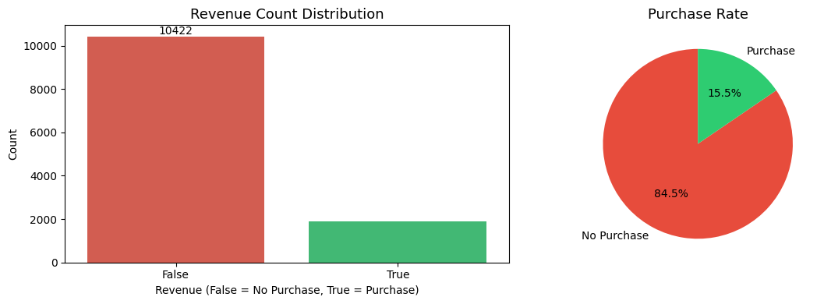
Figure 2.1 — Revenue (target) distribution: count plot and proportion
Purchase rate also varies meaningfully by segment. Returning visitors make up the bulk of traffic, but conversion rate differs by visitor type and by month of the year, pointing to seasonal and behavioural patterns a purely static model would miss.
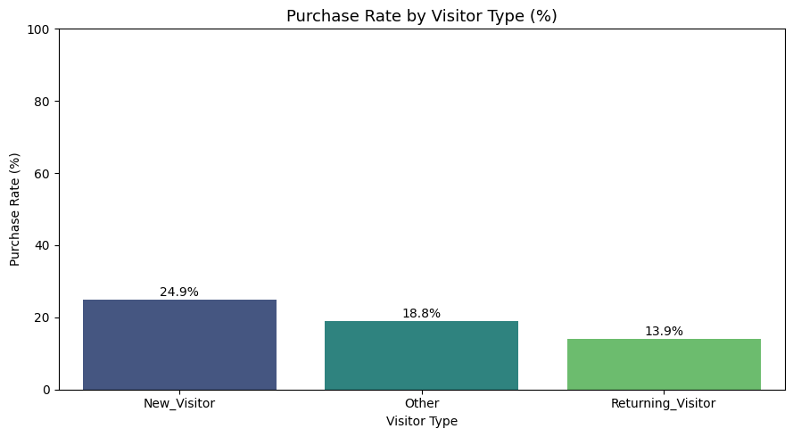
Figure 2.2 — Purchase rate (%) by visitor type
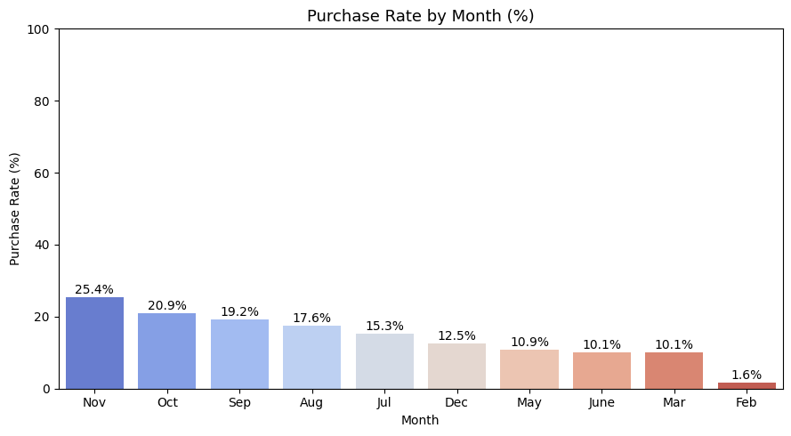
Figure 2.3 — Purchase rate (%) by month
PageValues — the average monetary value of pages a visitor viewed prior to a transaction — shows the clearest separation between the two classes: sessions that convert are heavily concentrated at higher PageValues, while non-converting sessions cluster near zero. This behavioural signal turns out to be the single strongest predictor in every model trained later in this report.
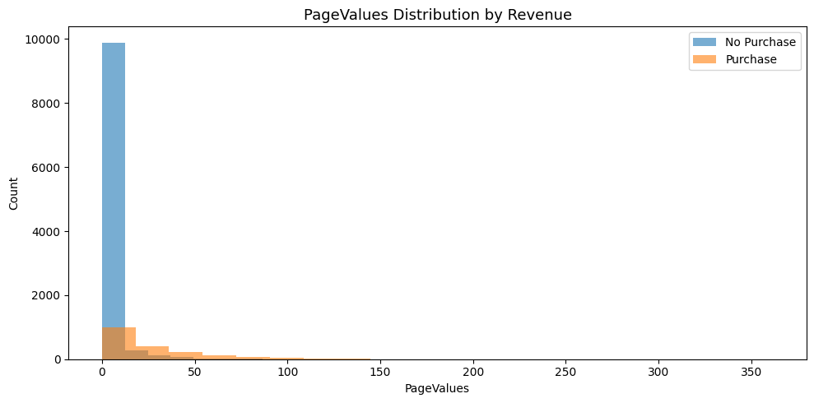
Figure 2.4 — PageValues distribution, split by purchase outcome

2.3 Assessing Data Quality
A structural quality check (df.info(), null counts, duplicate check) found the dataset to be largely clean:
- No missing values in any of the 18 columns — all 12,330 rows are fully populated.
- 125 exact duplicate rows were found and later removed during preparation, bringing the working dataset to 12,205 rows.
- Data types were appropriate throughout: 7 integer columns, 7 float columns, 2 boolean columns, and 2 text/categorical columns (Month, VisitorType).
- Z-score outlier screening flagged 3,312 extreme cells (|z| > 3) across the 10 numeric columns, concentrated in BounceRates, ExitRates and SpecialDay — addressed in Section 3.6.

3. Data Preparation

3.1 Data Integration
Not applicable to this project. All 18 variables originate from a single session-tracking export, so no merging or integration across data sources was required.

3.2 Data Cleaning & Missing Value Analysis
Missing-value analysis (df.isnull().sum()) confirmed zero nulls across every column, so no imputation of missing values was necessary. Data cleaning instead focused on duplicate sessions: 125 exact duplicate rows (about 1.0% of the data) were identified and removed before the train/test split. This ordering matters — removing duplicates before splitting prevents an identical row from appearing in both the training and test sets, which would let the model "see" a test example during training and artificially inflate evaluation metrics. After cleaning, the working dataset contains 12,205 rows and 18 original columns.

3.3 Data Imputation
Since the dataset had no missing values, no imputation strategy (mean/median/mode filling, KNN imputation, etc.) was required. This step is documented here as "not applicable" for completeness, consistent with the assignment structure.

3.4 Variable Standardization
Categorical columns Month and VisitorType were converted with LabelEncoder to integer codes (e.g., Month: Feb=2, Mar=5, ... ; VisitorType: New_Visitor=0, Other=1, Returning_Visitor=2). Boolean columns Weekend and Revenue were cast to 0/1 integers. All numeric features were then standardized using scikit-learn's StandardScaler (zero mean, unit variance), fitted on the training set and applied to both train and test sets. Standardization is strictly required for the Logistic Regression baseline and does no harm to the tree-based models, so it was applied uniformly for a clean, reproducible pipeline.

3.5 Feature Selection / Feature Engineering
A correlation screen against the target guided feature understanding: PageValues (r = 0.492) and ExitRates (r = −0.204) stood out as the strongest linear signals among the raw variables, followed by ProductRelated, ProductRelated_Duration and BounceRates. No raw variable was dropped, since tree-based models can naturally down-weight low-signal features; instead, the focus shifted to engineering new features that better expose non-linear, ratio-based relationships for the trees to split on.
Engineered Feature | Formula | Correlation with Revenue
PageValuePerDuration | PageValues / (TotalDuration + 1) | 0.282
TotalPageviews | Administrative + Informational + ProductRelated | 0.162
TotalDuration | Sum of the three *_Duration columns | 0.154
ExitBounceGap | ExitRates − BounceRates | −0.142
IsSpecialDayFlag | 1 if SpecialDay > 0, else 0 | −0.088
ProductPageRatio | ProductRelated / (TotalPageviews + 1) | 0.081
AvgProductDuration | ProductRelated_Duration / (ProductRelated + 1) | 0.064
Table 3.1 — Seven engineered features and their correlation with the target
Seven new features were added, expanding the feature set from 18 to 25 columns (24 predictors + target after dropping Revenue from X). Notably, PageValuePerDuration — value generated per second of browsing — has a stronger correlation with Revenue (0.282) than all but one raw feature, and later emerges as the second most important predictor in both Random Forest and XGBoost (Section 5.3), confirming that the engineering effort added genuine signal rather than noise.

3.6 Outlier Detection and Treatment
Outliers were identified using a z-score threshold (|z| > 3) on the ten numeric behavioural columns, flagging 3,312 extreme cells — most heavily in BounceRates (593), ExitRates (599) and SpecialDay (478). Rather than removing or capping these values, they were deliberately retained. This is a considered choice, not an oversight: the four models used in this project (Logistic Regression apart) are dominated by tree-based algorithms — Decision Tree, Random Forest and XGBoost — which split on thresholds rather than assume a bell-shaped distribution, making them naturally robust to extreme values. An unusually long product-browsing session is not necessarily bad data; it may represent a genuinely highly engaged visitor, which is exactly the kind of signal the model should learn from rather than discard.

4. Exploring Several Classification Models
After preparing a stratified 80/20 train-test split (9,764 training sessions, 2,441 test sessions, both preserving the 15.6% purchase rate), four classification algorithms were trained and evaluated on identical data to ensure a fair, apples-to-apples comparison:
- Logistic Regression — an interpretable linear baseline, trained with class_weight="balanced" to counter the 5.5:1 class imbalance.
- Decision Tree — a single interpretable non-linear model (max_depth = 8, class_weight = "balanced") that shows what one tree alone can capture.
- Random Forest — a bagged ensemble of 200 trees (class_weight = "balanced"), trading some interpretability for stability and reduced overfitting.
- XGBoost — a gradient-boosted ensemble of 200 trees (learning_rate = 0.1, max_depth = 5), using scale_pos_weight to rebalance the minority "purchase" class — XGBoost's equivalent of class_weight="balanced".
All four models were trained on the same 24-feature, standardized training set (which includes the seven engineered features from Section 3.5), so any performance differences reflect genuine differences between the algorithms rather than differences in the data each model saw.

5. Model Evaluation and Diagnostics

5.1 Comparison Leaderboard
Because the target is imbalanced, accuracy alone is a misleading yardstick — a model that always predicts "no purchase" would still score roughly 84.5% accuracy while being commercially useless. The table below reports Accuracy, Precision, Recall, F1 Score and ROC-AUC for all four models on the held-out test set (2,441 sessions).
Model | Accuracy | Precision | Recall | F1 Score | ROC-AUC
Logistic Regression | 0.8664 | 0.5534 | 0.7592 | 0.6402 | 0.8999
Decision Tree | 0.8447 | 0.5024 | 0.8089 | 0.6199 | 0.8786
Random Forest | 0.8984 | 0.7279 | 0.5602 | 0.6331 | 0.9243
XGBoost | 0.8763 | 0.5781 | 0.7749 | 0.6622 | 0.9259
Table 5.1 — Leaderboard: all four models on the 2,441-session test set
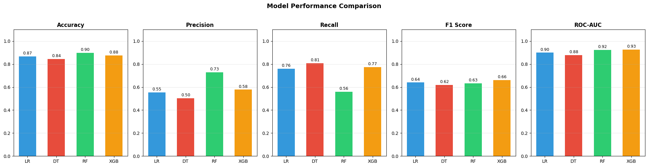
Figure 5.1 — Visual comparison of Accuracy, Precision, Recall, F1 and ROC-AUC across models
XGBoost is selected as the best model, ranked by F1 Score (0.6622) — the metric that best balances catching real buyers (Recall) against not over-flagging browsers as buyers (Precision) on an imbalanced target. XGBoost also posts the highest ROC-AUC (0.9259), meaning it separates buyers from non-buyers most cleanly across every possible decision threshold. Random Forest achieves the highest raw Accuracy (0.8984) and by far the best Precision (0.7279), making it attractive if the business specifically wants to minimise false alarms (e.g., before triggering a costly discount), while Logistic Regression and Decision Tree favour Recall — catching more true buyers at the cost of more false positives. The choice of "best" model therefore depends on the business action attached to a positive prediction; XGBoost is the strongest all-round default.

5.2 Confusion Matrices & ROC Curves
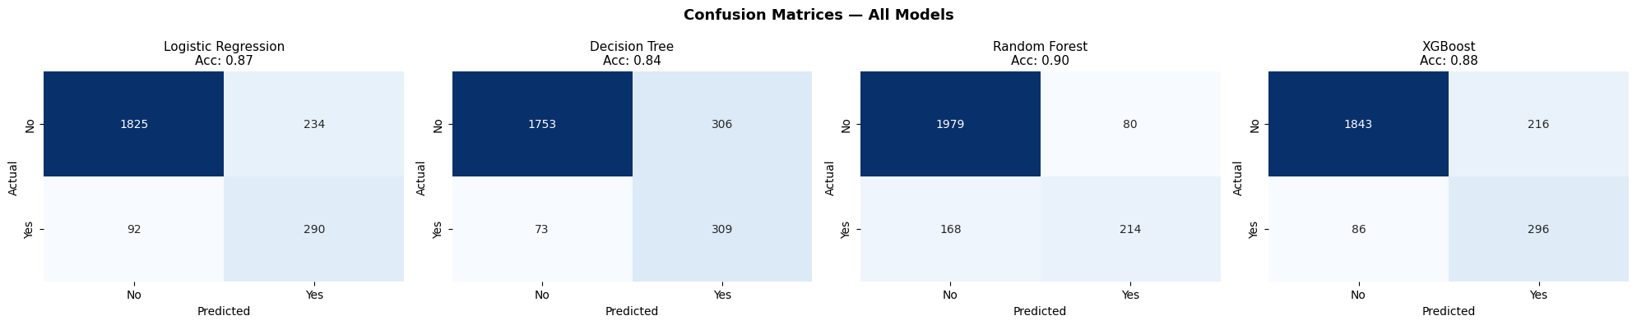
Figure 5.2 — Confusion matrices for Logistic Regression, Decision Tree, Random Forest and XGBoost
The confusion matrices show the practical trade-off behind the numbers: Random Forest makes the fewest false-positive errors (flagging a browser as a buyer) but also misses the most real buyers (lowest Recall, 0.5602). XGBoost and Logistic Regression catch substantially more real buyers (Recall of 0.7749 and 0.7592 respectively) at the cost of more false alarms — generally the safer trade-off for a marketing use-case, where missing a genuine buyer is more costly than showing one extra promotional banner to a browser.
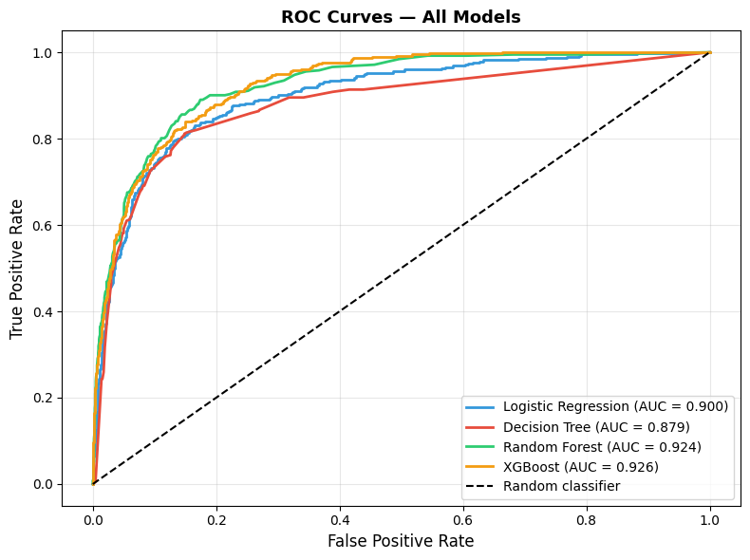
Figure 5.3 — ROC curves for all four models (higher and further left is better)
All four ROC curves sit well above the diagonal "random classifier" line, with XGBoost (AUC = 0.926) and Random Forest (AUC = 0.924) forming a clearly stronger tier over Logistic Regression (AUC = 0.900) and the single Decision Tree (AUC = 0.879). This confirms that ensembling — whether bagging (Random Forest) or boosting (XGBoost) — meaningfully improves the model's ability to rank sessions by purchase likelihood, which matters if the business later wants to tune the decision threshold (e.g., only trigger an intervention above a stricter confidence cut-off).

5.3 Feature Importance Diagnostics
Random Forest and XGBoost — the two strongest models — were compared on which features drive their predictions, since this is where the payoff of feature engineering (Section 3.5) becomes visible.
Rank | Random Forest — Top Feature | Importance | XGBoost — Top Feature | Importance
1 | PageValues | 0.2340 | PageValues | 0.3915
2 | PageValuePerDuration * | 0.1848 | PageValuePerDuration * | 0.1291
3 | ExitRates | 0.0625 | Month | 0.0884
4 | TotalDuration * | 0.0521 | TotalDuration * | 0.0279
5 | ProductRelated_Duration | 0.0514 | TotalPageviews * | 0.0274
Table 5.2 — Top-5 features by importance (* = engineered feature)
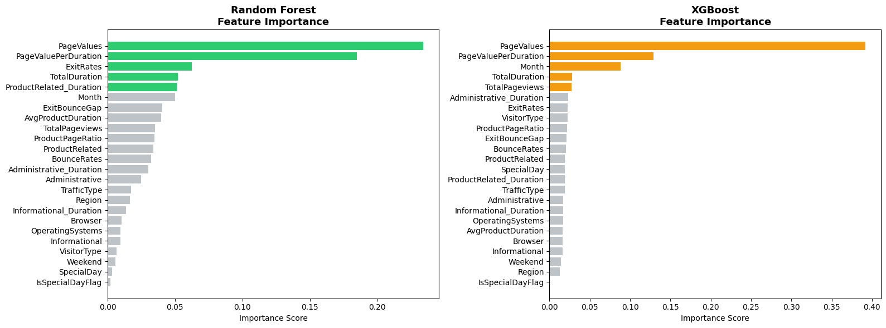
Figure 5.4 — Feature importance: Random Forest (left) vs XGBoost (right)
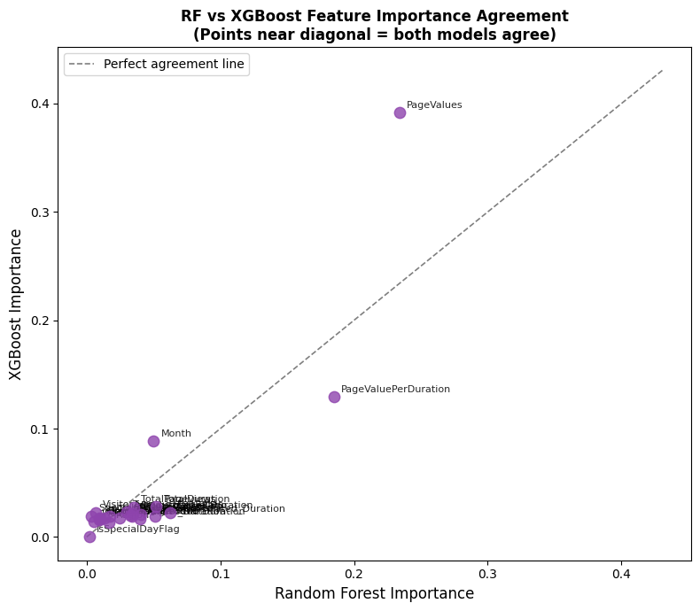
Figure 5.5 — Random Forest vs XGBoost importance per feature (points near the diagonal = agreement)
Both models agree strongly on the top of the ranking: PageValues and the engineered PageValuePerDuration occupy the top two positions in both Random Forest and XGBoost, together accounting for over 40% of total importance in each model. This is strong, model-agnostic evidence that "value generated per unit of browsing time" is the single most reliable behavioural predictor of purchase intent. Three of the seven engineered features — PageValuePerDuration, TotalDuration and TotalPageviews — rank inside the top five for at least one model, confirming that Section 3.5's feature engineering earned its place rather than adding noise. The two models diverge most on ProductRelated_Duration and Administrative_Duration, where Random Forest and XGBoost rank them quite differently — a reminder that bagged and boosted trees can reach similar accuracy via different internal reasoning, and that any single-model interpretation should be treated with some caution.

6. Democratizing the Solution
A predictive model only creates business value if the people who run marketing campaigns and manage the website can act on it without needing a data science team on standby. Three concrete steps are proposed to democratize this XGBoost-based solution:
- 1. Wrap the model behind a simple scoring API. The trained XGBoost model can be serialized (e.g., via joblib or ONNX) and exposed through a lightweight REST endpoint that accepts a session's current behavioural metrics and returns a purchase-probability score in real time. This lets the website's front end or marketing-automation tool (e.g., trigger a chat pop-up or discount banner) consume the prediction without any Python or ML knowledge.
- 2. Build a no-code dashboard for business users. A self-serve dashboard (e.g., in Power BI, Tableau, or a lightweight internal web app) can surface the leaderboard, the top predictive drivers (PageValues, PageValuePerDuration, ExitRates), and daily/weekly conversion-probability trends, so marketing and product managers can monitor model behaviour and campaign impact without touching the underlying code.
- 3. Translate feature importance into plain-language playbooks. Because PageValues and time-efficient browsing are the strongest signals, customer-facing teams can be given simple, non-technical rules of thumb (e.g., "prioritise retargeting for sessions with high page value but no completed purchase") derived directly from the model's feature importances, rather than requiring them to interpret model internals directly.
Together, these steps move the model out of a notebook and into the hands of the people who set marketing budgets and design the on-site experience — which is the point of building it in the first place.

7. Conclusion & Business Recommendations
This project built and compared four classification models — Logistic Regression, Decision Tree, Random Forest, and XGBoost — to predict purchase intent from 12,330 e-commerce browsing sessions, with a particular focus on tree-based algorithms as specified in the assignment brief.

Key Findings
- Class imbalance is the central challenge. Only 15.5% of sessions convert (5.5:1 imbalance). Accuracy alone is misleading; F1 Score and ROC-AUC were treated as the primary metrics, and class_weight="balanced" / scale_pos_weight were applied across all four models to counter the imbalance.
- XGBoost is the recommended production model. It achieves the best F1 Score (0.6622) and the highest ROC-AUC (0.9259), offering the strongest overall balance of catching real buyers without excessive false alarms.
- Feature engineering added real, measurable value. The engineered PageValuePerDuration feature ranks as the #2 most important predictor in both Random Forest and XGBoost — ahead of every raw feature except PageValues itself.
- PageValues is the dominant behavioural signal. Across every correlation analysis and every model's feature-importance ranking, PageValues consistently emerges as the strongest single predictor of purchase intent, making it the most actionable real-time signal for the business.
- Model choice should follow the business action. Random Forest's superior Precision (0.7279) suits high-cost interventions (e.g., discount codes) where false positives are expensive; XGBoost's superior Recall/F1 suits lower-cost interventions (e.g., a banner or chat prompt) where missing a genuine buyer is the bigger loss.

Recommendation
Deploy the XGBoost model as the default purchase-intent scorer, using PageValues and PageValuePerDuration as the primary real-time signals for triggering on-site interventions, and revisit the Random Forest variant for any high-cost promotional actions where precision matters more than recall. Democratizing access to these scores — via a scoring API and a business-facing dashboard — is the next step to convert this analysis into ongoing commercial value.

