PRACTICAL-02

TASK-01
Task 1: Develop a C program that demonstrates how a Linux operating system executes a command entered by a user that 1. Accept a Linux command as input. 2. Create a child process using fork(). 3. Execute the command in the child process using an appropriate exec() system call. 4. Allow the parent process to wait for the child using wait (). 5. Display the Process ID (PID) of both parent and child processes.
- Write a C code to create a process using fork() system call.
- Read the user input as shell command.
- Use a system call exec() to execute the shell command.
- Use a wait() system call for waiting a parent process.
- Display the PIDs of parent and child processes.
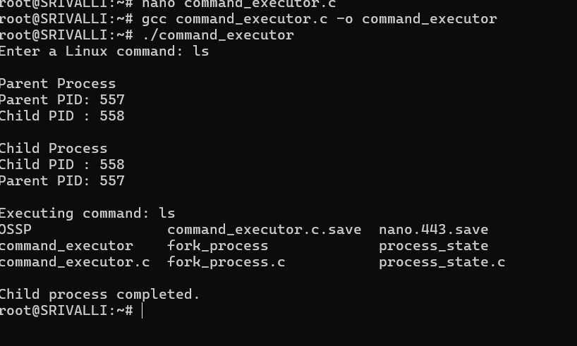
REPORT:
Title: Command Execution using fork() and exec()
The program was developed to create a parent and child process using fork(). The child process executes the Linux command entered by the user using exec(). The parent process waits for the child using wait(). The PID and PPID of both processes were also displayed.

Task-2: Using Linux terminal commands (uname, lscpu, ps, top), investigate the relationship between hardware resources and operating system services. Prepare a report explaining how the OS abstracts CPU, memory, storage, and I/O devices.
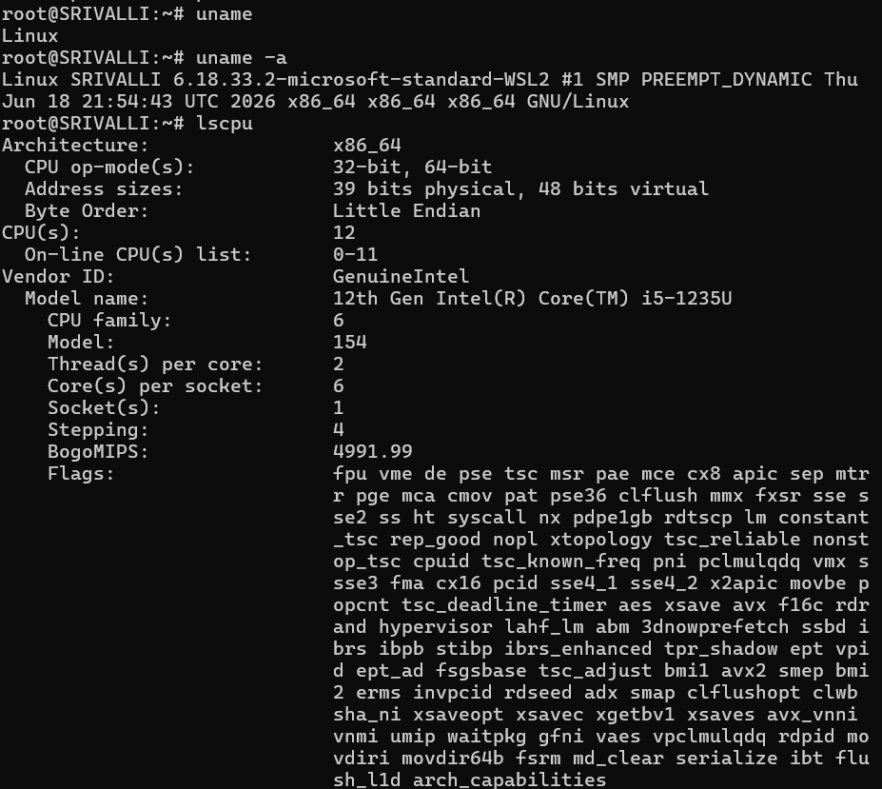
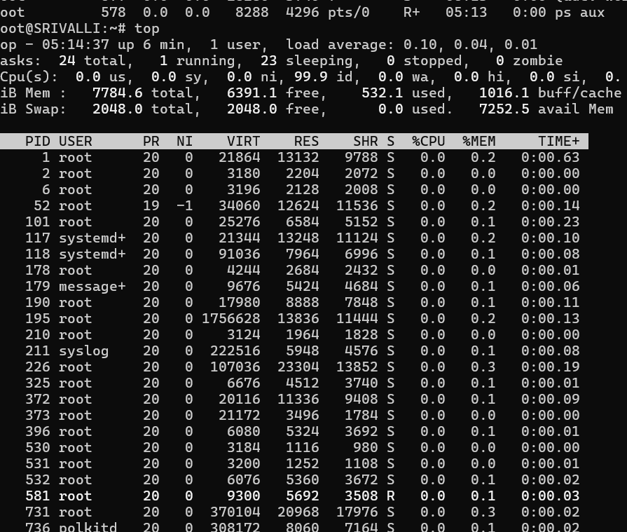
REPORT:
Title: Hardware Resources and OS Services
In this task, Linux commands like uname, lscpu, ps, and top were used to check system information, CPU details, running processes, and resource usage. This helped us understand how the operating system manages CPU, memory, storage, and other hardware resources.

